Deep learning in CEST
In order to generate numerous training samples, I analyzed the Lorenz parameters. Every Z spectrum consists of two Lorenz curves, one denotes the water, and the other represent the creatine.
- WJG_cest_sta_main.m
  - The distribution of K2 K3
There are four parameters in Lorenz function. Two of them decide the location and the max value, and the other two (K2、K3) determine the shape of the curve. So the first step is to general determine the range of K2 and K3.
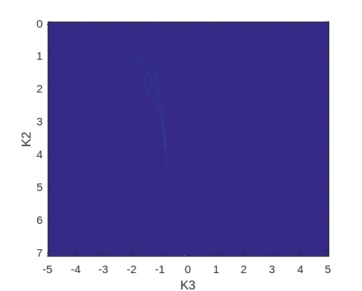
Figure 1 the distribution of k2 & k3（FSE CEST experiments）
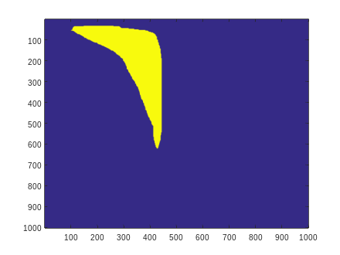
Figure 2 determine the k2 k3 range manually
  - Generate K2 and K3 in the range determined in Figure 2.
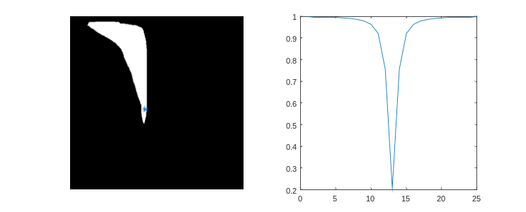
Figure 3. The point (blue) denotes the generated K2 and K3; the corresponding Z spectrum
  - Search the parameter space (search_K2K3.m)
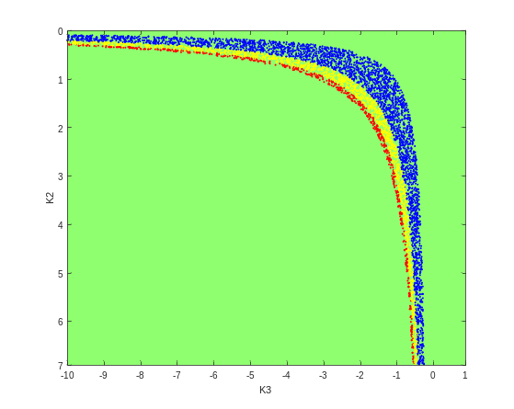
Figure 4 k2 & k3 distribution（theoretical）, the red dot means the minimum value is smaller than 0.1; the yellow dot means the minimum value is smaller than 0.3; the blue dot means the minimum value is smaller than 0.7.

- WJG_generate_cest_simu.m
  - Generate different shapes to simulate tissues(WJGshape_cest.m)
The code can generate different shapes, such as circle, square, triangle and so on.
Different tissues have different CEST effects, and corresponding to different Z spectrums.
In order to generate more realistic models, I add the texture of nature images to the tissue. And finally, Gaussian filter and Gaussian noise are added.
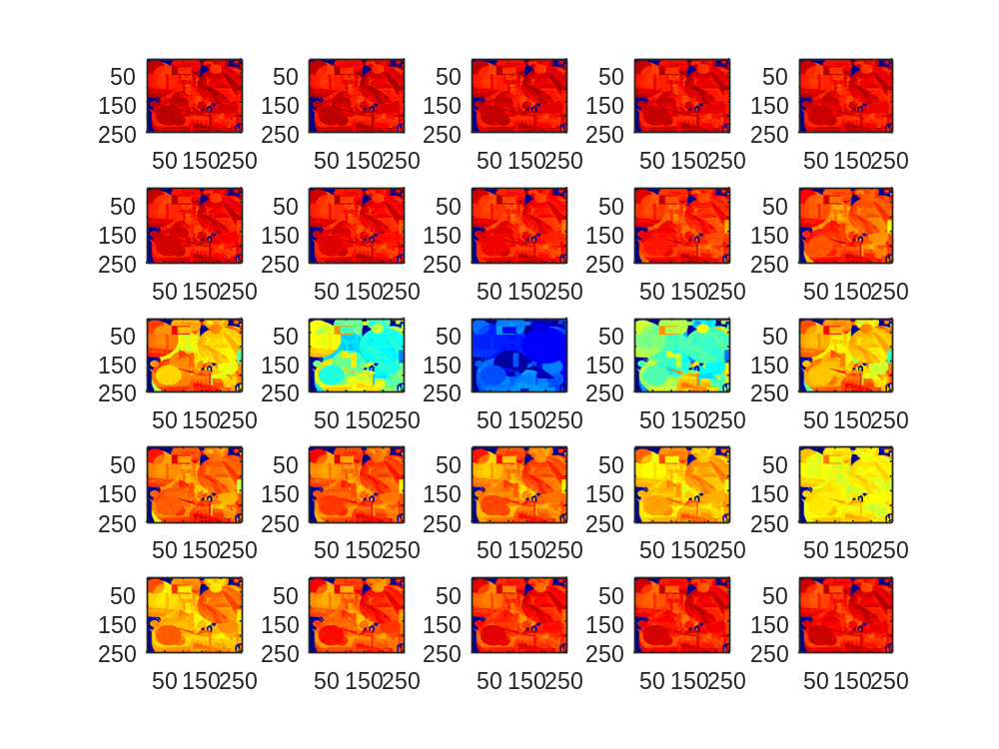
Figure 5 before Gaussian filter
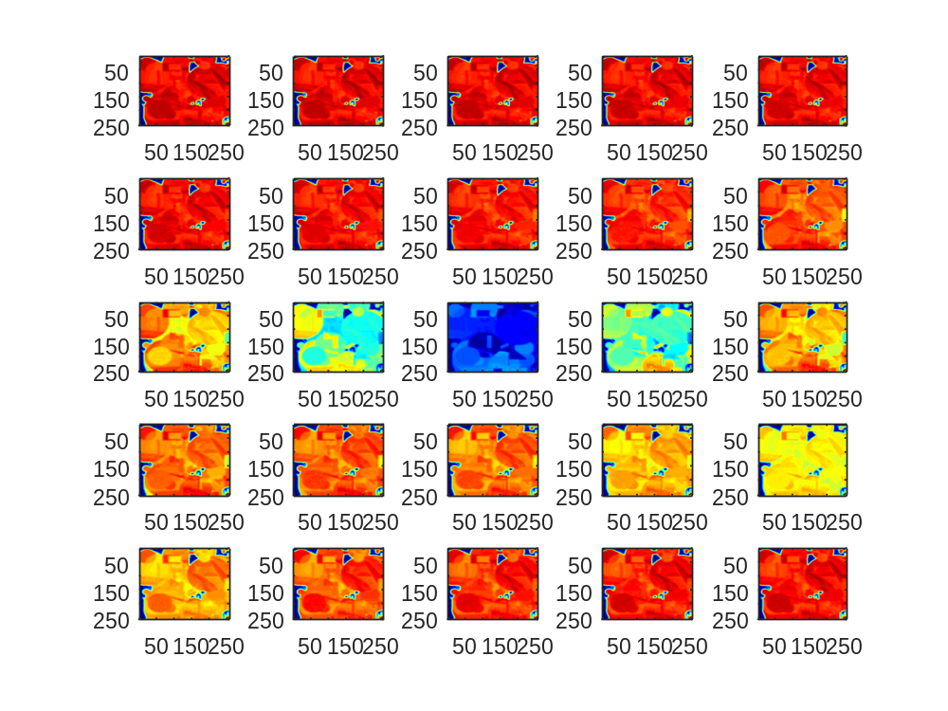
Figure 6 after Gaussian filter

