This document describes how to use MRiLab to generate the training samples. The newest version is placed under “/data3/wj/MRiLab” in our server (59.77.36.18). The overall workflow (Fig. 1) can be divided into two parts, random sample generation and sequence simulation.
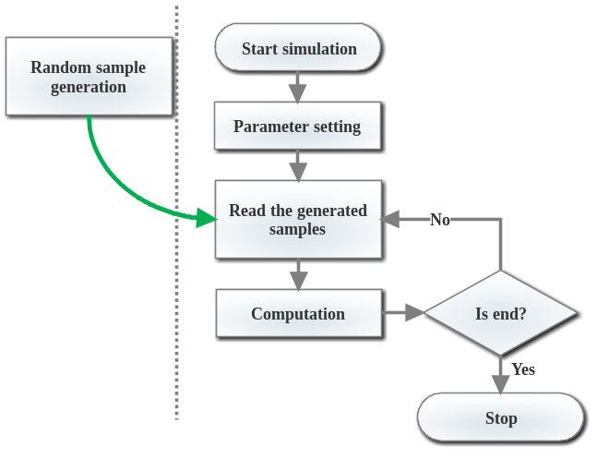
Fig. 1 The overall workflow
- Type “MRiLab” in Command Window to open the MRiLab
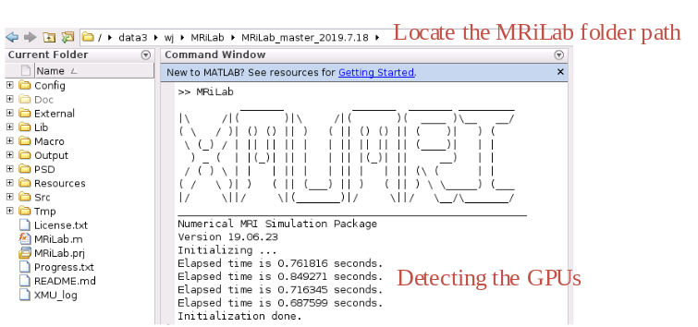
Fig. 2 open the MriLab
I recommend the MATLAB2018a or above. Because the lower version is very slow in GPU initialization.
- Load a phantom
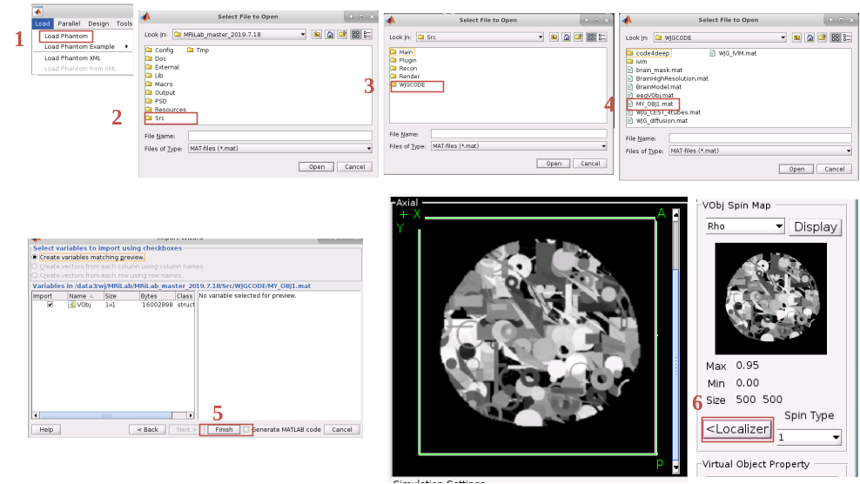
Fig. 3 load a phantom
Of course, you can make a phantom by yourself, and place it in any location as you like. The following steps demonstrate how to generate a sample. (This steps can be skipped.)
  - There is a simple example in “/Src/WJGCODE/code4deep/T2star”.
  - Generate random samples is a time-consuming task. So I generate the random samples before simulation. The code is “WJG_gen_obj2.m”.( “2” indicates the version)
  - “WJG_gen_obj.m” is used for reading the generated samples.
- Sequence selection
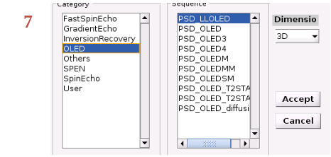
Fig. 4 sequences
All the sequences (SPEN and OLED) can only be used in our own group, should not be shared with others before they published.
- Parameter setting
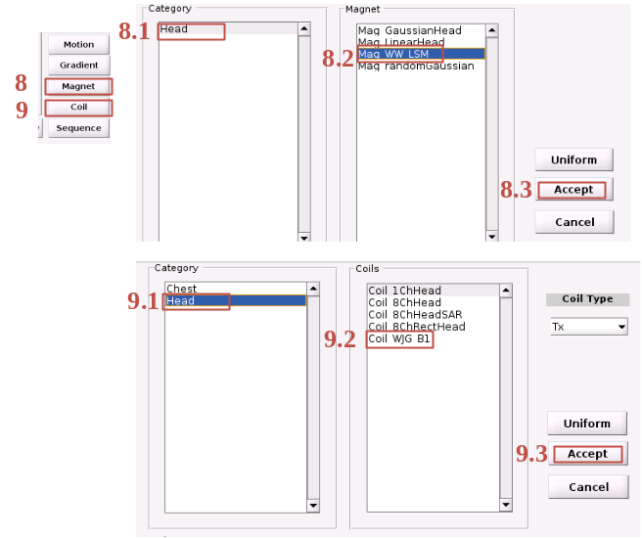
Fig. 5 B₀ and B₁ setting
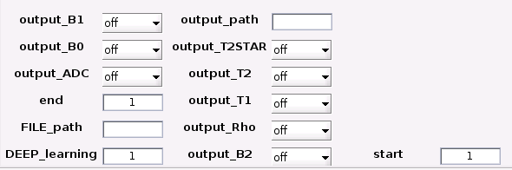
Fig. 6 parameters setting
output_XXX can be turn on or off to determine whether this parameter should be output or not;
FILE_path is the directory contains the generated random samples;
output_path is the directory placed the training samples;
In order to run multiple MRiLab simultaneously, I designed the following two parameters.
start is the start number of the training samples;
end is the end number of the training samples
DEEP_learning is a flag to determine to simulate the sequence with the original MRiLab or the modified MRiLab. It should be set to 1, if you want to generate the training samples.

The number of generate samples should not be larger than 900. It means end-start<900.

