1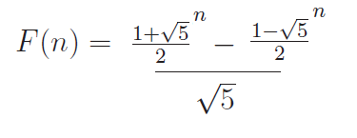 The cheap way to do Fibonacci

Memorize the greek alphabet both case.

Perceptron Node. IT is a piece wise function.

Learning Rate scales it. I think I already knew this Change in W = Old W- learningrate **( change )**\* what I need.

Always use a bias rate

Turn it in as a zip.

40% do the project.

Not linear sperable si the line thng and its on the wrong side of the line.

The weird linearly sperable chart is kind of cool with the xor messing up the linearly sepreable.

Continuous is useless tag Nominal Ordinal is useful number

Data Normalization v* =(v-min)/(max-min)

Linear can be good if you have valid data but can get screwed up with junk data. Is also kind of limited.

Sumation of (pred-y)^2 -Sumation(pred)^2

Or w =(X transpose X )^-1 X transpose Y

This is for the Euclidean distance.

C(t-z)x of I is perceptron

Delta C(t-net)x of I is delta where net is the summation of it.

Log is cool just get probability then for odds do p/(1/p) for odds. Then do log of odds. Do the one on wolf ram alpha.

We want momentum to get us out of maxima and minima

Statistical Significantce. Confidence interval stats 121 if they overlap might not be significant. If they don’t will be. Pvalue test statistic.