Assignment M3P3

Weiyu Wan , wwan9@gatech.edu

# Part 1. Technical Indicators

In this part, I used three different kind of indicators. There are Moving Average indicator, Rate-of-Change (ROC) indicator, and the Relative Strength Index (RSI).

**Note:** All the data in figures of this part are normalized to 1.0 by divided the value at the start of the date range.

* 1. Simple Moving Average (SMA) indicator

Moving averages smooth the price data to form a trend following indicator. They do not predict price direction, but rather define the current direction with a lag. Moving averages lag because they are based on past prices. Despite this lag, moving averages help smooth price action and filter out the noise.

A simple moving average is formed by computing the average price of a security over a specific number of periods. Most moving averages are based on closing prices. A 5-day simple moving average is the five day sum of closing prices divided by five. As its name implies, a moving average is an average that moves. Old data is dropped as new data comes available. This causes the average to move along the time scale.

The calculation of SMA is as following:

Daily Closing Prices: 11,12,13,14,15,16,17

First day of 5-day SMA: (11 + 12 + 13 + 14 + 15) / 5 = 13

Second day of 5-day SMA: (12 + 13 + 14 + 15 + 16) / 5 = 14

Third day of 5-day SMA: (13 + 14 + 15 + 16 + 17) / 5 = 15

Here we will use the relative different between SMA(5) and SMA(15) as an indicator of trend. It is calculated with the following formula:

$$MA_{diff}= \frac{MA_{t}\left(5\right)-MA_{t}(15)}{Close_price(t)}$$

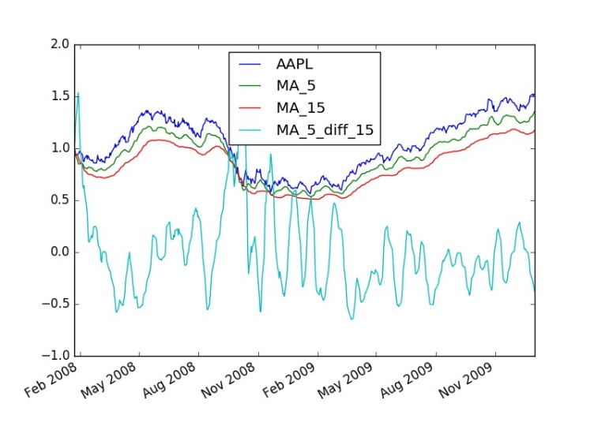

Figure 1. MA5, MA15, MA(5, 10 diff) with close price of AAPL

Reference:

http://stockcharts.com/school/doku.php?st=sma&id=chart\_school:technical\_indicators:moving\_averages

* 1. Rate-of-Change (ROC) indicator

The Rate-of-Change (ROC) indicator, which is also referred to as simply Momentum, is a pure [momentum oscillator](http://stockcharts.com/school/doku.php?id=chart_school:technical_indicators:introduction_to_technical_indicators_and_oscillators#momentum_oscillators) that measures the percent change in price from one period to the next. The ROC calculation compares the current price with the price “n” periods ago. The plot forms an oscillator that fluctuates above and below the zero line as the Rate-of-Change moves from positive to negative. As a momentum oscillator, ROC signals include centerline crossovers, divergences and overbought-oversold readings.

It can be calculated with the following formula:

$$ROC= \frac{Close\left(t\right)-Close(t-n)}{Close(t-n)}$$

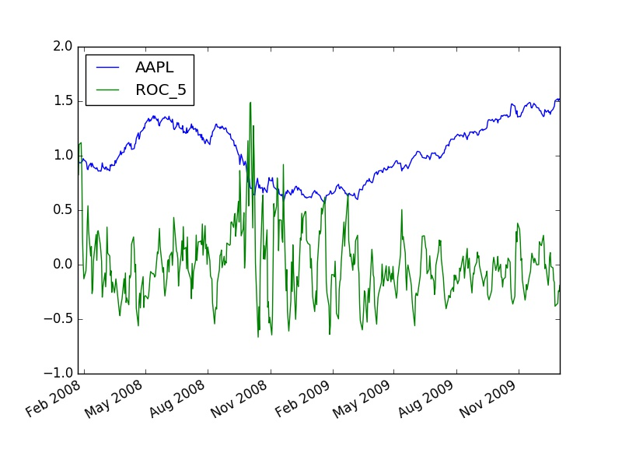

Figure 2. ROC(5) with close price of AAPL

Reference: <http://stockcharts.com/school/doku.php?id=chart_school:technical_indicators:rate_of_change_roc_and_momentum>

* 1. Relative Strength Index (RSI)

The Relative Strength Index (RSI) is a momentum oscillator that measures the speed and change of price movements. RSI oscillates between zero and 100. Traditionally, RSI is considered overbought when above 70 and oversold when below 30. Signals can also be generated by looking for divergences, failure swings and centerline crossovers. RSI can also be used to identify the general trend.

Given a period n, for example, RSI can be calculated with following formula:

$$RSI=100- \frac{100}{RS}$$

$$RS={Average Gain}/{Average Loss}$$

Note: Average Gain is the total earning divided by time period n, Average Loss is the total loss divided by the time period n.

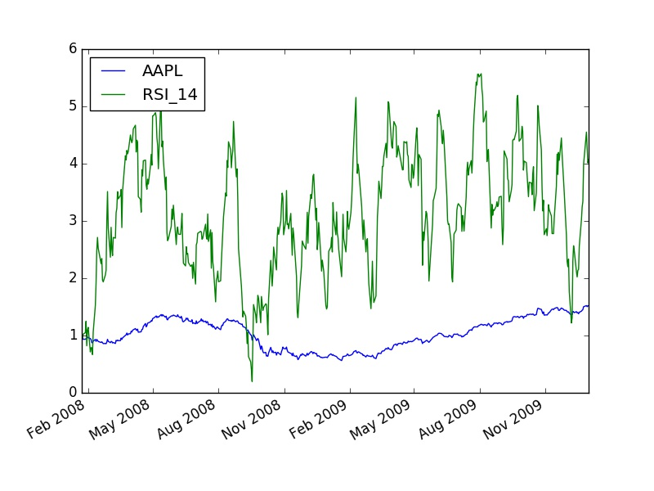

Figure 3. RSI(14) with close price of AAPL

Reference:

<http://stockcharts.com/school/doku.php?st=rsi&id=chart_school:technical_indicators:relative_strength_index_rsi>

# Part 2: Best Possible Strategy

The best strategy is constructed with the following rule: Every day: if the stock will go up tomorrow, buy it. If the stock will go down tomorrow, short it.  And close all positions every day.

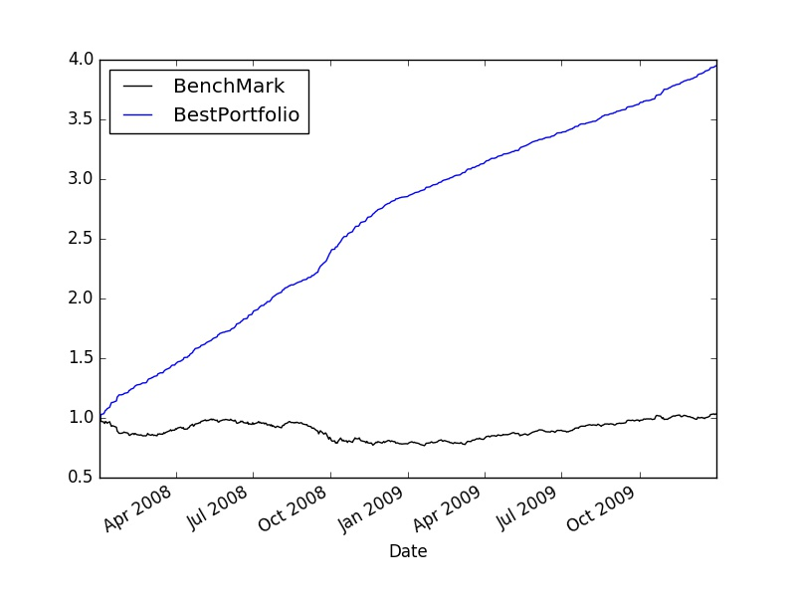

Figure 4. Best portfolio vs Benchmark

The performance of best portfolio and benchmark are as following:

Date Range: 2008-01-02 00:00:00 to 2009-12-31 00:00:00

Cumulative Return of BestPortfolio: 2.94948

Cumulative Return of BenchMark : 0.03164

Standard Deviation of BestPortfolio: 0.003219370857476855

Standard Deviation of BenchMark : 0.008740537520147718

Average Daily Return of BestPortfolio: 0.0027342012745606116

Average Daily Return of BenchMark : 0.00010006911696834135

Final Portfolio Value of BestPortfolio: 394948.0

Final Portfolio Value of BenchMark: 103164.0

# Part 3: Manual Rule-Based Trader

The manual strategy is designed based on ROC(5), RSI(14) and relative different between SMA(5) and SMA(15). (The value of the indicators are not normalized)And we will trade with the following rule:

When ROC(5) < -0.04, RSI(14) < 40 and MA\_5\_diff\_10 < -0.015, we will short.

condition\_short = (df["ROC\_5"] < -0.04) & (df["RSI\_14"] < 40) & (df["MA\_5\_diff\_15"] < -0.015)

When ROC(5) > 0.05, RSI(14) > 65 and MA\_5\_diff\_10 > 0.015, we will long.

condition\_long = (df["ROC\_5"] > 0.05) & (df["RSI\_14"] > 65) & (df["MA\_5\_diff\_15"] > 0.015)

The meaning of the strategy:

For short condition: the ROC stand for the momentum, we wish the stock has a drop momentum. But for safety we do not wish the stock is weak. Therefore, we require RSI(14) < 40. And MA\_5\_diff\_10 < -0.015 means the stock is Bear.

For long condition: the ROC stand for the momentum, we wish the stock has a rocket momentum. But for safety we do not wish the stock has strong buy power. Therefore, we require RSI(14) > 65. And MA\_5\_diff\_10 > 0.015 means the stock is Bull.

By run “python rule\_based.py” we can generate the order file. With the order file, we can update “if \_\_name\_\_ == "\_\_main\_\_": ” with “manual\_bench\_simulate()“ and run “Python marketsim.py” to get the following result.

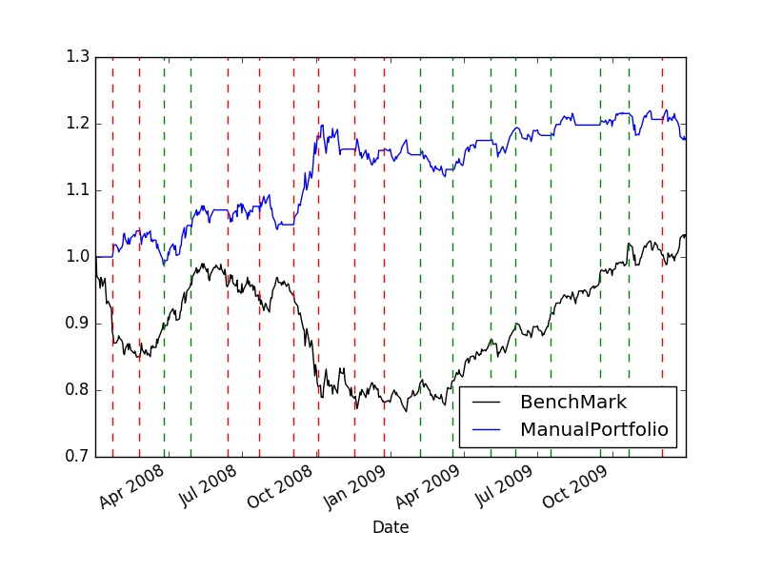

Figure 5. Manual Strategy vs Benchmark

Date Range: 2008-01-02 00:00:00 to 2009-12-31 00:00:00

Cumulative Return of ManualPortfolio: 0.17764

Cumulative Return of BenchMark : 0.03164

Standard Deviation of ManualPortfolio: 0.005983279945156924

Standard Deviation of BenchMark : 0.008740537520147718

Average Daily Return of ManualPortfolio: 0.00034230492368556855

Average Daily Return of BenchMark : 0.00010006911696834135

Final Portfolio Value of ManualPortfolio: 117764.0

Final Portfolio Value of BenchMark: 103164.0

# Part 4. ML Trader

4.1 Machine learning model

The classification is implemented based on Decision Tree. The features are ROC\_5, RSI\_14 and MA\_5\_diff\_15. Before we train the model, we normalize the features with the following methods:

$$z= \frac{x-μ }{σ}$$

And we label the data with the following rule:

We first labeled in the following rule, if the stock drop more than 15% after 21 holding days, we labeled it as -1. If the stock’s return more than 15% after 21 holding days, we labeled it as 1.

We build a decision tree with RTLearner.py, the number of leaf is 5. We trained decision tree with the normalized data. After training the model, we can get the predicted label. If the predicted label is < 0, we label as -1. If the predicted label is > 0, we label as 1.

4.2 Model tweak:

**Note: The result may change, since the tree is split randomly. Set random seed np.random.seed(4102017)**

When leaf = 5,

Bound is 15%, Final Portfolio Value of MachinePortfolio: 143802.0.

We adjusted the bound as 12%: Final Portfolio Value of MachinePortfolio: 134490.0

We adjusted the bound as 17%: Final Portfolio Value of MachinePortfolio: 146492.0

When Bound is 17%,

Leaf = 7, Final Portfolio Value of MachinePortfolio: 142346.0

Leaf = 10, Final Portfolio Value of MachinePortfolio: 124754.0

Finally, we choose Leaf = 5, bound = 17%.

4.3 Figure

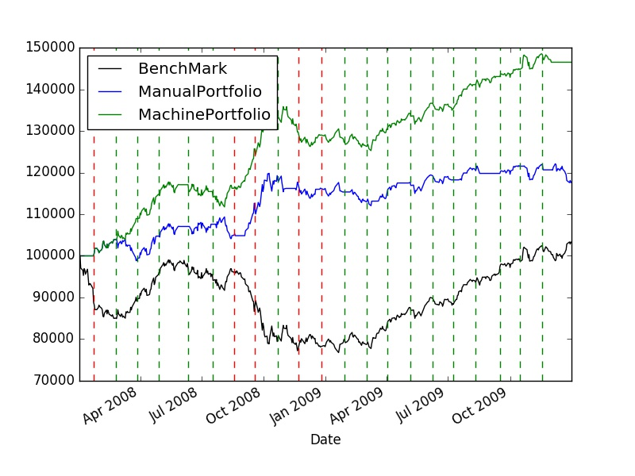

Figure 6. Machine Learning vs Manual Strategy vs Benchmark

(Leaf = 5, long\_bound = 17%, short\_bound=-17%)

4.4 Performance

Date Range: 2008-01-02 00:00:00 to 2009-12-31 00:00:00

Cumulative Return of MachinePortfolio: 0.46492

Cumulative Return of ManualPortfolio: 0.17764

Cumulative Return of BenchMark : 0.03164

Standard Deviation of MachinePortfolio: 0.005593637429768362

Standard Deviation of ManualPortfolio: 0.005983279945156924

Standard Deviation of BenchMark : 0.008740537520147718

Average Daily Return of MachinePortfolio: 0.0007734095333034427

Average Daily Return of ManualPortfolio: 0.00034230492368556855

Average Daily Return of BenchMark : 0.00010006911696834135

Final Portfolio Value of MachinePortfolio: 146492.0

Final Portfolio Value of ManualPortfolio: 117764.0

Final Portfolio Value of BenchMark: 103164.0

# Part 5. Visualization of data

The features we selected is RSI\_14 and ROC\_5

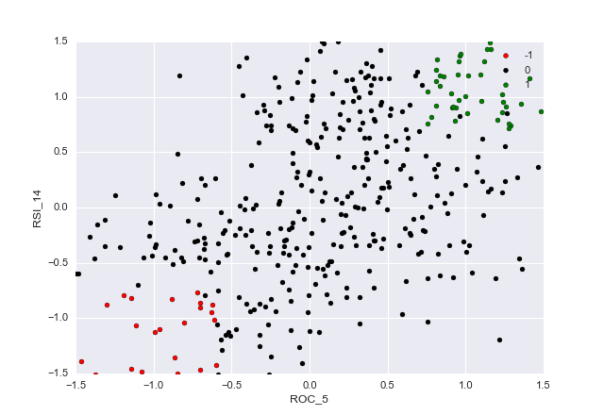

Figure 7. Manual Strat Scatter

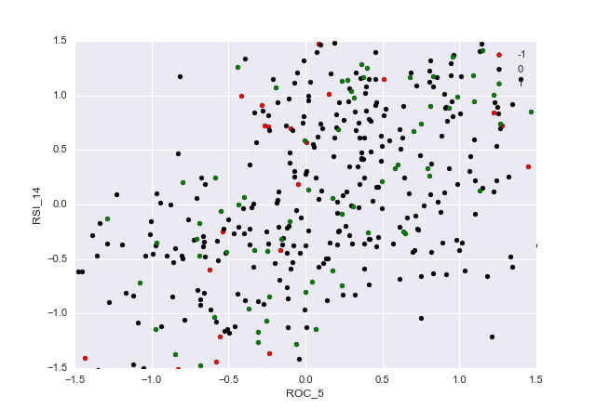 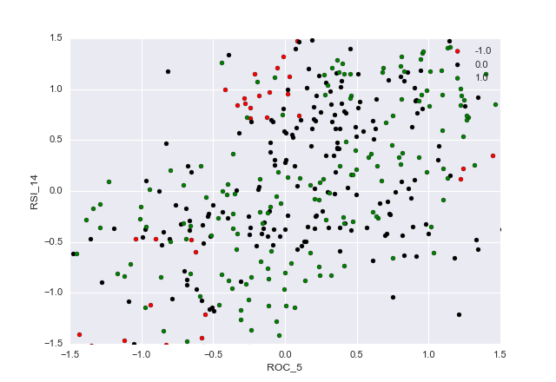

Figure 8.  training data for ML strategy Figure 9. ML strategy after train

# Part 6. Comparative Analysis

# C:\Users\vodkabuaa\AppData\Local\Microsoft\Windows\INetCache\Content.Word\bench_Manual_Machine.jpg

Figure 10. Manual Strat vs Machine learning Portfolio vs Bench Mark

Performance:

Date Range: 2010-01-04 00:00:00 to 2011-12-30 00:00:00

|  |  |  |
| --- | --- | --- |
|  | In Sample | Out of Sample |
| Cumulative Return of MachinePortfolio | 0.46492 | 0.27874 |
| Cumulative Return of ManualPortfolio | 0.17764 | -0.11506 |
| Cumulative Return of BenchMark | 0.03164 | 0.38034 |
| Standard Deviation of MachinePortfolio | 0.005593637429768362 | 0.00830483166433606 |
| Standard Deviation of ManualPortfolio | 0.005983279945156924 | 0.00857322075346746 |
| Standard Deviation of BenchMark | 0.008740537520147718 | 0.008553519757270927 |
| Average Daily Return of MachinePortfolio | 0.0007734095333034427 | 0.0005233167994038434 |
| Average Daily Return of ManualPortfolio | 0.00034230492368556855 | -0.00020636735019116046 |
| Average Daily Return of BenchMark | 0.00010006911696834135 | 0.0006775081056200108 |
| Final Portfolio Value of MachinePortfolio | 146492.0 | 127874.0 |
| Final Portfolio Value of ManualPortfolio | 117764.0 | 88494.0 |
| Final Portfolio Value of BenchMark | 103164.0 | 138034.0 |

Analysis:

From the above figure, out of the sample, the benchmark has the best performance and machine learning method have the second best performance and Manual rule best method is the worst. This is mainly because the in sample data is in a special case, the market drop and rocket significantly, this rule may works. And machine learning methods learned something special that is not obviously. Therefore, it has better performance both in sample and out of the sample. The benchmark is always very hard to beat.