20. Distance Problems
- Find the distance between A=(1,1) and B=(5,4) as shown in the picture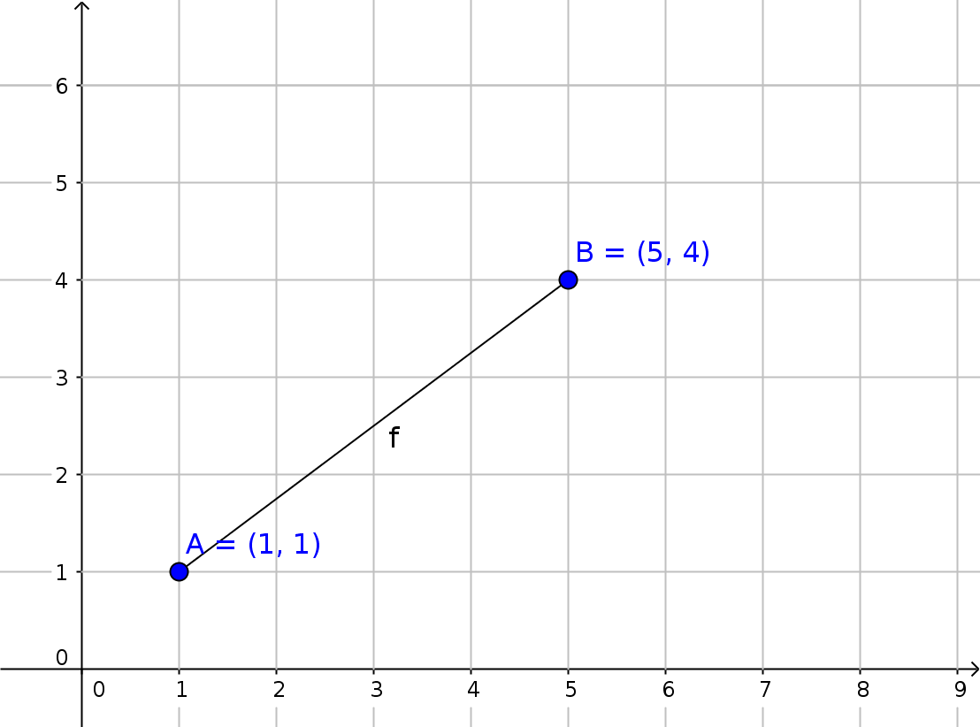
- Find the distance between A=(1,0) and B=(9,6) as shown below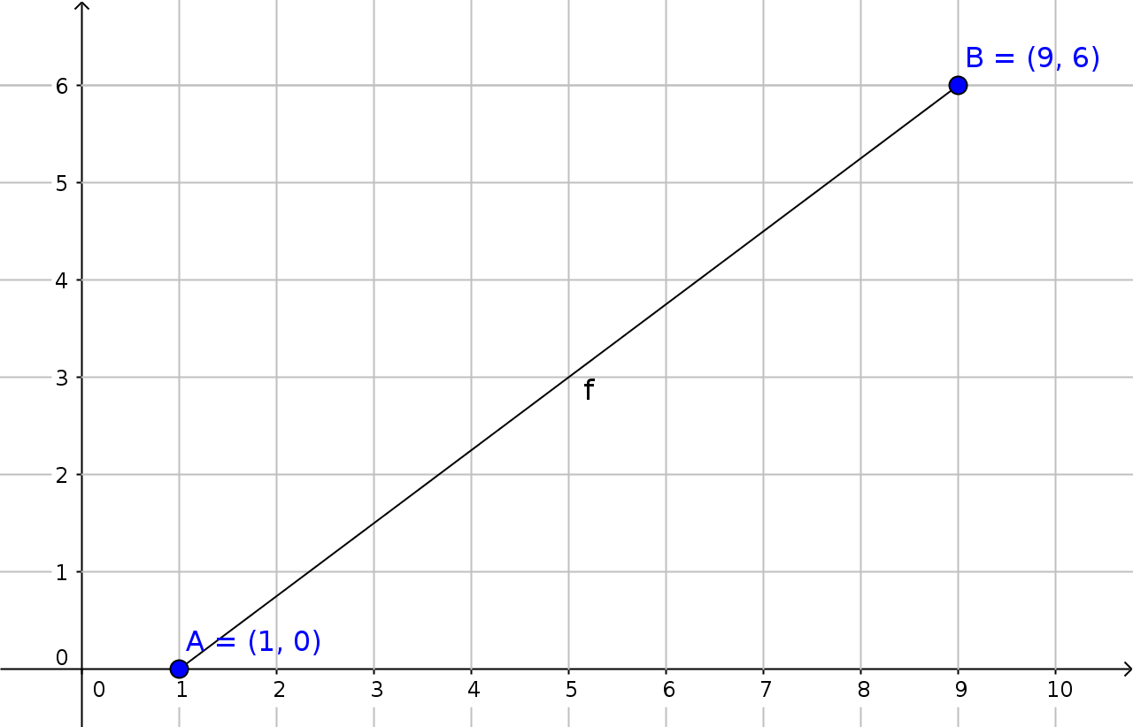
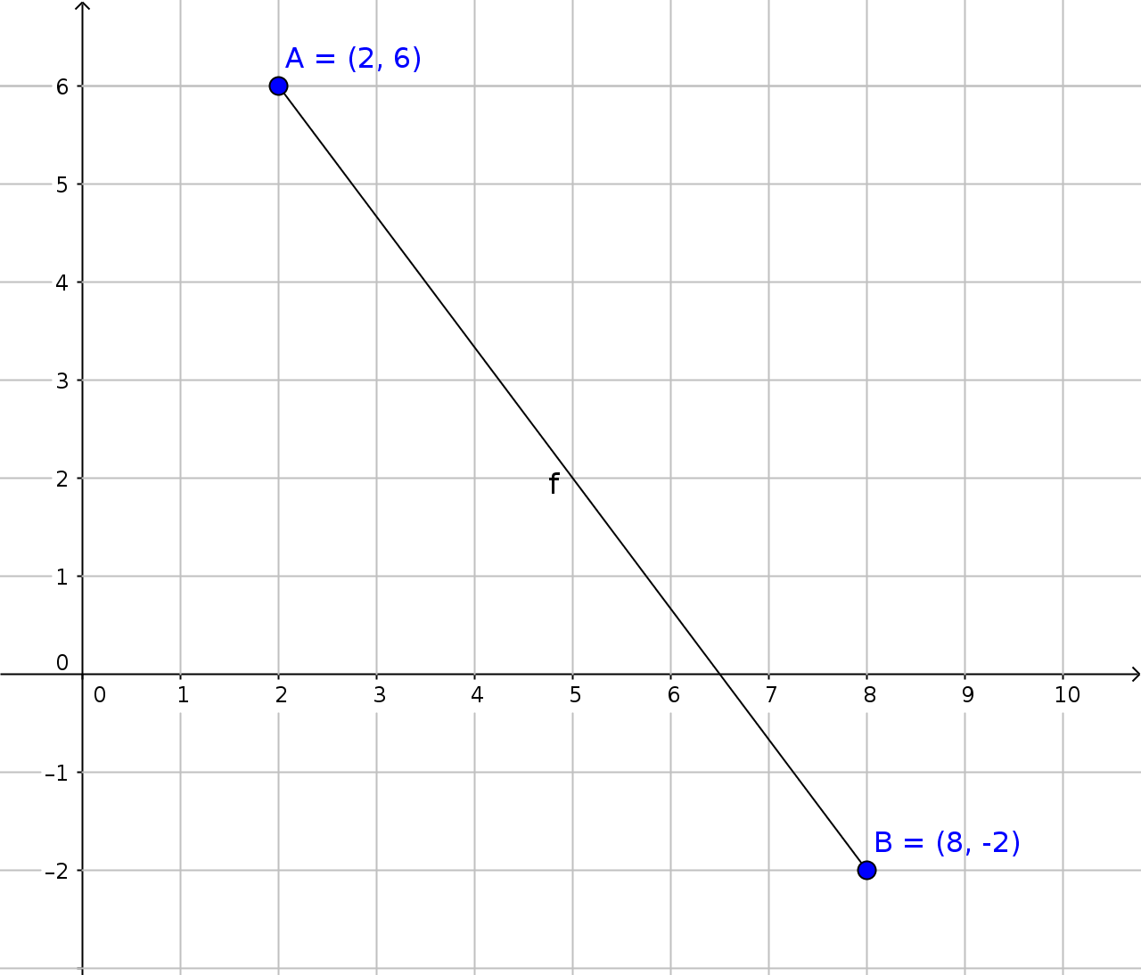
- Find the distance between A=(2,6) and B=(8, -2) as shown to the right.

20. Distance Answers
1. 5
2. 10
3. 10

