Knock Code Exercises

Introduction
The knock code was first seen in ancient Greece, developed by Polybius around 300 BC. It is a way of sending messages when all you can do is knock or tap on something. For English the standard layout is
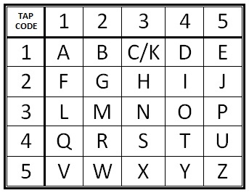
The first knock is the row to look at in the table, the second set of knocks is the column. So knocking 2 times, pause and knocking 3 times would be the letter in row 2 column 3 of the table, in other words H. We would write this letter down as 2,3 for short.

Exercises
- What is the knock code for HI?
- What does the knock code message 3,2 1,1 4,4 2,3 say?
- Write the knock code for your name.
- Translate
2,2 3,4 3,4 1,4 5,2 3,4 4,2 1,3

Knock Code
Extra Exercises
- What is the knock code table missing in order to make entire sentences? How would you fix this issue?
- What are some abbreviations, like LOL, that you can think of that would make it quicker to communicate with knock code with your friends?
- What if someone was listening in to your knock code conversation with a friend and you didn’t want them to understand the questions? How could you change the knock to so the you and your friend would understand, but someone else listening in could not?
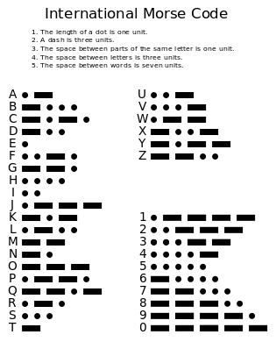
- The table to the right is the Morse code table. The dot represents sending a short sound and the dash represents a long sound. Can you think of a way to send Morse code messages via knocking or hitting something to make a noise? Or perhaps using something else to make a sound?

