Coordinates
Exercises

Introduction
The coordinate plane is pictured below. It allows us to locate any point in the plane by it position away the origin, the point (0,0).
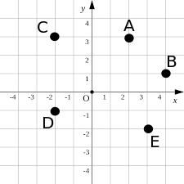
- In the xy plane pictured above, what are the coordinates of the following points?
  - A
  - B
  - C
  - D
  - E
- Using a piece of graph paper draw:
  - An x and y axis and the origin.
  - Plot the point A = (5,1)
  - Plot the point B = (0,5)
  - Plot the point C = (-4, 3)
  - Plot the point D = (3, -5)
  - Plot the point E = (-4, -3)

Coordinates
Answer Key
- Answers:
  - (3,2)
  - (1,4)
  - (-2,3)
  - (-2,-1)
  - (-3, -2)
- 