第一题：
程序在执行过程当中，在加锁代码处会出现死锁的情况：
- 线程 1：锁定账户 A （持有 A，等待 B）
- 线程 2：锁定账户 B （持有 B，等待 A）
- 两者会永久等待对方的锁，形成死锁
通过在加锁环节中间添加sleep语句发现出现了死锁（如下图），所以代码存在问题。
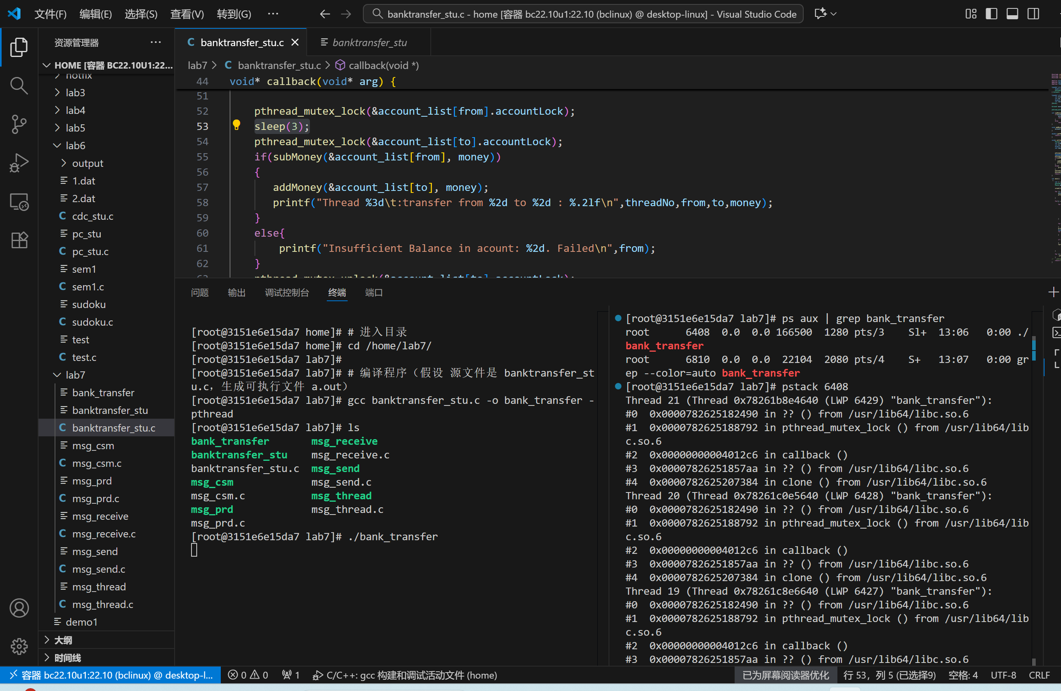
解决方法：按照顺序加锁，避免产生死锁
void* callback(void* arg) {
Paras* paraPointer = (Paras*)arg;
int from = paraPointer->from;
int to = paraPointer->to;
double money = paraPointer->value;
int threadNo = paraPointer->threadNo;
//***代码改动区域***
// 固定锁的获取顺序：先小后大
int first = (from < to) ? from : to;
int second = (from < to) ? to : from;
// 按固定顺序加锁
pthread_mutex_lock(&account_list[first].accountLock);
pthread_mutex_lock(&account_list[second].accountLock);
if(subMoney(&account_list[from], money)) {
addMoney(&account_list[to], money);
printf("Thread %3d\t:transfer from %2d to %2d : %.2lf\n", threadNo, from, to, money);
} else {
printf("Insufficient Balance in account: %2d. Failed\n", from);
}
pthread_mutex_unlock(&account_list[second].accountLock);
pthread_mutex_unlock(&account_list[first].accountLock);
return NULL;
}
第二题：
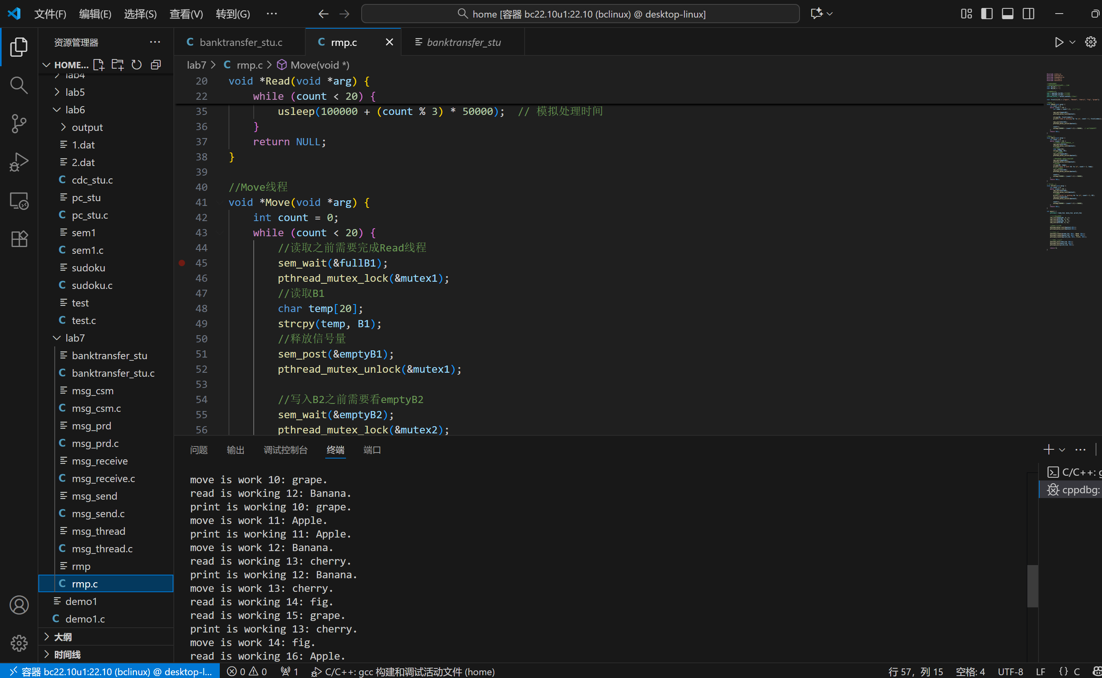
#include <stdio.h>
#include <pthread.h>
#include <semaphore.h>
#include <string.h>
#include <unistd.h>
//共享缓冲区
//共享资源需要互斥来进行保护
char B1[20] = "";
char B2[20] = "";
//信号量定义
sem_t emptyB1,fullB1;//同步B1
sem_t emptyB2,fullB2;//同步B2
pthread_mutex_t mutex1,mutex2;//互斥锁
char fruit[5][10] = {"Apple", "Banana", "cherry", "fig", "grape"};
//Read线程
void *Read(void *arg) {
int count = 0;
while (count < 20) {
int index = count % 5; //环形循环
sem_wait(&emptyB1);
pthread_mutex_lock(&mutex1);
strcpy(B1, fruit[index]);
printf("read is working %d: %s.\n", count + 1, fruit[index]);
sem_post(&fullB1);
pthread_mutex_unlock(&mutex1);
count++;
usleep(100000 + (count % 3) * 50000); // 模拟处理时间
}
return NULL;
}
//Move线程
void *Move(void *arg) {
int count = 0;
while (count < 20) {
//读取之前需要完成Read线程
sem_wait(&fullB1);
pthread_mutex_lock(&mutex1);
//读取B1
char temp[20];
strcpy(temp, B1);
//释放信号量
sem_post(&emptyB1);
pthread_mutex_unlock(&mutex1);
//写入B2之前需要看emptyB2
sem_wait(&emptyB2);
pthread_mutex_lock(&mutex2);
//写入B2
strcpy(B2, temp);
printf("move is work %d: %s.\n", count + 1, temp);
//释放信号量
sem_post(&fullB2);
pthread_mutex_unlock(&mutex2);
count++;
usleep(150000 + (count % 4) * 50000);
}
return NULL;
}
// Print线程
void *Print(void *arg) {
int count = 0;
while (count < 20) {
sem_wait(&fullB2);
pthread_mutex_lock(&mutex2);
//打印B2
printf("print is working %d: %s.\n", count + 1, B2);
sem_post(&emptyB2);
pthread_mutex_unlock(&mutex2);
count++;
usleep(200000 + (count % 5) * 50000);
}
return NULL;
}
int main() {
pthread_t read_tid, move_tid, print_tid;
//初始化信号量
sem_init(&emptyB1, 0, 1);
sem_init(&fullB1, 0, 0);
sem_init(&emptyB2, 0, 1);
sem_init(&fullB2, 0, 0);
//互斥锁初始化
pthread_mutex_init(&mutex1,NULL);
pthread_mutex_init(&mutex2,NULL);
// 创建线程
pthread_create(&read_tid, NULL, Read, NULL);
pthread_create(&move_tid, NULL, Move, NULL);
pthread_create(&print_tid, NULL, Print, NULL);
// 等待线程结束
pthread_join(read_tid, NULL);
pthread_join(move_tid, NULL);
pthread_join(print_tid, NULL);
sem_destroy(&emptyB1);
sem_destroy(&fullB1);
sem_destroy(&emptyB2);
sem_destroy(&fullB2);
pthread_mutex_destroy(&mutex1);
pthread_mutex_destroy(&mutex2);
return 0;
}
第三题：
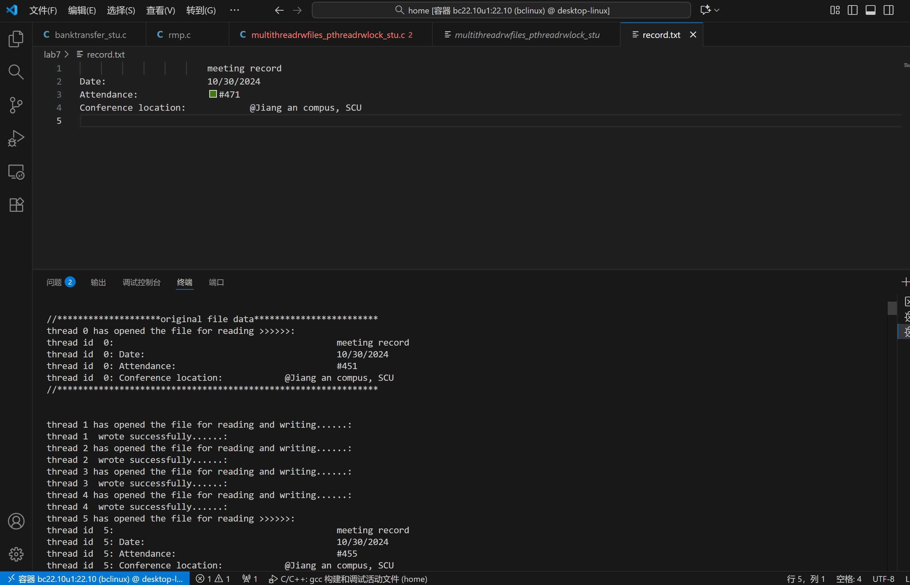
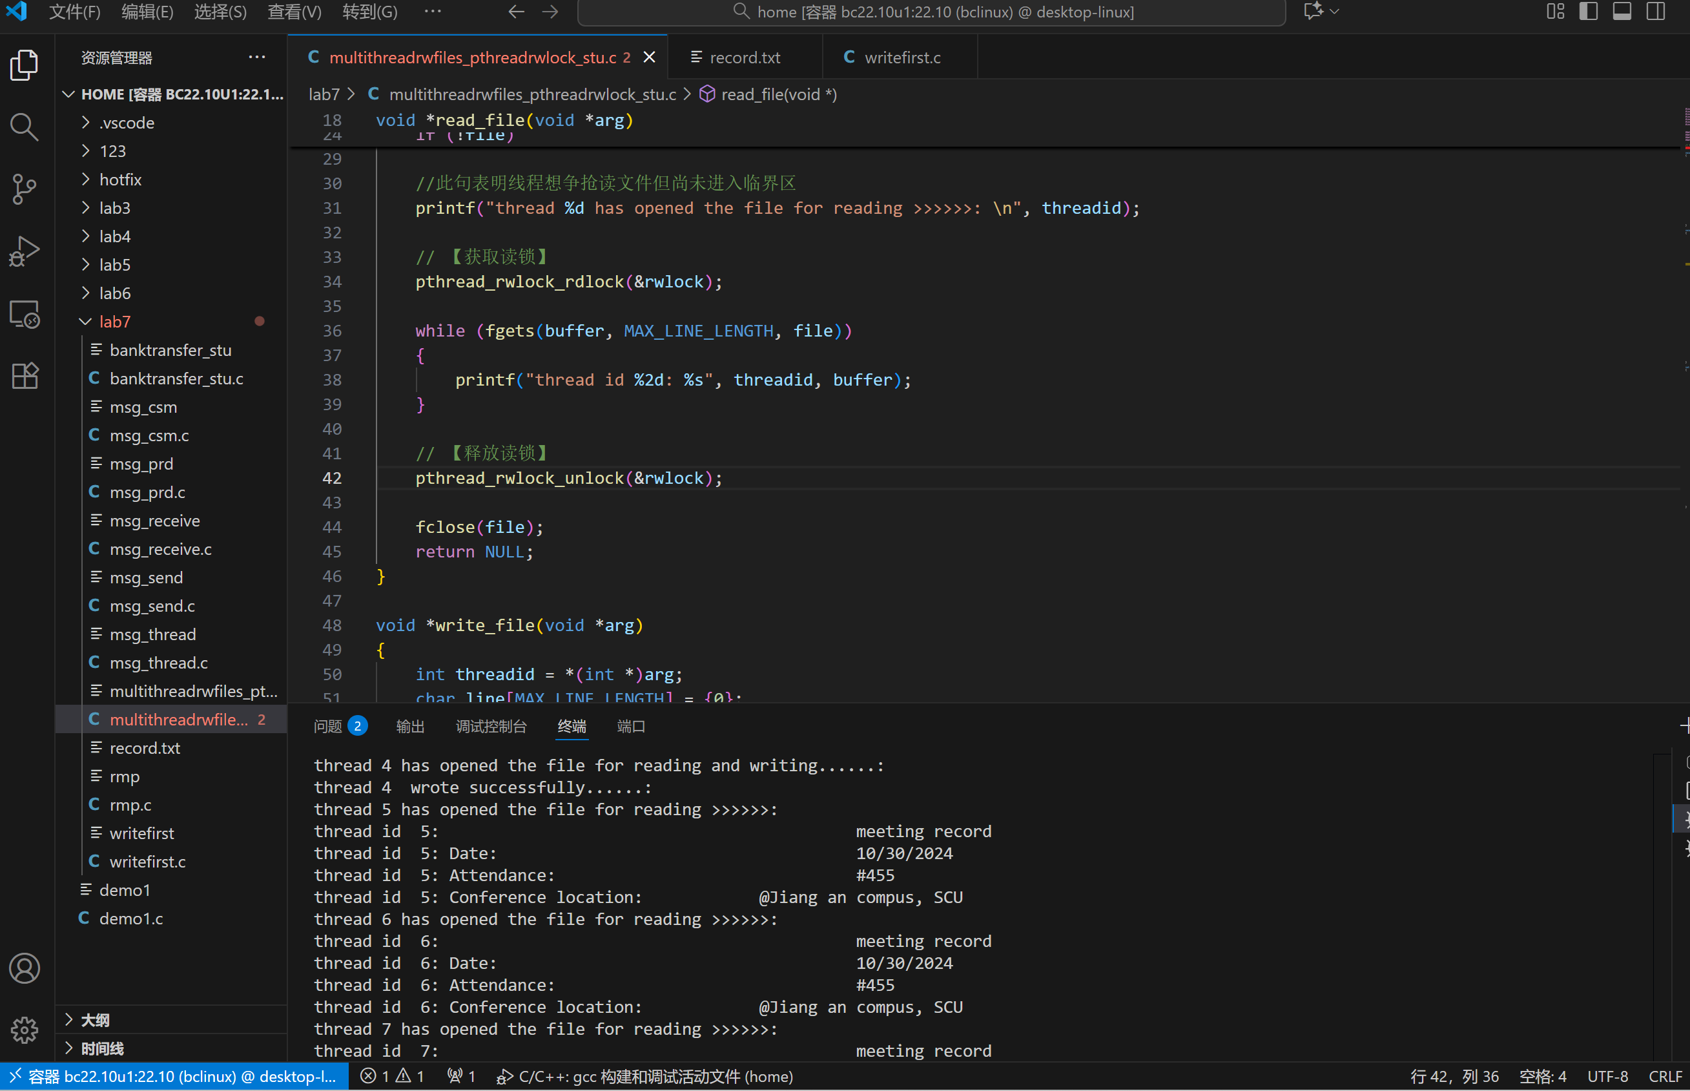
#include <stdio.h>
#include <stdlib.h>
#include <pthread.h>
#include <string.h>
#include <time.h>
#include <unistd.h>
#include <semaphore.h>
#define READ_THREADS 16
#define WRITE_THREADS 4
#define MAX_LINE_LENGTH 256
#define LOOP_NUM 5
// 全局读写锁定义
pthread_rwlock_t rwlock;
void *read_file(void *arg)
{
int threadid = *(int *)arg;
char buffer[MAX_LINE_LENGTH];
FILE *file = fopen("record.txt", "r");
if (!file)
{
perror("Failed to open file");
return NULL;
}
//此句表明线程想争抢读文件但尚未进入临界区
printf("thread %d has opened the file for reading >>>>>>: \n", threadid);
// 【获取读锁】
pthread_rwlock_rdlock(&rwlock);
while (fgets(buffer, MAX_LINE_LENGTH, file))
{
printf("thread id %2d: %s", threadid, buffer);
}
// 【释放读锁】
pthread_rwlock_unlock(&rwlock);
fclose(file);
return NULL;
}
void *write_file(void *arg)
{
int threadid = *(int *)arg;
char line[MAX_LINE_LENGTH] = {0};
char *numberStart;
int number;
FILE *file;
// 打开文件以读取和写入
file = fopen("record.txt", "r+");
if (file == NULL)
{
perror("无法打开文件");
return EXIT_FAILURE;
}
//此句表明线程想争抢写文件但尚未进入临界区
printf("thread %d has opened the file for reading and writing......: \n", threadid);
// 【获取写锁】
pthread_rwlock_wrlock(&rwlock);
//写操作
while (fgets(line, sizeof(line), file))
{
// 寻找#并处理#后的人数
numberStart = strchr(line, '#');
if (numberStart != NULL)
{
number = atoi(numberStart + 1); // 获取#后面的数字
number++; // +1
sprintf(numberStart + 1, "%d", number); // 写回更新后的数字
// 定位到文件的开头并重写第三行
fseek(file, -strlen(line) - 1, SEEK_CUR);
fputs(line, file);
fflush(file); // 刷新输出缓冲区
break; // 处理完第三行后跳出循环
}
}
// 关闭文件
fclose(file);
//此句在临界区内表面即将退出临界区
printf("thread %d wrote successfully......: \n", threadid);
// 【释放写锁】
pthread_rwlock_unlock(&rwlock);
return EXIT_SUCCESS;
}
int main()
{
pthread_t read_threads[READ_THREADS], write_threads[WRITE_THREADS];
int thread_id[READ_THREADS + WRITE_THREADS] = {0};
// 【初始化读写锁】
pthread_rwlock_init(&rwlock, NULL);
srand(time(NULL));
//print the original file before multithreads read and write
int rootid = 0;
printf("//********************original file data************************\n");
read_file(&rootid);
printf("//**************************************************************\n\n\n");
// initialize thread id
for (int i = 0; i < READ_THREADS + WRITE_THREADS; i++)
{
thread_id[i] = i+1;
}
for (int i = 0; i < LOOP_NUM; i++)
{
// Create write threads
for (int i = 0; i < WRITE_THREADS; i++)
{
pthread_create(&write_threads[i], NULL, write_file, &thread_id[i]);
sleep(rand()%(WRITE_THREADS+1));
}
// Create read threads
for (int i = 0; i < READ_THREADS; i++)
{
pthread_create(&read_threads[i], NULL, read_file, &thread_id[i + WRITE_THREADS]);
}
// Join write threads
for (int i = 0; i < WRITE_THREADS; i++)
{
pthread_join(write_threads[i], NULL);
}
// Join read threads
for (int i = 0; i < READ_THREADS; i++)
{
pthread_join(read_threads[i], NULL);
}
}
// 【销毁读写锁】
pthread_rwlock_destroy(&rwlock);
return 0;
}

第四题（选做题）
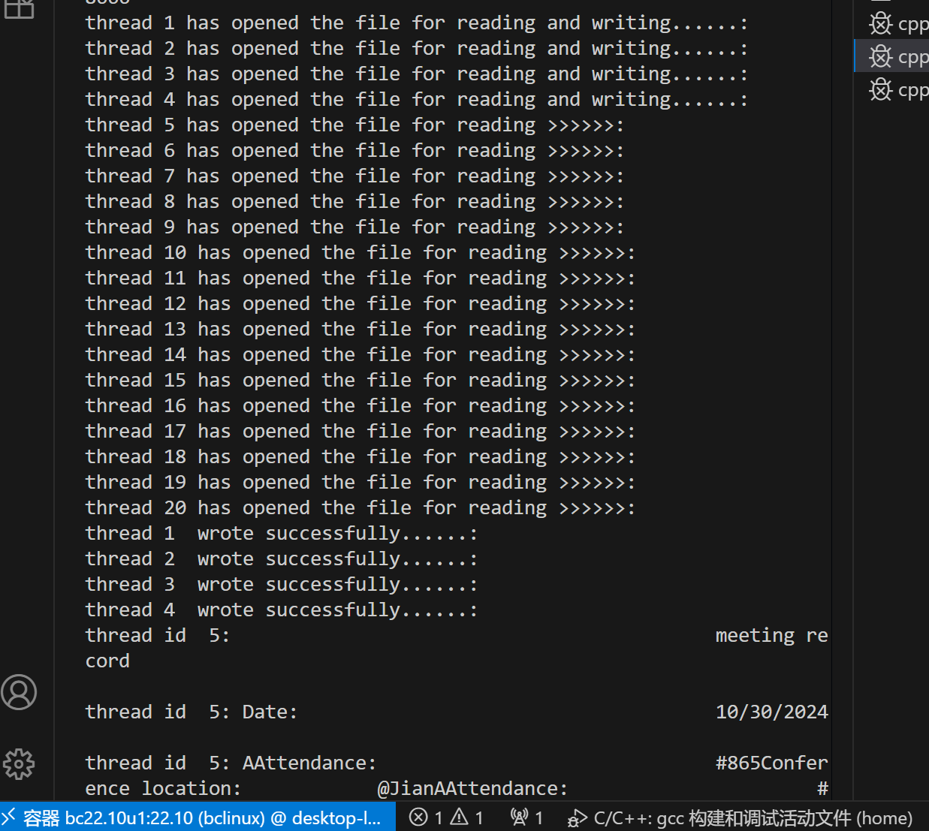
#include <stdio.h>
#include <stdlib.h>
#include <pthread.h>
#include <string.h>
#include <time.h>
#include <unistd.h>
#include <semaphore.h>
#define READ_THREADS 16
#define WRITE_THREADS 4
#define MAX_LINE_LENGTH 256
#define LOOP_NUM 5
// 读者优先的信号量定义
sem_t writemutex, readmutex, z, mutex1, mutex2;
int rcount = 0, wcount = 0;
void *read_file(void *arg)
{
int threadid = *(int *)arg;
char buffer[MAX_LINE_LENGTH];
FILE *file = fopen("record.txt", "r");
if (!file)
{
perror("Failed to open file");
return NULL;
}
printf("thread %d has opened the file for reading >>>>>>: \n", threadid);
sleep(1);
// 【读者优先的读操作信号量控制】
sem_wait(&z);
sem_wait(&readmutex);
sem_wait(&mutex1);
rcount++;
if (rcount == 1)
sem_wait(&writemutex);
sem_post(&mutex1);
sem_post(&readmutex);
sem_post(&z);
while (fgets(buffer, MAX_LINE_LENGTH, file))
{
printf("thread id %2d: %s", threadid, buffer);
}
// 【读者优先的读操作信号量释放】
sem_wait(&mutex1);
rcount--;
if (rcount == 0)
sem_post(&writemutex);
sem_post(&mutex1);
fclose(file);
return NULL;
}
void *write_file(void *arg)
{
int threadid = *(int *)arg;
char line[MAX_LINE_LENGTH] = {0};
char *numberStart;
int number;
FILE *file;
file = fopen("record.txt", "r+");
if (file == NULL)
{
perror("无法打开文件");
return EXIT_FAILURE;
}
printf("thread %d has opened the file for reading and writing......: \n", threadid);
sleep(1);
// 【读者优先的写操作信号量控制】
sem_wait(&mutex2);
wcount++;
if (wcount == 1)
sem_wait(&readmutex);
sem_post(&mutex2);
sem_wait(&writemutex);
while (fgets(line, sizeof(line), file))
{
numberStart = strchr(line, '#');
if (numberStart != NULL)
{
number = atoi(numberStart + 1);
number++;
sprintf(numberStart + 1, "%d", number);
fseek(file, -strlen(line) - 1, SEEK_CUR);
fputs(line, file);
fflush(file);
break;
}
}
sem_post(&writemutex);
// 【读者优先的写操作信号量释放】
sem_wait(&mutex2);
wcount--;
if (wcount == 0)
sem_post(&readmutex);
sem_post(&mutex2);
fclose(file);
printf("thread %d wrote successfully......: \n", threadid);
return EXIT_SUCCESS;
}
int main()
{
pthread_t read_threads[READ_THREADS], write_threads[WRITE_THREADS];
int thread_id[READ_THREADS + WRITE_THREADS] = {0};
// 【初始化读者优先的信号量】
sem_init(&writemutex, 0, 1);
sem_init(&readmutex, 0, 1);
sem_init(&z, 0, 1);
sem_init(&mutex1, 0, 1);
sem_init(&mutex2, 0, 1);
srand(time(NULL));
int rootid = 0;
printf("//********************original file data************************\n");
read_file(&rootid);
printf("//**************************************************************\n\n\n");
for (int i = 0; i < READ_THREADS + WRITE_THREADS; i++)
{
thread_id[i] = i+1;
}
for (int i = 0; i < LOOP_NUM; i++)
{
for (int i = 0; i < WRITE_THREADS; i++)
{
pthread_create(&write_threads[i], NULL, write_file, &thread_id[i]);
sleep(rand()%(WRITE_THREADS+1));
}
for (int i = 0; i < READ_THREADS; i++)
{
pthread_create(&read_threads[i], NULL, read_file, &thread_id[i + WRITE_THREADS]);
}
for (int i = 0; i < WRITE_THREADS; i++)
{
pthread_join(write_threads[i], NULL);
}
for (int i = 0; i < READ_THREADS; i++)
{
pthread_join(read_threads[i], NULL);
}
}
// 【销毁信号量】
sem_destroy(&writemutex);
sem_destroy(&readmutex);
sem_destroy(&z);
sem_destroy(&mutex1);
sem_destroy(&mutex2);
return 0;
}

