简答题：50 points
A generic process framework for software engineering encompasses five activities and a set of umbrella activities that are applicable across the entire software process. What are they? (10 Points)

Where is the differences between the Black-box testing techniques and the White-box testing techniques? (10 points)

Incremental process models tend to be among the most widely used in the industry. Describe the conditions under which such models should be used and what an “increment" means in terms of project work and delivery. (10 Points)

非标准答案题 10 points
What is software engineering in your opinion? (10 points)

In an online course selection system, students can query course information, select courses, drop selected courses, and log in to the system. The system administrator can log in, has an extended function to retrieve passwords, and can maintain course information (such as adding, modifying, and deleting courses). Additionally, querying course information includes two specific functions: querying by course number and querying by course name. Based on the above description, please draw a use case diagram for this online course selection system.

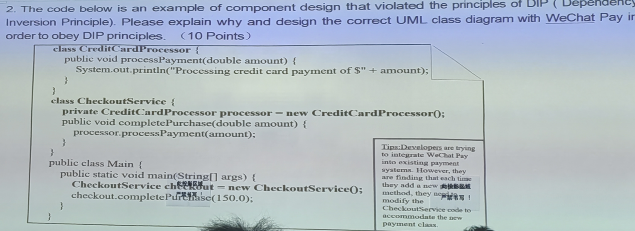
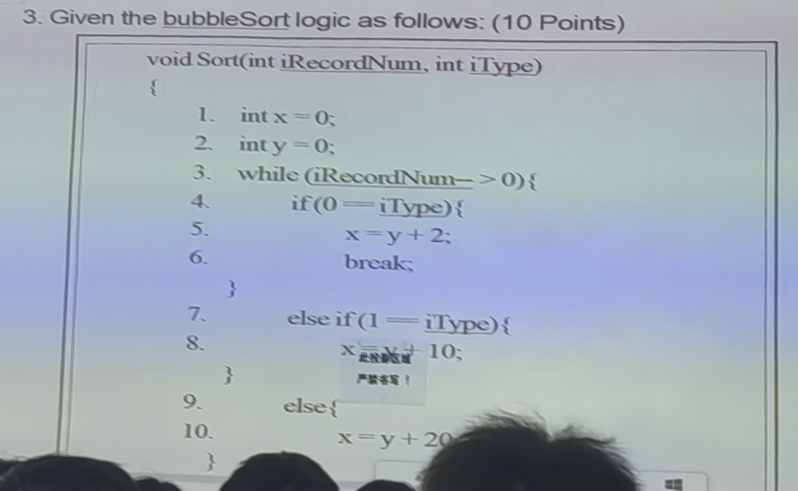

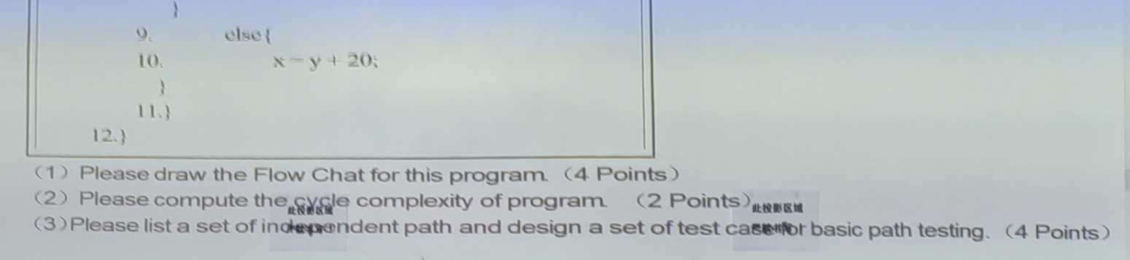

UI 用户输入输出什么东西，标注清楚
按钮？方式，提示？？？
系统输出什么？多个界面
一般是三个或者四个界面
根据需求的过程，交互的信息完成

流程图
如果最后没有节点的话吗，要假设一个

