C fundamentals and Type conversion
Student ID __2024141460368______
Student Name _____陈登科_____________
Start Time ____2026.3.12, 19:20____
Finish Time _____2026.3.12, 21:00__

1. Objectives:
To write simple C programs covering:
- Understand how a character is stored in memory;
- Understand how an integer is stored in memory;
- Understand array and pointer; and
- Perform conversion from eight bits (character) to eight bytes to be displayed on screen.

2. Type and Format in memory – character, integer, short and float

2.1
This exercise is to determine the memory size of different type.

lab1_1.c
//Determine the memory size of declaration and variable type
#include <stdio.h>
#include <ctype.h>
#include <conio.h>
#include <string.h>
#include <stdlib.h>

void main()
{
char c;
char s[128];
short i;
short n[64];
printf("%3d %3d\n", sizeof(c), sizeof(char));
printf("%3d %3d\n", sizeof(s), sizeof(char[128]));
printf("%3d %3d\n", sizeof(i), sizeof(short));
printf("%3d %3d\n", sizeof(n), sizeof(short[64]));
}

The display is:

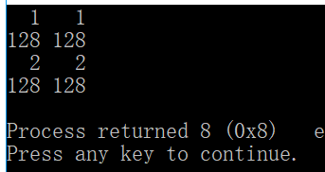

Now execute the above program and fill in the following:

Type | Size in byte | Size in bit
Short | 2 | 16
Char | 1 | 8
Short[32] | 64 | 512
Char[64] | 64 | 512

2.2
Use the approach of the above, determine the memory size of integer, float, integer[128], float[16] (lab1_2.c)

Write a program to verify your answer and fill in the following: [hint, use sizeof(…) ]
Type | Size in byte | Size in bit
Int | 4 | 32
Float | 4 | 32
Int[128] | 512 | 2048
Float[16] | 64 | 256

Write down your expression amongst the difference in size between character, integer, float, short, char[8], int[8], short[8], float[8]
Char:1B
Int:4B
Float:4B
Short:2B
type[n]:sizeof(type) * n

2.3
This exercise is to display the decimal and octal values so that you know how it is stored in memory.

lab1_3.c
//Determine the memory size of declaration and variable type
#include <stdio.h>
#include <stdlib.h>
#include <ctype.h>
#include <conio.h>
#include <string.h>

void main()
{
char i;
for (i=30; i<41; ++i)
printf("i: dec=%d oct=%o\n", i, i);
}

the output is:

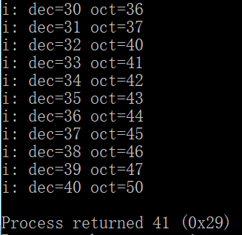

Now modify the above programme to display decimal, octal, hex and unsigned as well. (Hints: hex, %x, unsigned %u)

Write down your codes below:
#include <stdio.h>
#include <stdlib.h>
#include <ctype.h>
#include <conio.h>
#include <string.h>

void lab1_3()
{
char i;
for (i=30; i<41; ++i)
printf("i: dec=%d oct=%o hex=%x unsigned=%u\n", i, i, i, i);
}

Write down the output of the first 4 lines so that you understand the difference among them.
i: dec=30 oct=36 hex=1e unsigned=30
i: dec=31 oct=37 hex=1f unsigned=31
i: dec=32 oct=40 hex=20 unsigned=32
i: dec=33 oct=41 hex=21 unsigned=33

2.4
This exercise is to dump the content of memory of different type so that you know how it is stored in memory.
lab1_4.c
//Determine the memory size of declaration and variable type
#include <stdio.h>
#include <ctype.h>
#include <conio.h>
#include <string.h>
#include <stdlib.h>

void main()
{
char a = '0'; // in hex 0x30, not 0
int i = 0x00000013; //in decimal is (1 x 16 + 3) = 19
short j = 18; //occupies two bytes,
float f = 1.25; //occupies 4 bytes
}

In order to display, you have to set a break point beside the line, the program will display a red circle as follows:

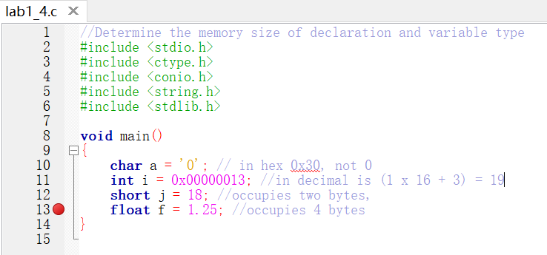

Now, type the address of each variable as shown in the left-bottom frame to locate whether they are. Here, we dump the address of variable ‘a’. Since, visual C reserves 4 bytes but char c uses one byte, you can see that the rest three bytes are set to 00 00 00 (the default setting).

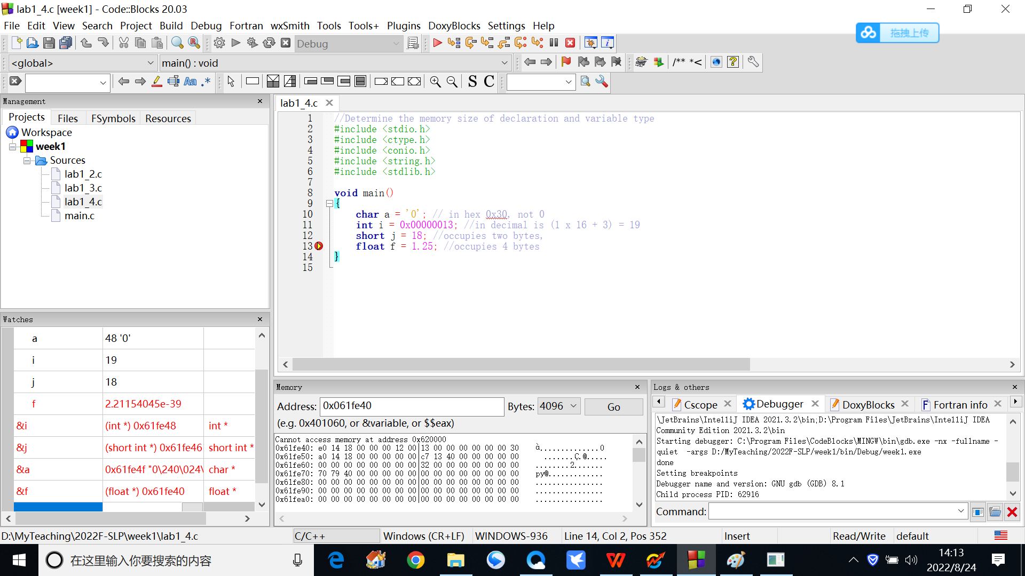
s

  - memory location of a is 0x0061fe4f, you have to type &a
  - then in the Address, key in 0x0061fe4f,
  - it displays 30

0x0061fe4f, the hexadecimal is 0x30 (ASCII)

Now, type and execute the above program and fill in the following, note that your addresses might be different from what I have below.

Variable | Memory address | Hexadecimal value
a | 0x0012ff28 | 0x30
i | 0x0012ff24 | 0x00000013
j | 0x0012ff20 | 0x0012
f | 0x0012ff1c | 0x3FA00000

3. Array and Pointer

3.1

The following is a very simple array definition. It defines an array called char a[4] which occupies 4 bytes, the value is 0x30 0x31 0x32 0x00. Note that 0x30 (ASCII) is 0 in decimal. The last character must be terminated by 0x00 or is called null. (ref. lab1_5.c)

lab1_5.c
#include <conio.h>
#include <string.h>
#include <stdlib.h>

void main()
{
char a[4] = "012";
}
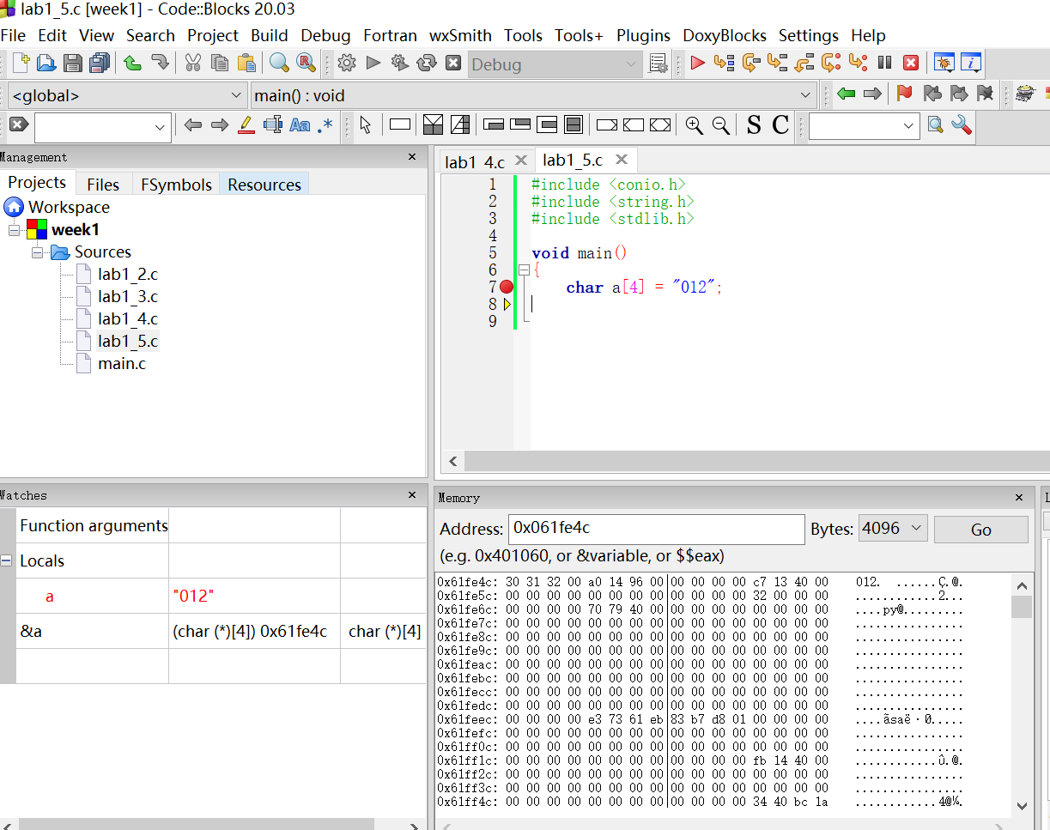
0x30 or 0
Null, 0x00

Based on the above, note that the address of array a is 0x0061fe4c. Now fill in the following:

Address | Type | Value
0x0061fe4c | a[0] | 0x30
0x0061fe4d | a[1] | 0x31
0x0061fe4e | a[2] | 0x32
0x0061fe4f | a[3] | 0x00

3.2
The following program lab1_6.c will display the content of an array a[11].

#include <stdio.h>
#include <ctype.h>
#include <conio.h>
#include <string.h>
#include <stdlib.h>

void main()
{
char a[11] = "0123456789";
for (int i = 0; i <10; ++i)
printf("The value of %d is %c in hex %x \n", i, a[i], a[i]);
}

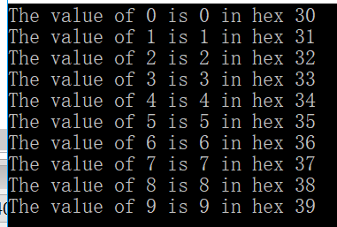

Now modify the above program to display the address of each location in hexadecimal and the value a[12], a[13], explain why you can display a[12] and [13] as you only defined them up to a[10] as follows. (Hint: The address of a[0] is &a[0])

(note that your value might be different.)
Write down the program
#include <stdio.h>
#include <ctype.h>
#include <conio.h>
#include <string.h>
#include <stdlib.h>

void lab1_5()
{
int i;
char a[11] = "0123456789";
for (i = 0; i <10; ++i)
printf("The value of %d is %c in hex %x, and the adress is %x in hex \n",
i, a[i], a[i], &a[i]);
printf("The value of 12 is %c in hex %x\n", a[12], a[12]);
printf("The value of 13 is %c in hex %x\n", a[13], a[13]);
}
Write down your explanation (hint: dump the memory location and look at the location of a[11], a[12] and a[13] etc. you then realize why?)
内存地址中：
0012FF24 38 39 00 CC 0A 00 00 00
可以看到a[10]处是‘\0’，a[11]处是CC，这是由于四字节的对齐要求，所以编译器填充
了一个CC。由于数组和整数i是在栈上分配的空间，i先定义故i的地址大，a[12]开
始的位置存放的0A000000就是整数i

3.3 Run the following program lab1_7.c
#include <stdio.h>
#include <ctype.h>
#include <conio.h>
#include <string.h>
#include <stdlib.h>

int main()
{
char a[11] = "0123456789";
char *ptr;
ptr = &a[0]; // it can be &a with same effect
for (int i = 0; i <11; ++i, ++ptr)
printf("The value of %d is %x in hex %x \n", i, ptr, *ptr);
return 0;
}
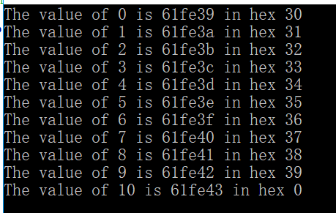

Now explain the meaning of the following of the above program.
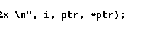
ptr==&a[i]
* ptr==a[i]

3.4

The following program lab1_8.c is about the integer array.

#include <stdio.h>
#include <ctype.h>
#include <conio.h>
#include <string.h>
#include <stdlib.h>

void main()
{
int a[7] = {12, 21, 31, 41, 51, 61};
for (int i = 0; i <6; ++i)
printf("The value of %d is %x in hex %x \n", i, &a[i], a[i]);
}

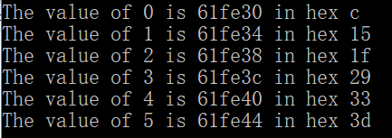

Now explain increment of address is 4 instead of 1.
因为每个int型变量占4个字节的内存，计算机是按字节寻址的，数组下标每次加1，
地址就会加4

3.5

Modify the above program with the same output with pointer instead of array a[] .

Write down the program (lab1_9.c)
#include <stdio.h>
#include <ctype.h>
#include <conio.h>
#include <string.h>
#include <stdlib.h>

void lab1_9()
{
int i;
int a[7] = {12, 21, 31, 41, 51, 61};
int *ptr = &a[0];
for (i = 0; i <6; ++i,++ptr)
printf("The value of %d is %x in hex %x \n", i, ptr, *ptr);
}

