Representation of Data
Student ID ___2024141460368_____
Student Name ______陈登科____________
Start Time ______3.21 17：40________
Finish Time _____3.21 18：25_________

1. Encode two float-point numbers step by step (1) 57.89 (2) -57.89
57 = 32+16+8+1=(11001)B，0.89=(0.1110001111010111000…)B
according to IEEE standard 754: float = 1 sign bit + 8 exponent bits + 23 fraction bits
57.89 = 11001. 111000111101011100… = 2^5 * 1.10011110001111010111000…

so:
57.89 -> 0 00000101 10011110001111010111000
-57.89 -> 1 00000101 10011110001111010111000

2. data lab

Follow the instruction (Data_Lab.html) in dlab-handout. Write down your source code and show your screenshot of testing result. The following is mine, BTW.
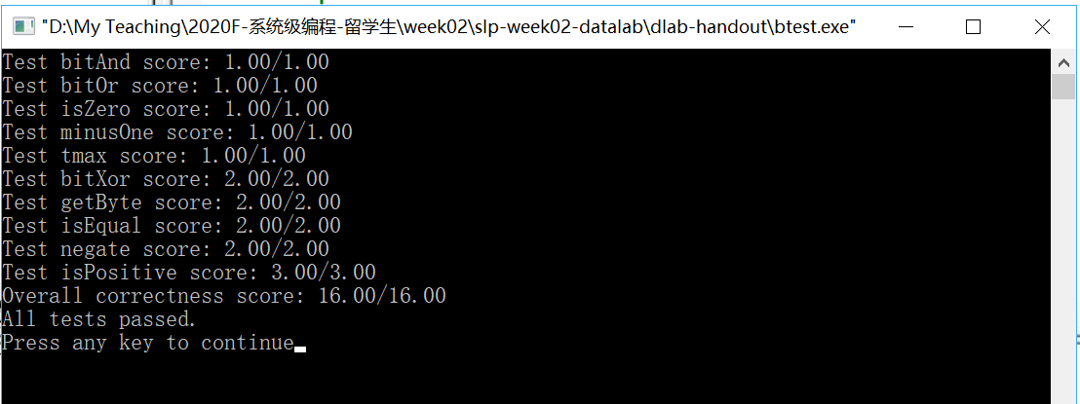
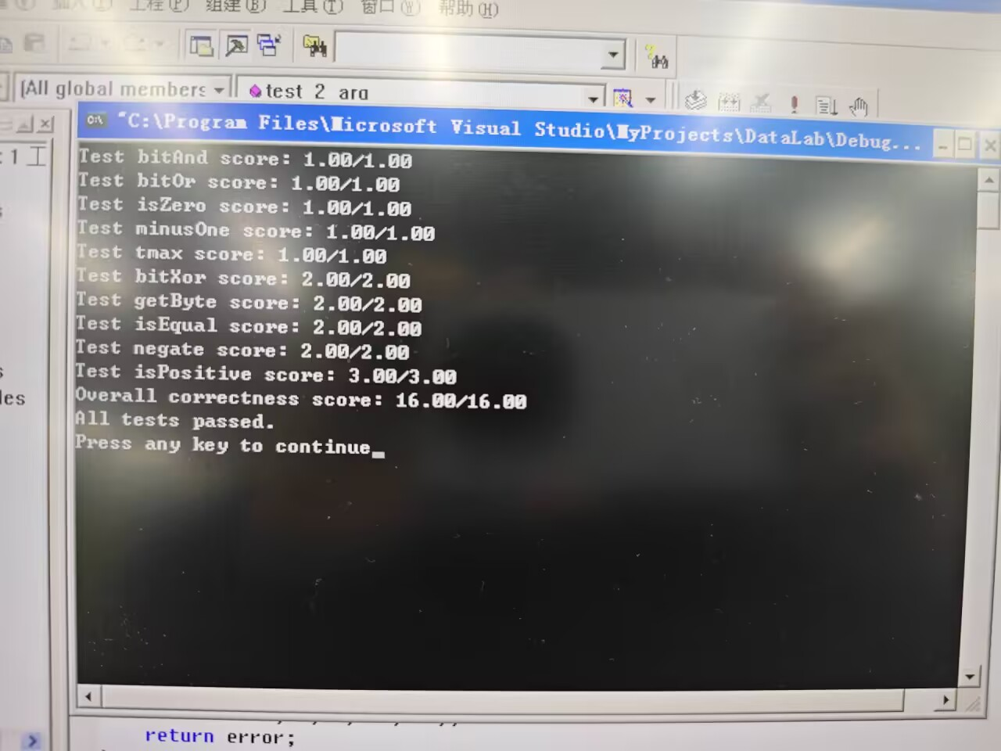
2.1
int bitAnd(int x, int y) {
return ~(~x | ~y);
}

2.2
int bitOr(int x, int y) {
return ~(~x & ~y);
}

2.3
int isZero(int x) {
return !x;
}

2.4
int minusOne(void) {
// 0xffff
return ~0;
}

2.5
int tmax(void) {
// 0111 1111 1111 1111 (0x7fff)
return ~(1<<31);
}

2.6
int bitXor(int x, int y) {
// x^y==~xy+x~y
return (~x&y)|(x&~y);
}

2.7
int getByte(int x, int n) {
// n * 8 == n << 3
return (x >> (n << 3)) & 0xFF;
}

2.8
int isEqual(int x, int y) {
return !(x^y);
}

2.9
int negate(int x) {
return ~x+1;
}

2.10
int isPositive(int x) {
return !(x>>31) & !!x;
}

