## 记住用户名

### 训练描述

1_用户首次访问系统登录界面显示如下效果

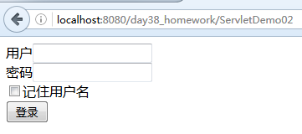

2_用户录入账户,密码而且选中记住用户名,点击登录按钮

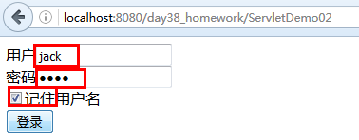

3_登录失败显示如下效果

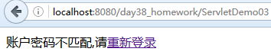

4_登录成功显示如下效果:

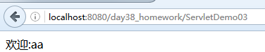

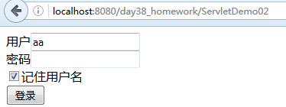5_此时用户再次访问登录界面,显示如下效果:

### 操作步骤描述

1_建立仓库day38_homework,建立以下表

CREATE TABLE users(

uid INT PRIMARY KEY AUTO_INCREMENT,

username VARCHAR(32),

PASSWORD VARCHAR(32)

);

INSERT INTO users VALUES(1,'jack','jack');

INSERT INTO users VALUES(2,'lucy','lucy');

INSERT INTO users VALUES(3,'mary','mary');

2_在ServletDemo02中向客户端输出表单,用于接收用户的账户和密码,效果如下

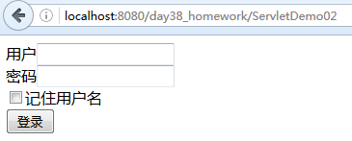

代码如下:

response.setContentType("text/html;charset=utf-8");

PrintWriter out = response.getWriter();

String str="";

String str01="";

str="<input type='checkbox' name='remUser' value='yes'/>记住用户名<br/>";

str01="用户<input type='text' name='user'/><br/>";

out.println("<form action='/day38_homework/ServletDemo03' method='post'>");

out.println(str01);

out.println("密码<input type='password' name='pass'/><br/>");

out.println(str);

out.println("<input type='submit' value='登录'/>");

out.println("</form>");

3_在ServletDemo03中接收用户表单数据,实现登录操作

response.setContentType("text/html;charset=utf-8");

PrintWriter out = response.getWriter();

String um = request.getParameter("user");

String up = request.getParameter("pass");

String re = request.getParameter("remUser");

User user = new User();

user.setUsername(um);

user.setPassword(up);

UserService UserService = new UserService();

User uu = UserService.login(user);

if (null != uu) {

out.print("欢迎:" + uu.getUsername());

} else {

out.print("账户密码不匹配,请<a href='/day38_homework/ServletDemo02'>重新登录</a>");

}

} catch (Exception e) {

e.printStackTrace();

}

4_实现UserService代码

public class UserService {

UserDao UserDao=new UserDao();

public User login(User user) throws SQLException {

return UserDao.login(user);

}

}

5_实现UserDao代码

public User login(User user) throws SQLException {

String sql="select * from users where username= ? and password=?";

QueryRunner qr=new QueryRunner(JDBCUtils.getDataSource());

Object[] params={user.getUsername(),user.getPassword()};

return qr.query(sql, new BeanHandler<User>(User.class),params);

}

6_在登录成功的基础上实现发送cookie代码

Cookie ck=new Cookie("username", um);

if (null != re && "yes".equals(re)) {

ck.setMaxAge(60 * 60 * 24 * 365);

ck.setPath("/day38_homework");

}else{

ck.setMaxAge(0);

}

response.addCookie(ck);

7_在ServletDemo02中判断是否存在名称为username的cookie来显示不同的表单内容.

代码如下:

String str="";

String str01="";

Cookie ck = CookUtils.getCookieByName("username", request.getCookies());

if(null==ck||"".equals(ck)){

str="<input type='checkbox' name='remUser' value='yes'/>记住用户名<br/>";

str01="用户<input type='text' name='user'/><br/>";

}else{

String username=ck.getValue();

str="<input type='checkbox' name='remUser' value='yes' checked='checked'/>记住用户名<br/>";

str01="用户<input type='text' name='user' value='"+username+"'/><br/>";

}

response.setContentType("text/html;charset=utf-8");

PrintWriter out = response.getWriter();

out.println("<form action='/day38_homework/ServletDemo03' method='post'>");

out.println(str01);

out.println("密码<input type='password' name='pass'/><br/>");

out.println(str);

out.println("<input type='submit' value='登录'/>");

out.println("</form>");

CookUtils代码如下:

public class CookUtils {

public static Cookie getCookieByName(String name,Cookie[] cks){

if(null==cks||cks.length==0){

return null;

}else{

for (Cookie ck : cks) {

if(ck.getName().equals(name)){

return ck;

}

}

}

return null;

}

}