**用户登录**

使用CSS样式排版出如图所示的效果

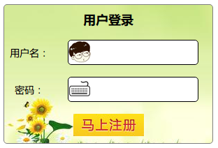

答案:

<!DOCTYPE HTML PUBLIC "-//W3C//DTD HTML 4.01 Transitional//EN"

"http://www.w3.org/TR/html4/loose.dtd">

<html xmlns="http://www.w3.org/1999/xhtml">

<head>

<meta http-equiv="Content-Type" content="text/html; charset=utf-8" />

<title>用户登录</title>

<style type="text/css">

table {

margin: auto;

height: 200px;

width: 300px;

border: 1px solid gray;

padding: 0px;

background-image: url(/images/bg1.jpg);

border-radius: 5px;

}

td {

text-align: center;

font-size: 14px;

}

#user, #pass{

width: 150px;

height: 32px;

border: 1px solid black;

border-radius: 5px;

}

th {

font-size: 18px;

}

#user {

background-image: url(images/head.png);

background-repeat: no-repeat;

padding-left: 35px;

}

#pass {

background-image: url(images/keyboard.png);

background-repeat: no-repeat;

padding-left: 35px;

}

#user:hover, #pass:hover {

border: 1px dashed orange;

}

#user:focus, #pass:focus {

background-color: lightyellow;

}

</style>

</head>

<body>

<table>

<tr>

<th colspan="2">用户登录</th>

</tr>

<tr>

<td>用户名：</td>

<td><input type="text" id="user"/></td>

</tr>

<tr>

<td>密码：</td>

<td><input type="password" id="pass"/></td>

</tr>

<tr>

<td colspan="2"><input type="image" src="images/regbtn.jpg" /></td>

</tr>

</table>

</body>

</html>