打印本次请求中所有的HTTP请求头信息,效果如下

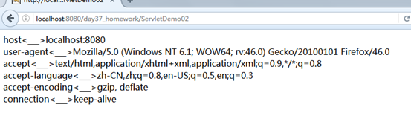

答案:

response.setContentType("text/html;charset=utf-8");

Enumeration<String> em = request.getHeaderNames();

while(em.hasMoreElements()){

String name = em.nextElement();

String value = request.getHeader(name);

response.getWriter().print(name+"<___>"+value+"<br/>");

}