获取表单中的内容,并在servlet中展示出来

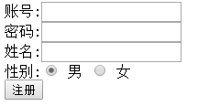

答案:

1.编写表单实现

https://attachment-center.boxuegu.com/data/picture/online/2018/04/04/17/2052aec4169a405e9a4483a43d33bf0d.png

2.servlet 获取数据

