多表查询之内连接

内连接

显示内连接
select * from classes c inner join student s on c.cid = s.cno;
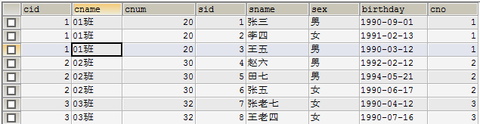

隐式内连接
SELECT * FROM classes c,student s WHERE c.cid = s.cno;
