多表查询之外连接

外连接

左外连接
SELECT * FROM classes c LEFT OUTER JOIN student s ON c.cid = s.cno;
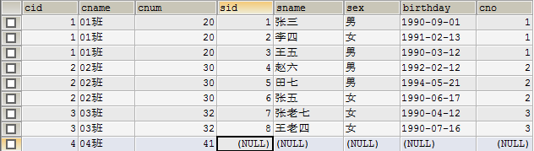

右外连接
select * from classes c right outer join student s on c.cid = s.cno;
