HTTP协议的抓包分析

分析HTTP协议

准备工作
- 创建页面
  - demo1.html
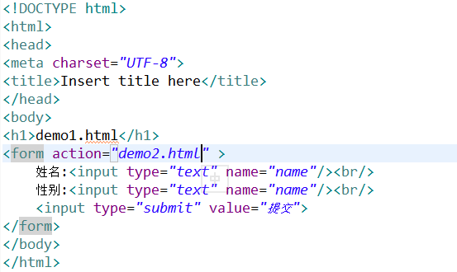
  - demo2.html
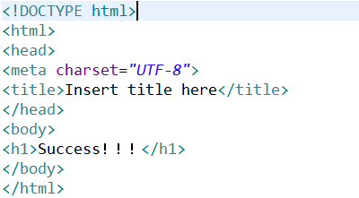

安装HTTPWatch

分析HTTP协议
- 请求部分
***** GET方式的请求
GET /web_test/demo2.html?name=aaa&name=man HTTP/1.1
Accept: text/html, application/xhtml+xml, */*
X-HttpWatch-RID: 9561-10011
Referer: http://localhost:8080/web_test/demo1.html
Accept-Language: zh-CN
User-Agent: Mozilla/5.0 (Windows NT 6.3; WOW64; Trident/7.0; rv:11.0) like Gecko
Accept-Encoding: gzip, deflate
Host: localhost:8080
DNT: 1
Connection: Keep-Alive

***** POST方式的请求
POST /web_test/demo2.html HTTP/1.1
Accept: text/html, application/xhtml+xml, */*
X-HttpWatch-RID: 9561-10041
Referer: http://localhost:8080/web_test/demo1.html
Accept-Language: zh-CN
User-Agent: Mozilla/5.0 (Windows NT 6.3; WOW64; Trident/7.0; rv:11.0) like Gecko
Content-Type: application/x-www-form-urlencoded
Accept-Encoding: gzip, deflate
Host: localhost:8080
Content-Length: 19
DNT: 1
Connection: Keep-Alive
Cache-Control: no-cache

name=bbb&name=woman
- 响应部分
HTTP/1.1 200 OK
Server: Apache-Coyote/1.1
Accept-Ranges: bytes
ETag: W/"151-1484111223984"
Last-Modified: Wed, 11 Jan 2017 05:07:03 GMT
Content-Type: text/html
Content-Length: 151
Date: Wed, 11 Jan 2017 05:14:00 GMT

<!DOCTYPE html>
<html>
<head>
<meta charset="UTF-8">
<title>Insert title here</title>
</head>
<body>
<h1>Success锛侊紒锛?/h1>
</body>
</html>

