案例准备

搭建开发环境

创建web项目
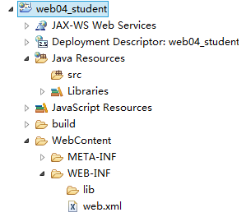

引入相关的jar包
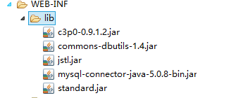

创建包结构，引入工具类
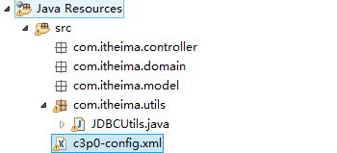

创建数据库和表
create database web04_student;
use web04_student;
create table student(
sid int primary key auto_increment,
sname varchar(20),
sex varchar(10),
age int
);
insert into student values (null,'张三','男',20);
insert into student values (null,'李四','女',23);
insert into student values (null,'王五','女',18);
insert into student values (null,'赵六','男',25);
insert into student values (null,'孙七','男',21);

