Appendix A – Reproducible Installation and Commissioning Guide
This document provides a step-by-step procedure for preparing and commissioning the Raspberry Pi 5 and supporting computers used by the SprayBot research platform. The current mobile robot implementation is OBot, an ODrive S1-based differential-drive prototype. Explanatory text accompanies each step so that the procedure can be followed and reproduced by another researcher.
This guide assumes that there is a base computer, preferably a laptop, running Ubuntu 24.04 Desktop. OBot and new development machines use ROS 2 Jazzy. The project ROS domain is 5 and CycloneDDS is the preferred ROS middleware. Alternative host environments such as WSL or containers are outside the scope of this guide.

A.1 Flash Ubuntu Server 24.04
Use Raspberry Pi Imager to prepare a bootable Ubuntu Server microSD card. The advanced settings allow the Raspberry Pi to be configured before first boot, eliminating the need for a monitor and keyboard. It is installed using apt, rpi-imager, or as downloaded from the Raspberry Pi download page. Currently the apt install has an earlier version so downloading is the only way to get the current version. Either works but the images in this guide are from the 2.1.x version.
Once installed start the imager. It requires admin privileges on the base computer.
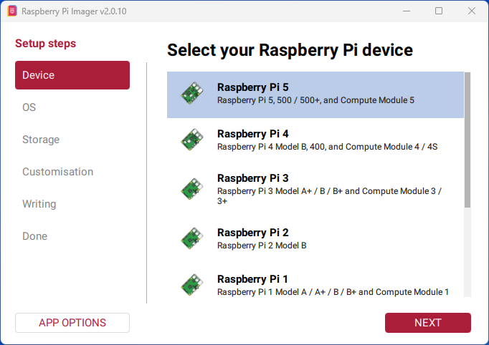
The imager comes up with the select the device page. Select Raspberry Pi 5 and click next.

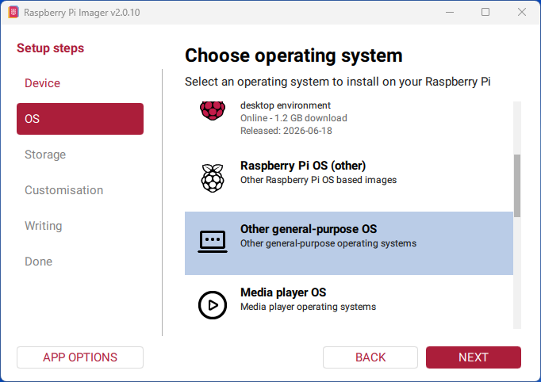
The next screen starts the select an operating system process. Scroll down and select other general purpose OS.

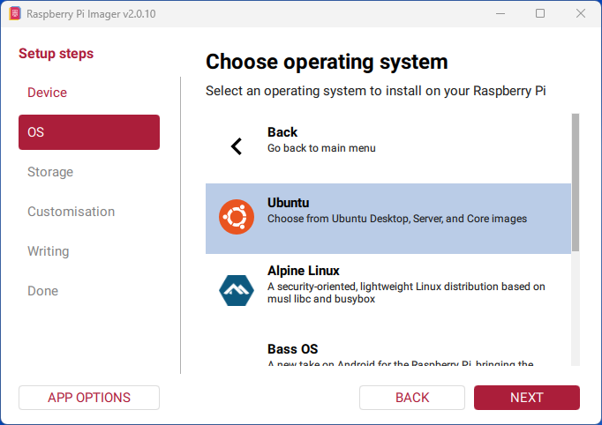
Next, select Ubuntu.

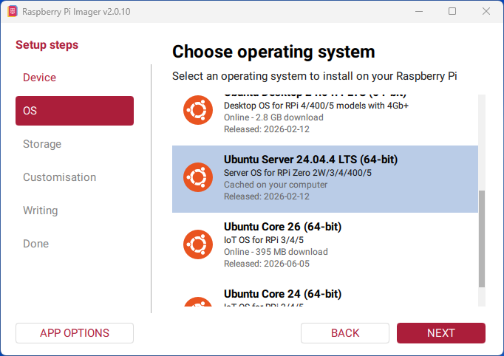
Finally, select Ubuntu server 24. Use the server version because the robot will usually not have a keyboard, mouse or display attached. Click next to proceed.

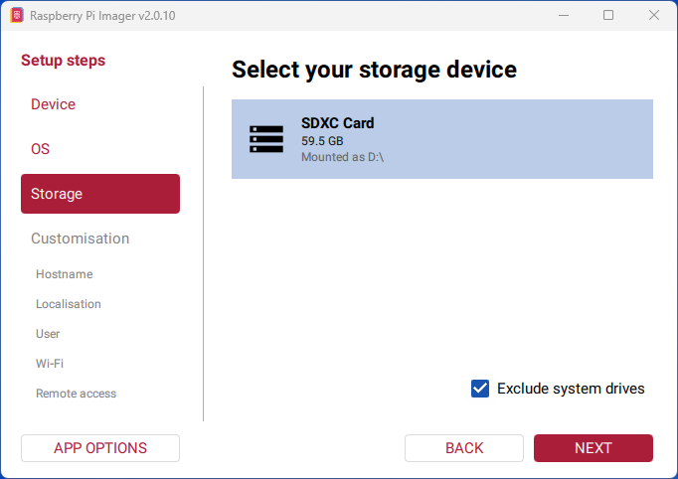
Insert the micro SD card into the base computer. Then select your SD card storage device from the list, usually there should be only one. Leave the exclude system drives checked.

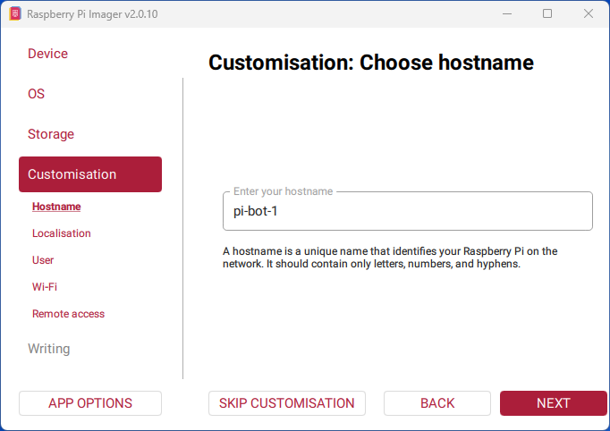
The first step of customization is selecting a host name. This is the name that will be used on the wifi network. If mDNS is running on the wifi router, which it usually is, then the bot can be accessed with “<hostname>.local”. In this example it would be pi-bot-1.local.

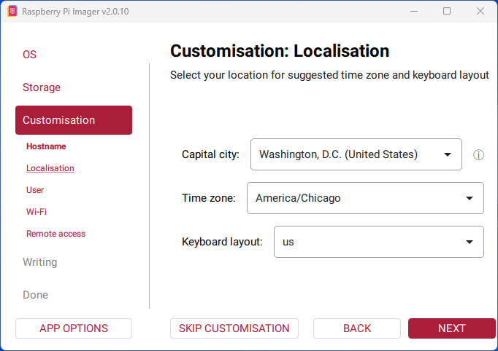
The second page of customization is localization. Select values appropriate for your actual locale. Note that these lists are long but the values shown are in the respective lists.

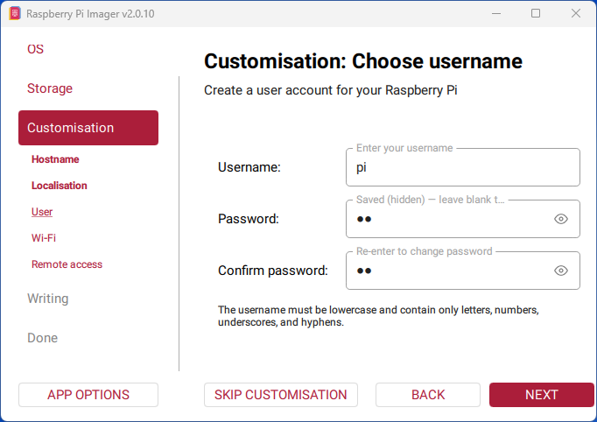
The third page is username. This will be the primary login id for the robot. Making them simple is best. Note that in this case are very short, e.g. “pi”. Since this is for a robot that will be running on an isolated wifi network security is not an issue (at least in the development phase). Record this info in a known place.

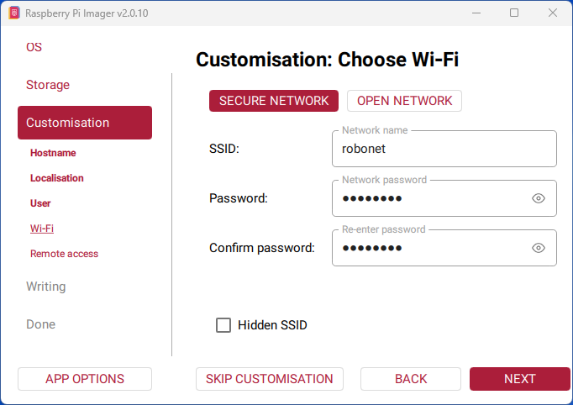
The fourth page specifies the wifi router to use. Best practice is to setup a separate router for robot development. Many organizations have strict rules for what goes on their networks, e.g. not allowing users to have admin rights, which are not compatible with robot development.

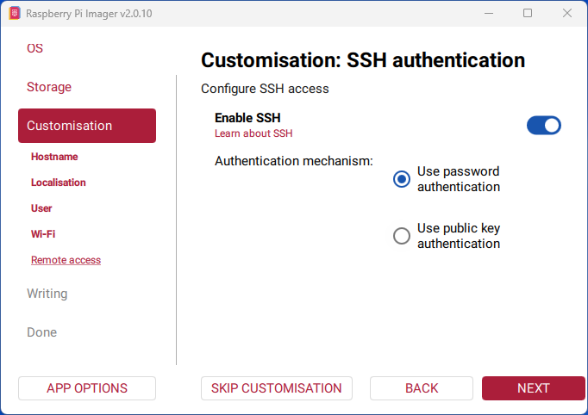
The fifth, and final, customization step is enabling ssh. ssh allows users to securely log into the rpi from another computer.

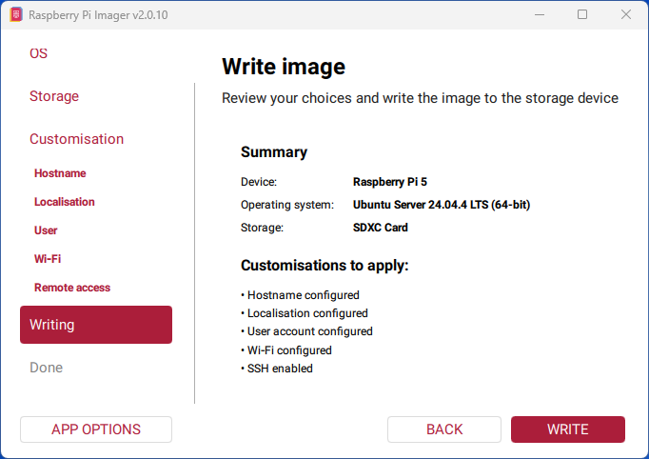
Once all the customizations are completed, the next step is to write everything to the sd card. The first page summarizes the what will be done.

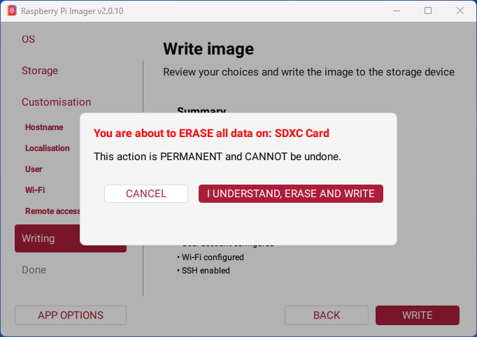
Before actually writing to the sd card, an “are you sure?” message appears. This action does permanently erase everything on the sd card.

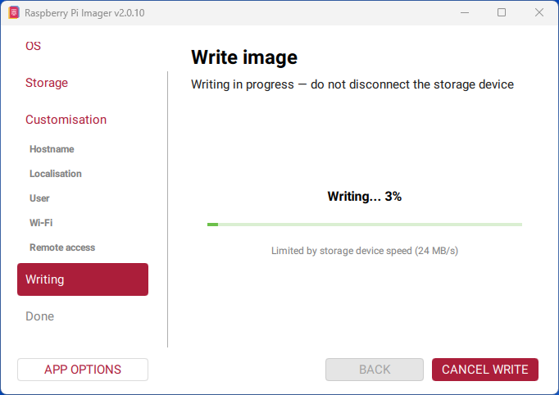
When the writing starts, a progress bar screen appears. The writing process takes some time, a few minutes, so the feedback is useful.

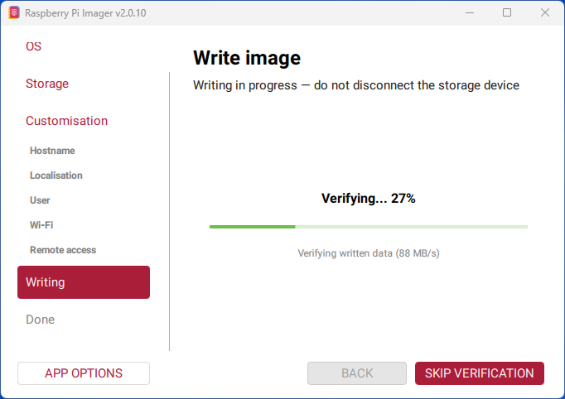
After the writing process finishes, the written data is verified to ensure that the sd card will work. Again, this takes some time so the progress bar is useful.

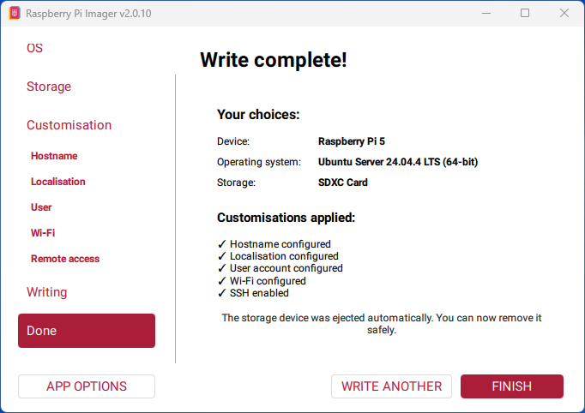
Finally, the sd card is ready to be inserted in the Raspberry Pi. It is safe to unplug the sd card from the base computer.

Recommended settings:
Hostname: pi-bot-1
Username: pi
Password: choose and record a local development password
Enable SSH (password authentication during initial setup)
Wi-Fi SSID and password: use the dedicated robot-development network in use at the installation site.

A.2 Initial Raspberry Pi Configuration

Connect using SSH
After the Raspberry Pi boots, connect remotely using SSH.
ssh pi@pi-bot-1.local

Update Ubuntu
Bring the operating system up to date before installing ROS 2.
sudo apt update
sudo apt full-upgrade -y
sudo reboot

Optional: Configure passwordless SSH
Generating an SSH key avoids repeatedly entering a password.
ssh-keygen -t ed25519
ssh-copy-id pi@pi-bot-1.local

Configure Passwordless sudo
On a dedicated research robot, allowing the pi user to run administrative commands without entering a password simplifies remote maintenance and automation. This should only be used on a physically secured, single-purpose system.
sudo visudo -f /etc/sudoers.d/010_pi-nopasswd
Add the following line, save the file, and exit:
pi ALL=(ALL) NOPASSWD:ALL
Verify the setting:
sudo -k
sudo true
Expected Result: The verification command completes without prompting for a password.

A.3 Install ROS 2 Jazzy

Configure the locale
ROS 2 requires a UTF-8 locale on a clean Ubuntu Server installation.
sudo apt install -y locales
sudo locale-gen en_US en_US.UTF-8
sudo update-locale LC_ALL=en_US.UTF-8 LANG=en_US.UTF-8
export LANG=en_US.UTF-8

Install ROS 2
Install the ROS 2 Jazzy base distribution and development tools.
sudo apt install -y ros-jazzy-ros-base
sudo apt install -y ros-dev-tools
sudo apt install -y ros-jazzy-demo-nodes-cpp ros-jazzy-demo-nodes-py
sudo apt install -y ros-jazzy-rmw-cyclonedds-cpp

Configure the shell
Automatically source ROS for every terminal session.
echo "source /opt/ros/jazzy/setup.bash" >> ~/.bashrc
echo "export ROS_DOMAIN_ID=5" >> ~/.bashrc
echo "export RMW_IMPLEMENTATION=rmw_cyclonedds_cpp" >> ~/.bashrc
source ~/.bashrc

Configure the ROS 2 Domain
ROS 2 uses a domain identifier to isolate discovery traffic between independent robot systems on the same network. Domain 5 is assigned to SprayBot/OBot. Every computer that must communicate with OBot must use ROS_DOMAIN_ID=5. CycloneDDS is used for the current OBot configuration.
echo "export ROS_DOMAIN_ID=5" >> ~/.bashrc
echo "export RMW_IMPLEMENTATION=rmw_cyclonedds_cpp" >> ~/.bashrc
source ~/.bashrc
Verify the setting:
echo $ROS_DOMAIN_ID
Expected Result: The terminal prints 5.

Source the OBot Workspace
After the OBot workspace has been created and built, add its setup file to .bashrc so the custom OBot packages are available in every terminal. On the robot, the OBot hardware-specific workspace is ~/obot_ws. Run this command only after ~/obot_ws/install/setup.bash exists.
echo "source ~/obot_ws/install/setup.bash" >> ~/.bashrc
source ~/.bashrc

Verify the installation
Run the talker/listener demonstration in two terminals.
ros2 run demo_nodes_cpp talker
ros2 run demo_nodes_py listener

A.4 Install the Waveshare 2-CH CAN FD HAT Rev. 2.1

Configure the device tree
Enable SPI and load the MCP2518FD drivers during boot.
dtparam=spi=on
dtoverlay=spi1-3cs
dtoverlay=mcp251xfd,spi0-0,interrupt=25
dtoverlay=mcp251xfd,spi1-0,interrupt=24

Bring up the interfaces
Configure both CAN channels for 1 Mbps.
sudo ip link set can0 up type can bitrate 1000000 restart-ms 100
sudo ip link set can1 up type can bitrate 1000000 restart-ms 100

Verify hardware
Connect CAN0 to CAN1 (H-H, L-L, G-G), enable both 120 Ω jumpers, then transmit a frame from can0 while monitoring can1.
candump can1
cansend can0 123#DEADBEEF
Expected Result: The frame should immediately appear on can1.

A.5 ODrive S1 CAN Commissioning
OBot uses two ODrive S1 motor controllers connected to the Raspberry Pi 5 through the Waveshare CAN HAT. The validated bus uses 1 Mbit/s CAN. CAN_H, CAN_L, and ground must be carried between nodes, and 120 ohm termination is enabled only at the two physical ends of the bus.

A.5.1 ODrive CAN Wiring
Mount the two S1 controllers so the CAN connectors can be reached with the available JST-GH cables. Connect CAN_H to CAN_H, CAN_L to CAN_L, and CAN ground to the HAT/system ground. Do not use the 12 V auxiliary conductor as a CAN signal. Keep the CAN_H/CAN_L pair twisted where wiring is extended.
The second S1 at the end of the bus has its 120 ohm termination switch enabled. The CAN HAT end is also terminated. Intermediate nodes must not add another termination resistor.

A.5.2 Bring Up and Inspect CAN
Run on OBot (pi-bot-1):
sudo ip link set can0 down 2>/dev/null || true
sudo ip link set can0 up type can bitrate 1000000 restart-ms 100
ip -details -statistics link show can0
Expected Result: can0 is UP/LOWER_UP and reports ERROR-ACTIVE under normal conditions.
Monitor traffic with:
candump -t a can0
With both S1 controllers powered and correctly configured, CAN traffic/heartbeats should be visible. If no frames are received, verify controller power, unique CAN node IDs, H/L/G continuity, and end termination before changing software configuration.

A.5.3 ODrive Node Configuration
Configure each ODrive S1 with a unique explicit CAN node ID. Node IDs should not be left in an ambiguous automatic state for the installed robot. Perform motor configuration/calibration using the ODrive tools before ROS control testing. Record the node IDs and any non-default controller settings with the robot configuration.

A.5.4 ROS Velocity Interface
ROS 2 Jazzy diff_drive_controller uses geometry_msgs/msg/TwistStamped for its command input. Current OBot teleoperation and navigation nodes publish stamped velocity commands, so the older twist_stamper compatibility package is not required and is not part of the current OBot source tree.

A.6 OBot ROS Workspace and Repository Layout
OBot-specific ROS packages are kept separate from code intended to be shared across future SprayBot robots. On the robot the OBot workspace is ~/obot_ws. On the primary development laptop (ros-24), the Git-managed development workspace is ~/Workspaces/obot_ws.
The repository contains source and configuration only. Colcon-generated build/, install/, and log/ directories are excluded by .gitignore and are recreated locally by colcon build.
Current repository layout:
src/ ROS 2 packages (obot, obot_bringup, obot_description, obot_msgs)
firmware/ CYD/ESP32 firmware
maps/ saved SLAM maps
bin/ project utility scripts
systemd/ project systemd service definitions/install helpers
doc/ project documentation
config/ machine/network configuration templates as needed

A.6.1 Build the OBot Workspace
Run on OBot or the development laptop from the appropriate OBot workspace root:
source /opt/ros/jazzy/setup.bash
colcon build --symlink-install
source install/setup.bash
After a successful build, verify the packages with:
ros2 pkg list | grep -E "^obot$|^obot_bringup$|^obot_description$|^obot_msgs$"

A.6.2 Current OBot Teleoperation
The OBot teleoperation launch file starts the ROS joy_node directly and then starts tank_mixer_node. A separate systemd joy service is therefore not required for the current OBot configuration. The tank mixer publishes geometry_msgs/msg/TwistStamped commands for the Jazzy command path.
Example on ros-24 after sourcing the workspace:
ros2 launch obot obot_teleop.launch.py

A.7 CycloneDDS Configuration
ROS_DOMAIN_ID=5 and rmw_cyclonedds_cpp are used on the current OBot computers. The development laptop has two Wi-Fi interfaces, so its current CycloneDDS XML explicitly selects the USB Wi-Fi interface used for the ROS graph and limits DDS packet sizes to avoid problematic IP fragmentation on wireless networks.
Example CycloneDDS XML used on ros-24:
<?xml version="1.0" encoding="UTF-8"?>
<CycloneDDS xmlns="https://cdds.io/config">
<Domain id="any">
<General>
<Interfaces>
<NetworkInterface name="wlx186945d99d28"/>
</Interfaces>
<FragmentSize>1200B</FragmentSize>
<MaxMessageSize>1400B</MaxMessageSize>
</General>
<Discovery>
<ParticipantIndex>auto</ParticipantIndex>
<MaxAutoParticipantIndex>50</MaxAutoParticipantIndex>
</Discovery>
</Domain>
</CycloneDDS>
Interface names are machine-specific. Verify the interface with ip link or nmcli before reusing this XML on another computer.

A.8 CYD ESP32 Spray Controller and Status Display
The current auxiliary controller is an ESP32-based CYD touchscreen. Its firmware is maintained under firmware/cyd_spray_controller in the OBot repository and is built with PlatformIO. The CYD has successfully run the micro-ROS talker/listener demonstration and can participate in the ROS 2 system through a micro-ROS agent.

A.8.1 CYD Local Configuration
Wi-Fi credentials and the micro-ROS agent address are kept in firmware/cyd_spray_controller/include/config.h. This file is intentionally excluded from Git. The repository contains include/config.example.h as the template for a new installation.
On a fresh checkout, create the local configuration with:
cd firmware/cyd_spray_controller
cp include/config.example.h include/config.h
Edit include/config.h with the site Wi-Fi credentials and micro-ROS agent IP address before building the firmware.

A.8.2 Valve Relay GPIO
The CYD temperature-and-humidity JST interface exposes ground, 3.3 V, GPIO 22, and GPIO 27. The present relay demonstration uses GPIO 22. Connecting the relay module to the correct ground, 3.3 V supply, and GPIO 22 causes the relay to switch under firmware control. GPIO 27 is also available and may be adopted later if the firmware and wiring are changed together.
The touchscreen demonstration includes an on/off button that toggles the valve relay. This verifies that the CYD can provide local operator input as well as display robot status.

A.8.3 micro-ROS Agent Verification
Start the micro-ROS agent on the ROS computer using the transport and port configured in the CYD firmware. After the CYD connects, verify that its node and topics appear in the ROS graph with ros2 node list and ros2 topic list. A successful talker/listener test should be completed before troubleshooting higher-level monitor subscriptions.

A.9 Documentation and Revision Control
The installation guide is stored in the repository as doc/SprayBot_Installation_Guide.docx. The filename remains constant. Git commit history and tags provide revision history, so version numbers do not need to be embedded in the filename. When the guide is updated, commit the document together with any source/configuration changes that the new procedure describes.
Current guide baseline: Ubuntu 24.04, ROS 2 Jazzy, ROS_DOMAIN_ID=5, CycloneDDS, OBot/ODrive S1 hardware, and CYD micro-ROS auxiliary controller.

