Hertz Native Android Application
Jason Ricardo, Christian Thomas and William Rivera

Final Draft
Thursday, March 31, 2016

CEN 4935 Senior Software Engineering Project
Instructors: Dr. Fernando Gonzalez & Dr. Janusz Zalewski
Software Engineering Department
Florida Gulf Coast University
Ft. Myers, FL 33965

1. Introduction
The Hertz Corporation is a Fortune 500 American company which is known for the rental car division. Like most companies in the 21st century, they embrace the digital mobile space and develop their own applications that consist of making reservations for a car rental, modifying the reservations and searching for a local office in the area. The problem with their mobile applications is that they are old, slow, buggy, crash a lot; therefore, they garnished a bad reputation in their respective mobile application stores according to user reviews. This is because Hertz mobile applications used a lot of wrapper functions that called subroutines directly to their main website (www.hertz.com) [1]. If the website went down for any reason, all the mobile applications would go down with it. Figure 1.1 shows that as of October in 2015, the application look very outdated compared to the applications like Facebook, Instagram or many leading giants in the technology industry.
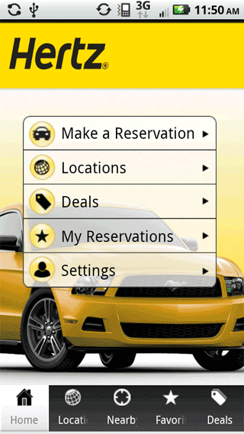
Figure 1.1 Hertz Official Android Application in 2015

The new applications need to be native in each of their ecosystems, they need to communicate directly with Hertz's servers, be able to gather data of the users locations and interact with the services provided by Hertz.
For the Android application, it is necessary to use the Android Studio Integrated Development Environment (IDE) with Genymotion emulator, which previews any design changes on the fly. All the libraries in this application use open source licenses and the images are been provided by the Hertz Corporation. In the last semester, the Android application developed for the senior project implemented the log in screen, main menu, sliding menu, web services and transition flow up to the calendar page. In this semester, the goal is to implement the web services into the application itself, add location services, develop a check out menu and test the software.

2. Software Requirements Specification

2.1 Introduction to Software Requirement Specifications
The purpose of this Software Requirement Specification (SRS) is to provide developers and IT personnel a basis for Quality Assurance testing along with an enlisting of requirements that the software must meet. This Software Requirement Specifications will be used to further implement future functionality of the software being developed will also provide the basis to ensure that Data Integrity is kept along with important functionality.
The generalized scope of the project is a custom Native Android application for Hertz (The Car Rental Company). This application will give the user the functionality to register for an account, log in to an account, view rental availability, and make a reservation. Furthermore, this application will interact with a web service that will give back customer account information back to the mobile application.

2.1.2 Definitions
- Controller – The controller handles request that come in through the specified port number
- Location Web service – Refers to the web server that handles Rental car location to provide Smart Push Notifications to the End User.
- MongoDB – NoSQL database that stores information through the use of documents.
- MVC – Model, View, Controller is a model used in Web Servers for establishing communication between different parties and doing so in a secure way
- Native Android – An application that is developed targeting an Android OS only without using
- RESTful Service – A service that does not change its running state between calls.
- Smart Push Notifications – Push notifications that make decisions based on a rules engine defined by an end user.
- Spring – Java framework used for enterprise applications that require scalability.
- Thin Client – A end user client which carries minimal logic and interacts mostly with a web server to provide utility.
- User Web services – Refers to the web server that handles customer information as a RESTful service.
- Validation – A set of checks and balances that ensure that the data is accurate.
- XML Layout – The format to establish page layouts for the android application.

2.1.3 Overview

Figure 2.1 Physical Diagram

Figure 2.2 Context Diagram

Figure 2.1 Physical diagram in the context of the physical entities. The software will be hosted on a server. This server will have an active connection to a database. The first physical server will host client information software. This data will be stored using MongoDB which is a separate database service. The second server that is displayed on the right side of the diagram shows the smart decision software that will be hosted on that server. This decision server will using Neo4j as a database and a validation engine. Therefore there considered separate entities.
Furthermore let’s view the context diagram portrayed in Figure 2.2 displaying all the interactions the software establishes. The system is using a thin client software which gives the functionality of log in, smart push notifications, Car selection, Rental Calendar, User Registration, and confirmations. This thin client is an android environment coded in Java which interacts with custom software on a web service. The custom software is built with an MVC structure using Spring Framework. The software of the web service is used by calling on the controller which generates a Service Response. The controller can then call the service which will contain the logic. Finally if service validates the information then it will be written to the database using the DAO component.
The third part of the software that interacts with the mobile application in this context diagram is the Location Service. This service follows the same architecture as the previous one with the exception of the functionality of taking in GPS coordinates. This service will interact with user service to communicate information about the user including whether they have insurance or not. This step is crucial in making decisions for the smart push notifications that will be sent back to the mobile application.

2.1.4 System Interfaces
The system interfaces are dependent on which user has what version of the Android operating system. The versions supported are from 4.4.2 called Jelly Bean up to version 6.0 called Marshmallow. The versions 4.4.2 up to 5.1.1 are very similar in design, but version 6.0 changed the way the calendar picker displays the dates. On Jelly Bean, the calendar picker had to show dates next to the complete calendar, but the same code on Marshmallow removes the actual date itself, leaving the calendar display a lot more cleaner.

2.1.5 User Interfaces
The user would be interacting with the program via a Material Design look implemented by Google in June of 2014 [2]. This method uses pastel and solid colors with clear and defined boundaries between each element. Its very similar to actual pieces of paper stack with each other in the physical world.

2.1.6 Hardware Interfaces
The system hardware interface will include a web server running on port 8080. This should ideally be a Tomcat deployment service. The Server hosting the web server will also be running a logical instance of MongoDB. The hardware interface for the mobile application can include a mobile phone using a 6” screen or smaller. Careful account for larger screens like those used in tablets up to 12” screen need to be researched.

2.1.7 Communication Interfaces
The Android devices should have an Internet communication which should make POST request to the web server. The communication will occur over the Internet using TCP/IP protocols and running on port 8080.

2.1.8 Memory
Memory is a huge problem when developing with Android applications due to the nature of how Android load images. When an image is created, Android Studio will try to increase the value and quality of the image to prevent the design from looking jagged. This in turn increases the memory allocation that the virtual emulator process will use for testing and how much memory Android itself will use to run the application. In newer devices is not a problem, but devices released 2 years ago and older will experience crashes and out of memory exceptions. To prevent this from happening, images were reduced drastically while making them useable.

2.1.9 Site Adaptations
The site adaptations of the software will include a run time execution of the Java application developed using the Spring Framework. The Android device needs to be running on Android 4.0 or newer and will be installed through the use of an APK.

2.2 Requirement Specifications
This section encompasses all of the requirements of the software including input/output, functional, and non-functional as well as design constraints. A detailed description of the software’s features is included.

2.2.1 Input/Output Requirements
- The software shall save the user’s name and password. (Hertz)
- The software shall allow the user to select a reserve location for their vehicle reservation. (Hertz)
- The software shall allow the user to select a return location for their vehicle reservation. (Hertz)
- This software should output confirmation email verifications for
  - Vehicle reservation (Hertz)
  - Billing notifications (Hertz)
- This software shall allow the client account to save
  - First Name (Hertz)
  - Last Name (Hertz)
  - Billing Information (Hertz)
  - Driver’s License Information (Hertz)
  - Current Address (Hertz)
- This software shall allow the client account to update
  - First Name (Hertz)
  - Last Name (Hertz)
  - Billing Information (Hertz)
  - Driver’s License Information (Hertz)
  - Current Address (Hertz)
- This software shall communicate with Neo4J database. (Hertz)
- This software shall communicate with MongoDB database. (Hertz)
- The software shall incorporate geolocation services into user interface. (Hertz)

2.2.2 Functional Requirements
- The software shall have a location function to find Hertz Rent-A-Car Centers, from zip code input. (Hertz)
- The software shall have a vehicle reservation function to
  - Select vehicle pick up time. (Hertz)
  - Designate vehicle return time. (Hertz)
  - Select vehicle pick up date. (Hertz)
  - Designate vehicle return date. (Hertz)
- This software shall have a vehicle selection function to
  - Select vehicle based on type. (Hertz)
  - Designate vehicle based on model. (Hertz)

2.2.3 Non-Functional Requirements
- This software shall have a response time of 3 seconds maximum when searching for a Hertz Location. (Hertz)
- This software shall have no more than 10 screens or pages for all functionality. (Hertz)
- This software shall notify the user if there is a loss of connection to the network, server or database. (Hertz)
- The web services shall provide a layer of security between the network and database.
- The web services shall have an object-oriented design to easily integrate
  - Software functionality. (Hertz)
  - Decrease software response time. (Hertz)
  - Decrease micro services run time. (Hertz)

2.2.4 Design Constraints
- This software design requires an established network connection. (Hertz)
- The iOS must enable global positioning for geolocation services. (Hertz)
- The database shall receive Java Objects from RESTful Web. (Hertz)
- The database shall send Java Objects to RESTful Web. (Hertz)
- The RESTful Web service shall
  - Convert client GET requests via HTTP. (Hertz)
  - Convert JSON objects to Java objects. (Hertz)
  - Use the DAO (Data Access Object) to access MongoDB. (Hertz)
  - Send JSON-based response to the client application. (Hertz)
  - Validate customer’s information before being sent to MongoDB. (Hertz)
  - Send push notifications to the client. (Hertz)
- The user interfaces of the iOS should resize with equivalent proportions. (Hertz)
- The Client shall receive push notifications from RESTful Web Services. (Hertz)

2.3 Operations
The user shall use the application for renting a vehicle, searching for locations or modifying a reservation. While this is happening, the application will store the users options locally until a decision at checkout has been made. This will in turn have the back end portion of the program communicate with the Hertz servers to confirm a reservation, make changes or save user data on favorite locations.

3. Design Description

3.1 Introduction to Design Description
3.1.1 Scope
This section describes the software design and establishes the information content and organization of the Hertz Mobile Application. This detailed design is a representation of the Hertz Mobile Application software to be used for recording design information and software construction activities. These activities include, when design descriptions lead to code and when code leads to a design description.
3.1.2 Purpose
This design description specifies requirements on the module design, module organization and module interactions within the software.
3.1.3 Design Overview
Described in this section will be a detailed description of the software design for the mobile application. In particular, what will be discussed are the software architecture, the detailed design, and the human-machine interface design. Software architecture refers to the different modules which make up the software and how they interact with each other. The detailed design will build on the modules detailed in the software architecture section from a static and dynamic perspective. From a static perspective, an outline of the details pertaining to each module will be explained, and from a dynamic perspective, the behavior of the software will be addressed. Lastly, the human-machine interface design will go into the details of how the GUI has been produced and its role in the interaction between the user and the software.
3.1.4 Conformance
The Hertz Mobile Application Design Description conforms to the IEEE Standard 1016-2009 [] by satisfying the requirements specified in Section 2.2 ‘Requirements Specification’. Requirements are denoted by the verb shall.

3.2 Software Architecture
3.2.1 Software Architecture Introduction
The Hertz Mobile Application architecture establishes a conceptual model for the software design documentation. This conceptual model features a top-down design which includes, basic terms, modules and interactions.
3.2.2 Overview
The software architecture is divided into four modules including the, human-machine interface, Heroku cloud platform, MongoDB and Neo4J. The realization of the relationships between these modules is expressed in Figure 3.1
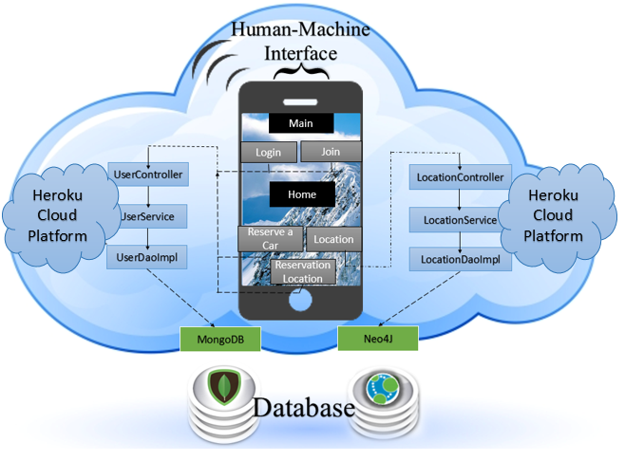
Figure 3.1 Structure Chart

The human-machine interface provides the user with the following functions; Login, Join, Reserve a Car, Reservation Location and Location. All five functions are programmed as buttons on the user screen, but exist on two different interfaces. The first interface, Main, offers the login and join buttons. Once one of these buttons is selected and carried out, the user will be brought to the Home interface. This interface, provides the user with three services, reserve a car, reservation location and Find Location.
The Heroku cloud platform manages the function requests based on the user selection. This platform offers two different micro services. The first service consists of the UserController, User Service, and UserDaoImpl. These services involve the sending and receiving of user related account information, billing information and account preferences, which are stored in MongoDB.
The second services are the LocationController, LocationServices and LocationDaoImpl. This set of services regard the sending and receiving of geolocation signals. These signals interact with the Neo4J database for increased network security.

3.3 Detailed Design
3.3.1 Static Perspective
Figure 3.3.1 is a Class Diagram that illustrates how the modules for the database and users are able to work together. While the UserEntity sets the actual account access information thru validation, the UserService thru the UserController is the one that saves the information in the database. This allows the classes from manipulating the data directly, it helps the future transition to other database technologies and reduces coupling while increasing cohesion.

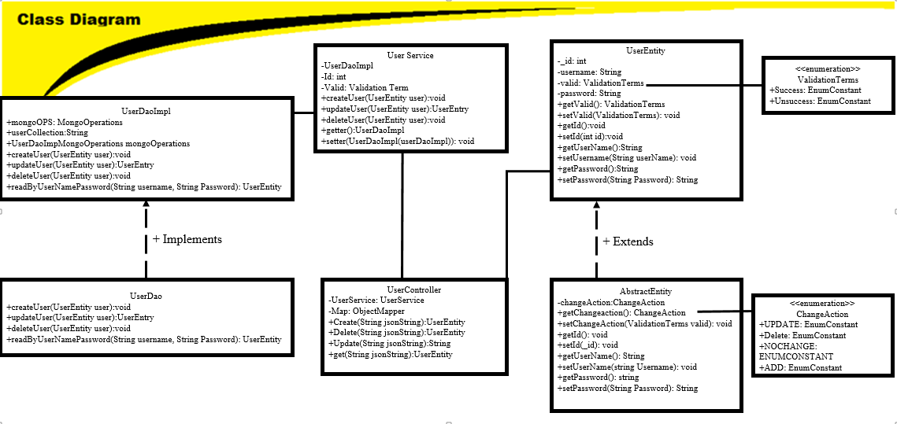
Figure 3.3.1 Class Diagram

The client application sends REST requests via HTTP to the RESTful Web service. The Web service receives GET requests, which are JSON strings, and the REST Controller converts the strings into Java objects. The controller converts JSON into POJOs by implementing a method, which maps each JSON object to the specific Java object. Depending on the client’s requests, the Web service can create a customer profile, update the customer’s information, retrieve customer’s data upon request, or delete a customer profile by accessing a NoSQL database, called MongoDB, from the DAO. The Web service is able to access the database from MongoDB methods and libraries. Figure 3.3 illustrates these class interactions as a Class Diagram.

3.3.2 Dynamic Perspective
Figure 3.2 illustrates the software behavior from when the Hertz Mobile Application launches to the location services portion.

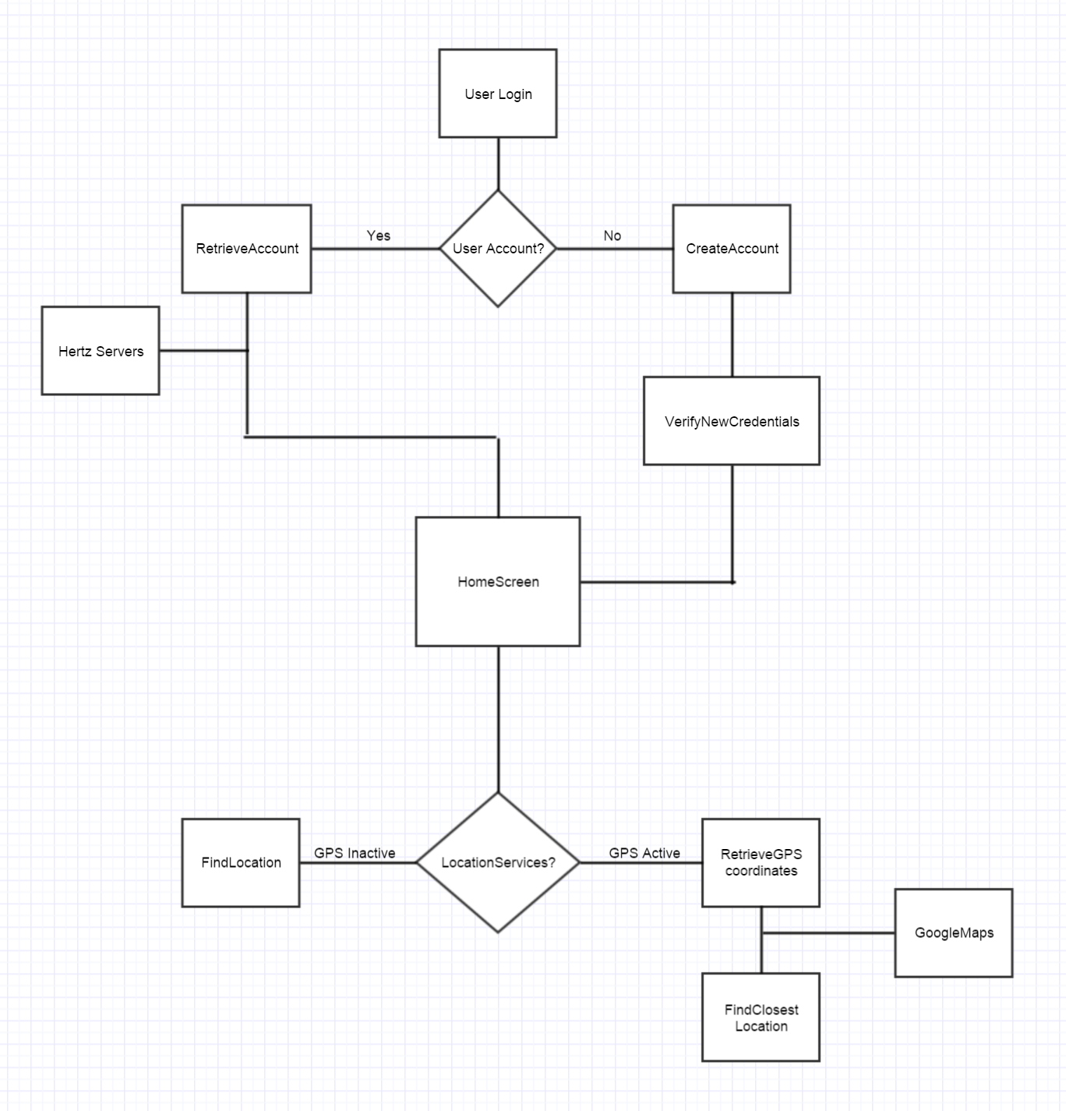
3.3.2 Software Behavior Flowchart

Once the application has launched, the server software will validate the connection and the user interface will proceed to the Main screen based on Heroku’s HTTP Post-Request in URL format. This interface offers the sign in and join commands that Heroku validates from the URL. If these commands return validated, the user is directed to the Home interface. This interface offers three services, Reserve a Car, Reservation Location and Find Location. The descriptions of these services are found in Section 3.4 Human-Interface Design.

3.4 Human-Machine Interface Design
3.4.1 Human-Machine Interface Design Introduction
The objectives of the Human Interface Design Document consists of being the primary document driving the implementation of the Hertz iOS mobile application human interface and provide the traceability of the design elements from the architecture documentation.

3.4.2 Overview
This section will detail the interactions between the user and the software. Every interaction will take place on the designed GUI displayed on the user’s mobile device.

3.4.3 Application Screens

3.4.3.1 Account Selection
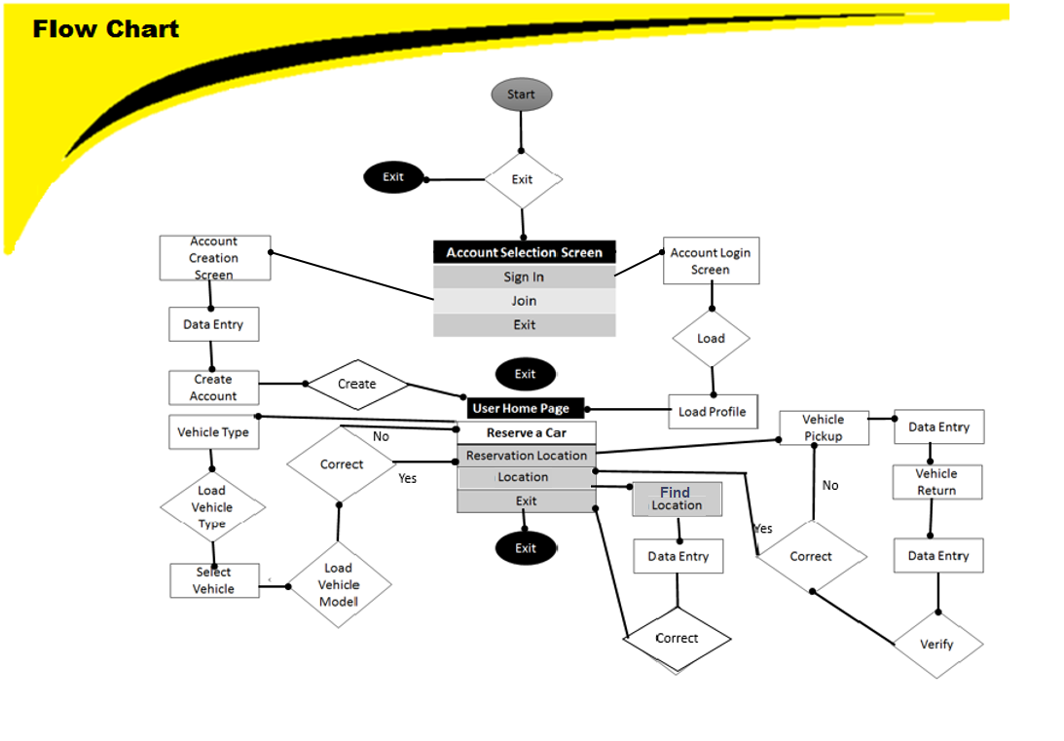
Figure 3.4.1 Interface Flow Chart

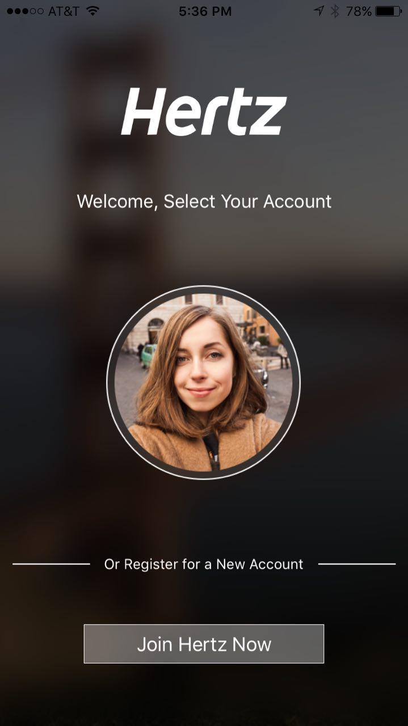
Figure 3.4.2 Mobile Application Screen – “Account Selection”

The join command proceeds to an account creation screen, where the user will input their personal information and billing information. These inputs will be converted to a JSON string object, relayed as an HTTP request to the web services and stored from the web services to MongoDB. If these requests are determined valid within the web services, then the user will be redirected to the Home screen.

3.4.3.2 Main
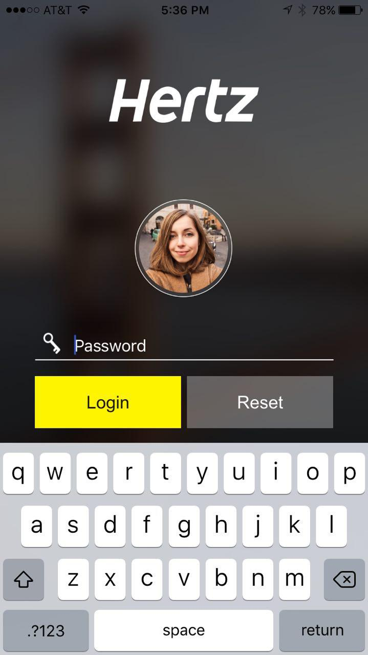
Figure 3.4.3 Mobile Application Screen – “Login Screen”

The sign in command reads the username and password as string variables within the mobile application. Both variables are converted to a JSON string object that is sent from an HTTP request to the web services. If the account string variables are validated by these services, then the interface will load the Home screen.

3.4.3.3 Home
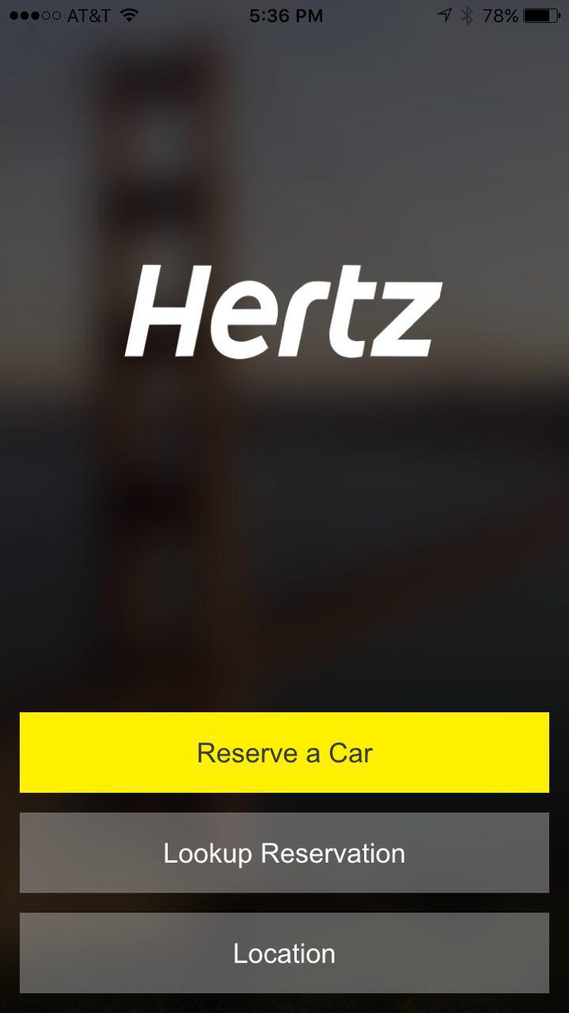
Figure 3.4.4 Mobile Application Screen – “Home Screen”

From the home screen shown in Figure 3.4.4, users will have the option to reserve a car, lookup an existing reservation, or search for a nearby Hertz location.

3.4.3.4 Car Reservation
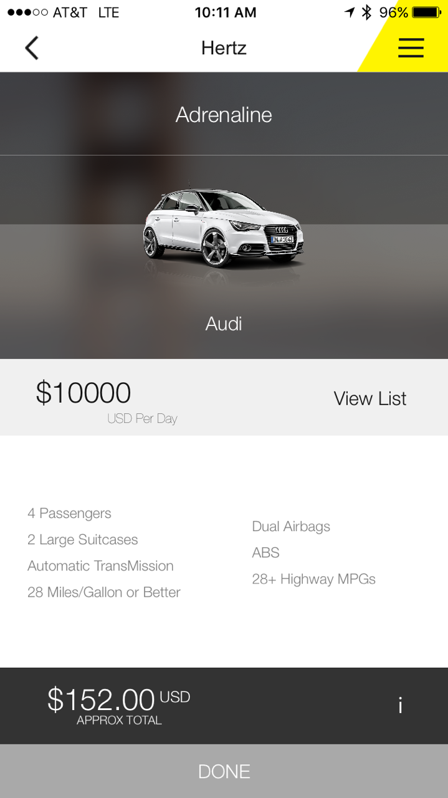

The Reserve a Car service redirects the user to several screens that provide the user with a choice of vehicle selection. First the vehicle type will be determined by the user as either luxury, sport, or convertible from a list menu. The user can then confirm the selected type to be directed to the following interface Vehicle Selection. This interface will offer several vehicles based on the vehicle types and are stored in MongoDB. In MongoDB the vehicle inventory is managed from the admin side. The user will can then confirm their vehicle selection and then, redirected to the Home screen.

3.4.3.4 Select Date
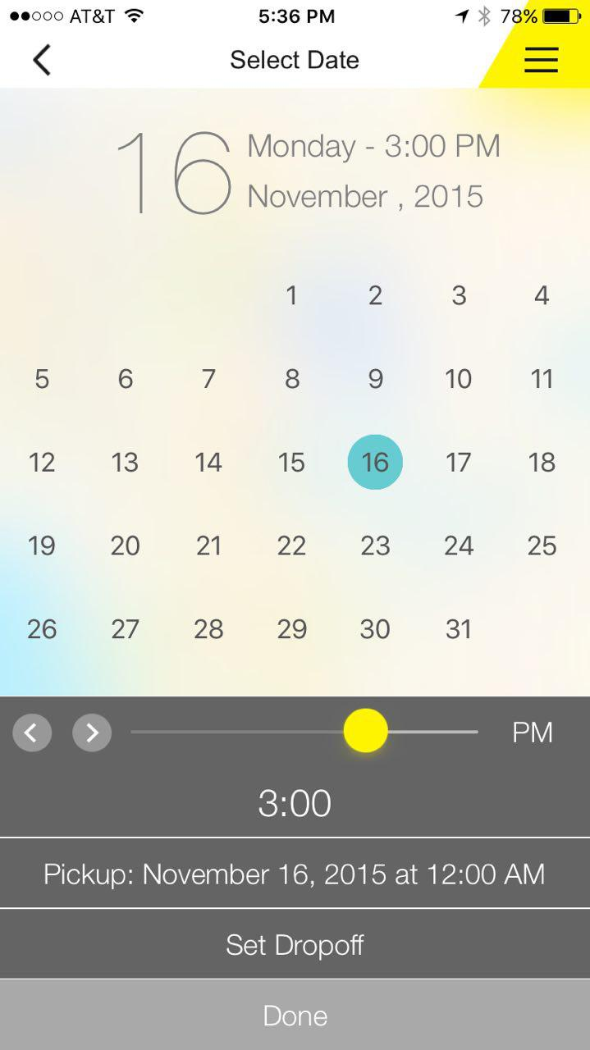
The Reservation Location service is only accessible after the user has been through the Reserve a Car service. The Reservation Location service provides the user with a calendar view that is touch screen accessible to select the day and time of vehicle pickup. The user will then have to confirm these days to proceed to the vehicle return interface. The vehicle return interface operates the same as vehicle return, redirected the user to the Home interface after confirmation.

3.4.3.4 Find Location

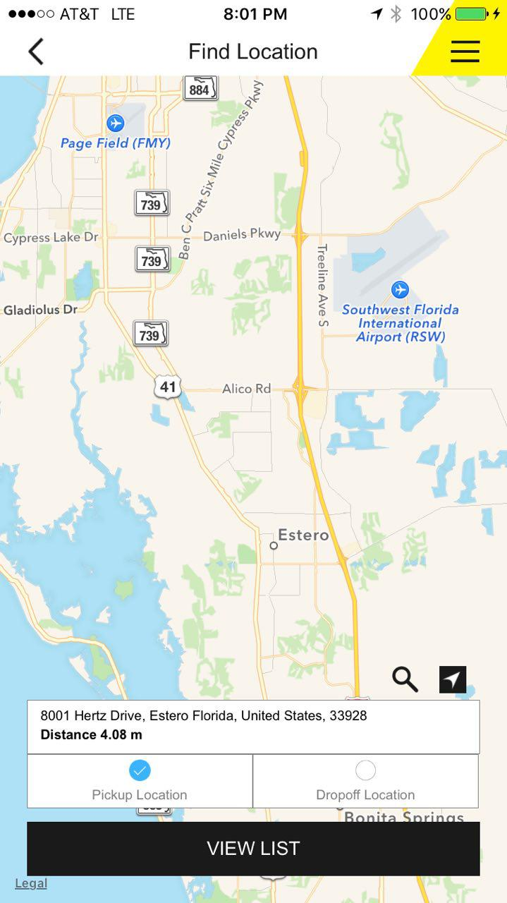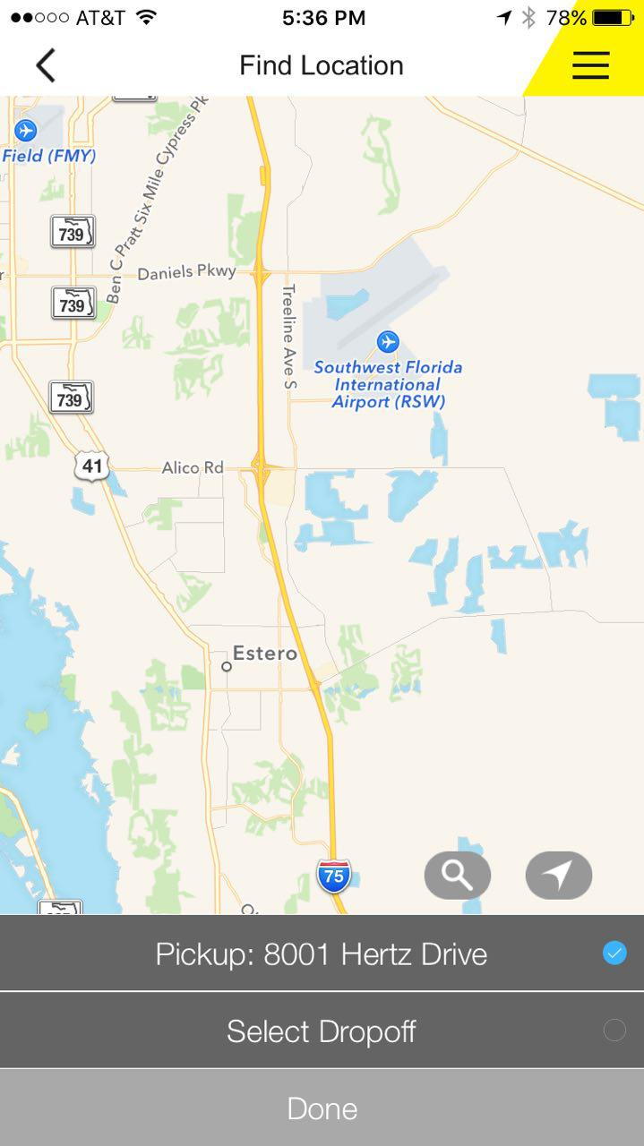

The Find Location service is only accessible after the Reserve a Car and Reservation Location service has been completed. This service will generate a list of Hertz locations for vehicle pickup based on the geographical location of the mobile phone.

4. Implementation
4.1 Android Implementation
A description of the implementation is presented in this section:
In figure 3.1.1 the log in screen is shown. This will be the first screen that our users will be able to interact with after being greeted by the splash screen. From here, users shall be able to log in to any existing accounts on this device by selecting the image of the user they wish to log in as. Users can press the arrow buttons to browse through the available users. If the user does not have an account with Hertz, they can register a new account by pressing the “Join Hertz” button which will take the user to the registration screen.
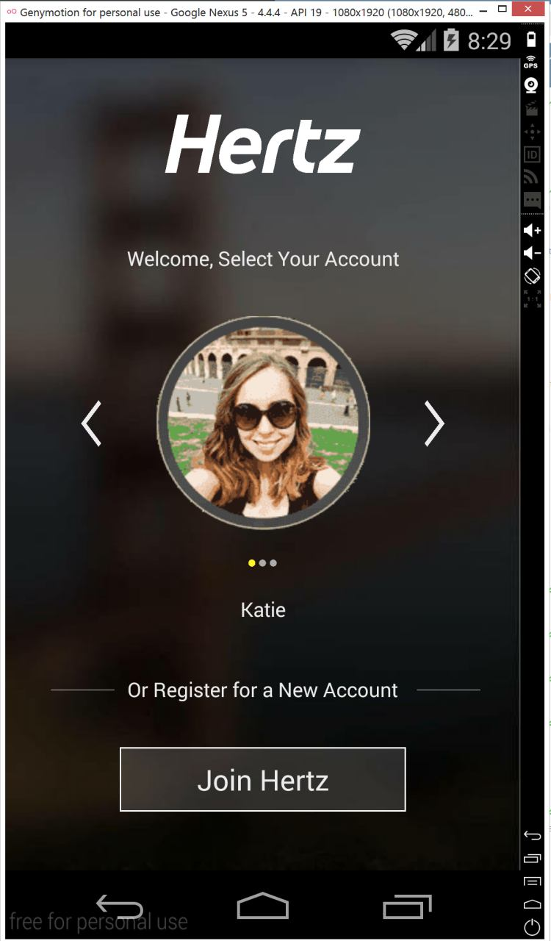
Figure 3.1.1
Figure 3.1.2 shows a screen shot of the car selection screen. From this screen a user shall be able to select a collection, select a vehicle from that collection, and view the vehicle’s specifications as well as pricing options. The available vehicles shown will be based on the Hertz location selected and the vehicles available from that location. Not shown in the image is a button at the bottom of the screen which allow for switching between viewing either the vehicle’s specification or pricing options. Also not shown is a button that will allow the user to select the current vehicle for the current reservation. The back button in the top left corner will allow the user to return to the previous screen.
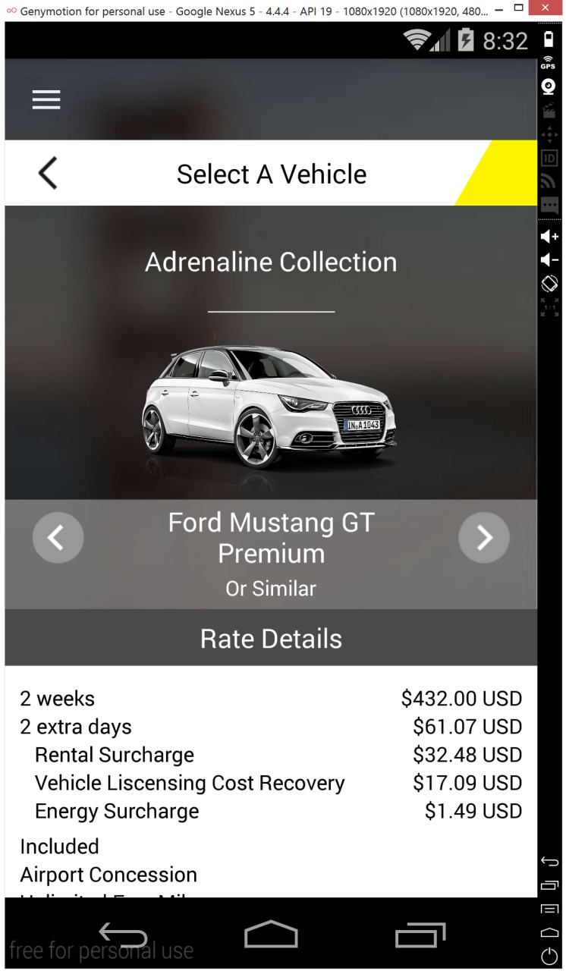
Figure 3.1.2
The following code is a snippet from the MapsActivity.java class. This class implements a map which will move to and zoom in on the user’s current position based on the latitude and longitude of the user. The program will also search for the five closest locations matching search criteria using the string “Hertz” and mark those locations with a pin. This class requires Google Play Services to be activated for this particular Android project. By selecting one of the pins, a user can select the Hertz location they wish to make a reservation at as well as receive directions to the location.
mMap = googleMap;
String hertzLocation = "Hertz";
List<Address> hertzList = null;
Geocoder geocoder = new Geocoder(this);
try {
hertzList = geocoder.getFromLocationName(hertzLocation, 5);
} catch (IOException e) {
e.printStackTrace();
}

if (checkSelfPermission(Manifest.permission.ACCESS_FINE_LOCATION) != PackageManager.PERMISSION_GRANTED && checkSelfPermission(Manifest.permission.ACCESS_COARSE_LOCATION) != PackageManager.PERMISSION_GRANTED) {
return;
}
mMap.setMyLocationEnabled(true);
LocationManager locationManager = (LocationManager) getSystemService(Context.LOCATION_SERVICE);
Criteria criteria = new Criteria();
String provider = locationManager.getBestProvider(criteria, true);
Location myLocation = locationManager.getLastKnownLocation(provider);
double latitude = myLocation.getLatitude();
double longitude = myLocation.getLongitude();
LatLng mylatLng = new LatLng(latitude, longitude);
mMap.moveCamera(CameraUpdateFactory.newLatLng(mylatLng));
mMap.animateCamera(CameraUpdateFactory.zoomTo(14));
for(int i=0;i<hertzList.size();i++){
Address address = hertzList.get(i);
LatLng latlng = new LatLng(address.getLatitude(), address.getLongitude());
mMap.addMarker(new MarkerOptions().position(latlng).title("Hertz"));
}

In Figure 3.1.3 is the main screen where the user will be interaction to many of the services for the Hertz Rental Division. The background of the screen is a static image that in the future will change according the user’s geographical area. This image has a blurred filter added to it to prevent images from affecting the text from the different fragments that will change across the static background. Fragments on the other hand is the behavior of the user interface that is used to keep that static image while having information come in and out without the need of creating additional activities. This helps keep the memory usage low, it keeps variables together and creates an effect of uniformity that the separate main activities would create.
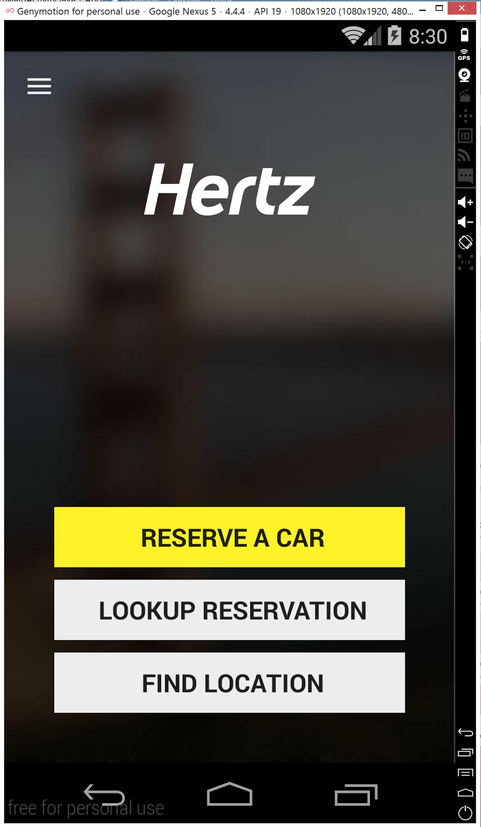
Figure 3.1.4

The main screen has a total of three buttons that should be the most common places the end user should be using. The “Reserve a Car” button immediately takes the user to pick a date, location and car. The “Look up Reservation” button should take the user to a search screen for the reservation number, user’s account number or phone number. The “Find Location” button should take the user to a map where the location services will automatically search his current location and find Hertz rental locations near by and will also have a search box for locations around the world.
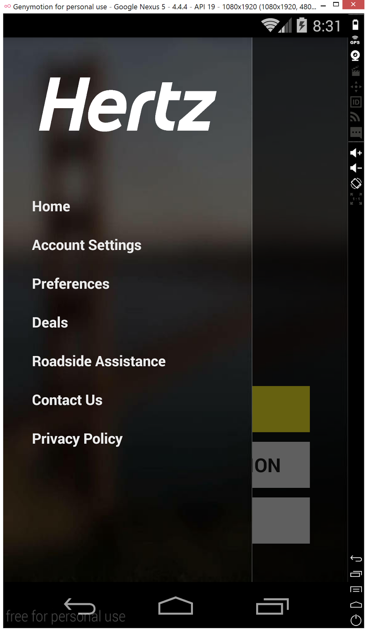
Figure 3.1.5

The main screen has a menu slider that comes from the left side of the screen as shown in Figure 3.1.5 which can be accessed by using the user’s finger and sliding from left to right or by tapping the 3 white line menu in the top left corner. In that menu, the user can access quick links to the application and user settings. The Roadside Assistance and Contact Us link shall take the user to a screen in Figure 3.1.6 that contains the phone number information for the services, which the user can click to call directly from the application.

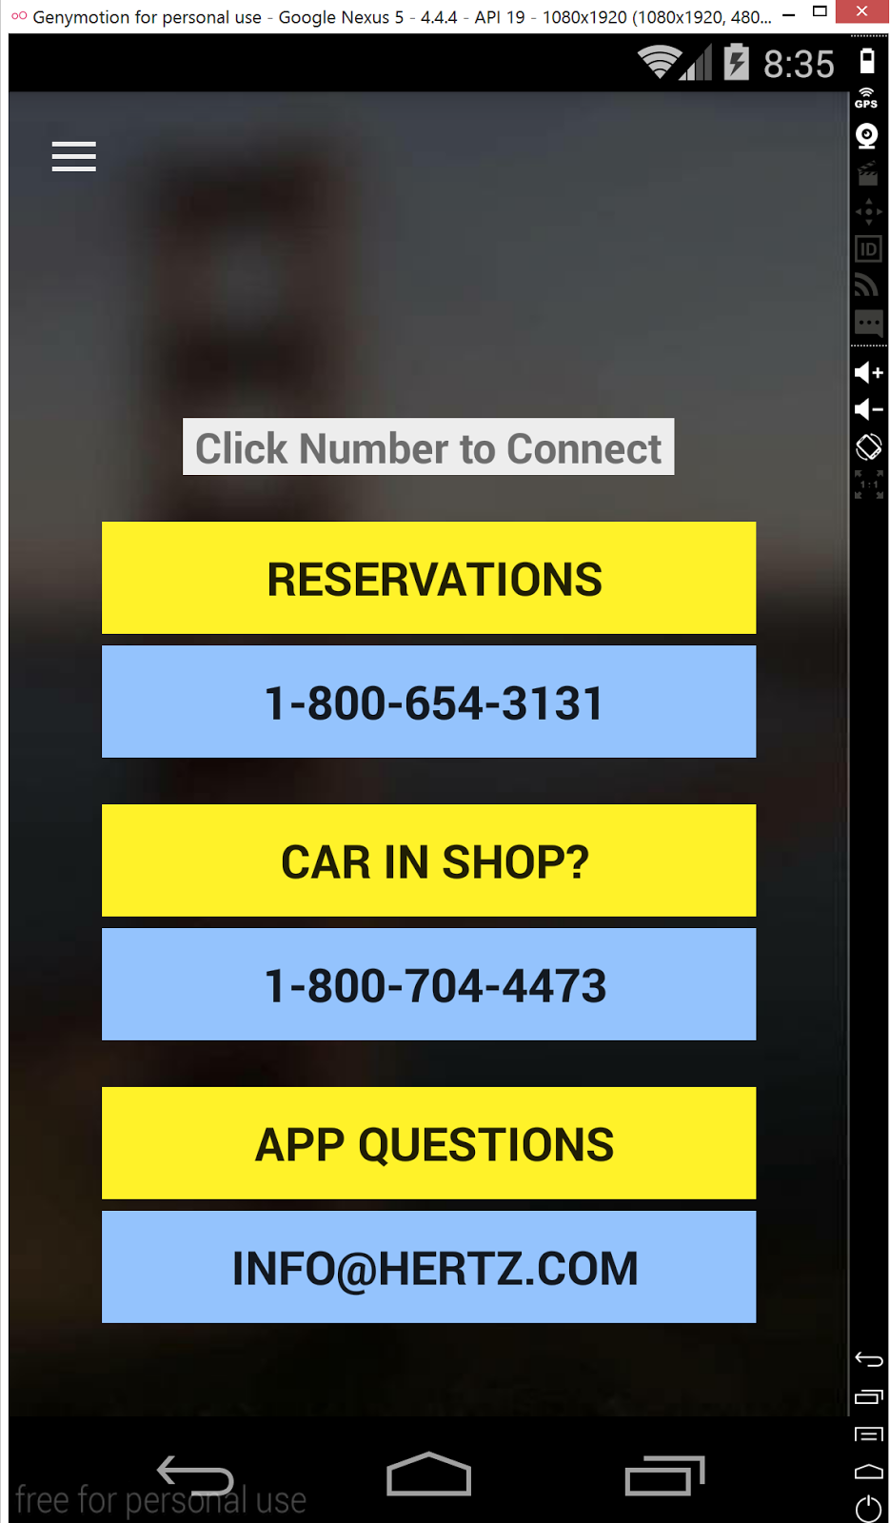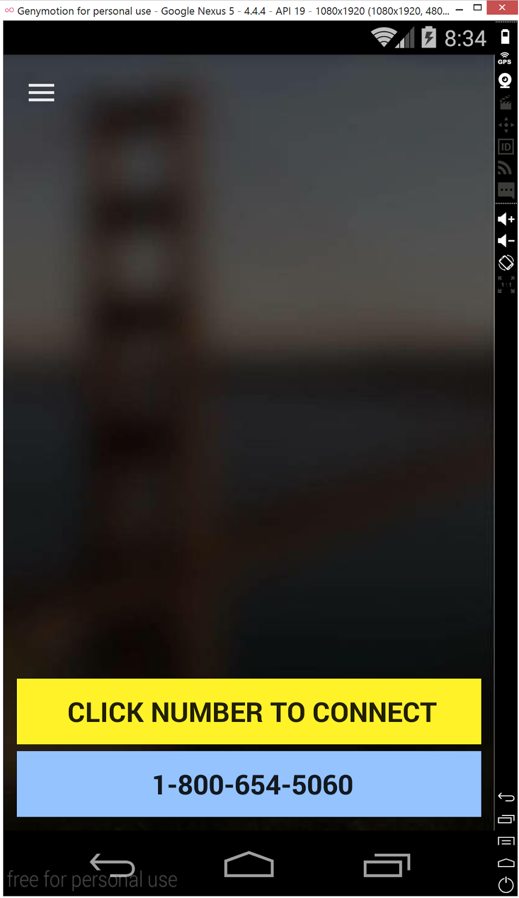
Figure 3.1.6

In the MainActivity.java is the main hub for all the program, meaning that user will be calling out fragments, activities and services from it. In order for the MainActivity to call a graphic user interface that the user can see, the class will use an onCreate() function.
The code goes as followed:
@Override
protected void onCreate(Bundle savedInstanceState) {
super.onCreate(savedInstanceState);
//Set screen to portrait mode this.setRequestedOrientation(ActivityInfo.SCREEN_ORIENTATION_PORTRAIT);
setContentView(R.layout.activity_main);

In the code above, the function onCreate() will initialize the activity and set the layout that will define your user interface by using the setContentView() function. The parameter used by the setContentView() function is an XML (Extensible Markup Language) file that contains the overall look of the screen being shown to the user. The XML file in this case is called activity_main.xml or just actvity_main.

4.2 Web Service
4.2.1 Maven Dependencies
The dependency manager for this project is Maven. A few keynotes for the web service is the spring version being used is 4.0. Also note the following dependencies include below are required for the web services to run.
<dependency>
<groupId>org.mongodb</groupId>
<artifactId>mongo-java-driver</artifactId>
<version>3.0.4</version>
</dependency>
<dependency>
<groupId>org.springframework.boot</groupId>
<artifactId>spring-boot-starter-web</artifactId>
</dependency>
<dependency>
<groupId>org.springframework.boot</groupId>
<artifactId>spring-boot-starter-test</artifactId>
<scope>test</scope>
</dependency>
<dependency>
<groupId>org.springframework.data</groupId>
<artifactId>spring-data-mongodb</artifactId>
</dependency>
<dependency>
<groupId>com.fasterxml.jackson.core</groupId>
<artifactId>jackson-databind</artifactId>
<version>2.4.2</version><!--$NO-MVN-MAN-VER$ -->
</dependency>
<dependency>
<groupId>org.codehaus.jackson</groupId>
<artifactId>jackson-mapper-asl</artifactId>
<version>1.9.13</version>
</dependency>
<dependency>
<groupId>jstl</groupId>
<artifactId>jstl</artifactId>
<version>1.2</version>
</dependency>

<dependency>
<groupId>com.github.dvdme</groupId>
<artifactId>ForecastIOLib</artifactId>
<version>LATEST</version>
</dependency>
4.2.2 Request and Response
Requests will be passed in as a parameter in the form of a Json string. This string will be converted to a POJO (Plain Old Java Object) which is now an easy to manipulate object. If there is any problem in the conversion of the string to pojo then these errors will be added to the service response. The conversion of Json to Pojo code snippet is below. In this code we pass the string we receive for conversion and use and ObjectMapper to perform the reading of the values against a specified class.
public static UserEntity convertToPojo(String userJSON) throws Exception {
mapper = new ObjectMapper();
UserEntity user = null;
// Convert JSON string to Object
user = mapper.readValue(userJSON, UserEntity.class);
return user;
}
The service response is a custom response made by the web services being implemented. The main idea of having a service response is to keep track of errors and successful completion of a request. All request are made a get requests including the Json string.
ServiceResposne is a class that contains a class value. This value is defined as any generic that extends a custom AbstractEntity. AbstractEntity handles the changes made on an object which implements this AbstractEntity. Below we see a code snippet for AbstractEntity. Here we see a controlled Enum that takes care of keeping track of the state of an object. The enum helps maintain an order of specific changes.
public abstract class AbstractEntity implements Serializable {
public boolean hasChanges() {
return changeAction == ChangeAction.ADD
|| changeAction == ChangeAction.DELETE
|| changeAction == ChangeAction.UPDATE;
}
public enum ChangeAction {
ADD, UPDATE, DELETE, NOCHANGE;
}
}
A final key point of ServiceResponse is that the class must be serialized so the returned response to the user is consistent with the framework ResponseBody requirements.
4.2.3 Controller
The controller will handle the request being made through an http request. All the controllers will be map specific functionality to the service layer of the web service. Let’s consider the code for a controller below. Here we see some special spring specific annotation. The first annotation to consider is @RequestMapping which handles the mapping from the request to the code segment in the controller. Now the value that is obtained from the thin client is the section {jsonStr}. Now there is still a bit of annotation within this login method of the controller. We see the return value is the custom ServiceResponse this is considered by spring to be a ResponseBody so it is annotated in that way by using @ResponseBody.
@RequestMapping(value="/login/{jsonStr}", method=RequestMethod.GET)
public @ResponseBody ServiceResponse<UserEntity> login(@PathVariable String jsonStr) {
return userService.login(jsonStr);
}
4.2.4 Service
The main logic of the webservice is contained within the service class. These classes are annotated with @Component annotation within spring. These classes are called strictly from within the webservice controller. This means at no point should there be a request mapping from the framework. This could prove to be a security risk. Let’s analyze a code snippet place below. We see the return of this login method within the service is also a ServiceResponse<UserEntity>. The actual conversion of json to pojo occurs within the service class. The reason to have the logic within this class is to keep track of errors and add them to the response that will be passed back to the thin client. This code starts with the conversion and if this is not successful then it automatically fails and sends back the response. This implementation avoids the interaction with the database that can affect the data integrity.
public ServiceResponse<UserEntity> login(String jsonStr) {
ServiceResponse<UserEntity> rs=new ServiceResponse<UserEntity>();
UserEntity user = null;
try {
user = Converter.convertToPojo(jsonStr);
user = userDaoImpl.loginUser(user);//user.getUserName(), user.getPassword());
if(user == null) {

user.setLogin(login.LOGIN_FAIL);
rs.setValue(user);
System.out.println("Login Fail!");
}else {
System.out.println("User does exist!");
user.setLogin(login.LOGIN_SUCCESS);
rs.setValue(user);
System.out.println("Login Successful!");
}
} catch(Exception e) {
rs.addErrors(new Error(e));
}

return rs;
}

4.2.5 Database
The implementation of the webservice consists of two different databases one in MongoDB and the other in Neo4j. The things to keep in mind in this implementation is that both of these databases are NoSQL databases. Mongodb is a document store which makes it fast and easy to implement without a lot of structure. This software creates a structure to prevent the database from becoming a mess. The following code snippet illustrates the login screen search of the document database. The query is built using the Query class imported using the maven dependency for MongoDB. Additionally the operation is performed by calling mongoOps which is a local variable of the class instance MongoOperations. Note that in the code snippet we throw the mongo exception to catch it in the service which called on the database. This setup will help document the errors.
public UserEntity loginUser(UserEntity user)//String username, String password)
throws MongoException {
Query query = new Query(Criteria.where("userName").is(user.getUserName())
.andOperator(Criteria.where("password").is(user.getPassword())));

boolean ifExists = mongoOps.exists(query, UserEntity.class, USER_COLLECTION);
if(!ifExists) {
System.out.println("User does not exist!");
user = null;
}

return user;
}
5. Testing
5.1 Test Plan
To test our project we considered our software requirements, which were presented in section 2, as well as the design of our user interface. We wanted to make sure that the test cases covered the requirements given to us and we also wanted to test that our application was user friendly. Our test cases below reflect the need to meet our requirements and provide an application that is easy to use for any user. The testing of our project was successful and shows that we have met the requirements provided to us and that our application behaves in a way which will be appealing to its users.

5.2 Test Report
Test ID | 1
Title | testFragments()
Directions | Tested the fragments to make sure they were created, attach to activity, detach from activity and assigned IDs
Expected Results | Pass
Actual Results | Pass

Test ID | 2
Title | testNavDrawerItem()
Directions | Tested the navigation drawer items for setting the title of each entry
Expected Results | Pass
Actual Results | Pass

Test ID | 3
Title | testNavDrawerItem2()
Directions | Tested the navigation drawer items for changing the existing title
Expected Results | Pass
Actual Results | Pass

Test ID | 4
Title | testNavDrawerItem3()
Directions | Tested the navigation drawer items for showing the proper notification of its status.
Expected Results | Pass
Actual Results | Pass

Test ID | 5
Title | testNavigationDrawer()
Directions | Tested the navigation drawer for adding the list of drawers and getting the item count.
Expected Results | Pass
Actual Results | Pass

Test ID | 6
Title | testFragmentDrawer()
Directions | Tested the fragment drawer to set a new drawer listener and making sure it was created
Expected Results | Pass
Actual Results | Pass
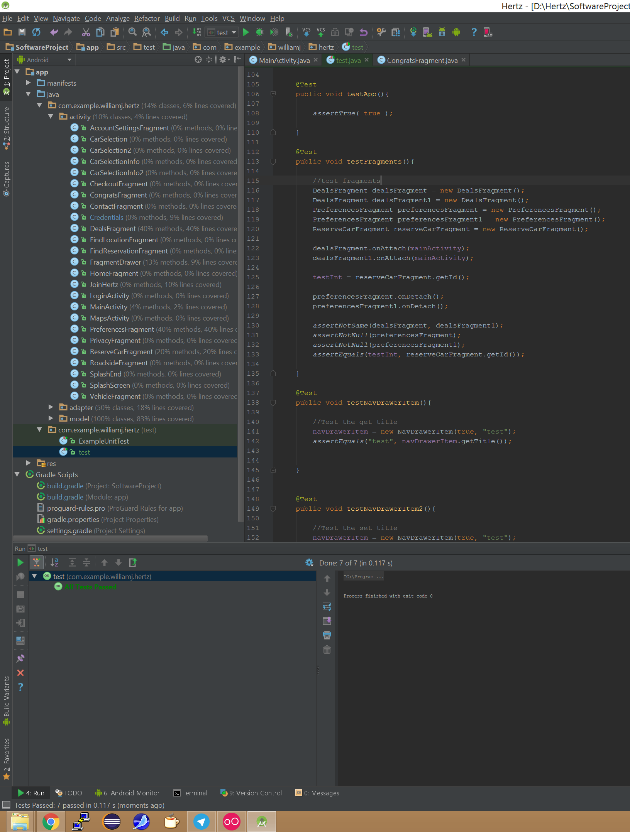
6. References

[1] B. Stroustrup, Wrapping C++ Member Function Calls: The C++ Report, AT&T Labs Research, Florham Park, New Jersey, June 2000, URL: www.stroustrup.com/wrapper.pdf
[2] L. Spradling, Quantum Paper and Google's Upcoming Effort to make consistent UI simple, Android Police, June 2015, URL: http://www.androidpolice.com/2014/06/11/exclusive-quantum-paper-and-googles-upcoming-effort-to-make-consistent-ui-simple/

