# Reflow Oven

A reflow oven is an essential piece of equipment for electrical engineers that facilitates the soldering of electrical components. Reflow ovens are used on an industrial scale as part of a highly efficient and scalable process for bonding components to printed circuit boards. In Lab 5, you got some experience soldering the PICAXE demo board with several components on it. This experience gave you some idea of the low efficiency of soldering by hand. Reflow ovens allow you to solder components *en masse*. They are used by developers (and students too!) to create complex circuits that can include *surface mount components*.

**Surface mount components** are a class of miniaturized electrical components that are bonded to the board with a thick metal solder paste. The small size of surface mount components makes them standard choices for use in many devices. You will find that many of the components which you have become familiar with in the laboratory (resistors, capacitors, microcontrollers, amplifiers, etc) have surface mount versions which are miniaturized for mounting on a printed circuit board. By including surface mount components rather than the *through hole* (the black epoxy packages you are used to seeing) components, manufacturing costs and device sizes are drastically reduced. For something like an implantable device, the miniaturization that surface mount components facilitate is essential.

The **Reflow** process is performed by the reflow oven. Components are glued to the circuit board using solder paste and the ensemble is baked at a specified set of temperatures. The temperature profile for this process is shown below in Figure 1. The overarching goal of the process is to bring the temperature of the solder (and the component) above the solder melting temperature. The solder alloy is specifically designed to melt at a relatively low temperature (218 °C) so that thermal stress on the electrical components may be minimized. Eectrical devices are composed of semiconductors whose properties can change drastically with heat treatment annealing. Likewise, the quality of the solder joint is very dependent on achieving the specified temperature profile. This means that a reflow oven must achieve precise temperature control, within minimal deviations from the specified curve.

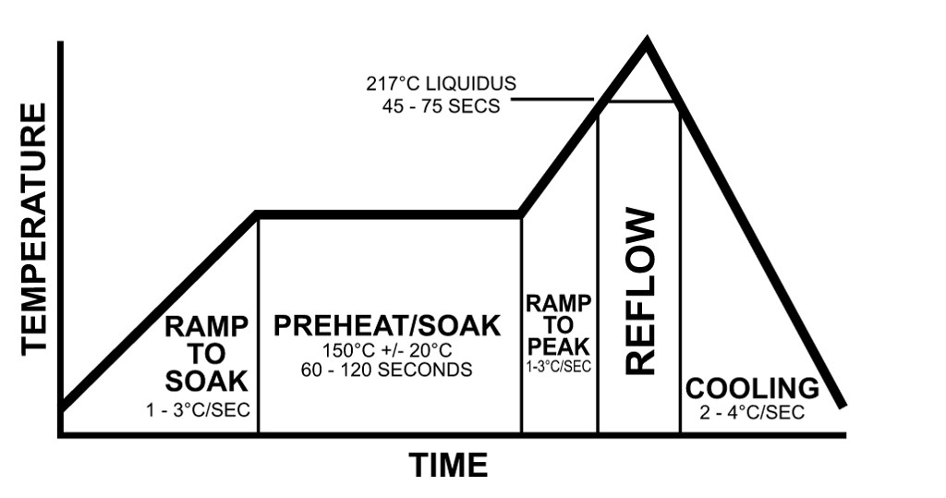

The reflow process may be broken down into several subsections described below:

* **Preheat** – The temperature is increased from room temperature to 150 °C. The ramp up rate must be 1-3 °C/s. The upper bound for the ramp rate is 3 °C/s due to risk of thermal shock for the components.
* **Soak** – The soak stage serves to remove oxides from the solder paste and activates the flux compounds. Soaking at too low a temperature may cause a solder ball to form.
* **Reflow** – At this stage, the solder paste reaches its melting point at the ‘liquidous’ temperature which is approximately 218 °C for lead free solder paste (Sn-Ag-Cu based). The board must not remain above the liquidous temperature for more than the recommended 60-90 s. Once the peak reflow temperature is achieved, cooling begins.
* **Cool** – The cooling stage must have a ramp down rate of less than -6 °C/s during the initial ramp down (245- 200 °C).

Achieving these steps in the specified order is essential to producing consistent solder joints. Without precise timing and temperature accuracy, the solder joints may not form, or they may form with unfavorable properties (high resistance). For analog circuits used in sensing (especially for Biomedical Engineering), the different between a 0.2 Ω solder joint and a 2 Ω solder joint could potentially be quite important.

The goal of the final design project will be to design a reflow oven. Here are the basic requirements of the oven you will design:

1. Design a **Control** **System** that will control the temperature of an oven by switching the ON/OFF state of a heating element.
   * Constantly monitor temperature to achieve the desired temperature profile.
   * Include software based fail-safes – What temperatures are unsafe?
2. Provide the capability to read **user input**:
   * The user should enter the exact reflow curve (A finite set of temperatures and times) that their solder composition requires.
3. Provide **User Output**:
   * What is the current oven temperature
   * What stage of the reflow process is the oven in?
   * How much time is left before the end of the reflow run.
4. **Produce statistics** on the agreement of the achieved reflow curve with the desired reflow curve:
   * What was the desired peak temperature?
   * What was the actual peak temperature?
   * Quantify the **error** of the reflow process.
5. **Autonomous Operation**
   * After accepting the user inputs, the oven should do its job without user intervention.

Extra Credit Extensions

1. User Output:
   1. Can you output the information on temperature, user chosen set points, etc. in a more usable form.
      1. Print information to the Arduino Serial Monitor
      2. Print information to MATLAB / graph that information.
2. User Interface:
   1. What feedback is useful to the user? Could you incorporate light or sound?
      1. LED indicators for Preheat / Soak / Reflow / Cooling modes.
      2. Buzzer indicator for beginning / end of run.
3. Sensing
   1. What is the resolution of your temperature measurement? What is it limited by?
      1. Could you improve the resolution with signal processing techniques?