# **CS550PA1—**Readme

**Members**:

**Jian Zhang:A20467790**

**JianshenWang:A20491172**

**WeiboWang A20503514**

# Illustrate

Detailed manual describing file and directory organization.This document guides the user through step-by-step instructions on how to run the program.This manual contains example commands

## 1.Installation Tools

### 1.Install Git

sudo apt update

sudo apt install git

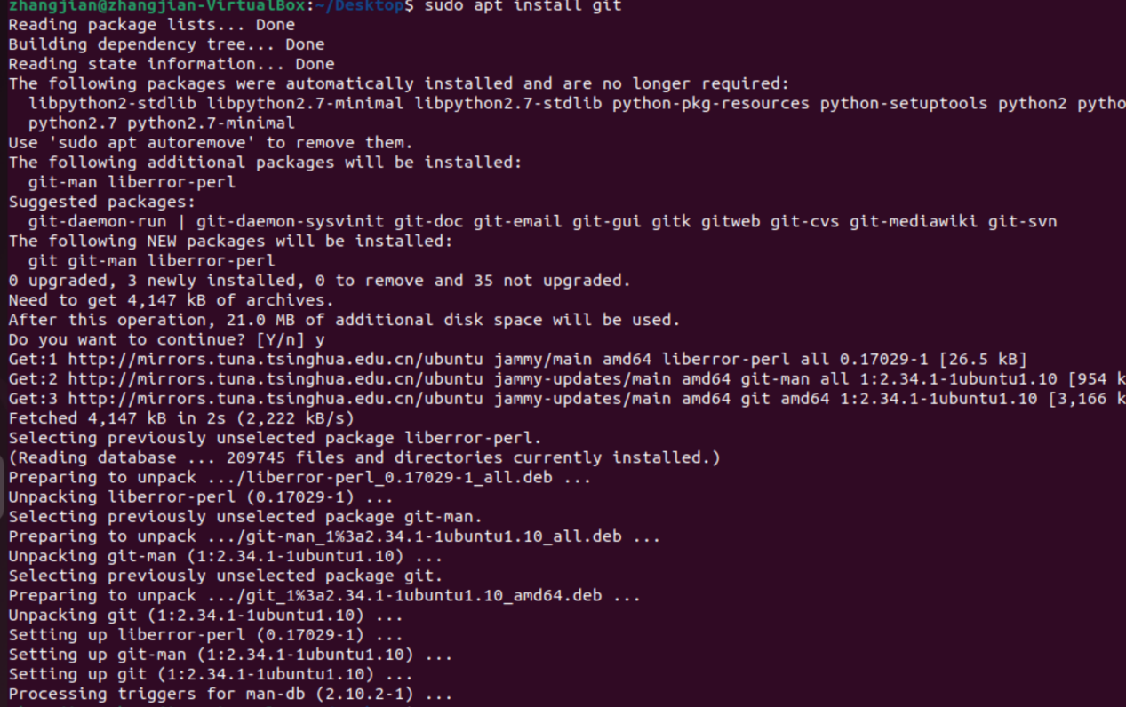

### **2. Install JAVA and check whether the installation is successful**

sudo apt-get install openjdk-8-jdk

java --version

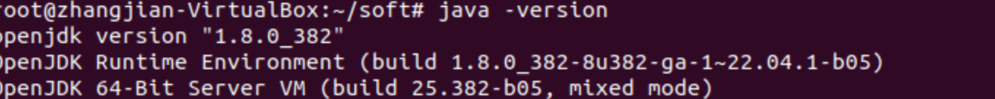

## Code download and compilation

### 1.Use git command to download

git clone

### 2.Compile source code

Switch the project src directory through the command line and view the current Java file

cd 550_par_01

Compile using make command and view the current compiled class file

make

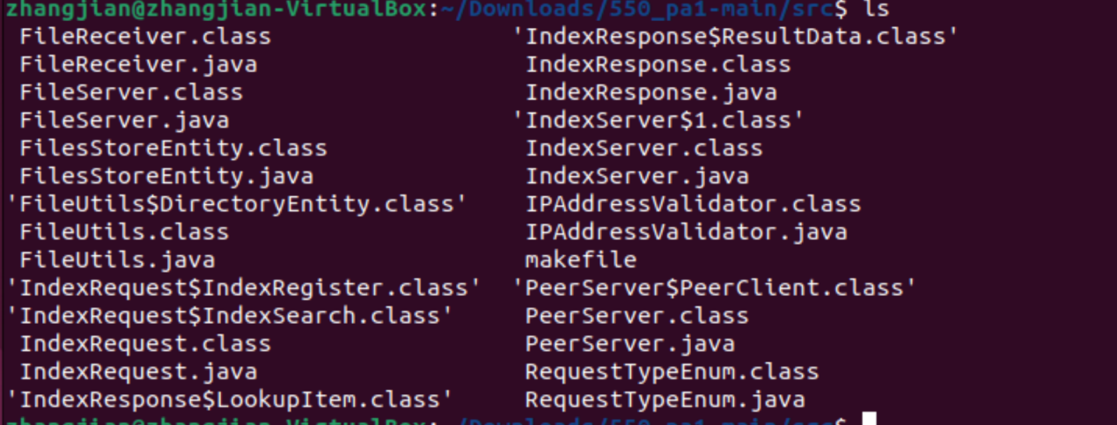

## Code directory structure description

### src

Store Java code

### out

Compiled Java CLASS file

### makefile

Javac specifies the compiled file output path

Clean delete compiled files

Run run_server java IndexServer

run_peer calls java PeerServer

|  |
| --- |
| default: all  all:  javac -d ../out/production/550_pa1/ *.java  clean:  $(RM) ../out/production/550_pa1/*.class  start_indexserver:  java -classpath ../out/production/550_pa1 IndexServer  start_peer:  java -classpath ../out/production/550_pa1 PeerServer  run_evaluation:  java -classpath ../out/production/550_pa1 TestClient |

## 4.Deploy 2 peers and 1 indexing server over 3 VMs

### 1.Before the service starts,Specify a directory that stores 3 files, namely • 1M: 1KB text files • 1K: 1MB text files • 10: 1GB binary file

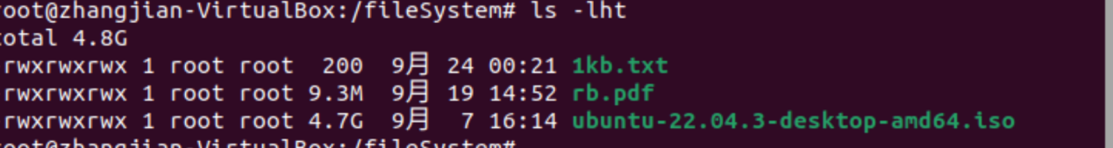

In 3 VM machines, repeat step 1, step 2,One of them starts IndexServer, and the other two start PeerServer.Their IP addresses are：192.168.199.178 192.168.199.188 192.168.199.178.103

Start the IndexServer service at 192.168.199.178,Other VMs start the PeerServer service

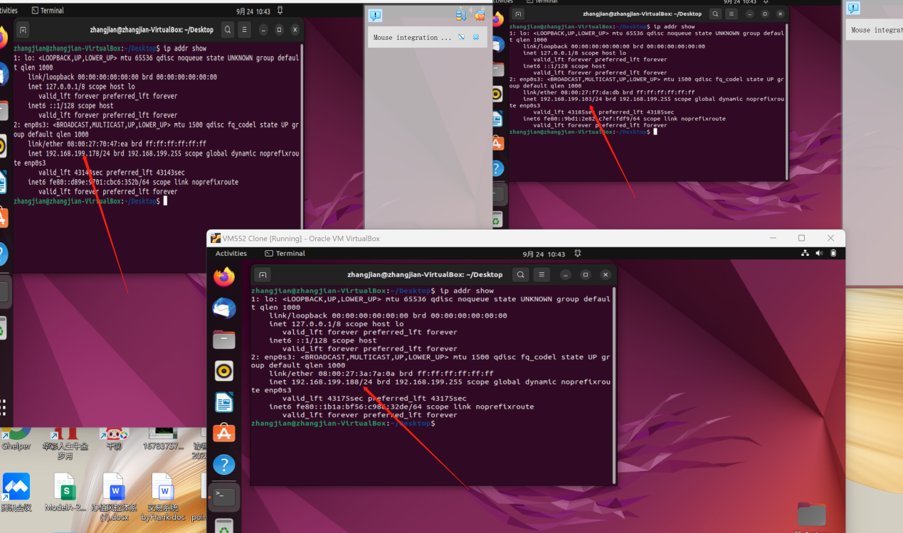

### 2.IndexServer Start

make start_indexserver



### 3.IndexServer Open port 8080 for external access

sudo ufw alow 8080/tcp



### PeerServer Start

Start PeerServer at 192.168.199.188 192.168.199.178.103 respectively

sudo ufw alow 10000

sudo ufw alow 10001

make start_peer

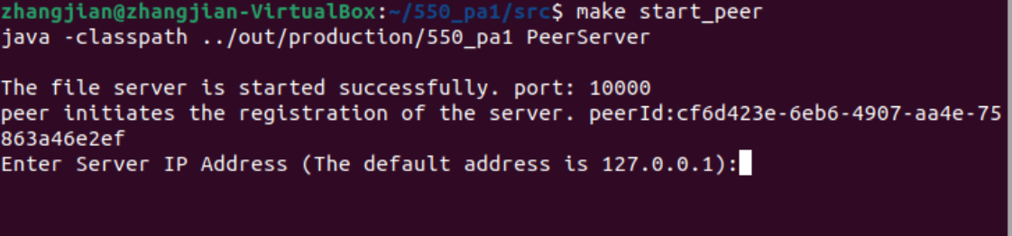

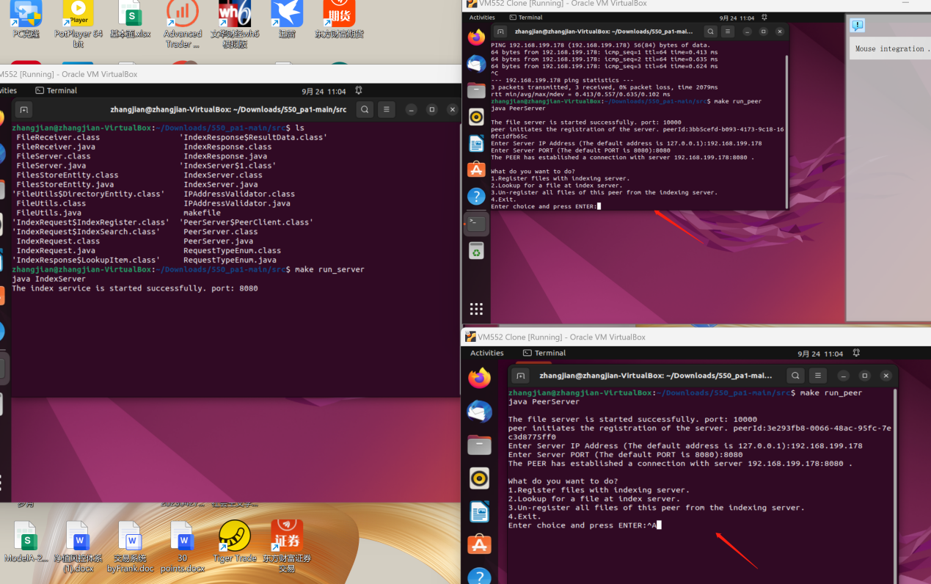

### 5.Pear connects to the server

Enter 192.168.199.178, and enter 8080 server port. After successful login, a successful connection to 192.168.199.178 appears.。

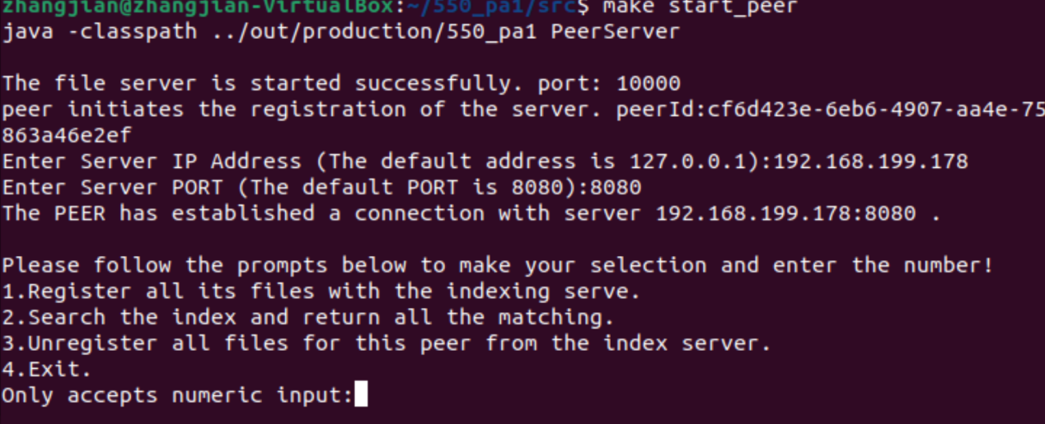

### 6.Enter the specified path and the prepared file directory/fileSystem

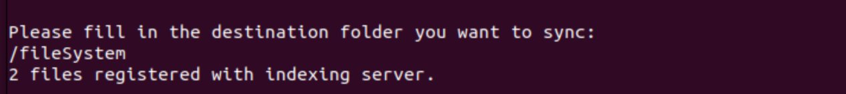

The server prompts to obtain 3 files for registration.



### 7.Query the file name, then enter the rb.pdf file, and return the meta information of the rb.pdf file.They are file Number, file owner ID, which is peerID, host address and port.



### 8.Download the file the file service，input y

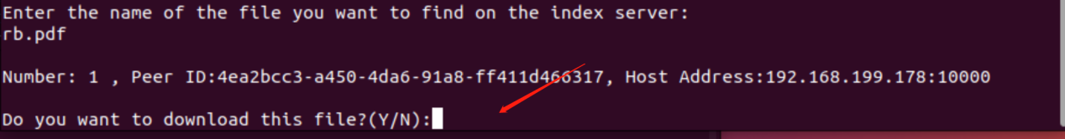

After the download is successful, you will be reminded of the saved file location.



