4.
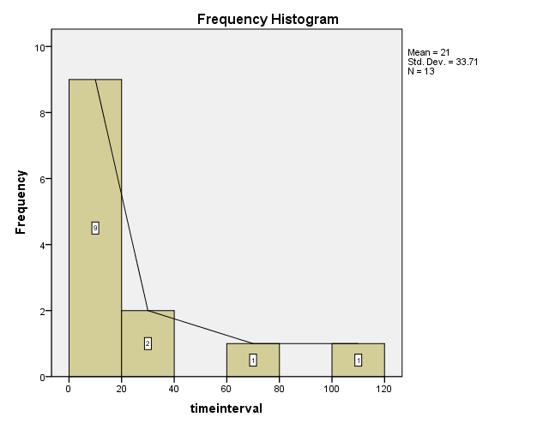
Descriptives
Statistic Std. Error
timeinterval Mean 21.00 9.349
95% Confidence Interval for Mean Lower Bound .63
Upper Bound 41.37
5% Trimmed Mean 17.06
Median 10.00
Variance 1136.333
Std. Deviation 33.710
Minimum 0
Maximum 113
Range 113
Interquartile Range 25
Skewness 2.174 .616
Kurtosis 4.449 1.191

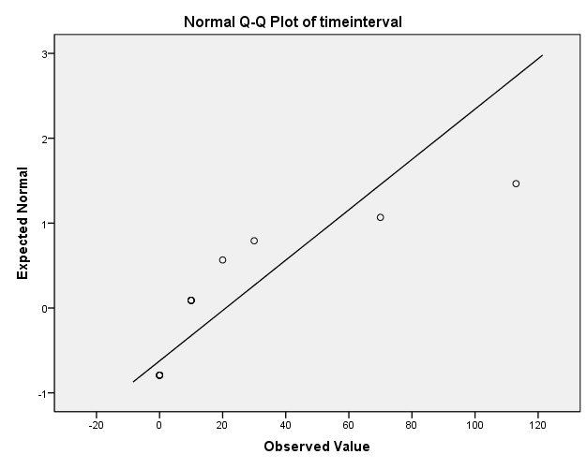

这是4个不同条件下X和Y分布的Q-Q图。

左上：对数正态分布与正态分布的QQ图
右上：正态与指数分布的QQ图
左下：指数与指数分布的QQ图
右下：logistic与logistic分布的QQ图
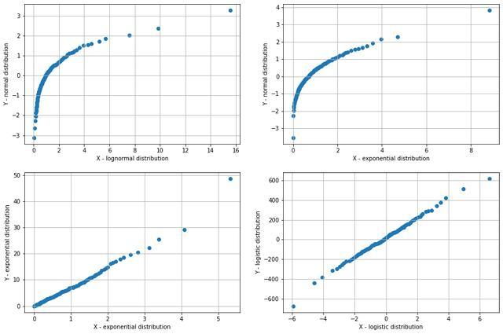

1.text = list(data['Notes'])
2.tokens = tokenize(text)
3.print(tokens)
4.#print(tokens)
5.mydict=count_corpus(tokens)
6.f='dict.txt'
7.tmp=mydict.items()
8.d_order=sorted(tmp,key=lambda x:x[1],reverse=True)
9.print(d_order)
10.with open(f,'w',encoding="utf-8") as fo:
11. for k,v in d_order:
12. print("%s,%s" %(k,v),sep='',file=fo)
13.key=[]
14.for i in range(21,31,1):
15. key.append(d_order[i][0])
16.print(key)
17.print(data._stat_axis.values.tolist() )
18.for i in key:
19. data[i] = data.apply(lambda _: 0, axis=1)
20.for i in range(2069):
21. for j in tokens[i]:
22. if j in key:
23. data.loc[i,j]+=1
24.class_mapping = {'Negative ID':0, 'Positive ID':1}
25.data['Lab Status'] = data['Lab Status'].map(class_mapping) 1.text = list(data['Notes'])
2.tokens = tokenize(text)
3.print(tokens)
4.#print(tokens)
5.mydict=count_corpus(tokens)
6.f='dict.txt'
7.tmp=mydict.items()
8.d_order=sorted(tmp,key=lambda x:x[1],reverse=True)
9.print(d_order)
10.with open(f,'w',encoding="utf-8") as fo:
11. for k,v in d_order:
12. print("%s,%s" %(k,v),sep='',file=fo)
13.key=[]
14.for i in range(21,31,1):
15. key.append(d_order[i][0])
16.print(key)
17.print(data._stat_axis.values.tolist() )
18.for i in key:
19. data[i] = data.apply(lambda _: 0, axis=1)
20.for i in range(2069):
21. for j in tokens[i]:
22. if j in key:
23. data.loc[i,j]+=1
24.class_mapping = {'Negative ID':0, 'Positive ID':1}
25.data['Lab Status'] = data['Lab Status'].map(class_mapping)
- text = list(data['Notes'])
- tokens = tokenize(text)
- print(tokens)
- #print(tokens)
- mydict=count_corpus(tokens)
- f='dict.txt'
- tmp=mydict.items()
- d_order=sorted(tmp,key=lambda x:x[1],reverse=True)
- print(d_order)
- with open(f,'w',encoding="utf-8") as fo:
- for k,v in d_order:
- print("%s,%s" %(k,v),sep='',file=fo)
- key=[]
- for i in range(21,31,1):
- key.append(d_order[i][0])
- print(key)
- print(data._stat_axis.values.tolist() )
- for i in key:
- data[i] = data.apply(lambda _: 0, axis=1)
- for i in range(2069):
- for j in tokens[i]:
- if j in key:
- data.loc[i,j]+=1
- class_mapping = {'Negative ID':0, 'Positive ID':1}
- data['Lab Status'] = data['Lab Status'].map(class_mapping)

