1. 论文框架

Achieving Conversational Goals with Unsupervised Post-hoc Knowledge Injection

论文主要使用了dialog model生成answer, 并利用context+answer在yelp等知识库中查询相关snippets作为后验知识, 并将后验知识在decoding的过程中注入到answer中, 从而获取更丰富的answer.

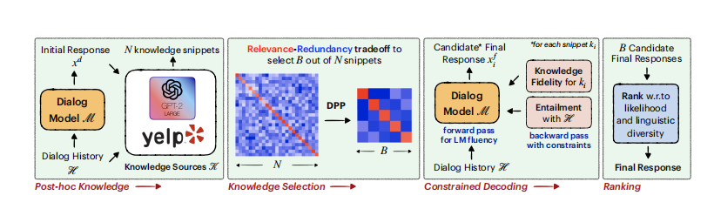

**相关的论文**

1. A Simple Language Model for Task-Oriented Dialogue

提出了一种面向任务型对话的生成模型=> 主要包括提取上下文belief, 检索数据库的result, 生成相关的action, 生成delex的answer, 进一步生成lexical的answer. (我实现的时候利用了这篇论文的生成模型作为dialogue model)

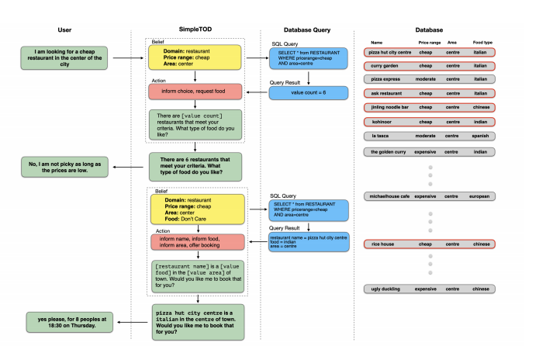

1. MultiWOZ - A Large-Scale Multi-Domain Wizard-of-Oz Dataset for Task-Oriented Dialogue Modelling

主要提出了MultiWOZ一种任务驱动对话的数据集

1. PLUG AND PLAY LANGUAGE MODELS: A SIMPLE APPROACH TO CONTROLLED TEXT GENERATION

提出了PPLM的框架, 通过建立属性模型(classifier or bag of words), 在每次网络forward+backword的过程中, 修改网络的hidden state, 从而可以控制生成文本的属性(比如 关键词, 情绪等)

(我的实现中 也利用了这部分框架中的Forward_+backward部分)

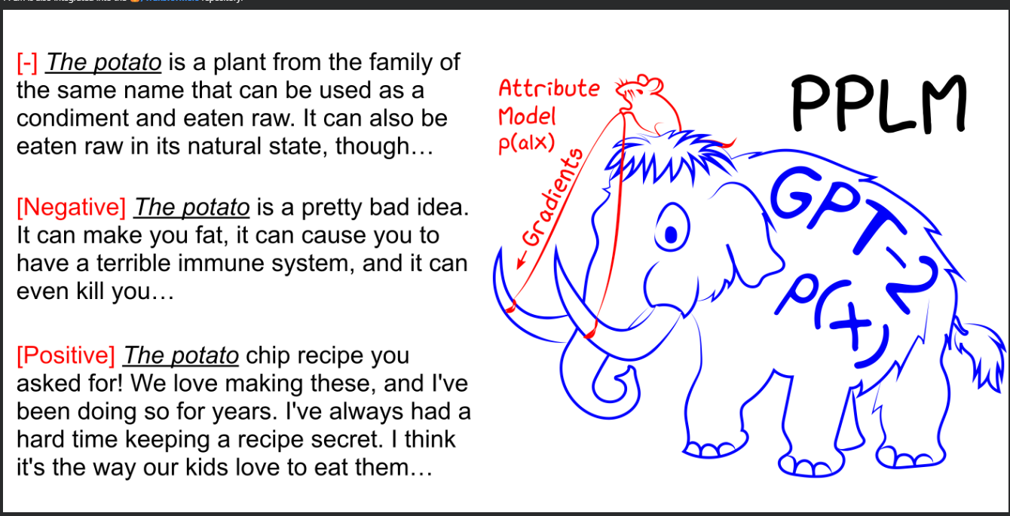

1. Back to the Future: Unsupervised Backprop-based Decoding for Counterfactual and Abductive Commonsense Reasoning

这篇论文进一步扩展了PPLM框架, 提出了DELOREAN decoding的方法. 这里的属性模型变成了generating future constraint.

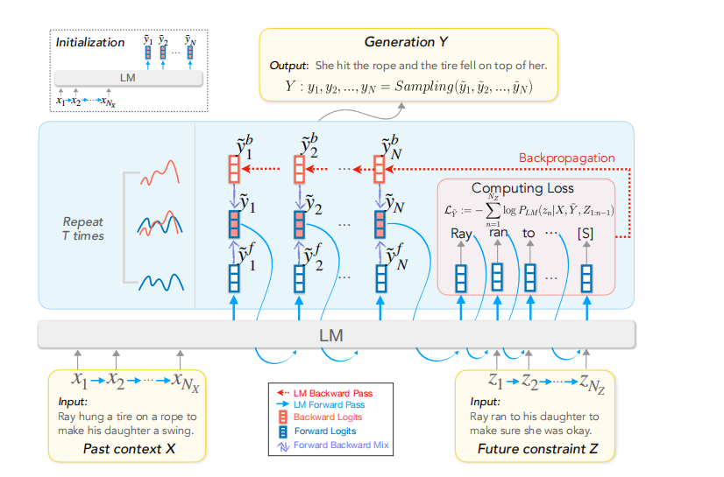

用于Abducive Reasoning以及*Counterfactual Reasoning任务*

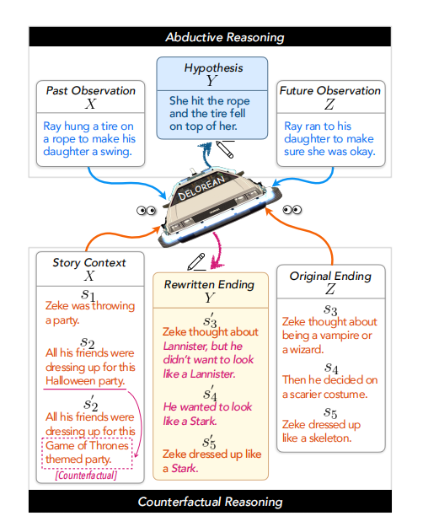

1. Unsupervised Enrichment of Persona-grounded Dialog with Background Stories

这篇论文和POKI挺像的 不过他用的是background story(检索方式也不一样), 框架差不多:

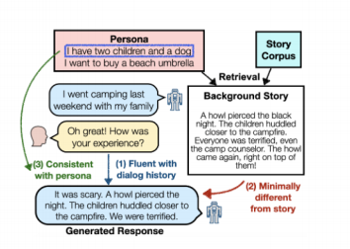

1. 复现步骤:

源码地址

<https://github.com/wjw136/POKI>

步骤参考

<https://github.com/wjw136/POKI/blob/master/README.md>

1. 实验结果:

例子1:

0: SNG0073.json -----------------------------------

= Prefix of sentence =

<|endoftext|><|endoftext|> <|context|> <|user|> i would like a taxi from saint john s college to pizza hut fen ditton. <|endofcontext|>   <|belief|> taxi destination pizza hut fenditton, taxi departure saint johns college <|endofbelief|>  <|dbsearch|>  <|endofdbsearch|> <|action|> taxi request leave <|endofaction|>

= Snippets of senetence =

<|endoftext|>Worst customer service I have encountered here... Was lied to not once but 3 times about a taxi being "on the way" 2 hours later after I'm home I get a call saying the taxi is outside. Comical. Never calling again.

= Unperturbed generated text =

<|endoftext|><|endoftext|> <|context|> <|user|> i would like a taxi from saint john s college to pizza hut fen ditton. <|endofcontext|>   <|belief|> taxi destination pizza hut fenditton, taxi departure saint johns college <|endofbelief|>  <|dbsearch|>  <|endofdbsearch|> <|action|> taxi request leave <|endofaction|>  <|response|> **sure! when would you like to leave?** <|endofresponse|>

= perturbed generated text =

<|endoftext|><|endoftext|> <|context|> <|user|> i would like a taxi from saint john s college to pizza hut fen ditton. <|endofcontext|>   <|belief|> taxi destination pizza hut fenditton, taxi departure saint johns college <|endofbelief|>  <|dbsearch|>  <|endofdbsearch|> <|action|> taxi request leave <|endofaction|>  <|response|> **no problem, just need to know when you want to be picked up and taxi to the pizza hut by the 2 hour -s after the time of the 1 call you have been given.** <|endofresponse|>

生成的answer对比:

**Initial:**

sure! when would you like to leave?

**After injection:**

no problem, just need to know when you want to be picked up and taxi to the pizza hut by the 2 hour -s after the time of the 1 call you have been given.

例子2:

5: PMUL4648.json -----------------------------------

= Prefix of sentence =

<|endoftext|><|endoftext|> <|context|> <|user|> please find a restaurant called nusha. <|system|> i do not seem to be finding anything called nusha. what type of food does the restaurant serve? <|user|> i am not sure of the type of food but could you please check again and see if you can find it? thank you. <|endofcontext|>   <|belief|> restaurant name nusha <|endofbelief|>  <|dbsearch|> restaurant match=0 booking=not available <|endofdbsearch|> <|action|> restaurant inform food, restaurant inform name, restaurant inform area <|endofaction|>

= Snippets of senetence =

<|endoftext|>i haven't eaten here yet but this review is based on an incident we had with this restaurant while making a reservation for our anniversary.  we would be traveling from ny to go eat at vetri.

after my bf made the reservation for this restaurant about a month ago for sept, the restaurant called back twice.  when my bf picked up, he found that the phone call was to inform him that the restaurant is tasting menu only that costs xxx amount of money and if it was ok with him, esp with drinks and everything.

now i dont know if this is their standard protocol, or if someone made a judgement call of their own, but my bf has a very generic hispanic last name, so that makes me a little suspicious.  we found this phone call to be very rude.  we have both been working in nyc fine dining restaurants for years but  we have never encountered this sort of situation.  it's just so disappointing because ive been a huge fan of chef marc ever since i began cooking, and friends that have worked with chef marc tell me the experience is amazing.  i've been wanting to go to vetri ever since i started cooking and now the phone call leaves us with a bad taste in our mouths before we even have the chance to go there and taste the food.

= Unperturbed generated text =

<|endoftext|><|endoftext|> <|context|> <|user|> please find a restaurant called nusha. <|system|> i do not seem to be finding anything called nusha. what type of food does the restaurant serve? <|user|> i am not sure of the type of food but could you please check again and see if you can find it? thank you. <|endofcontext|>   <|belief|> restaurant name nusha <|endofbelief|>  <|dbsearch|> restaurant match=0 booking=not available <|endofdbsearch|> <|action|> restaurant inform food, restaurant inform name, restaurant inform area <|endofaction|>  <|response|> **yes, the nusha serves indian food.** <|endofresponse|>

= perturbed generated text =

<|endoftext|><|endoftext|> <|context|> <|user|> please find a restaurant called nusha. <|system|> i do not seem to be finding anything called nusha. what type of food does the restaurant serve? <|user|> i am not sure of the type of food but could you please check again and see if you can find it? thank you. <|endofcontext|>   <|belief|> restaurant name nusha <|endofbelief|>  <|dbsearch|> restaurant match=0 booking=not available <|endofdbsearch|> <|action|> restaurant inform food, restaurant inform name, restaurant inform area <|endofaction|>  <|endofaction|> <|response|> **yes, the nusha is a restaurant that serves indian food in the city s centre.** <|endofresponse|>

生成的answer对比:

**Initial:**

yes, the nusha serves indian food.

**After injection:**

yes, the nusha is a restaurant that serves indian food in the city s centre.

通过上面的两个例子可以看出, 在POKI框架下, 通过检索后验知识并注入到模型的hidden_state, 可以有效提高生成的回答的语义丰富性与准确性.

更多的例子可以参考:

<https://github.com/wjw136/POKI/blob/master/perturb.log>