

Database System Concepts
Experiment Report

Student Name：王建伟
Student Number：201930420160
Class:19计联
Teacher:汪秀敏

Overview
【Experimental purpose and requirement】
- Design a MIS for Computer Science college of SCUT. (45’)
It is used to manage the information about courses and scores. It can record, modify, query, and get statistical data about the students’ and courses’ information.
Students’ information includes: student’s ID, Name, Sex, Entrance Age, Entrance Year and Class. The Sex must be male or female. The Entrance Age is between 10 and 50. The length of student’s ID is 10.
Courses’ information includes: course’s ID, Name, Teacher’s ID, Credit, Grade(which grade can take this course), Canceled Year(can be null). The length of course’s ID is 7. Only if a student’s grade is larger than the course’s Grade and he/she chose the course earlier than the course’s Canceled Year, the course can be choose.
Teachers’ information includes: teacher’s ID (the length is 5), Name, Courses (that he/she can teach).
Course choosing information includes: student’s ID, course’s ID, Teacher’s ID, Chosen year, Score. Student’s ID is a foreign key pointing to Students’ information. Course’s ID is a foreign key pointing to Courses’ information. Teacher’s ID is a foreign key pointing to Teachers’ information. If a student drops out, his/her course choosing information need to be deleted.
1. Information about student, course and course choosing can be modified. (6’, 2’ for each table)
2. Information about student, course and course choosing can be inserted and deleted. (6’, 2’ for each table)
3. Information about student and courses he/she chose can be queried based on a student’s ID or Name. If ID and Name are not given, show all students’ and their courses information. (12’)
4. The score of a course that a student chose can be queried based on a student’s Name (or ID) and a course’s Name (or ID). If no student’s and course’s ID or Name are given, show all scores of all students’ courses. (12’)
5. Information about course or course choosing can be queried based on course’s Name or ID. If no course’s Name or ID is given, show information about all courses or all course choosing. (7’)
6. Information about teacher or courses a teacher teaches can be queried based on a teacher’s Name or ID. If no teacher’s Name or ID is given, show information about all teachers or all courses they teach. (7’)
7. Average scores of a student, all students, students in the same class and a course can be queried. (15’)
Authorities (6’)
1. A student can modify no information.
2. An administrator can modify information of students, courses and course choosing. But he/she can’t modify students’ score.
3. A teacher can modify students’ score.
Use any databases, such as DBMS SQL Server, Oracle, or DB2,
Use any programming languages, such as java, c++, asp.net, php. Use c/s or b/s Model.
Submitted materials:
1. Program manual. (papers and electronic copy)
2. Source Code. (electronic copy)
3. Database design document, SQL commands creating tables or views. (papers and electronic copy)

【Experiment environment】
OS：Windows 10
Microsoft C#
Mariadb
Experiment
- User manual
- 创建在本机开启mysql服务,创建william用户,并设置密码为123456,创建MDB数据库,并用file_database文件夹下两个sql查询文件建立表并导入数据.
- 打开software文件夹下的MIS for Computer Science college of SCUT_1.exe,若连接数据库成功,则出现信息提示,并成功进入学生信息管理系统.
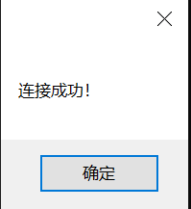
- Design schema of database:
Firstly, I create the database called mdb to store the data of all information for the system;
Then, I use seven tables to store the data and the relationship among students, teachers and administers that is choose, course, permission1, permission2, permission3, student and teacher.
- Choose table:
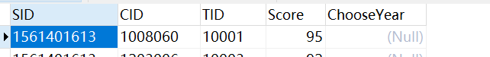
- Course table:
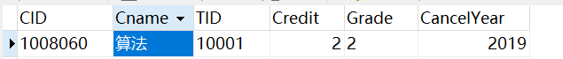
- Permission1 table:
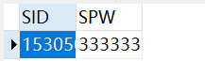
- Permission2 table:
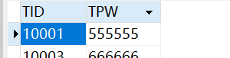
- Permission3 table:
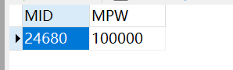
- Student table:
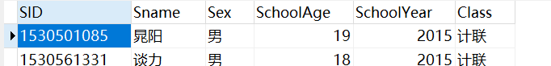
- Teacher table:
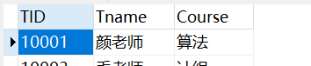
Also, I create some constrants like foreign keys constraints, nomal contraints and so on.
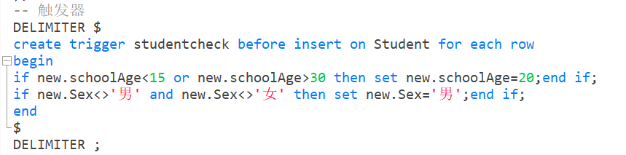
- The design schema of the GUI:
- For the system initialize and connect to the database:
If the system successfully connect to database, then a information dialog will show:

- For the login interface:
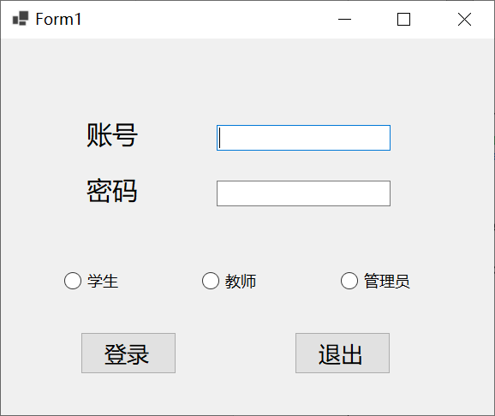
There will be three kinds of modes which are the students, teachers and administors.
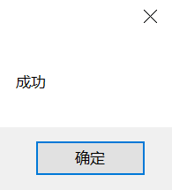
With correct account and password, the user can login their account.
- For the student interface:
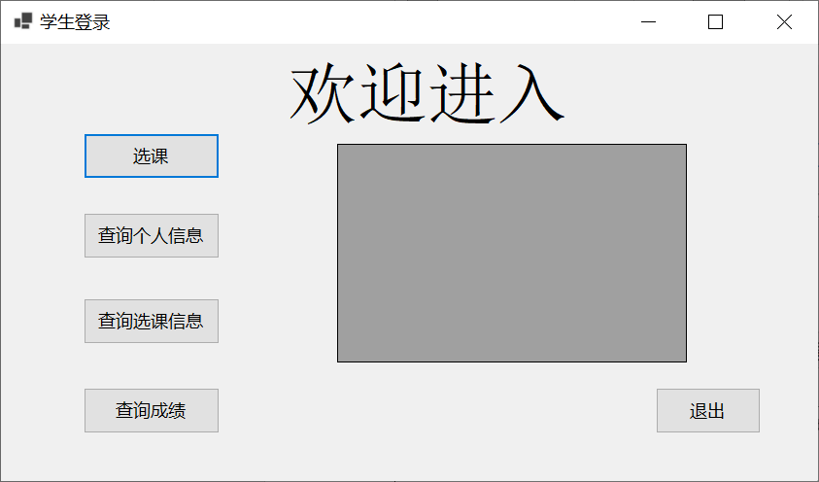
There are four kinds of functions for the student.
- Course-choosing:
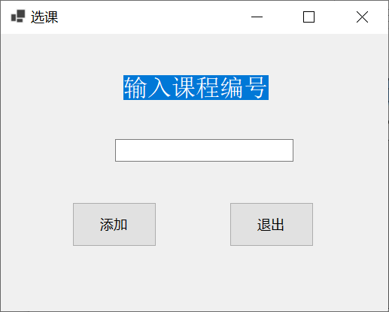
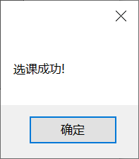
- Personal information
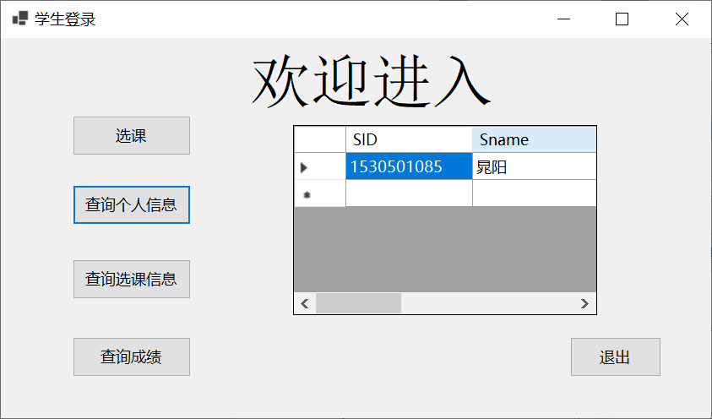
- Course information
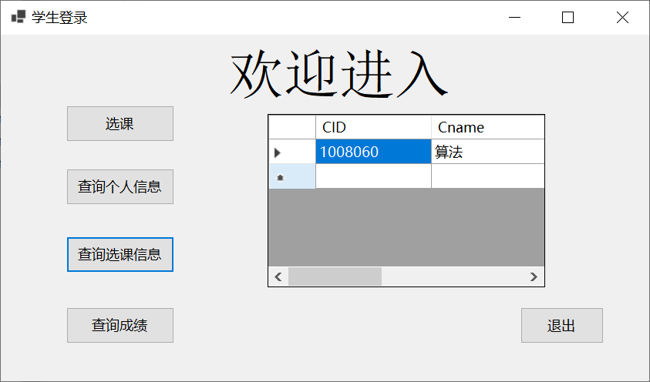
- Grade information
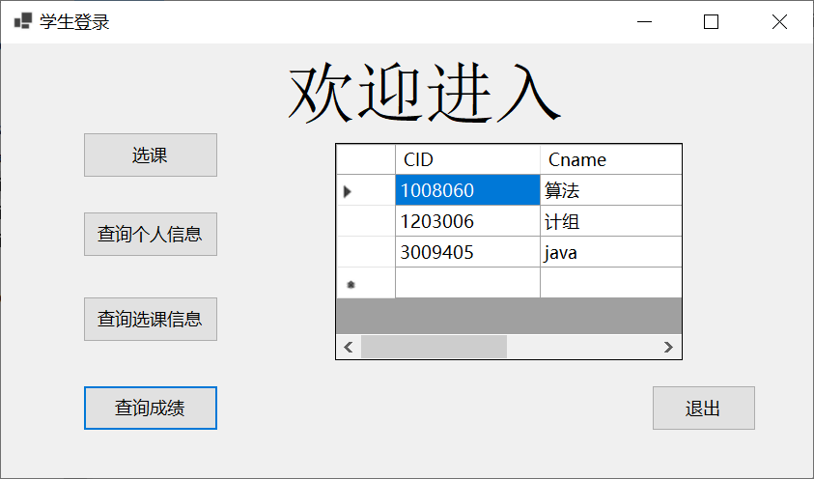
- For the teacher interface:
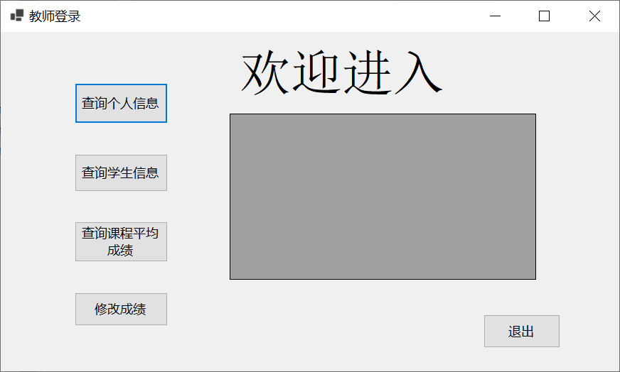
There are also four kinds of functions which is shown as follow:
- Query about personal information:
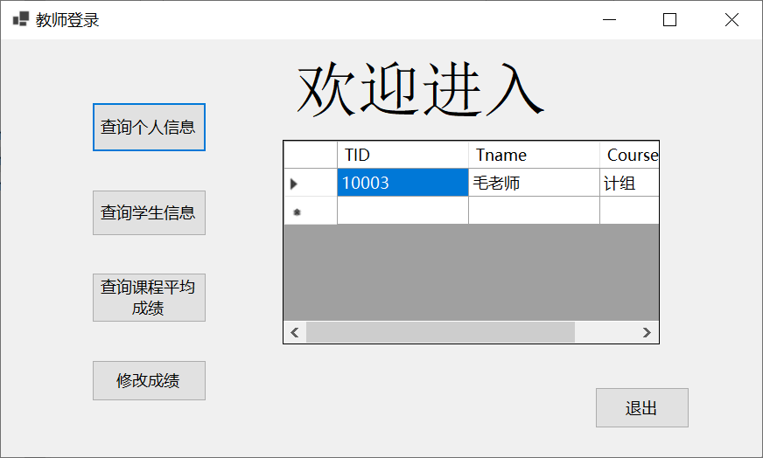
- Query about student information:
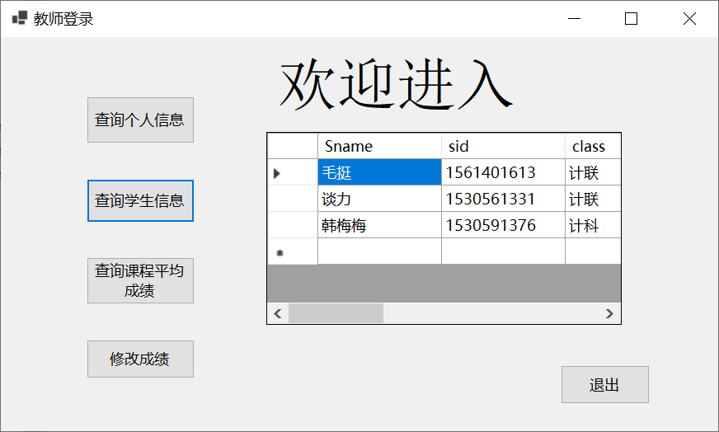
- Query about average grade:
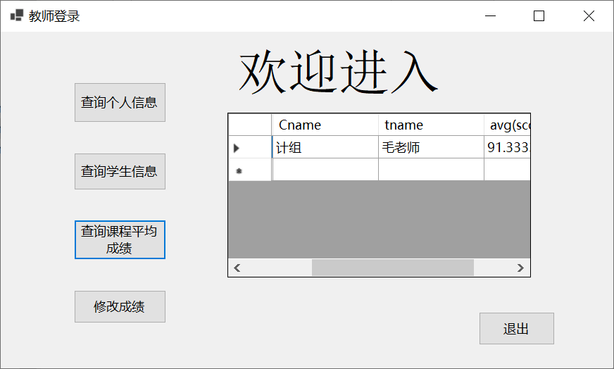
- Modify the grade:
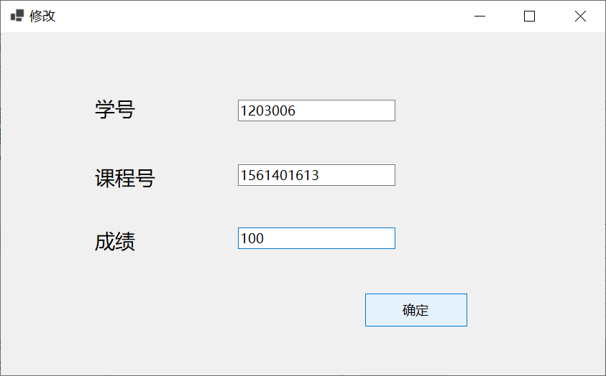

- For the administer interface:
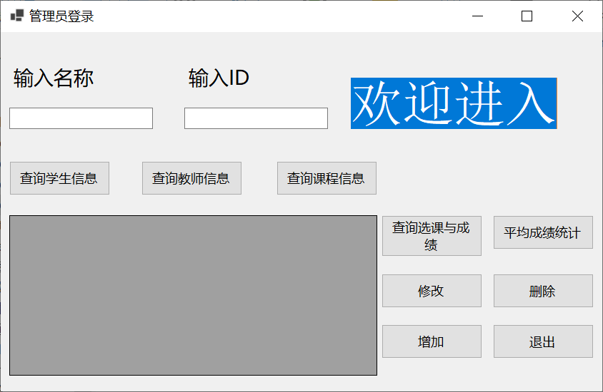
There are mainly two parts for the functions of administers which are querying functions and the other special functions.
  - For the query part:
- Student information

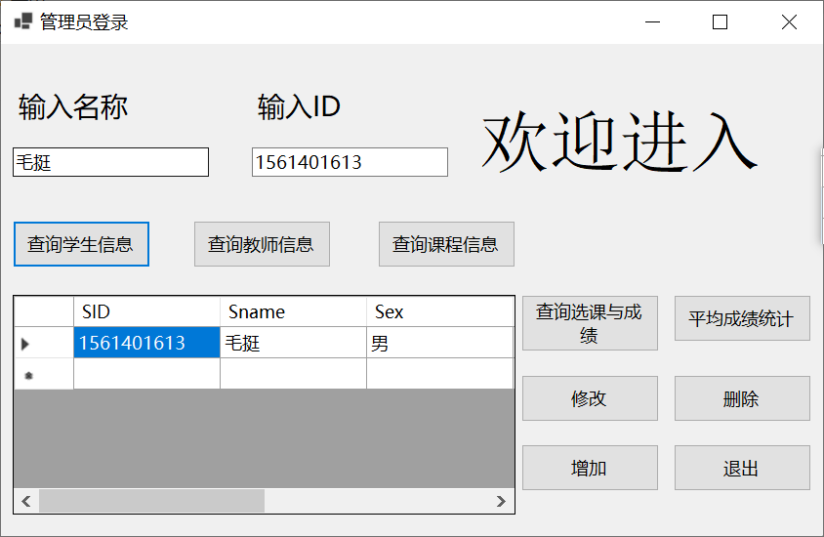
- Teacher information

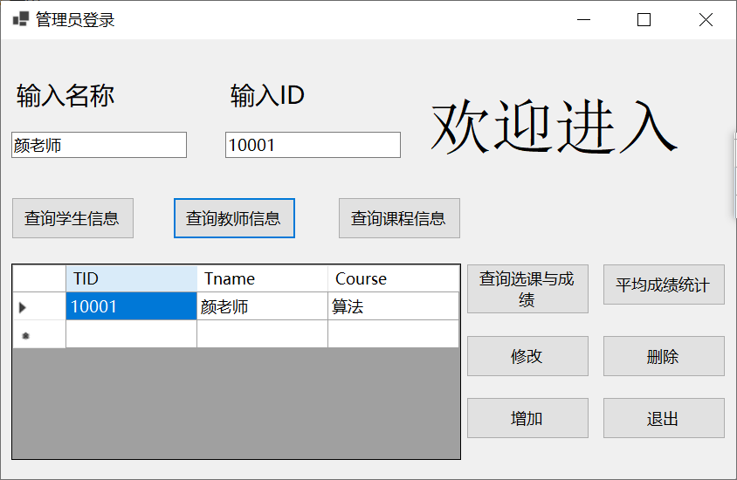
- Course information:

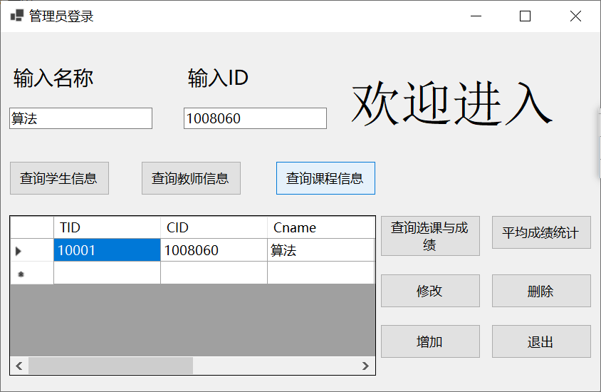
  - For the other special functions:
- For the query about the course choosing with the grade:
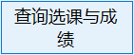
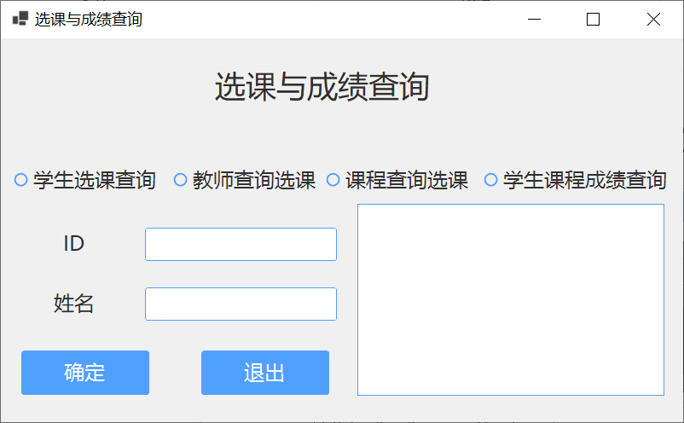
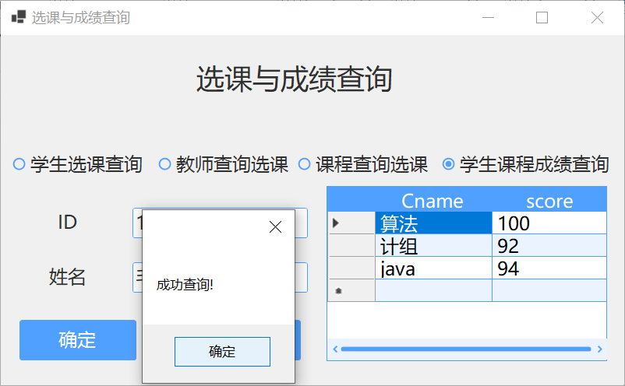
- For the Average score statistics:

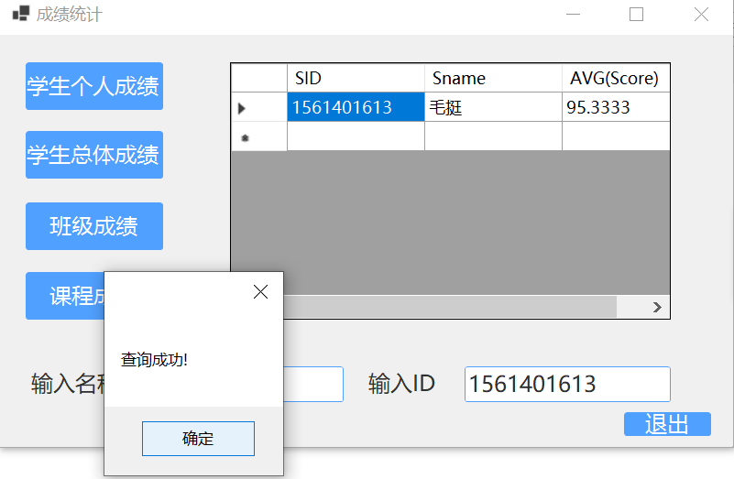
- Modifying:

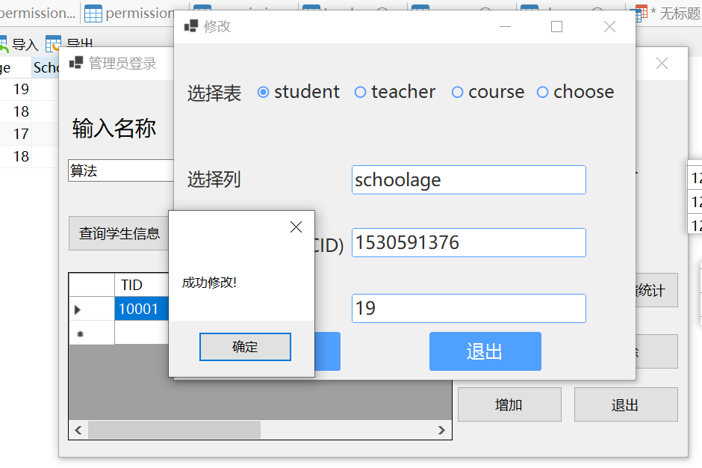
- Deleting

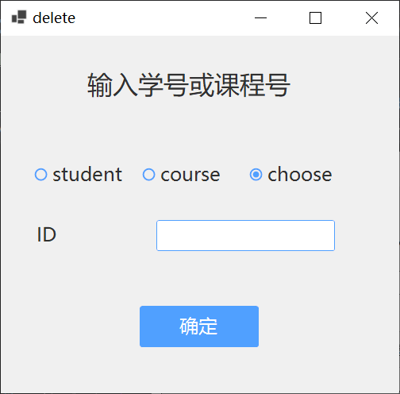
- Adding

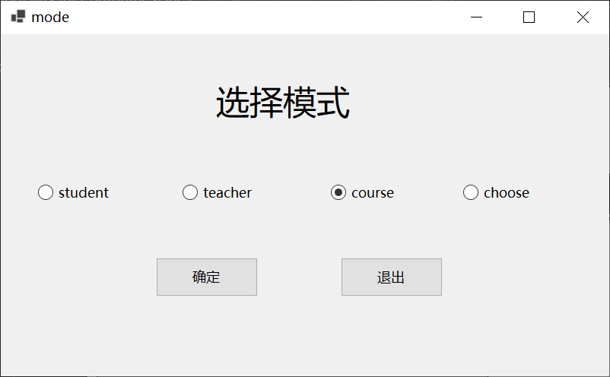
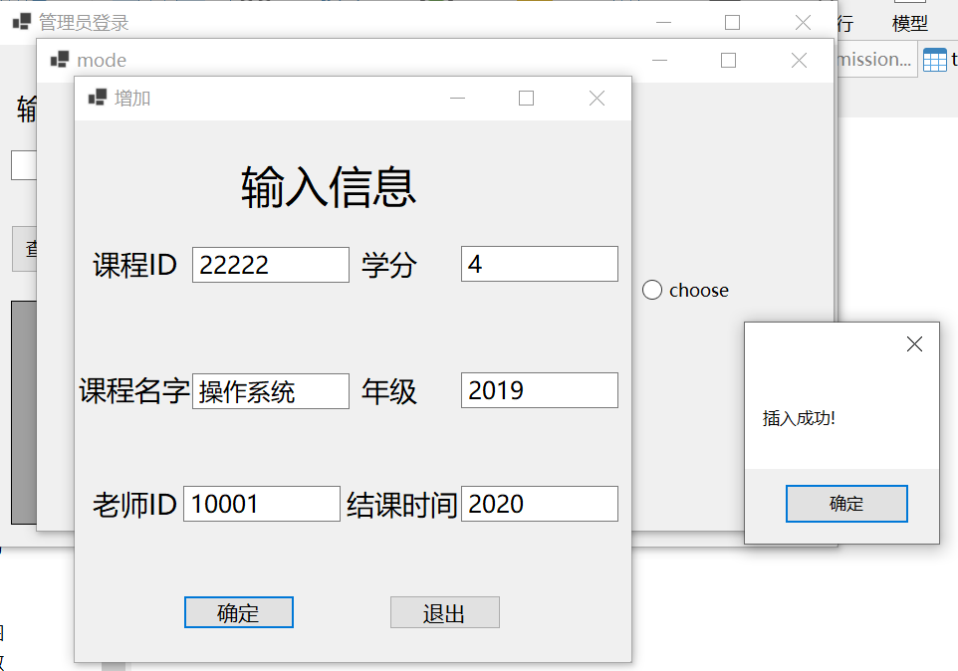
- Main code architecture:
When I designed the code architecture, just naturally divide it into three parts which are the initial connection of database, the operations on every GUI interface, and the encapsulation of the database operation like adding, deleting,, verifying and querying;
- The connection of database:
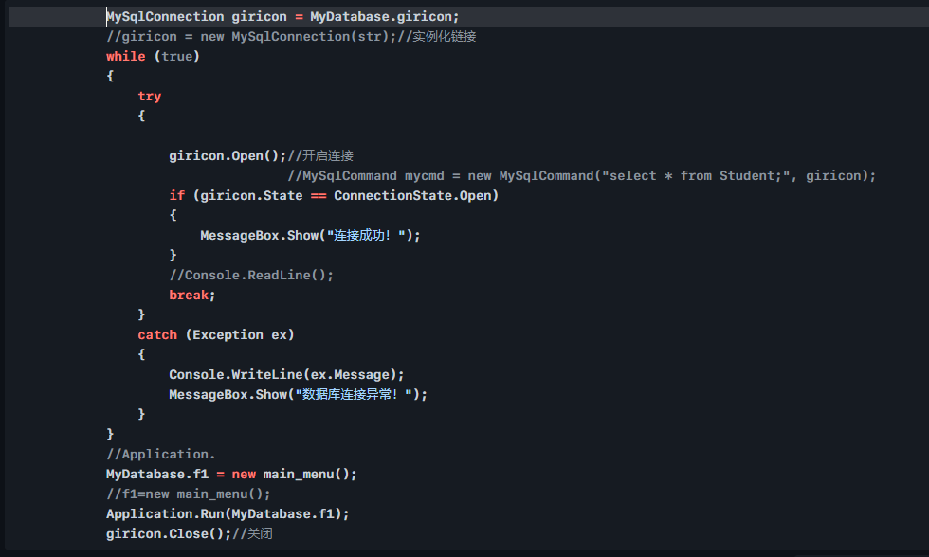
- For each GUI:
I just store all interface as static data member of a class named MyDatabase and initialize them when calling:
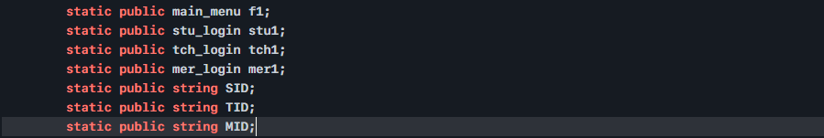
- For the various querying operation of database:
There two version, where one for operations with returning values like querying and the other for operations without returning like adding:
