问题一：
1.
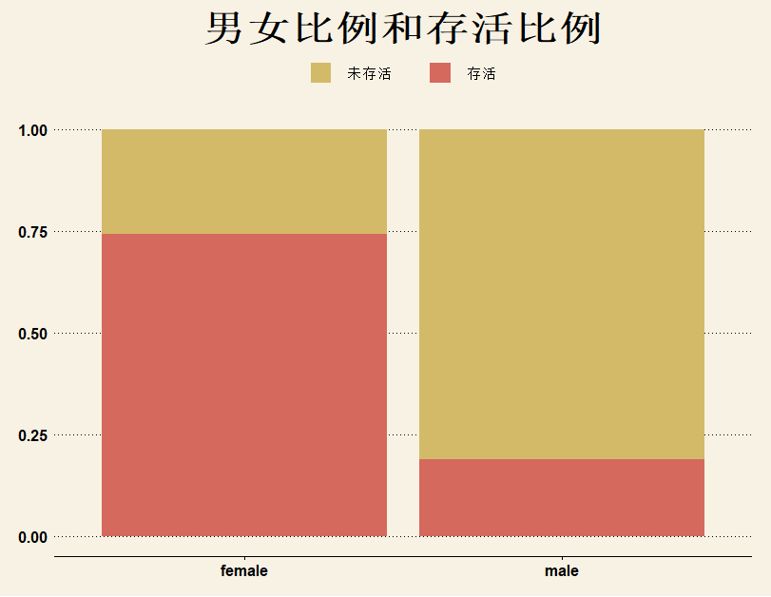
女性存活比例大于男性
2.

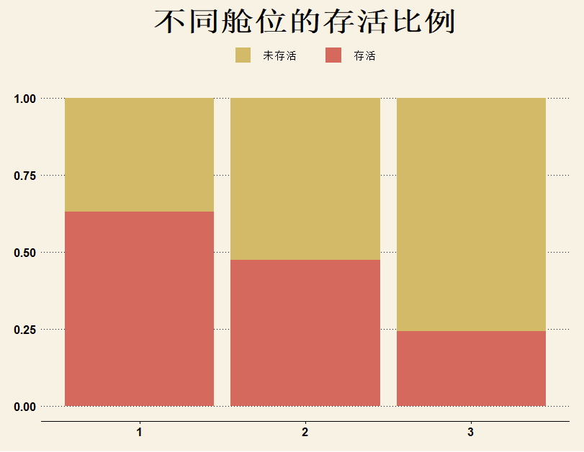
3号舱存活率最低，1号舱存活率最高，社会地位越高存活率越高

3.
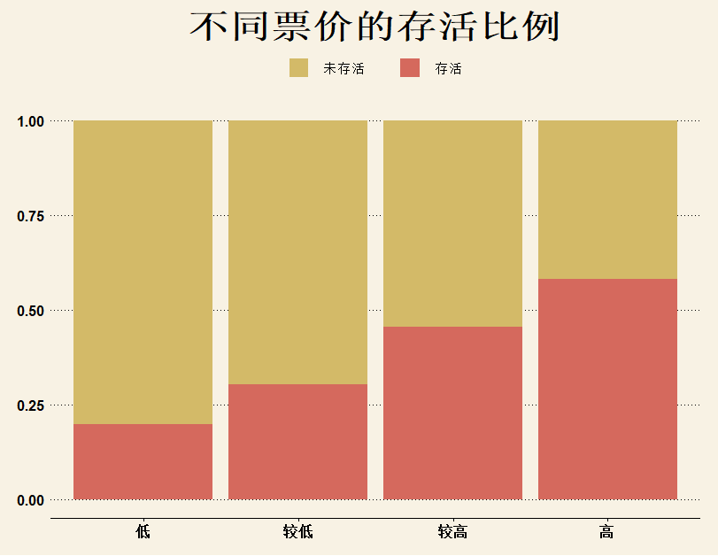

船票价格越高，存活率越高
4.
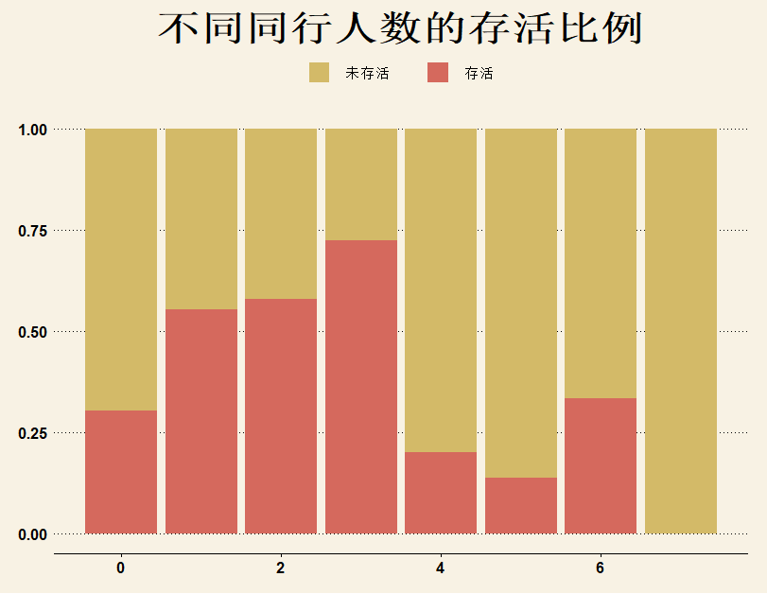
小于等于3个同行，同行越多，存活率越高，4个同行以上存活率低

- 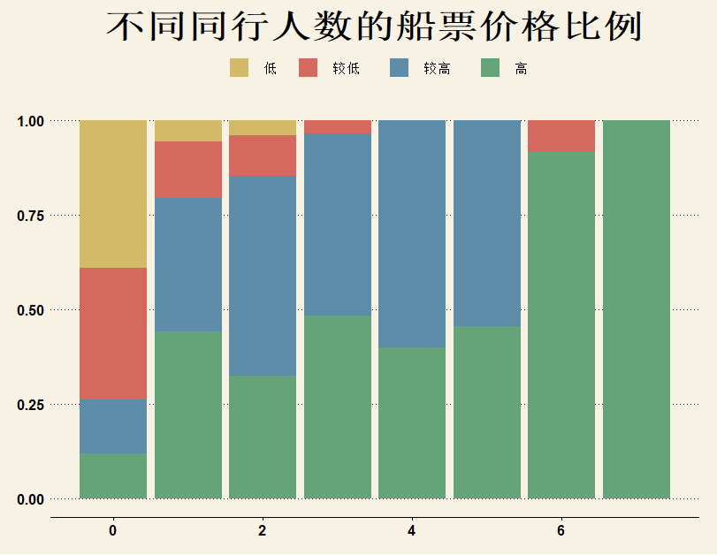

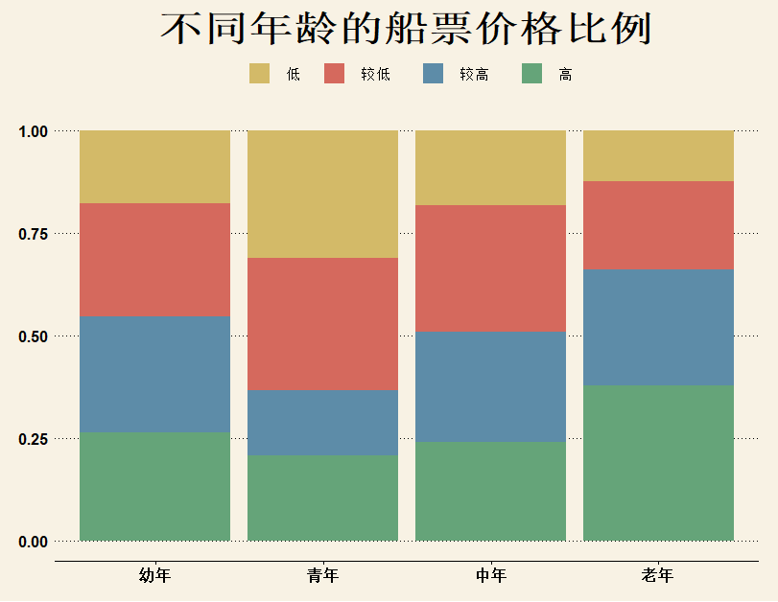
同行人数越多，船票价格越高，老年人船票价格高，青年人船票价格最低
问题二：
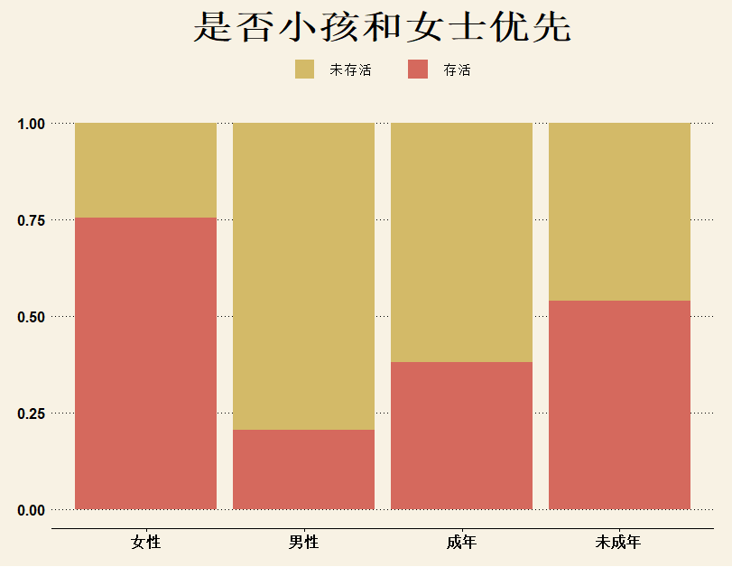
女士的存活率高于男性，所以有遵循女士优先，未成年人存活率略高于成年人，不足以说明未成年优先

回归模型：
Call:
glm(formula = Survived ~ cl + Sex, family = binomial(), data = t_d)

Deviance Residuals:
Min 1Q Median 3Q Max
-1.8430 -0.6582 -0.6582 0.7792 1.8088

Coefficients:
Estimate Std. Error z value Pr(>|z|)
(Intercept) 1.0365 0.1503 6.897 5.3e-12 ***
cl未成年 0.4597 0.2455 1.873 0.0611 .
Sexmale -2.4558 0.1855 -13.237 < 2e-16 ***
---
Signif. codes: 0 ‘***’ 0.001 ‘**’ 0.01 ‘*’ 0.05 ‘.’ 0.1 ‘ ’ 1

(Dispersion parameter for binomial family taken to be 1)

Null deviance: 964.52 on 713 degrees of freedom
Residual deviance: 747.20 on 711 degrees of freedom
AIC: 753.2

Number of Fisher Scoring iterations: 4
由于性别P值远小于0.05，有理由相信采用了女士优先，年龄的P值为0.06，不是特别显著，不足以说明未成年人优先。

问题三：
Call:
glm(formula = Survived ~ peer + Fare + Embarked + Pclass + Age +
Sex, family = binomial(), data = new_data)

Deviance Residuals:
Min 1Q Median 3Q Max
-2.6696 -0.6503 -0.3947 0.6230 2.4368

Coefficients:
Estimate Std. Error z value Pr(>|z|)
(Intercept) 16.381850 608.929234 0.027 0.97854
peer -0.224492 0.082705 -2.714 0.00664 **
Fare 0.004551 0.006131 0.742 0.45790
EmbarkedC -12.118481 608.928979 -0.020 0.98412
EmbarkedQ -12.974923 608.929183 -0.021 0.98300
EmbarkedS -12.545539 608.928971 -0.021 0.98356
Pclass2 -1.042390 0.395025 -2.639 0.00832 **
Pclass3 -2.217706 0.438827 -5.054 4.33e-07 ***
Age -0.041724 0.008261 -5.051 4.40e-07 ***
Sexmale -2.657401 0.221755 -11.984 < 2e-16 ***
---
Signif. codes: 0 ‘***’ 0.001 ‘**’ 0.01 ‘*’ 0.05 ‘.’ 0.1 ‘ ’ 1

(Dispersion parameter for binomial family taken to be 1)

Null deviance: 964.52 on 713 degrees of freedom
Residual deviance: 634.53 on 704 degrees of freedom
AIC: 654.53

Number of Fisher Scoring iterations: 13
由P值大于0.05的得出，登船港口和船票对是否存活无关，去掉这两个因数，继续分析
Call:
glm(formula = Survived ~ peer + Pclass + Age + Sex, family = binomial(),
data = new_data)

Deviance Residuals:
Min 1Q Median 3Q Max
-2.6921 -0.6501 -0.3996 0.6334 2.4447

Coefficients:
Estimate Std. Error z value Pr(>|z|)
(Intercept) 4.28838 0.45175 9.493 < 2e-16 ***
peer -0.20184 0.07365 -2.740 0.00614 **
Pclass2 -1.38947 0.28273 -4.914 8.90e-07 ***
Pclass3 -2.62063 0.28373 -9.236 < 2e-16 ***
Age -0.04312 0.00816 -5.285 1.26e-07 ***
Sexmale -2.66403 0.21827 -12.205 < 2e-16 ***
---
Signif. codes: 0 ‘***’ 0.001 ‘**’ 0.01 ‘*’ 0.05 ‘.’ 0.1 ‘ ’ 1

(Dispersion parameter for binomial family taken to be 1)

Null deviance: 964.52 on 713 degrees of freedom
Residual deviance: 639.24 on 708 degrees of freedom
AIC: 651.24

Number of Fisher Scoring iterations: 5
P值小于0.05，拟合成功，社会地位，同行人数，性别，年龄会影响存活率

问题四：年龄和性别与社会地位的关系
Call:
multinom(formula = Pclass ~ Age + Sex, data = p_d)

Coefficients:
(Intercept) Age Sexmale
中 1.213673 -0.04327821 0.3280973
低 2.320590 -0.07498065 1.0768190

Residual Deviance: 1352.095
AIC: 1364.095
P值
(Intercept) Age Sexmale
中 4.199198e-05 5.76719e-08 1.403308e-01
低 0.000000e+00 0.00000e+00 2.757708e-07

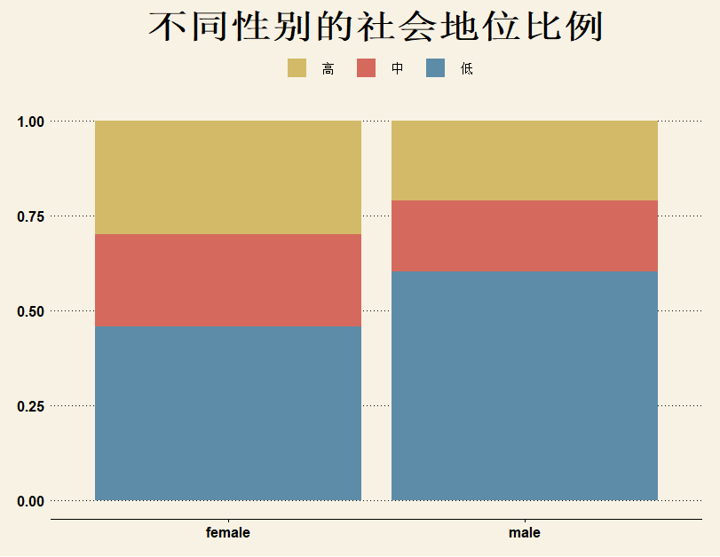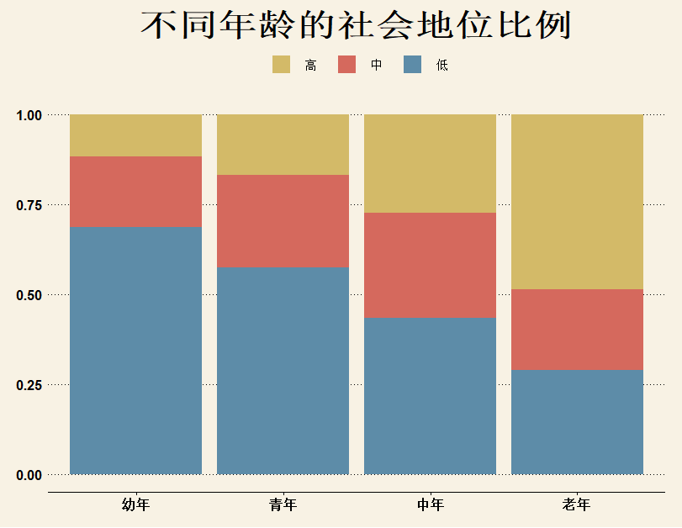
年龄对社会地位非常显著，性别不是特别显著

