程序内容：

#include<iostream>

#include"tinystr.h"

#include"tinyxml.h"

#include<string>

using namespace std;

void LibraryXml() {

using namespace std;

const char \* xmlFile = "l.xml";

TiXmlDocument doc;

if (doc.LoadFile(xmlFile)) {

doc.Print();

} else {

cout << "can not parse l.xml" << endl;

return;

}

TiXmlElement\* rootElement = doc.RootElement();

TiXmlElement\* classElement = rootElement->FirstChildElement();

TiXmlElement\* studentElement = classElement->FirstChildElement();

for (; classElement!= NULL; classElement = classElement->NextSiblingElement() ) {

cout <<classElement->Value()<<endl;

studentElement=classElement->FirstChildElement();

TiXmlAttribute\* attributeOfStudent = classElement->FirstAttribute();

for (;attributeOfStudent != NULL; attributeOfStudent = attributeOfStudent->Next() ) {

cout << attributeOfStudent->Name() << " : " << attributeOfStudent->Value() << std::endl;

}

for (TiXmlElement\* StudentElement=studentElement; StudentElement != NULL; StudentElement = StudentElement->NextSiblingElement() ) {

if(!StudentElement->FirstChildElement()){

cout <<StudentElement->Value()<<" : " <<StudentElement->FirstChild()->Value()<<endl;}

else {cout <<StudentElement->Value()<<endl;

TiXmlElement \* StudenElement=StudentElement->FirstChildElement();

for (; StudenElement!= NULL; StudenElement = StudenElement->NextSiblingElement()) {

cout <<StudenElement->Value()<<" : " <<StudenElement->FirstChild()->Value()<<endl;

}

}

}

}

}

int main(){

LibraryXml();

system("pause");

return 1;

}

运行结果截图：

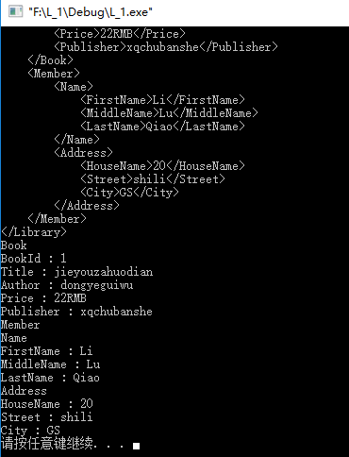

xml文件：

<?xml version="1.0" encoding="UTF-8"?>

<!DOCTYPE Library SYSTEM "C:\Users\Administrator\Desktop\LL.dtd">

<Library>

<Book BookId="1">

<Title>jieyouzahuodian</Title>

<Author>dongyeguiwu</Author>

<Price>22RMB</Price>

<Publisher>xqchubanshe</Publisher>

</Book>

<Member>

<Name>

<FirstName>Li</FirstName>

<MiddleName>Lu</MiddleName>

<LastName>Qiao</LastName>

</Name>

<Address>

<HouseName>20</HouseName>

<Street>shili</Street>

<City>GS</City>

</Address>

</Member>

</Library>

外部DTD:

<?xml version="1.0" encoding="UTF-8"?>

<!ELEMENT Library(Book,Member)>

<!ELEMENT Book(Title,Author,Price,Publisher)>

<!ELEMENT Title(#PCDATA)>

<!ELEMENT Author(#PCDATA)>

<!ELEMENT Price(#PCDATA)>

<!ELEMENT Publisher(#PCDATA)>

<!ELEMENT Member(Name,Address)>

<!ELEMENT Name(FirstName,MiddleName,LastName)>

<!ELEMENT FirstName(#PCDATA)>

<!ELEMENT MiddleName(#PCDATA)>

<!ELEMENT LastName(#PCDATA)>

<!ELEMENT Address(HouseName,Street,City)>

<!ELEMENT HouseName(#PCDATA)>

<!ELEMENT Street(#PCDATA)>

<!ELEMENT City(#PCDATA)>

<!ATTLIST Book BookI CDATA #REQUIRE>