### Promise

1. Try...catch...
   1. 捕获异常
      1. 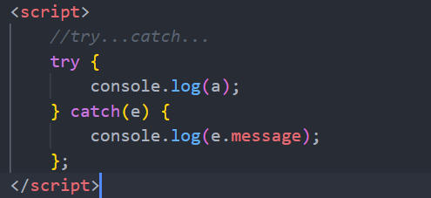
   2. 抛出异常
      1. 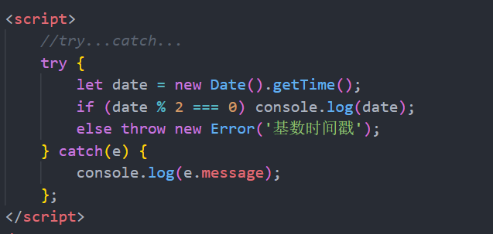
2. 基本概念
   1. 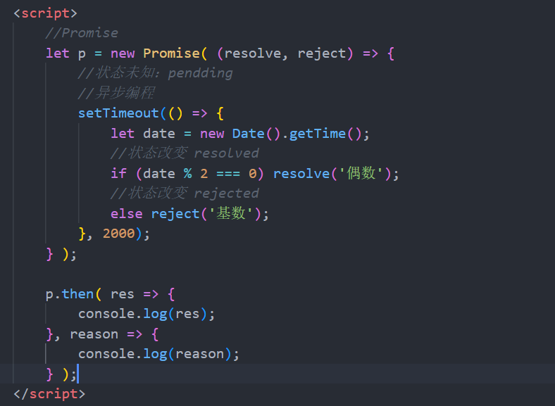
3. 链式编程
   1. 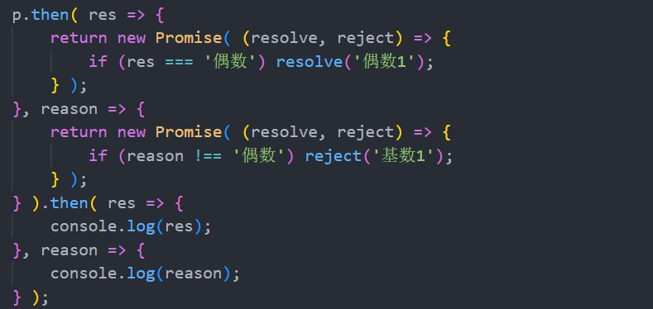
4. Promise常见API
   1. Promise.prototype.then(res => {}, reason => {})
   2. Promise.prototype.catch(reason => {})
   3. Promise.prototype.finally()
   4. Promise.resolve().then(res => {})
   5. Promise.reject().then(reason => {})
   6. Promise.all([‘Promise对象’, ‘Promise对象’]).then(values => {})
   7. Promise.race([‘Promise对象’, ‘Promise对象’]).then(val => {})