Assignment 3

(Last Update: 30 Oct)

**Introduction**

Download the code for this assignment [here](https://drive.google.com/file/d/1R6MLOmS9Irlnlbh9AiCCF6dyB3t5gqec/view?usp=sharing) and then unzip the archive.

As in assignments 1 and 2, this assignment uses [python 3](https://www.python.org/downloads/). Do not use python 2. You can work on the assignment using your favorite python editor. We recommend [VSCode](https://en.wikipedia.org/wiki/Visual_Studio_Code).

Post any questions or issues with this assignment to our discussion forum. Alternatively you may also contact your TA directly.

This assignment uses autograding for Problem 1, Problem 2 and Problem 3. For the first question of this assignment we rely on the random number generator generating the same random sequence. Same as in Assignment 2. This time, we will be using the random.choices() function as follows.

| import random  from collections import Counter  seed = 2  if seed!=-1:  random.seed(seed, version=1)  n = 0.1 #noise  a = 'N' #intended action  d = {'N':['N', 'E', 'W'], 'E':['E', 'S', 'N'], 'S':['S', 'W', 'E'], 'W':['W', 'N', 'S']}  l = []  for _ in range(100000):  l += random.choices(population=d[a], weights=[1 - n*2, n, n])[0]  print(Counter(l).keys()) # equals to list(set(words))  print(Counter(l).values()) # counts the elements' frequency  print(l[:5]) |
| --- |

This will give the following output.

| dict_keys(['W', 'N', 'E'])  dict_values([10025, 80059, 9916])  ['W', 'W', 'N', 'N', 'E'] |
| --- |

Note that we obtain ~80% intendent actions and 10% unintended actions here. Make sure that you understand the output and that you can reproduce it on your machine before proceeding. Note that we use anaconda python 3.9 to obtain the above result.

**Problem 1: An MDP Episode**

In this part of the assignment, we are going to play an episode in an MDP by following a given policy. Consider the first test case of problem 1 (available in the file test_cases/p1/1.prob).

| seed: 2  noise: 0.1  livingReward: -0.05  grid:  _ _ _ 1  _ # _ -1  S _ _ _  policy:  E E E exit  N # N exit  N W N W |
| --- |

The first part of this file specifies an MDP. S is the start state with four available actions (N, E, S, W), _ is an ordinary state with the same four available actions and 1,-1 are states where the only available action is exit and the reward are 1 and -1 respectively. The reward for action in other states is -0.05. # is a wall.

Actions are not deterministic in this environment. In this case with noise = 0.1, we are successfully acting 80% of the time and 20% of the time we will act perpendicular to the intended direction with equal probability, i.e. 10%, for each unintended direction. If the agent attempts to move into a wall, the agent will stay in the same position. Note that this MDP is identical to the example that we covered extensively in our class.

The second part of this file specifies the policy to be executed.

As usual, your first task is to implement the parsing of this grid MDP in the function read_grid_mdp_problem_p1(file_path) of the file parse.py. You may use any appropriate data structure.

Next, you should implement running the episode in the function play_episode(problem) in the file p1.py.

Below is the expected output. Note that we always use exactly 5 characters for the output of a single grid and that the last line does not contain a new line.

| Start state:  _ _ _ 1  _ # _ -1  P _ _ _  Cumulative reward sum: 0.0  --------------------------------------------  Taking action: W (intended: N)  Reward received: -0.05  New state:  _ _ _ 1  _ # _ -1  P _ _ _  Cumulative reward sum: -0.05  --------------------------------------------  Taking action: W (intended: N)  Reward received: -0.05  New state:  _ _ _ 1  _ # _ -1  P _ _ _  Cumulative reward sum: -0.1  --------------------------------------------  Taking action: N (intended: N)  Reward received: -0.05  New state:  _ _ _ 1  P # _ -1  S _ _ _  Cumulative reward sum: -0.15  --------------------------------------------  Taking action: N (intended: N)  Reward received: -0.05  New state:  P _ _ 1  _ # _ -1  S _ _ _  Cumulative reward sum: -0.2  --------------------------------------------  Taking action: S (intended: E)  Reward received: -0.05  New state:  _ _ _ 1  P # _ -1  S _ _ _  Cumulative reward sum: -0.25  --------------------------------------------  Taking action: N (intended: N)  Reward received: -0.05  New state:  P _ _ 1  _ # _ -1  S _ _ _  Cumulative reward sum: -0.3  --------------------------------------------  Taking action: E (intended: E)  Reward received: -0.05  New state:  _ P _ 1  _ # _ -1  S _ _ _  Cumulative reward sum: -0.35  --------------------------------------------  Taking action: E (intended: E)  Reward received: -0.05  New state:  _ _ P 1  _ # _ -1  S _ _ _  Cumulative reward sum: -0.4  --------------------------------------------  Taking action: E (intended: E)  Reward received: -0.05  New state:  _ _ _ P  _ # _ -1  S _ _ _  Cumulative reward sum: -0.45  --------------------------------------------  Taking action: exit (intended: exit)  Reward received: 1.0  New state:  _ _ _ 1  _ # _ -1  S _ _ _  Cumulative reward sum: 0.55 |
| --- |

As you can see, in this question we don’t use any discount factor. We will introduce that in the next question. You can also try some of the other test cases such as test_cases/p1/8.prob.

| seed: 42  noise: 0.2  livingReward: -1  grid:  # 10 #  -100 _ -100  -100 _ -100  -100 _ -100  -100 _ -100  -100 S -100  # 1 #  policy:  # exit #  exit N exit  exit N exit  exit N exit  exit N exit  exit N exit  # 1 # |
| --- |

With a correct implementation, you should be able to pass all test cases.

| (base) scdirk@Dirks-Air a3 % python p1.py -8  Grading Problem 1 :  ----------> Test case 1 PASSED <----------  ----------> Test case 2 PASSED <----------  ----------> Test case 3 PASSED <----------  ----------> Test case 4 PASSED <----------  ----------> Test case 5 PASSED <----------  ----------> Test case 6 PASSED <----------  ----------> Test case 7 PASSED <----------  ----------> Test case 8 PASSED <---------- |
| --- |

**Problem 2: Policy Evaluation**

In problem 2 you will implement policy evaluation as follows

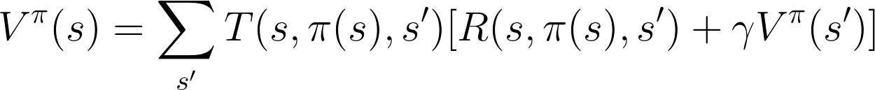

This time we have discounting and we also introduce a new variable for the number of iterations. Here is the first test case.

| discount: 0.9  noise: 0.1  livingReward: 0  iterations: 10  grid:  -10 100 -10  -10 _ -10  -10 _ -10  -10 S -10  policy:  exit exit exit  exit N exit  exit N exit  exit N exit |
| --- |

Note that there is no randomness involved this time and that we use discounting.

As usual, your first task is to implement the parsing of this grid MDP in the function read_grid_mdp_problem_p2(file_path) of the file parse.py. You may use any appropriate data structure.

Next you implement value iteration for policy evaluation as discussed in class. Your policy_evaluation(problem) function in p2.py should return the evolution of values as follows.

| V^pi_k=0  | 0.00|| 0.00|| 0.00|  | 0.00|| 0.00|| 0.00|  | 0.00|| 0.00|| 0.00|  | 0.00|| 0.00|| 0.00|  V^pi_k=1  | -10.00|| 100.00|| -10.00|  | -10.00|| 0.00|| -10.00|  | -10.00|| 0.00|| -10.00|  | -10.00|| 0.00|| -10.00|  V^pi_k=2  | -10.00|| 100.00|| -10.00|  | -10.00|| 70.20|| -10.00|  | -10.00|| -1.80|| -10.00|  | -10.00|| -1.80|| -10.00|  V^pi_k=3  | -10.00|| 100.00|| -10.00|  | -10.00|| 70.20|| -10.00|  | -10.00|| 48.74|| -10.00|  | -10.00|| -3.10|| -10.00|  V^pi_k=4  | -10.00|| 100.00|| -10.00|  | -10.00|| 70.20|| -10.00|  | -10.00|| 48.74|| -10.00|  | -10.00|| 33.30|| -10.00|  V^pi_k=5  | -10.00|| 100.00|| -10.00|  | -10.00|| 70.20|| -10.00|  | -10.00|| 48.74|| -10.00|  | -10.00|| 33.30|| -10.00|  V^pi_k=6  | -10.00|| 100.00|| -10.00|  | -10.00|| 70.20|| -10.00|  | -10.00|| 48.74|| -10.00|  | -10.00|| 33.30|| -10.00|  V^pi_k=7  | -10.00|| 100.00|| -10.00|  | -10.00|| 70.20|| -10.00|  | -10.00|| 48.74|| -10.00|  | -10.00|| 33.30|| -10.00|  V^pi_k=8  | -10.00|| 100.00|| -10.00|  | -10.00|| 70.20|| -10.00|  | -10.00|| 48.74|| -10.00|  | -10.00|| 33.30|| -10.00|  V^pi_k=9  | -10.00|| 100.00|| -10.00|  | -10.00|| 70.20|| -10.00|  | -10.00|| 48.74|| -10.00|  | -10.00|| 33.30|| -10.00| |
| --- |

This example should look familiar. We have covered it in chapter 2 of our lecture slides.

Hint: The output of an individual floating point value v was done as follows

| return_value += '|{:7.2f}|'.format(v) |
| --- |

Finally, check the correctness of your implementation via

| (base) scdirk@Dirks-Air a3 % python p2.py -7  Grading Problem 2 :  ----------> Test case 1 PASSED <----------  ----------> Test case 2 PASSED <----------  ----------> Test case 3 PASSED <----------  ----------> Test case 4 PASSED <----------  ----------> Test case 5 PASSED <----------  ----------> Test case 6 PASSED <----------  ----------> Test case 7 PASSED <---------- |
| --- |

**Problem 3: Value Iteration**

Now it is time to complement value iteration.

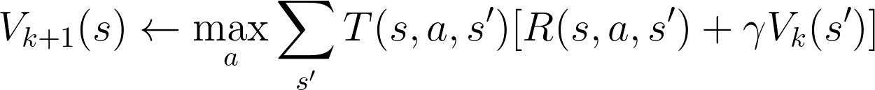

This time, the provided problems do not include policies:

| discount: 1  noise: 0.1  livingReward: -0.1  iterations: 10  grid:  _ _ _ 1  _ # _ -1  S _ _ _ |
| --- |

As usual, load the problem definition in the function read_grid_mdp_problem_p3(file_path) of the file parse.py.

Next implement value_iteration(problem) in p3.py such that it returns the following string for the first test case. Note that this is still a non-deterministic environment as before with the same stochastic motion.

| V_k=0  | 0.00|| 0.00|| 0.00|| 0.00|  | 0.00|| ##### || 0.00|| 0.00|  | 0.00|| 0.00|| 0.00|| 0.00|  V_k=1  | -0.10|| -0.10|| -0.10|| 1.00|  | -0.10|| ##### || -0.10|| -1.00|  | -0.10|| -0.10|| -0.10|| -0.10|  pi_k=1  | N || N || N || x |  | N || # || N || x |  | N || N || N || N |  V_k=2  | -0.20|| -0.20|| 0.68|| 1.00|  | -0.20|| ##### || -0.20|| -1.00|  | -0.20|| -0.20|| -0.20|| -0.20|  pi_k=2  | N || N || E || x |  | N || # || W || x |  | N || N || N || S |  V_k=3  | -0.30|| 0.40|| 0.75|| 1.00|  | -0.30|| ##### || 0.32|| -1.00|  | -0.30|| -0.30|| -0.30|| -0.30|  pi_k=3  | N || E || E || x |  | N || # || N || x |  | N || N || N || S |  V_k=4  | 0.16|| 0.58|| 0.81|| 1.00|  | -0.40|| ##### || 0.43|| -1.00|  | -0.40|| -0.40|| 0.10|| -0.40|  pi_k=4  | E || E || E || x |  | N || # || N || x |  | N || N || N || S |  V_k=5  | 0.34|| 0.66|| 0.82|| 1.00|  | -0.05|| ##### || 0.49|| -1.00|  | -0.50|| -0.10|| 0.16|| -0.16|  pi_k=5  | E || E || E || x |  | N || # || N || x |  | N || E || N || W |  V_k=6  | 0.46|| 0.69|| 0.83|| 1.00|  | 0.16|| ##### || 0.51|| -1.00|  | -0.20|| 0.01|| 0.26|| -0.08|  pi_k=6  | E || E || E || x |  | N || # || N || x |  | N || E || N || W |  V_k=7  | 0.52|| 0.70|| 0.83|| 1.00|  | 0.30|| ##### || 0.52|| -1.00|  | 0.01|| 0.11|| 0.30|| 0.00|  pi_k=7  | E || E || E || x |  | N || # || N || x |  | N || E || N || W |  V_k=8  | 0.54|| 0.71|| 0.83|| 1.00|  | 0.37|| ##### || 0.52|| -1.00|  | 0.15|| 0.16|| 0.32|| 0.04|  pi_k=8  | E || E || E || x |  | N || # || N || x |  | N || E || N || W |  V_k=9  | 0.56|| 0.71|| 0.84|| 1.00|  | 0.41|| ##### || 0.52|| -1.00|  | 0.23|| 0.19|| 0.34|| 0.06|  pi_k=9  | E || E || E || x |  | N || # || N || x |  | N || E || N || W | |
| --- |

Once you are done. Check if you can pass all test cases as follows.

| (base) scdirk@Dirks-Air a3 % python p3.py -4  Grading Problem 3 :  ----------> Test case 1 PASSED <----------  ----------> Test case 2 PASSED <----------  ----------> Test case 3 PASSED <----------  ----------> Test case 4 PASSED <---------- |
| --- |

**Problem 4: Q-Value TD Learning**

In the final problem of this assignment you will implement temporal difference learning of Q values.



Your task is to apply temporal difference learning of Q values to the test case 2 of problem 3 and see if you can get an optimal policy. Discount, noise and living reward should be the same as specified in the test case. In your solution, you should …

* start from initial Q values = 0
* use epsilon greedy (with decay) or exploration functions to force exploration
* implement an appropriate learning rate decay to reach an optimal policy
* stop your iteration when the a solution is found (don’t compare against optimal policy to decide when to stop)
* run your learning algorithm multiple times (don’t set a fixed seed) and output how often the optimal policy can be found e.g., 9/10

Note that the optimal policy for this example can be found on slide 15 of chapter 2 (same as test case 2 of problem 3) shown below.

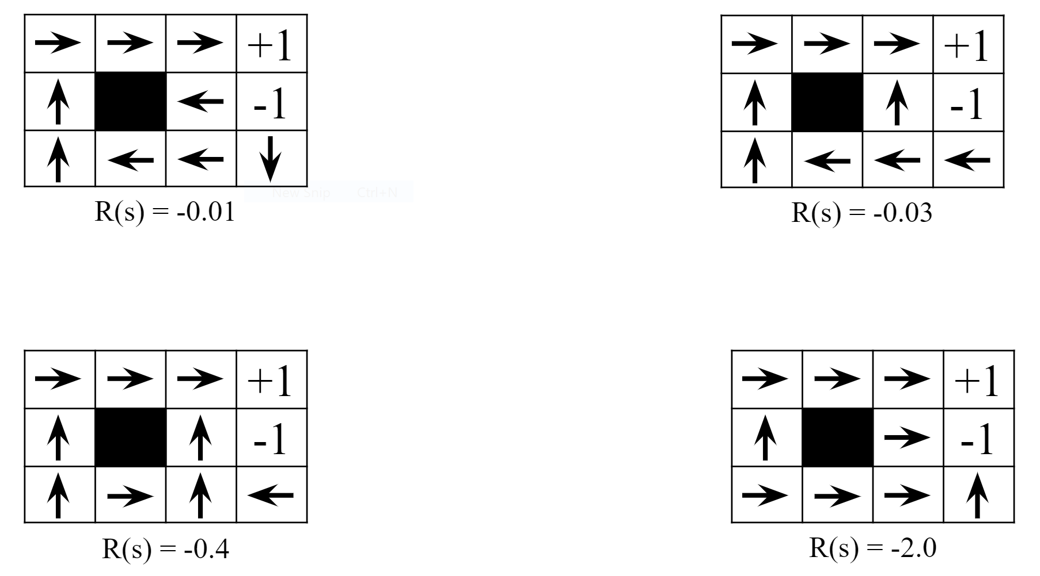

Write your findings with short analysis as comments in the beginning of the file p4.py.

There are no autograder and no test cases provided for this question. You should provide all parameters and the problem definition itself in the file p4.py. Also tell us how to run your code.

To submit your assignment to Moodle, *.zip the following files ONLY:

* p1.py
* p2.py
* p3.py
* p4.py
* parse.py

Do not zip any other files. Use the *.zip file format. Make sure that you have submitted the correct files.