使用微服务Spring Boot的公共投诉系统后端应用程序的设计和开发
摘要
电子政务是治理领域中ICT（信息和通信技术）的一种实施，用于改善政府或公共部门向公众提供的服务。 例如，智慧城市，在线许可服务，这项研究的目的是开发基于Web应用程序的公共投诉服务应用程序，该应用程序使用springboot微服务架构。 微服务架构用于将应用程序功能划分为多个部分，或者基于业务流程将许多微服务与服务互连在一起，从而成为具有完整业务流程的单个应用程序。 该体系结构的优点之一是可以添加更多微服务而不影响其他微服务。 该应用程序已部署在可以通过浏览器访问的云环境中。
关键字：电子政务； 微服务； 投诉服务；Spring Boot
1.简介
电子政务包括使用电子通讯技术（例如互联网）来改善公民对公共服务的访问[1]。 电子政务的实施提高了报告管理系统的管理效率和速度，并提高了政府管理流程的透明度。 通过它，出现了一个称为善政的方面。 但是，在印度尼西亚实施电子政务面临许多问题，例如用于开发和运营电子政务应用程序的费用问题，技术性问题。例如安全性问题，隐私，系统更新和人力资源问题，而这些问题缺乏管理能力。 云技术成为解决这些问题的替代解决方案之一。 该模型允许消费者通过可在各种设备中访问的提供程序来在线使用云中存在的应用程序，而不必担心这些问题。
微服务技术的使用可以为云中的电子政务系统提供一些优势。 微服务中的模块化概念允许管理应用程序中单独存在的服务。 对特定服务的开发的影响是它不会干扰其他服务。 可以在其他服务中区分服务的能力建设，以便适当地使用资源。 同样，可以使用不同的编程语言来开发服务[2]。
2.相关工作
Sam Newman [3]开发微服务应用程序，首先要进行的工作是确定环境或有限上下文的边界。 简单地说，要指定可以从应用程序业务流程中看到的应用程序的受限上下文，然后可以根据用户的功能组将其分组，例如，财务部门负责付款，而仓库部门则参与其中 在客户订单中。 然后将每个功能放到一个模块中。 然后，该模块将成为有界上下文，以创建与所制作模块的目的相匹配的微服务。 已经制作的微服务将应用其他模块之间的松散耦合和与所制作的模块互连的高凝聚力微服务的概念。 最后，可以确定将数据写入数据库并从数据库读取数据的部分。
Purnama＆Yatini [4]使用Node.js开发了一个论文管理应用程序，目的是避免话题或论文标题的任何相似之处（通常是抄袭）。 Node.js是使用微服务架构构建的，旨在简化应用程序的开发。 如果需要添加新功能，则无需重新创建应用程序，并且可以独立添加功能。 花费更少的时间进行进一步的开发。
Janssen＆Joha [5]解释说，公共部门仍然很少使用软件即服务（SaaS）模型。 尽管公共/电子政府部门中的SaaS有望带来许多优势，例如节省成本和提高效率，但挑战依然严峻，例如质量，安全性，隐私性以及在该地区定制不同系统的需求 。
3.方法论
3.1 功能需求分析
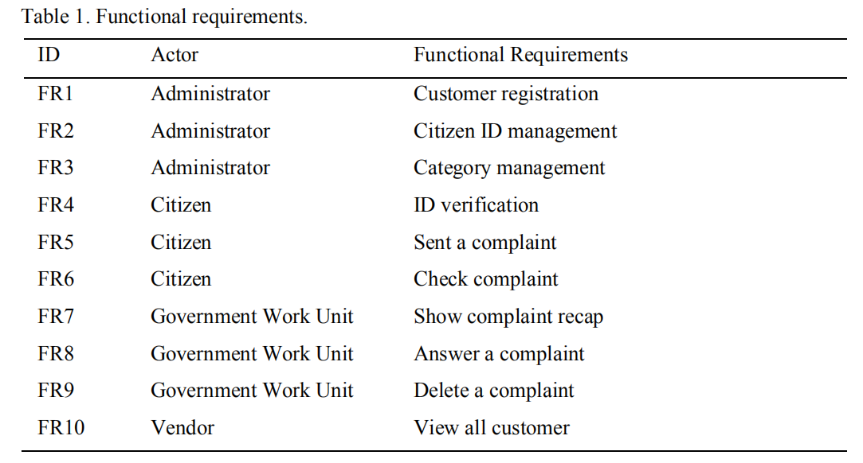
通过查看一些类似的应用程序进行功能需求分析。 例如，在Kediri市的publiccomplaint Web应用程序[6]。 通过查看应用程序的设计文档可以进行分析。 此外，还从文献研究中进行了分析，以找到一些与电子政务公共报告应用程序的功能要求有关的信息。
功能需求包括参与者需求和功能需求。 参与者是将使用该应用程序的用户。 使用该应用程序的参与者很少包括管理员，供应商，公民和政府工作单位。 功能需求本身就是应用程序的功能。 一些功能要求的清单表1中显示了该应用程序。
3.2 为微服务建模
提出功能要求后，下一步就是对微服务进行建模。 此步骤将功能需求（也称为有界上下文）拆分为一些与有界上下文的目的匹配的微服务。 换句话说，微服务是由一个或多个微服务组成的组，并且它们相互连接以执行业务流程或功能。 表2中显示了此应用程序中的微服务。
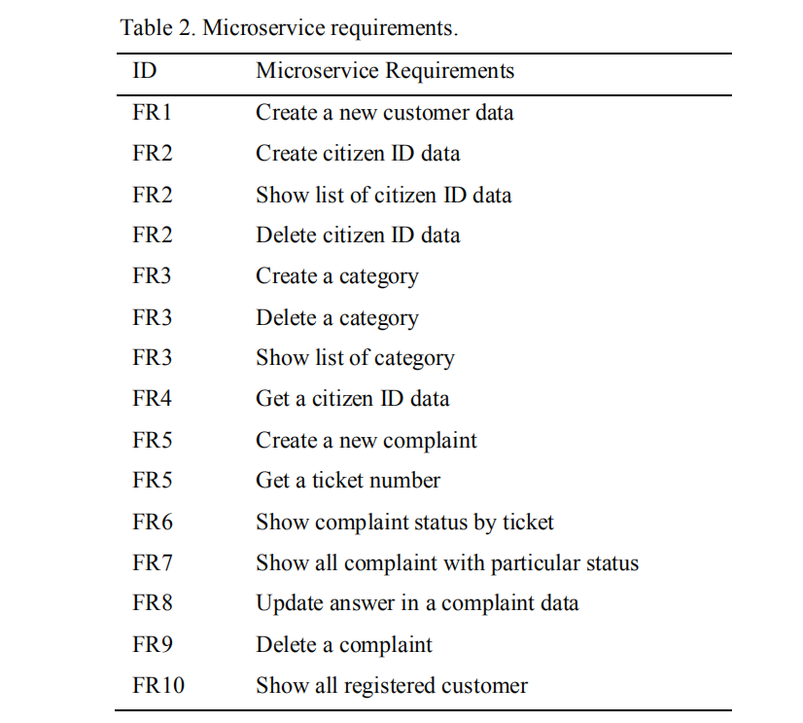
3.3 设计用例
通过对功能需求的分析生成了设计用例。 用例显示了参与者与应用程序之间的交互，如图1所示。
3.4 应用开发
此阶段是根据功能需求，微服务需求和用例对应用程序进行编码的过程。 这项研究致力于使用Java编程语言和springboot框架开发后端应用程序。 Springboot框架因具有多个优点而受到青睐。
Spring支持MVC并提供RESTful Web服务功能。 Spring包中还提供了数据库连接。 Spring框架还支持依赖项注入。 依赖注入是在应用程序中轻松进行配置依赖，因此在应用程序开发过程中变得更加方便。 每个spring框架还支持Aspect Object Programming（AOP）[7]。 使用spring boot的另一个优点是tomcat服务器可以轻松地包含在内并且可以直接运行[8]。
还需要开发前端应用程序以与后端进行通信以进行业务流程。 前端开发使用打字稿编程语言和Angular2框架进行。
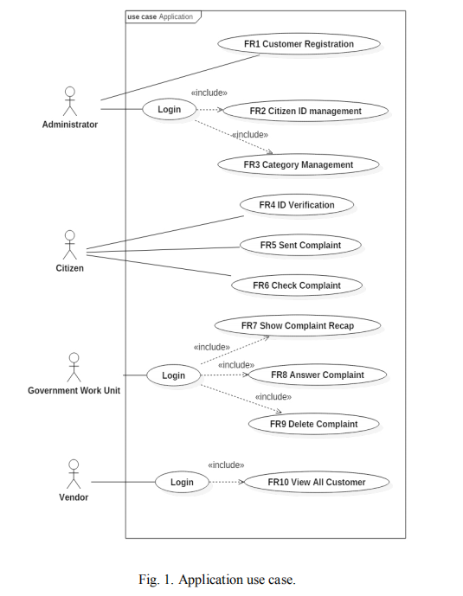
3.5 微服务黑盒测试
黑匣子测试是一项旨在检查功能性应用程序是否正确运行而又不知道该应用程序内部是否存在进程的测试[9]。 黑匣子测试是通过创建测试用例来完成的，该用例的形式为功能应用程序预期的测试输入和输出。 可以在不使用算法或低粒度级别的应用程序上进行测试[10]，因此不需要花费很多时间[11]。 尽管要测试微服务，需要进行两项测试，即白盒测试和黑盒测试，但本研究仅执行黑盒测试，因为该应用程序不使用任何复杂的算法，并且具有较低的粒度细节，因此黑盒测试就足够了。
4.申请业务流程
公共投诉应用程序由特定的单位或团队操作和管理。 在某些情况下，在万隆等地区[12]，这种应用程序是在指挥中心进行操作和管理的，因此其工作是最佳的。
此公共投诉应用程序是基于云的应用程序。 地方政府可以通过向供应商支付一些钱来租用应用程序服务。 可以由政府指派管理员来运行应用程序。 管理员可以上传公民ID数据。
公民通过网络中的应用程序提出投诉。 首先，市民必须根据管理员上载的数据ID来验证其ID。 之后，他们的投诉将保存在数据库中，并准备由政府工作部门进行管理。 首先，系统有一个选择阶段来过滤投诉内容。 选择过程由指挥中心的政府工作单位管理。 有效的投诉内容将按照管理员创建的类别进行分类，然后发送到指挥中心外的正确的政府部门，以便可以在现场通过正确的答案和正确的后续措施来回答投诉。 如果在现场处理或处理了投诉人的报告，则发送投诉的公民可以将投诉状态更改为完成，以告知政府投诉已得到充分解决。
- 应用架构5. 应用架构
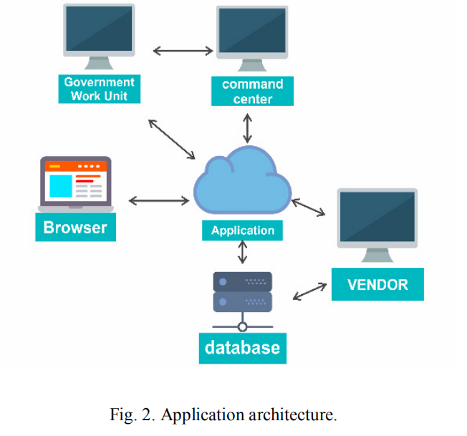
使用云技术的公共投诉应用程序具有如图2所示的云体系结构。前端应用程序以及后端应用程序以及应用程序数据库将与应用程序数据库一起存储在云中，以节省资源使用。 公众可以通过浏览器访问该应用程序。 通过Web应用程序提交的投诉将被发送到数据库中，以供政府进一步管理，在这种情况下，政府是指挥中心和其他政府工作单位。 供应商可以通过后端或前端访问应用程序以对应用程序执行维护。
6.微服务架构
有一个工具可以使开发人员更轻松地查看应用程序上所有可用的微服务。该工具称为swagger。 Swagger是一个标准框架，它使开发人员可以快速找到和理解应用程序上的所有服务，而无需访问程序代码，应用程序开发文档，也无需检查应用程序服务网络[13]。 Swagger基于使用springboot框架创建的控制器类来映射微服务。类控制器（或可以称为控制器）是springboot中的类文件，由根据业务需要执行输入输出过程的方法组成。在控制器类中，可以将方法制成REST API。 Swagger显示已在应用程序中创建的所有控制器。在每个swagger控制器中，都可以使用所用方法的描述来访问REST API（所用的REST方法通常是GET，POST，DELETE，PUT），然后是REST API URL，以及控制器类中的方法名称。 REST API将被前端应用程序用作通过已定义的预定义通信方法访问微服务。
6.1 类控制器
表3显示了应用程序中存在的类控制器以及相关的微服务。
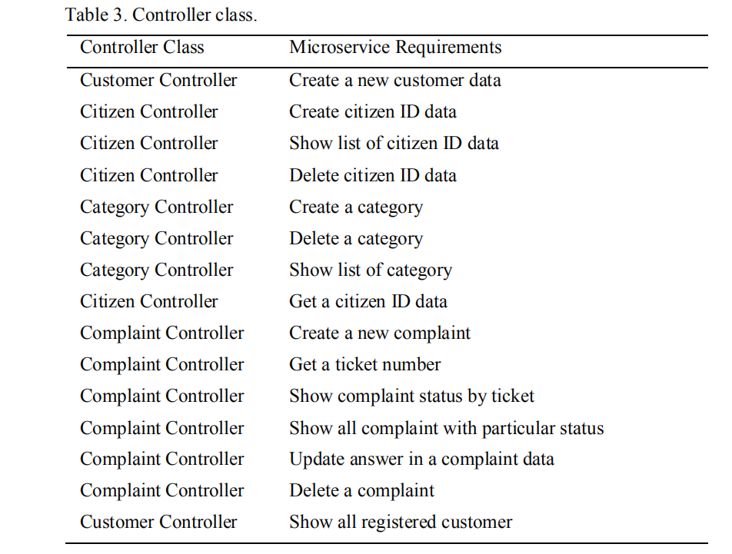
6.2 Rest方法
表4是一个表，其中包含应用程序中存在的REST方法信息以及相关的微服务。
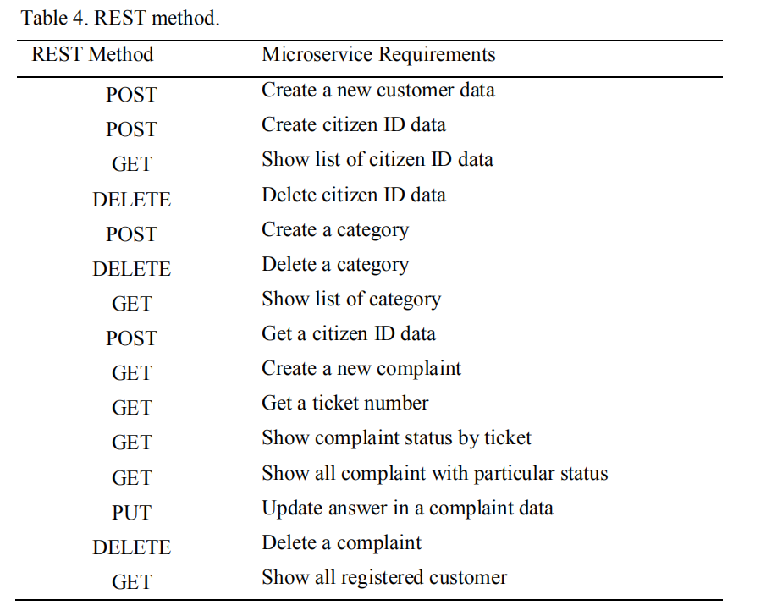
6.3 REST URL
表5包含REST的URL。 该URL用于在前端和后端之间进行通信。
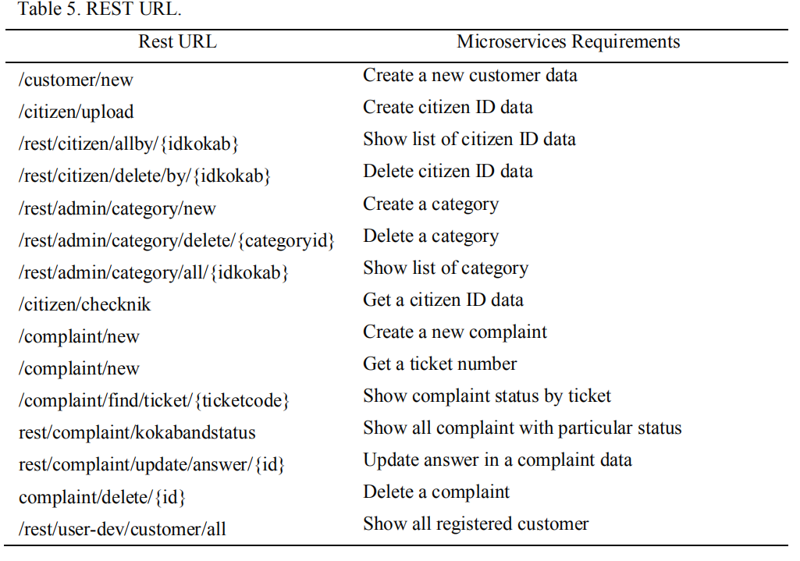
6.4 架构图
前端可以分为四个用户界面（UI），分别是管理员的管理仪表板（Admin UI），政府工作单位的操作员UI，公民用来创建和检查合规性的UI投诉以及供应商UI 由供应商使用。 每个UI将与某个微服务相关联，如图3所示。
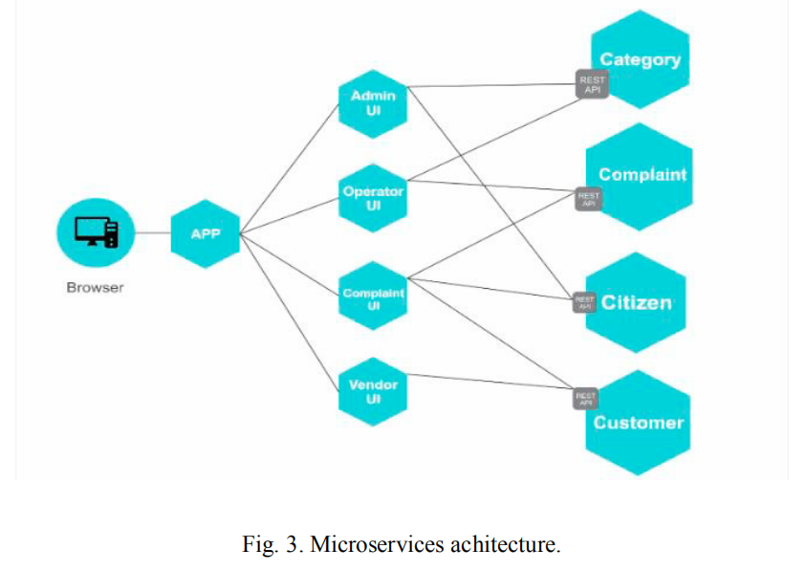
6.5保护微服务
图1描绘了管理员，政府工作单位和供应商具有登录功能。登录本身
用于保护那些参与者的微服务。这些参与者必须填写其用户名和密码，然后系统会将它们与数据库中保存的数据进行比较。如果用户名和密码匹配，则系统将发送Jason Web令牌（JWT）。 JSON Web令牌（JWT）是一种紧凑的，URL安全的方法，用于表示要在后端和前端两方之间转移的声明[14]。 JWT包含一些声明，例如，涉及用户角色及其仪表板的用户范围，令牌时间过期。因此，当时间到了时，它将再次需要登录过程以及一些不是敏感信息的其他附加信息。密码本身需要安全地保存在数据库中。需要完成散列功能，因此数据库中的密码不仅是纯文本，因此很容易被盗。这项研究使用的是BCrypt算法。 BCrypt是一种具有低哈希冲突的不可逆算法，使用该算法我们的密码受到适当的保护[15]。 Java语言提供了bcrypt库，因此这是一种便捷的方法。
7.结论
基于本研究已经完成的过程，得出以下结论：1）公众投诉是使用Springboot框架通过微服务架构开发的一种应用程序服务。因此，此应用程序已部署在云中。在部署应用程序时，从后端制作了一个jar文件。前端也已部署到相同的云系统以及所使用的数据库应用程序中。要访问该应用程序，需要使用一个浏览器，该浏览器将创建与云中应用程序的通信。 2）在开发微服务应用程序时，应将功能需求分解为几个微服务，这些微服务通过已确定的业务流程相互连接以形成统一的应用程序。 3）使用微服务架构的优点是可以添加更多功能需求，并且还可以在其中添加微服务而不影响其他微服务。因此，开发人员可以独立添加更多功能，并创造业务价值，从而节省进一步开发的时间。
致谢
这项研究得到了“ Penelitian Laboratorium PUPT ITS 2017”研究补助金的支持/资助，合同号：566 / PKS / ITS / 2017。

Design and Development of Backend Application for Public Complaint Systems Using Microservice Spring Boot
Abstract
E-government is an implementation of ICT (information and communication technologies) in the field of governance in improving services to the public by a government or public sector. For example, Smart City, online licensing services,
community complaint services, etc. The purpose of this research is to develop public complaint service application based on webapplication which uses springboot microservice architecture. Microservice architecture was used to divide the application functionality into many parts, or many micro-services based on business process and the services are interconnected, becoming a single application with a complete business process. One of the advantages of this architecture is that more microservice can be added without affecting others. The application was deployed in a cloud environment that can be accessed through a browser.
Keywords: e-Government; Microservices; Complaint Services; Spring Boot
1. Introduction
E-government consists of the use of electronic communication technologies such as internet, for improving citizens access to public services [1]. Implementation of E-Government provides the efficiency and speed of management on the reporting administration system, as well as the transparency of processes that occur in government administration. Through it, an aspect emerged which is called good governance. However, the implementation of E-government in Indonesia faces many issues such as expense issues for developing and operating e-government applications, technical issues such as security issues, privacy, and system update and human resource issues in which there is lack of capability to manage it. Cloud technology becomes one of the alternative answers to tackle those issues. This model allows consumers to use applications that exist in the cloud online through providers that can be accessed in various kinds of devices without worrying about those issues.
The use of microservice technology can give some advantages to the e-government system in the cloud. The concept of modularity in microservice allows the management of services that exist separately in an application. The impact to a development of a particular service is that it will not interfere with other services. Capacity building of a service can be distinguished among other services so that the resource is used appropriately. Also, the development of services can be developed with different programming languages [2].
2. Related works
Sam Newman [3] developing a microservice application, first to conduct is determining the boundaries of the environment or bounded context. Simply, to specify the bounded context of the application that can be seen from the application business process which can then be grouped according to functional groups from the user, e.g., the finance department is in charge of the payment, and the warehouse department is engaged in customer orders. Then each function will be put together into one module. The module then becomes the bounded context to create microservices that match the purpose of the module made. The microservices that have been made will apply the concept of loose coupling between other modules and high cohesion microservice that are interconnected with the module made. Finally, the part which will do data writing to the database and read data from the database can be determined.
Purnama & Yatini [4] developed a thesis management application using Node.js which aims to avoid any similarity of topic or thesis title which is often the case of plagiarism. Node.js was built using microservice architecture purposing the ease of development of the application. When there is a case of new functional addition, re-creating the application is unnecessary, and the function can be added independently. It takes less time for further development.
Janssen & Joha [5] explained that the use of the Software as a Service (SaaS) model in the public sector is still infrequent. Although SaaS in the public/e-government sector promises many advantages, such as cost-saving and effectiveness, the challenges are severe, e.g., quality, security, privacy, and also the need to customize different systems in the region One with other areas.
3. Methodology
3.1. Functional requirement analysis
Functional requirement analysis was conducted by looking at some similar applications. For example, the publiccomplaint web application in Kediri city [6]. The analysis was attained through looking at design document of the application. Also, the analysis was made from literature studies to find some information related to the functional requirement of e-government public reporting applications.
Functional requirement consists of actor requirement and functional requirement. The actor is a user who will use the application. Few actors who use the application include an administrator, vendor, citizen, and the government work unit. The functional requirement itself is the function of the application. A list of some functional requirements
of the application is in Table 1.
3.2. Model the microservice
After a functional requirement was made, the next step is to model the microservice. This step splits the functional requirement which is also known as bounded context into some microservices that match the purpose of the bounded context. In other words, the microservice is a group consisting of one or more microservices, and they are interconnected to perform a business process or a function. The microservices in this application is in Table 2.
3.3. Designing use case
The designing use case was generated from the analysis of functional requirement. Use case shows the interaction between the actor with the application like the Fig. 1.
3.4. Application development
This phase is the process of coding the application based on functional requirement, microservices requirement, and use case. This research focuses on developing the back-end application using java programming language and springboot framework. Springboot framework was favored for it has several advantages.
Spring has supported MVC and provides a RESTful Web Service feature. A database connection has also been provided in the spring package. Spring framework also supports a dependency injection. Dependency injection is the ease of configuration dependency in the application so that in the application development process becomes more convenient. Each spring framework also supports Aspect Object Programming (AOP) [7]. The additional advantage using spring boot is that a tomcat server could easily be included and can be run directly [8].
Developing the front-end application is also needed for communicating to the back-end for making business process. The front-end development is made using typescript programming language and Angular2 framework.
3.5. Microservice blackbox testing
Blackbox testing is a test conducted to check whether the functional application is running correctly without knowing the processes occur within the app [9]. Blackbox testing was done by creating a test case in the form of test input and output expected from functional applications. Testing can be done on applications that do not use algorithms or low granularity levels [10], so it does not take much time [11]. Although for testing microservice two testings are needed, which are white box and black box testing, this research just performs the black box test because the application does not use any sophisticated algorithm and has low granularity details then the black box test is enough.
4. Application business process
The public complaint application is operated and managed by a specific unit or team. In some cases, in areas such as Bandung city [12], this kind of application is operated and managed in command center so that its work is optimal.
This public complaint application is a cloud-based application. Local governments can rent the application services by paying some money to the vendor. An administrator can be assigned by the government for operating the applications. The administrator can upload citizen ID data.
Citizens create complaint via the application in web. To begin with, citizens must verify their ID based on the uploaded data ID by the administrator. After that, their complaint will be saved on the database and ready to be managed by the government work unit. First, there is a selection stage by the system to filter the content of thecomplaint. The selection process is managed by the government work unit in the command center. Valid complaint content will be classified by category that has been created by the administrator and then sent to the right government unit outside the command center so that that complaint can be answered with the right answer and right follow-up in the field. If the complainant report is addressed or handled in the field, then the citizen who sent the complaint may change the complaint status to completion to inform the government that the complaint has been adequately addressed.
5. Application architecture

The public complaint application that uses cloud technology has a cloud architecture like Fig. 2. Front-end applications will be stored in the cloud as well as back-end applications along with application databases in the same cloud service to save resource usage. The application is accessible to the public on the web through a browser. Complaints submitted through the web application will be sent into the database for further management by the government which in this case is the command center and other government work unit. Vendors access the applications either back-end or front-end to perform maintenance on the application.
6. Microservice architecture
There is a tool that can make it easier for developers to see all the microservice available on the application. The tool is called swagger. Swagger is a standard framework that allows developers to quickly find and understand all the services on the application without accessing the program code, application development documentation, and without requiring inspection of the application service network [13]. Swagger maps the microservice based on the controller class that has been created using springboot framework. Class controller (or can be called a controller) is a class file in springboot which consists of methods to perform an input-output process according to business needs made. In the controller class, the methods can be made into a REST API. Swagger shows all the controllers that have been created in the application. In each swagger controller the REST API can be accessed with the description of the method used (the REST method used is usually GET, POST, DELETE, PUT), then there is the REST API URL, and also the method name in the controller class. REST API is what will be used by the front-end application as access to a microservice with a predefined communication method that has been made.
6.1. Class controller
Table 3 shows class controllers that exist in the application with the associated microservices.

6.2. Rest method
Table 4 is a table containing REST method information that exists in the application with the associated microservices.
6.3. REST URL
Table 5 contains the URL of the REST. The URL is used to communicate between front end and backend.
6.4. Architecture diagram
The front-end can be divided into four user interfaces (UI), namely admin dashboard (Admin UI) for administrator, Operator UI for government work unit, UI complaint that is used by citizen to create and check compliant, and Vendor UI that is used by the vendor. Each UI will be associated with some microservice as shown in Fig. 3.

6.5. Securing microservice
Fig. 1 depicts that administrator, government work unit, and the vendor have login functionality. The login itself is to be used to secure microservices for those actors. Those actors have to fill their username and password, and then the system will compare them to saved data in the database. If username and password match, the system will send a Jason web token (JWT). JSON Web Token (JWT) is a compact, URL-safe means of representing claims to be transferred between two parties which are the back-end and the front-end [14]. JWT contains some claims such as user scope that refers to the user actor and their dashboard, expired token time. So, when the time comes it will require a login process again and some additional information which is not of sensitive information that was required. The password itself need to be saved in database safely. Hashing function needs to be done so the password in the database is not a just plain text so it can be stolen easily. This research is using a BCrypt algorithm. BCrypt is an irreversible algorithm with low hash collision, using which our password is protected with properprotection [15]. The Java language provides bcrypt library, so this is a convenient way.
7. Conclusion
Based on the processes that have been done in this research, conclusions are as follows: 1) The public complaint is an application as a service developed with microservice architecture using springboot framework. Therefore, this application was deployed in the cloud. In deploying the application, a jar file was made from the back-end. The front-end was also deployed into the same cloud system as well as database applications used. To access the application, it takes a browser that will create communication to applications that are in the cloud. 2) In developing a microservice application, the functional needs should be broken down into several microservices that are interconnected to form a unified application by business processes that have been determined. 3) The advantages of using microservice architecture are that more functional needs can be added and also microservices within it without affecting other microservices. Thus, the developer can add more functionality independently, and that creates a business value which saves time to further development.
Acknowledgement
This research was supported/funded by “Penelitian Laboratorium PUPT ITS 2017” research grant, under contract number: 566/PKS/ITS/2017.

