**Tutorial for Initialing ModuleWare ROM**

02/13/2014

By Junxiang Wu

This tutorial introduce how to convert binary code into Intel HEX format by using a Perl script and load the generated file(s) into the ROM.

If your data is not binary number, for example it is formatted as hex file other than Intel HEX format, you may consider converting it into binary first and then using the script. Or you can read the original Moduleware reference manual and develop your own way to convert the data.

**Introduction**

The Intel HEX file format only supports byte-addressing, so the width of the **dout** port must be exactly 8 bits. Thus if your data is wider than 8 bits, you should use more than one rom. Say your data bus is 16-bit, you can put two 8-bit rom in parallel. And our script can give out two separate hex files for each of the rom.

The width of the addr port should be 16 bits (if the HEX file contains no extended linear addressing) or 31 bits (if the HEX file contains extended linear address records). **However our script does not support HEX file contains extended linear address, which means the addr port will be no more than 16 bits (i.e. max ROM table size 65536, which would be enough for most of the case)** If the address port width is less than these values, the ROM table may be reduced compared to the number of records in the HEX file. In this case, a warning is issued but does not stop HDL generation.

**Script Instruction**

Let’s still assume our data bus is 16-bit as an example.

First, you should have put two ROMs in parallel in HDL designer and a text file contains data which you want to load into the ROM. (data.txt)

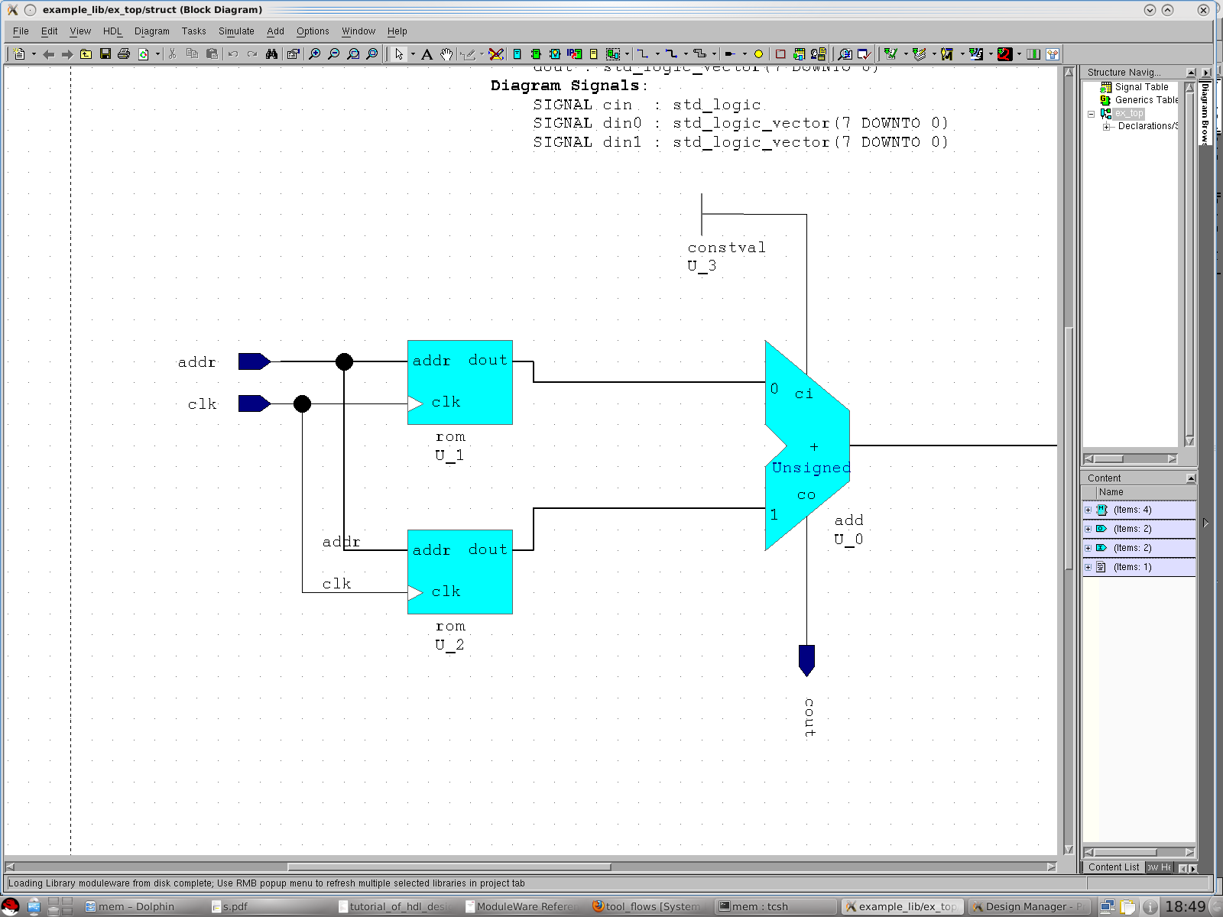

data.txt:

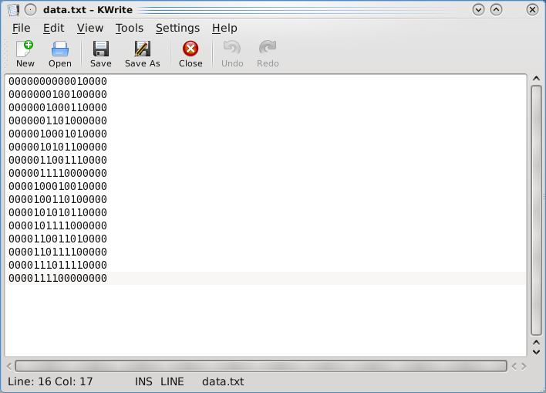

Then copy the hex.pl script into the same directory with data.txt and run the script.

Command format is “*perl hex.pl <number of rom> <data file name>*”.

The script can convert up to 4 ROMs, which is 32 bits binary.

Because we have two ROMS, here we type “perl hex.pl 2 data.txt”.

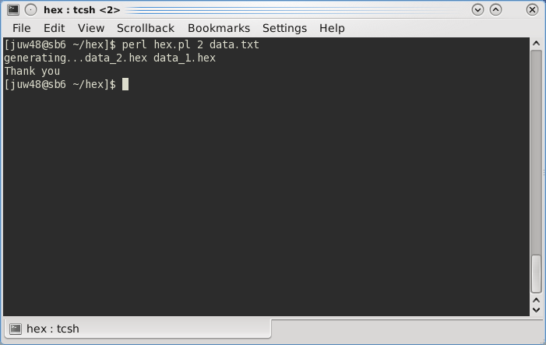

The hex files in the same directory. data_1.hex contains the high order 8-bit while data_2.hex contains the low order 8-bit.

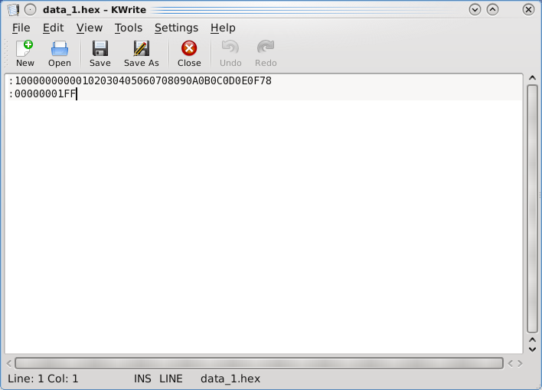

Now we can load the hex file into our design, just double click on the ROM and then specify the path to our generated hex file in the property window accordingly.

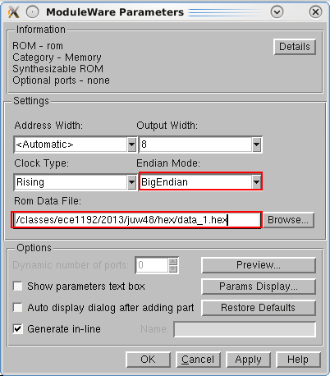

Another thing you should pay attention to is the “Endian Mode”. It referrers to address’s endian. Usually we choose “Big Endian“. The difference between “Big Endian” and “Little Endian” can be illustrated by the image below.

