**To login to the Randi:**

*If you are off campus, please make sure the VPN is connected!*

**For Mac User:**

1. Open the terminal on your system.

1. Type the following command using the username from the Training Account Excel Sheet $ ssh <username>@randi.cri.uchicago.edu



1. After entering the above command, you should see a screen prompting you for a password. If you see anything different, please confirm that your VPN is connected.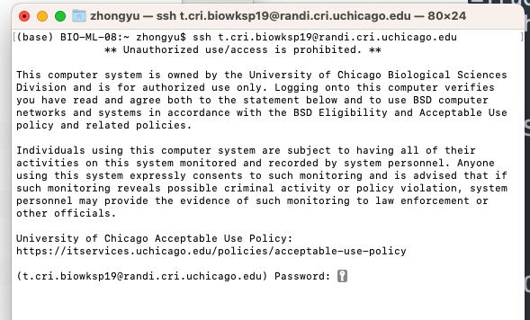
2. Paste the passcode from the Excel sheet. Please note that you won't see any characters after pasting or typing. Press Return on your keyboard, and the terminal will accept your passcode. For first-time login, a secure alert may ask you to verify the fingerprint, select Yes to connect.
3. If you see the screen below after entering your passcode, congratulations! You have successfully logged in to Randi using your Training Account.

**For Windows User:**

1. Download PuTTY <https://www.chiark.greenend.org.uk/~sgtatham/putty/latest.html>



1. After installation, open PuTTY terminal.



1. In the Host Name section, input <username>@randi.cri.uchicago.edu (replace zhongyu1 with the Username from the Training Account Excel Sheet).



1. For first time log in, accept the security alert if it pops up.



1. A new window will open, asking for the password. Paste the passcode from the Excel sheet. Please note that you won't see any characters after pasting or typing. Press Return on your keyboard, and the terminal will accept your passcode.

1. If you see the screen below after entering your passcode, you have successfully logged in to Randi using your Training Account.

