CADENCE

A Networked Focus Timer and Attention-Measurement Instrument
Embedded firmware · computer-vision analysis host · web dashboard
PROJECT REPORT
Wakibul Zaman Nithor
20 August 2026
github.com/wkblzmn/Cadence · revision 777dae9 + USB/ESP-NOW revision

Contents

1. Introduction
Cadence is a desk instrument that answers two questions a stopwatch cannot: how long you actually worked, and how much of that time your attention was on the work. A physical button on a physical box starts a session, a camera watches the seat, a desktop program decides frame by frame whether the person in that seat is oriented toward their work, and a web dashboard reports what the week actually looked like.
It is built in three tiers. The sensing tier is two ESP32-S3 boards: a hub carrying a 320×240 display, a rotary encoder, a focus-timer button and environmental sensors, and a camera board carrying an OV3660 that puts an MJPEG stream on the local network. The analysis tier is a Python application on the desktop PC that consumes that stream, runs MediaPipe's Face Landmarker over it and classifies attention. The service tier is a Next.js application on Vercel over a Neon PostgreSQL database, which ingests everything the other tiers produce and is the only place in the system where a total is ever computed.
That last clause is the rule the rest of the design follows: the devices emit events and never accumulate. The hub does not store "hours worked today"; it stores that a button was pressed at a moment, and what kind of press it was. Every duration, ratio, streak and daily total shown anywhere is folded out of that event stream by SQL at read time. This costs a dense piece of SQL and buys numbers that cannot drift — no counter on a microcontroller for a power cut to corrupt, no second source of truth to disagree with the first, and no migration when the definition of a day changes.
This report documents the system at revision 777dae9, dated 18 August 2026. The hub, the camera board, the analysis application, the schema, the API, the dashboard and both enclosures are built and working; on-device inference and an ESP-NOW satellite node are deliberately not. One recent change matters to anyone reading the data: until 18 August the vision tier ran in a browser tab served by the camera board, and replacing it with the desktop application corrected three classifier defects, two of which redefine what the recorded numbers mean. Section 9 sets out why.

2. Objectives
The primary five define the deliverable.
- Build a physical focus timer that starts, pauses, resumes and stops a session from one hardware button, and shows session and environment state on a local display without needing a phone or a computer to be useful.
- Measure the room the work happens in — illuminance, temperature, humidity and pressure — and record it alongside the sessions.
- Measure attention rather than mere presence: distinguish a person working from a person sitting at the desk looking elsewhere, without any video leaving the local network.
- Persist everything through an authenticated API that tolerates an unreliable radio link — no duplicated rows on retry, no lost events on a dropped connection, no invented timestamps.
- Present the result as a web dashboard showing daily totals, longest unbroken stretch, attention quality and the task list, and feed a condensed version back to the hub's own screen.
Three engineering standards were adopted alongside them, and several later sections exist to show they were met. Make every failure visible, because a system that reports success while dropping data is worse than one that fails loudly. Prove each subsystem alone before integrating it, with one diagnostic sketch establishing one fact. And degrade rather than stop: a missing sensor, an unreachable camera, a closed analysis host or a dead network must each cost one feature, not the system.

3. Requirements

3.1 Functional
ID | Requirement | Realised by
FR-1 | One button starts, pauses and resumes on short press; stops on a long press (800 ms). | Hub timer state machine
FR-2 | The device emits session events and never stores totals. | 32-entry event queue; SQL fold
FR-3 | Events survive a network outage, and events queued before the clock is set still arrive with correct UTC timestamps. | Durable queue; uptime stamping plus boot-epoch conversion
FR-4 | Environment and illuminance are sampled and posted every 60 s; display brightness follows room light. | Reading POST; BH1750 driving backlight PWM
FR-5 | The task list is pulled from the dashboard and shown on the device. | GET /api/todos, 60 s refresh
FR-6 | Video reaches the analysis host over a USB cable and never touches a network. | Framed JPEG over UART at 2 Mbaud; MJPEG on port 81 retained as fallback
FR-7 | Attention is classified as focused, distracted or absent while, and only while, a session runs. | Session gating via the board's held state
FR-8 | One attention sample every two seconds, by majority vote over that window's frames. | Analysis host voting window
FR-9 | Samples reach the database through the camera relay wherever it is reachable, and directly when it is not. | Camera-board relay; direct POST fallback with a disk-spooled queue
FR-10 | A retried POST must not create a duplicate row. | Unique indexes; ON CONFLICT DO NOTHING
FR-11 | Dashboard and hub both report daily focus seconds, session counts, longest stretch and attention quality. | SQL views and functions; /api/stats/hub

3.2 Non-functional
ID | Requirement | Target
NF-1 | Classification rate | 8 Hz recording, 2 Hz idle
NF-2 | Hub UI responsiveness | Rendering and input never blocked by network I/O
NF-3 | Video confidentiality | Frames never leave the local network
NF-4 | Ingest authentication | Static bearer token, constant-time comparison
NF-5 | Low-light operation | Usable below the ~30 lux point at which the sensor's automatic exposure loops fail
NF-6 | Timezone correctness | Day boundaries in Asia/Dhaka; storage in UTC

3.3 Hardware and software
Element | Choice | Role
Hub MCU | ESP32-S3 DevKit N8R2 | Display, input, sensors, networking
Display | LockerBox 3.2" ILI9341, 240×320 | Three-page UI, landscape at rotation 1
Sensors | BH1750 (0x23); BME280 (0x76), BMP280 or DHT22 | Illuminance and auto-dim; environment
Input | HW-040 rotary encoder; Omron B3F button | Page navigation; session control
Camera MCU | ESP32-S3-CAM N16R8 + OV3660 | MJPEG stream, session state, focus relay
Firmware | Arduino-ESP32 core 3.x, FreeRTOS, LovyanGFX, U8g2 font tables | Two tasks pinned across both cores
Analysis | Python 3.12 · MediaPipe Face Landmarker (float16) · OpenCV · NumPy · Tkinter | Runs on the desktop PC
Web | Next.js 16, React 19, Tailwind 4, TypeScript 5, on Vercel | Ingest, statistics and dashboard
Database | Neon PostgreSQL 16, serverless HTTP driver | Plain PostgreSQL; no provider-specific SQL
Enclosures | Parametric OpenSCAD, printed in PETG | Hub shell, lid and stand; camera shell and yoke

4. System Design
Two features of Figure 1 are worth stating before the detail: there is no wire between the hub and the camera board, and the analysis host never talks to the backend directly.
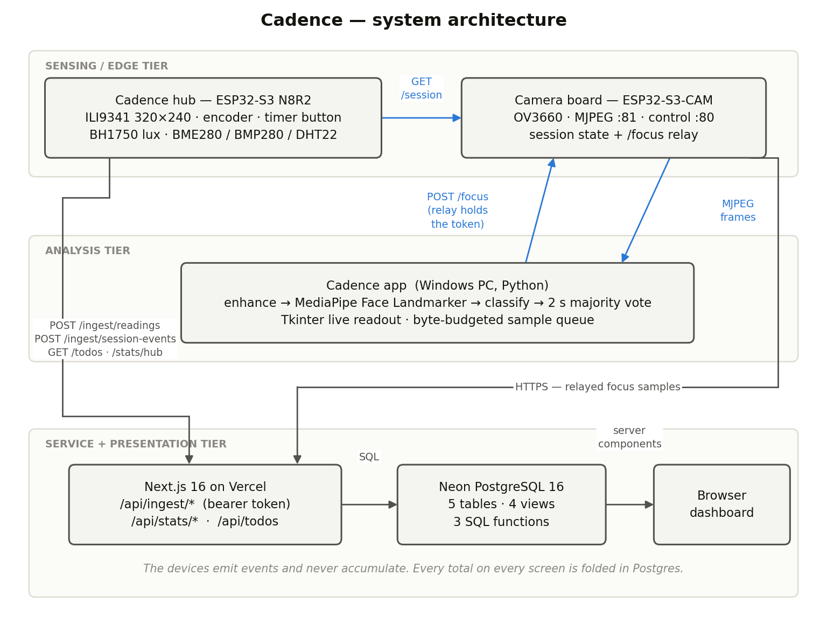
Figure 1 — System architecture. Blue paths are local-network only; grey paths cross the internet.

4.1 Hub
The hub is the part a person touches, and the only component that works entirely alone: with no camera, no analysis host and no network it is still a working focus timer with a local display. Internally it is split across both cores of the S3, and the split is not an optimisation. Rendering and input run in the Arduino loop on core 1; all networking runs in a FreeRTOS task on core 0, because the HTTP client blocks and a two-second TLS handshake in the render loop would freeze the display and drop encoder detents while it ran. The event queue, the task list and the statistics block are each shared across that boundary and each carries its own mutex, so a fifteen-frame-per-second render never waits behind a network drain. The interface is three encoder-navigated pages: Home, with the clock, session timer, week chart, attention bar and camera-state pill; Tasks; and Status.

4.2 Camera board
The board serves an MJPEG stream and holds session state. It performs no inference. It runs two HTTP servers on two ports, which follows directly from the web-server library's behaviour: it serves one client at a time and a streaming handler never returns while its viewer stays connected, so serving video from port 80 makes the board deaf to every other request and one stale browser tab locks it out until power-cycled. Port 80 carries control and always answers; port 81 carries MJPEG from its own task.
The board also holds the session state on the hub's behalf, because the hub cannot address the analysis host. The hub pushes state every thirty seconds; the host polls for it every two. The board expires a state it has not heard about for ninety seconds — three heartbeats — so a hub that loses power cannot leave the pipeline recording, and one dropped heartbeat cannot stop a live session. Its relay endpoint exists to keep the API token in firmware: the host posts samples in plain HTTP over the LAN, and the board splices on its device identifier and forwards them over TLS with the token attached.

4.3 Analysis host and classifier
The host owns the whole pipeline — connect, measure brightness, enhance only when darkness justifies the cost, run the landmarker, classify, vote over a two-second window, queue one sample per window — and a window showing what the system currently thinks you are doing, which is what makes the classifier inspectable rather than a matter of faith. Its threading mirrors the hub's for the same reason: Tkinter owns the main thread and both halves of the loop block, so the pipeline runs on a worker that publishes a snapshot the window reads when it repaints.
A frame is classified from three measurements, each normalised against its own limit. Yaw and pitch come from landmark geometry — the nose's offset over the eye span — which is scale-invariant, so it does not care how far away you sit, and does not depend on an axis convention that has changed between library versions. Gaze is a signed two-component vector built from ARKit blendshapes: the shapes come in opposing pairs, so each direction is the average of its pair minus the opposite direction's, giving a quantity centred on zero at a neutral gaze. Eye closure is measured but never scored — a blink is absorbed by the voting window, and sustained closure is drowsiness, a different signal this project does not claim to detect.
The three terms combine by taking the worst offender: the ratio is the largest of |yaw|/0.20, |pitch|/0.28 and gaze magnitude/0.30. Above 1.0 the frame is distracted; confidence is the distance from that boundary on whichever side it fell, so an unambiguous verdict carries high confidence regardless of which verdict it was. All three are measured against a calibrated centre recorded over eight seconds of sitting normally; without it everything reads distracted, and the application says so rather than quietly reporting nonsense.

4.4 Data model and API
The schema is five tables and none of them stores a total: devices, readings (every sensor field nullable, so a missing sensor still yields a usable lux row), session_events (the sole basis for every duration), focus_samples, and todos. On top sit the views and functions that fold them, each link answering a specific failure:
- session_intervals pairs each opening event with whatever event closes it — a second start with no intervening stop still terminates the interval, because two overlapping sessions are not something the device can produce.
- session_intervals_clamped caps an interval left open by a power loss at four hours: longer than any plausible unbroken session, short enough that a crash costs one afternoon rather than a week.
- session_segments splits intervals at local-day boundaries, so 23:30 to 00:45 is thirty minutes on one day and forty-five on the next. It is the only place the split is implemented; everything else derives from it.
- focus_islands and focus_daily collapse consecutive same-state samples into runs — breaking a run both on a state change and on a gap of more than ten seconds — and turn those runs into per-day focused, distracted and absent seconds, longest stretch, break count and focus ratio.

Endpoint | Method | Auth | Purpose
/api/ingest/readings | POST | Bearer | One environment and illuminance sample
/api/ingest/session-events | POST | Bearer | A batch of timer events
/api/ingest/focus | POST | Bearer | A batch of attention samples, relayed by the board
/api/stats/daily | GET | open | Daily totals over an arbitrary range
/api/stats/hub | GET | open | The hub's Home screen in one response
/api/todos | GET / POST / PATCH / DELETE | open read | The task list

The two statistics routes are separate on purpose. The general one returns labelled objects over an arbitrary range; the hub route returns seven bare integers oldest-first, an integer percentage instead of a float and 1/0 instead of booleans, because its consumer is a microcontroller with a hand-rolled scanner and one TLS handshake to spend. Both compute every number in PostgreSQL and aggregate nothing of their own.

4.5 Pin assignment
Signal | GPIO | Destination
TFT SCK / MOSI / CS / DC / RST | 12 / 11 / 10 / 16 / 17 | ILI9341 panel
TFT backlight | 15 | Panel LED pin, driven as LEDC PWM
I²C SDA / SCL | 8 / 9 | BH1750 and BME280 in parallel
Encoder CLK / DT / SW | 4 / 5 / 6 | HW-040
Timer button | 7 | Omron B3F, diagonal leg pair, INPUT_PULLUP
DHT22 data | 18 | Optional single-wire environment sensor

Reserved: GPIO 0 (boot strap), 19–20 (native USB), 26–32 (internal flash and PSRAM), 43–44 (UART0) and 45–46 (strapping). The whole build runs at 3.3 V; there is no 5 V rail anywhere in it, and both the display and the encoder are destroyed or degraded by one.

5. Flowchart
Figure 2 traces one full cycle of the analysis host, from launch through the frame loop to the batched delivery of a completed sample. Connector A joins the two columns; connector B is the return to the top of the frame loop.
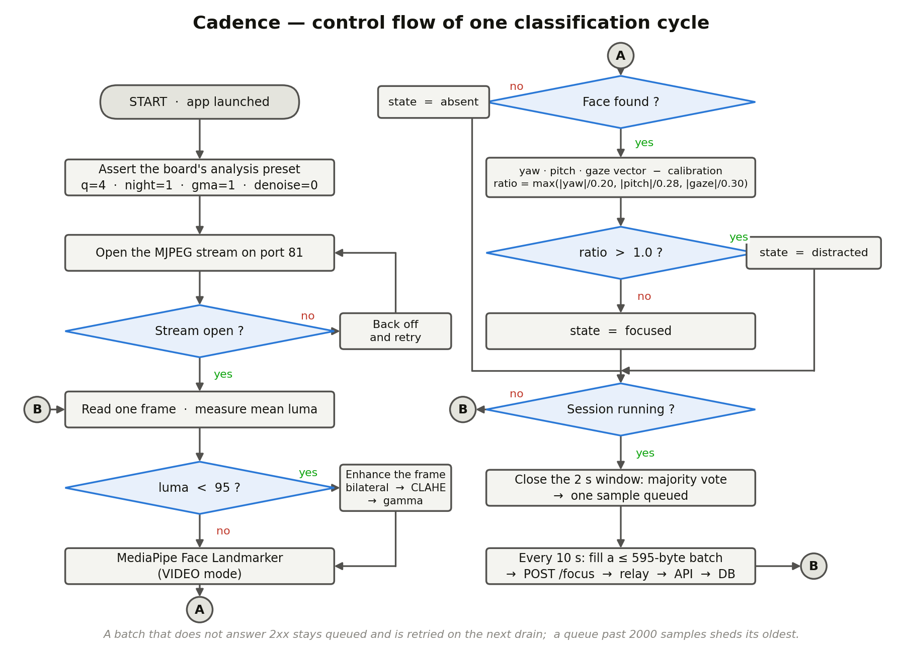
Figure 2 — Control flow of one classification cycle in the analysis host.
Three properties are easy to miss. The frame loop never stops: frames are read and classified whether or not a session is recording, because reading the stream is what tells the board a viewer is attached. The session gate sits late, not early — everything upstream of it happens regardless, and it decides only whether the verdict is recorded, which is what lets the live readout stay honest while the recorded data stays confined to real sessions. And a single frame never decides a state, so a blink is a minority in its window and disappears while a real lapse spans several windows and survives.

6. Program
The system is roughly eight thousand lines across four languages. Rather than reproduce them, this section lists the four passages that carry the most weight: the definition of attention, the event source, the delivery rule and the fold.

6.1 The classifier
Gaze is assembled as a signed vector before its magnitude is taken. The earlier implementation took a maximum over mixed blendshapes, which section 9 shows made the entire gaze term inert.
Listing 1 — app/cadence/analysis.py (abridged)
def gaze_vector(scores):
"""Signed (horizontal, vertical) eye direction from ARKit blendshapes.
Looking one way raises two shapes at once: a glance to your left is
eyeLookOutLeft on the left eye and eyeLookInRight on the right."""
s = lambda n: scores.get(n, 0.0)
left = (s("eyeLookOutLeft") + s("eyeLookInRight")) / 2
right = (s("eyeLookInLeft") + s("eyeLookOutRight")) / 2
down = (s("eyeLookDownLeft") + s("eyeLookDownRight")) / 2
up = (s("eyeLookUpLeft") + s("eyeLookUpRight")) / 2
return left - right, down - up

# ... in classify(), after subtracting the calibrated centre:
gaze_mag = math.hypot(gh, gv)

# How far past its own limit the worst offender is. Above 1.0 is
# distracted, and the distance from 1.0 is how sure we are either way.
ratio = max(abs(yaw) / 0.20, abs(pitch) / 0.28, gaze_mag / 0.30)
state = "distracted" if ratio > 1.0 else "focused"
conf = min(1.0, max(0.5, 0.5 + abs(ratio - 1.0) * 0.5))

6.2 The timer state machine
The elapsed-time counter is display-only and explicitly forbidden from being persisted; the event, not the total, is what leaves the device. The camera notification is derived from the timer's state rather than the event name, because they are the same fact and two switches over one fact are how two things drift apart.
Listing 2 — firmware/cadence_hub/cadence_hub.ino (abridged)
// Display-only. The server recomputes everything from the event stream.
// This resets on power loss by design. Do not write it to NVS. Do not
// let it become the source of truth.
uint32_t sessionAccumMs = 0, sessionStartMs = 0;

static void emitSessionEvent(const char *type) {
evqPush(type); // queued against uptime, not wall clock
camNotify(timerState == T_RUNNING ? 1 : timerState == T_PAUSED ? 2 : 0);
}

static void timerShortPress() {
switch (timerState) {
case T_IDLE:
sessionAccumMs = 0; sessionStartMs = millis();
timerState = T_RUNNING; emitSessionEvent("start"); break;
case T_RUNNING:
sessionAccumMs += millis() - sessionStartMs;
timerState = T_PAUSED; emitSessionEvent("pause"); break;
case T_PAUSED:
sessionStartMs = millis();
timerState = T_RUNNING; emitSessionEvent("resume"); break;
}
}

6.3 The delivery rule
Batches are measured in bytes against the firmware's real limit rather than counted. Section 9 describes the failure this replaced.
Listing 3 — app/cadence/relay.py (abridged)
# The board's relayPush rejects a body at or over RELAY_BODY_MAX -- and
# that is *after* handleFocus splices the device_id on, costing 29 bytes.
BODY_BUDGET = 640 - 29 - 16 # 16 bytes of slack

def _next_batch(self):
"""Take as many samples as fit in one relay body."""
batch = []
for s in self.pending:
trial = batch + [s]
if len(encode(trial).encode()) > BODY_BUDGET and batch:
break
batch = trial
return batch

# A failed batch goes back to the front rather than being dropped: a
# transient error should cost a delay, not the data.

6.4 The fold
This is the only place in the system where a session is split at a day boundary. Every daily figure on the dashboard and on the hub derives from it, which is what guarantees they agree.
Listing 4 — db/schema.sql (abridged)
-- A session from 23:30 to 00:45 is 30 minutes on one day and 45 on the
-- next. Days are local (Asia/Dhaka), not UTC -- a "day" is what the
-- user experienced. Storage stays UTC; only the bucketing is local.
create or replace function session_segments(p_tz text default 'Asia/Dhaka')
returns table (device_id text, source text, day date,
seg_start timestamptz, seg_end timestamptz)
language sql stable as $$
with bounds as (
select i.device_id, i.source, i.started_at, i.ended_at,
generate_series(
date_trunc('day', i.started_at at time zone p_tz),
date_trunc('day', i.ended_at at time zone p_tz),
interval '1 day') as local_day_start
from session_intervals_clamped i
)
select device_id, source, local_day_start::date as day,
greatest(started_at, (local_day_start at time zone p_tz)),
least(ended_at, (local_day_start + interval '1 day') at time zone p_tz)
from bounds
-- Drop the zero-length segment a midnight-ending session leaves on the
-- following day, so that day stays off the chart entirely.
where least(...) > greatest(...);
$$;

7. Working Principle

7.1 A session, end to end
- The button is pressed. The input handler debounces it, classifies it as a short press, and advances the timer from idle to running. The on-screen timer starts, and it is display-only.
- An event is queued. The word "start" and the current uptime go into a 32-entry ring under a mutex — uptime, not wall clock, because the press may precede NTP; the boot epoch converts it later. The same call tells the network task to arm the camera board. Nothing blocks.
- The network task drains the queue: it snapshots the events, releases the mutex, performs the handshake and POST with the mutex released, and on a 2xx commits exactly the number it snapshotted — anything queued during the request stays queued.
- The analysis host notices within two seconds. A failed poll returns the last known state rather than idle, because one dropped request over Wi-Fi is not a stopped session.
- Frames are classified at 8 Hz — measured for brightness, enhanced if dark, put through the landmarker in video mode, reduced to a state and a confidence. Every two seconds the accumulated votes collapse to a majority and one sample is queued; every ten seconds the queue drains in byte-sized batches through the board's relay.
- A long press stops the session and the board is told to go idle. Both timers reset, having never been authoritative. When the dashboard is next opened, PostgreSQL pairs the events into intervals, clamps anything left open, splits at local midnight, sums the segments and collapses the samples into runs. Nothing was accumulated anywhere before this moment.

7.2 Timing
Interval | Value | Why
Classification rate | 8 Hz / 2 Hz idle | The board rarely exceeds ~12 fps; idle work keeps the readout live cheaply
Voting window | 2 s | Absorbs a blink or a glance, still catches a real lapse
Sample upload | 10 s | Amortises the round trip without letting the queue grow
Session poll | 2 s | How quickly the pipeline reacts to the button
Hub → camera heartbeat | 30 s | Refreshes the board's held state and the status pill
Camera session TTL | 90 s | Three heartbeats: one drop cannot stop a session, a dead hub cannot leave one running
Reading / stats refresh | 60 s | Enough resolution for a room; keeps the hub current
Long-press threshold | 800 ms | Separates stop from pause without accidental triggering

7.3 Why the arming chain is indirect
The hub cannot start the analysis host — it has no way to address a desktop program, knowing only what its firmware was compiled with. So the chain is built from hops between things that can name each other: the hub names the board, and the host polls the board. This is also why the host's own Start button does not write the running state back to the board: the hub re-pushes its own idea of that state every thirty seconds, so anything the host wrote there would be overwritten within half a minute and the recording would stop by itself. Local sessions are held in the application instead.
The consequence a user must know is that nothing is recorded unless the analysis host is running. The hub's Home screen therefore carries a status pill visible from the chair, and its five states are the whole diagnostic surface for the vision tier: STANDALONE (no camera has ever answered — a supported mode, not a fault), CAM LOST (it answered before and has stopped), NO VIEWER (the board is up but no host is attached, so nothing is being recorded), READY, and TRACKING.

7.4 Working in a dark room
The desk this was built for is dim, so low light is attacked from both ends of the link. On the board the application asserts an analysis preset at startup instead of inheriting whatever the camera was left in: higher JPEG quality, gamma on, the sensor's own denoiser off — on a face the detail it removes is the eye and mouth structure the landmarker reads — and night mode on. That last is the important one: exposure and gain are manual-mode registers, ignored while the automatic loops run, which is why raising ceilings and targets had no effect for a long time.
On the PC every frame is measured and given only the work its darkness justifies: bilateral denoising, then local contrast equalisation on the lightness channel, then gamma — in that order, because denoising last would smooth away the structure the contrast stretch had just raised. The strength is a ramp rather than a switch, since a threshold would make enhancement flicker as the light drifted across it, and a landmarker fed alternately enhanced and raw frames tracks worse than one fed either consistently. A well-lit frame is returned untouched, so a lit desk pays nothing. If both fail, the host climbs an exposure ladder on the board — but only when frames are dark and faces are actually being missed, since exposure time is frame rate, and it climbs without ever descending, because dropping back would oscillate against the condition it is correcting.

8. Implementation
Nothing was integrated before it was proven alone. Seven diagnostic sketches each establish one fact, and the wiring guide specifies a rebuild order in which every step is verifiable before the next is added, so a fault is always in the thing just touched. Two of them overturned expectations rather than confirming them: a quadrature trace showed the encoder produces two steps per click rather than four and rests alternately in two states, and a pull-up probe established that the environment sensor was powered but dead.
The graphics library was changed under duress. TFT_eSPI crashes on initialisation with the ESP32-S3 under Arduino core 3.x — a store-prohibited fault confirmed by register dump and reproduced with two independent sketches including the library's own diagnostic example. LovyanGFX resolved it and, as a side effect, moved the panel configuration into the sketch rather than a library header, removing a whole class of confusion about whether a setup file took effect. U8g2 is included but drives nothing: it is present for its font tables, which LovyanGFX renders directly, and the dead-code pass drops the two thousand faces the sketch never names.
The event queue is the durability mechanism: the network task snapshots it, sends with the mutex released, and commits exactly what it snapshotted — holding a mutex across a two-second handshake would block the UI on its next button press, and clearing rather than counting would discard anything pressed during the request. On the camera board, the loop task's stack is explicitly raised to 16 KB, because the relay performs a TLS handshake inside a web-server handler running on that task; the handshake wants about 6 KB against a default of 8, and an overflow there would present as a random reboot whenever a sample was posted. The camera configuration itself was settled by measurement: VGA is a floor rather than a ceiling, because the smaller sizes measured zero frames on this three-megapixel sensor and the larger ones are just more bytes for a model that downscales before inference.
In the analysis host, detection runs in MediaPipe's video mode so tracking carries between frames; that mode requires strictly increasing timestamps, and a reconnecting stream can present the same millisecond twice, so the detector is wrapped in a class whose only state is that counter. The stream connection reopens itself rather than ending the run, because the PC boots faster than the board joins the network and a host that gives up on the first attempt is never running when you sit down. Calibration checks its yield, not just its count: the file this rule replaced had been built from eight usable frames and passed a guard that only rejected below five, and that baseline then silently defined centre for every session after it.
On the backend, validation is hand-rolled so every rule is visible in the route enforcing it. Timestamps must be ISO 8601 and within seven days of now, because a timestamp the device could not have produced signals a fault that coercion would hide inside the data. The distinction between 400 and 500 is load-bearing: the hub treats 4xx as "drop this event" and 5xx as "keep it queued", so a database outage reported as a bad request would make the device discard good data. Idempotency comes from unique indexes with conflict clauses — and, just as importantly, the routes now report how many rows were actually inserted, because a swallowed duplicate and a real write previously both answered 201 with no way to tell them apart.
Both enclosures are parametric models in which one tolerance value drives every derived dimension, and a nine-minute test coupon carrying the encoder bushing hole, the button cap hole, an insert boss and a section of the display rib slot is printed before committing six hours to the shell. Three decisions in them are function rather than decoration: the light sensor sits behind a baffle, because backlight leaking into the case makes auto-dim chase its own tail; the environment sensor has its own vented chamber, because sharing air with a lit panel and a Wi-Fi SoC puts a reading five to ten degrees high and, worse, stably so; and the USB opening is one wide slot, because the two sockets sit differently on every clone of this board.

Component | Language | Lines
Hub firmware | C++ (Arduino) | 2,044
Camera firmware and preview page | C++ (Arduino), HTML/JS | 1,241
Bring-up diagnostics (in repository) | C++ (Arduino) | 328
Analysis application | Python | 1,640
Dashboard and API | TypeScript / TSX | 1,605
Database schema and fold | SQL | 391
Enclosure models | OpenSCAD | 929

9. Results and Discussion
End to end, the built system does the following. A press of the hardware button starts a session and arms the vision tier; the host classifies at eight frames per second and produces one sample every two seconds; samples reach PostgreSQL through the board's relay without the desktop application ever holding a credential; and the dashboard reports daily focus seconds, session counts, longest unbroken stretch, focused/distracted/absent seconds, attention breaks and a focus ratio, all folded at read time. The hub renders a condensed version from a single API response. With no camera board and no analysis host, the hub remains a fully working focus timer.
The figures below are measurements recorded during development and bring-up, as documented in the project's wiring reference, firmware comments and commit history. They are development measurements on one set of hardware, not the output of a controlled evaluation.
Quantity | Recorded value | Note
Classification rate | 8 Hz while recording | Against a stream that rarely exceeds ~12 fps
Enhancement cost | ≈ 10 ms dark, ≈ 0.06 ms lit | Of the 125 ms available per cycle at 8 Hz
Stream bandwidth | ≈ 0.5 Mbps peak | Across every camera configuration tested
Usable resolutions | VGA only | QVGA and CIF measured zero frames on this sensor
Relay body limit | 640 bytes | Firmware constant; batches sized in bytes against it
Encoder resolution | 2 steps per click | Half-detent; rest alternates between two states
Low-light failure point | ≈ 30 lux | Below this the sensor's automatic loops return black
Calibration yield guard | ≥ 20 of ~60 frames | Replaced a guard that accepted 8

9.1 The classifier rewrite
The most consequential result of this project is negative: for most of the vision tier's life its central feature did not work, and it took a rewrite to discover that.
The gaze term never fired. The original classifier took a maximum over six mixed ARKit blendshapes, which are not zero at a neutral gaze because opposing eyes carry partial scores. The measured baseline sat at 0.418, leaving 0.582 of headroom against a limit of 0.35, so firing required a raw score above 0.77 — and a real glance down at a phone measures about 0.72. The term was dead, which means the classifier was head-pose-only, blind to precisely the case the design cared most about: a phone on the desk moves the eyes and not the head. The shape set also omitted looking up, so a glance at a monitor above the main one was invisible.
Confidence was inverted. The original formula fell as a person turned further away, so the least ambiguous distracted samples reached the database carrying the lowest confidence on the scale — a confidence-in-focused score wearing the wrong label.
And batches larger than eight samples could never be delivered. The previous host posted up to a hundred per request against a relay that rejects any body at or over 640 bytes. Under normal timing a drain carried five and squeaked under the limit, so it worked — until a network hiccup let the queue reach nine, after which every retry failed identically and the queue could never drain again. This is the most instructive bug in the project: a latent defect that manifests only once something else has already gone slightly wrong, and which then makes the recovery path permanently impossible.
Because the first two defects change what focused means, rows written before 18 August 2026 came from a different definition and are not comparable to anything written after. This is recorded in the application's documentation rather than papered over, and it is why the calibration file carries a schema version that refuses rather than migrates.

9.2 Discussion
Deriving totals in SQL was the right call and would have been hard to reverse later. Two bugs that would have been data corruption in a device-accumulates design were instead single-function fixes: an interval left open by a power loss, solved by a clamp, and a session crossing midnight, solved by a split. An earlier revision had two code paths bucketing days differently and disagreeing by exactly one midnight crossing — a stronger argument for a single definition than any amount of reasoning in advance.
Making failures visible repeatedly paid for itself, because the three worst defects here were all silent successes: the 201 returned on a discarded duplicate, a status line that read healthy while every request failed, and the dead gaze term. Splitting the vision tier off the microcontroller was correct, and the intermediate design was not — running inference in a browser tab served by the board introduced a dependency nothing in the system could see, and the tell was blunt: a tab left open overnight reported an unbroken four-hour focus that never happened, which is what motivated both the session gating and the ten-second gap rule.

10. Challenges
- Diagnosing a dead sensor without a multimeter. With the internal pull-ups disabled, a bus line still reading solidly high can only be held there by an external resistor tied to the module's supply — so a high line proves the module is powered. The sensor was then shown silent at four bus speeds, in both pin orientations, alone on the bus, with no breadboard in the path. Power confirmed, wiring confirmed, chip dead.
- A graphics library that could not initialise. Diagnosis required ruling out the wiring, the panel and the sketch before concluding the library was at fault, which meant reproducing the crash with the library's own diagnostic example.
- An encoder that was not what it claimed. It counted erratically until a trace captured every quadrature transition of one physical click. Every assumption in the decoder had to be rewritten around a half-detent mechanism.
- A camera sensor that would not brighten. For a long stretch, no amount of raising exposure ceilings, gain ceilings or brightness targets made a dim room usable, because the values being set are manual-mode registers ignored while the automatic loops run. Nothing reported an error; the settings were accepted and had no effect.
- A batching bug that only appeared after a hiccup. Its difficulty was not the fix but the diagnosis: under all normal conditions the code worked, and it failed permanently only after an unrelated transient pushed the queue past a threshold nothing in the code named.
- Interfaces that reported success while losing data. Three separate instances, none of which produced an error, a log line or a visible symptom. Each was found by checking whether the data made sense, not by anything alerting — the strongest theme in this project's engineering history.
- Name resolution on a demonstration network. The hub finds the board by mDNS, which survives an address-lease change that a hard-coded address would not — but mDNS is unreliable on exactly the phone hotspots a demonstration is most likely to use, and captive portals do not work at all.
- Timezone and day boundaries. Several distinct bugs from one root: resolving "today" in the wrong place. The deployment runs in UTC, so asking the application layer for today's date in Asia/Dhaka lands a day early for six hours out of every twenty-four. The day window is now resolved in the database, and day keys are handled as strings from end to end.

11. Limitations
- It measures a proxy, not attention. Head pose and gaze indicate where the eyes point, not whether the mind is engaged. Someone staring at the screen while thinking about something else records as focused. The system measures orientation toward the work and should be read as that.
- No controlled evaluation has been performed. The figures in section 9 are development measurements on one set of hardware with one subject. There is no labelled ground truth, no accuracy or false-positive rate, and no inter-subject validation.
- One face, one seat, one calibration. The baseline is specific to a seating position, so a materially different seat or camera placement requires recalibration — and a stale baseline makes everything read distracted, which the application reports but cannot correct.
- Recording requires the desktop application to be running, because the camera board performs no inference. Sessions are still timed and stored, but no attention data exists for them. The status pill makes this visible; it does not make it not so.
- The vision tier needs the PC and both boards on one local network. A deliberate confidentiality choice — frames never leave the LAN — but it means the system does not work away from that network.
- Authentication is a static bearer token, and reads are open. The token is compiled into firmware and is enough to keep the write endpoints off the open internet; it is not real security. Certificate validation is skipped on the devices, a documented deviation. Network credentials are compile-time constants, so changing networks means reflashing both boards.
- The four-hour clamp under-reports genuine long sessions, and midnight-crossing sessions are split across two days. Both were judged the better failure — the alternative to the clamp is an open interval that grows without bound and corrupts every total downstream — but both are worth knowing when reading the chart.
- The environment sensor is currently absent. The fitted unit is dead and awaiting replacement, so temperature, humidity and pressure are not being recorded at present. Firmware degrades gracefully and illuminance is unaffected.
- Attention data predating 18 August 2026 is not comparable to data after it. See section 9.1.
- The system is single-device. The schema references a device identifier throughout, but the deployment, the dashboard and the statistics routes are built around one hub.

12. Future Work
- On-device inference. Moving classification onto the camera board would remove the dependency on a desktop application being open, which is the largest usability limitation in the current design. It is parked as a separate effort because it is a different engineering problem: a model small enough for the S3, and an accuracy budget to match.
- A labelled evaluation. The most valuable next step scientifically — a ground-truth-labelled session set, so accuracy, false-positive rate and the sensitivity of the three limits can be stated numerically rather than argued from design. With that data the fixed limits could give way to per-person thresholds derived at calibration time.
- Drowsiness as a separate signal. Eye closure is already measured and deliberately not scored; a sustained-closure detector would be a genuinely different and useful output.
- Per-task attribution. The task list and the session stream exist side by side but are not linked. Attributing focused seconds to the task selected during them would turn the dashboard from a record of how long into a record of on what.
- The ESP-NOW satellite node, placing environmental sensing away from the heat of the hub itself, and Wi-Fi provisioning on first boot so changing networks does not mean reflashing two boards.
- Real authentication. Per-device tokens with rotation, authenticated read endpoints, and certificate validation on the devices.
- Versioned classifier output. Recording which classifier definition produced a row would have made the 18 August discontinuity a query filter rather than a caveat in a document.

13. Conclusion
Cadence works. A press of a physical button starts a session; a camera and a desktop pipeline decide, eight times a second, whether the person in the seat is oriented toward their work; the verdicts survive an unreliable radio link and arrive in a hosted database without the analysis machine ever holding a credential or a single video frame leaving the local network; and a web dashboard and the device's own screen report what the week looked like, with every figure folded from an event stream rather than read from a counter. Removing the camera tier leaves a working focus timer. Removing the network leaves a working clock and a queue that drains when the network returns.
The decision the project would defend most strongly is the one made first: that devices emit events and never accumulate. It cost a dense piece of SQL and paid for itself repeatedly — a power loss mid-session, a session crossing midnight and a change of timezone were each a single-function fix in one place rather than a data migration or a permanent inaccuracy.
The most useful thing this project produced, though, is not in the deliverable. It is the observation that every serious defect encountered here reported success: an endpoint that answered 201 whether it wrote a row or discarded one, a status display that read healthy while every request failed, a batching rule that worked until an unrelated hiccup made it fail permanently, and a classifier whose most important term was arithmetically incapable of ever firing, sitting under comments explaining why that term mattered most. None raised an error. All were found by asking whether the data made sense, and the changes that followed — reporting rows actually inserted, distinguishing armed from unreachable, sizing batches against the real constraint, and putting a pill on the home screen whose only job is to announce that nothing is being recorded — are worth more than the features they protect.
What the system does not yet do is bounded honestly in section 11: it measures orientation toward work rather than engagement with it, it has not been validated against labelled ground truth, and it needs a desktop application open to record anything at all. Those are the next three problems, in that order.

14. Revision: Wired Transport and Radio Sync
Sections 4.2, 4.3, 6.1 and 7.4 describe the system at revision 777dae9. This section records the changes made after it, and the measurements that forced them. Where the two disagree, this section is current.

14.1 The wireless video path was not viable
Measured from the analysis host over a single 40-second capture, the MJPEG path delivered a median inter-frame gap of 615 ms, a 95th percentile of 2671 ms and a worst case of 6331 ms, with only 2 per cent of frames arriving inside 150 ms, on a link carrying 0.12 Mbps. Every exposure and quality setting available produced between 0.6 and 1.8 frames per second.
The same board over USB delivers 19.6 frames per second at 210 KB/s, saturating the link. The sensor was never the constraint, and an early conclusion in this project that attributed the deficit to the transport was reached from a single 98 ms minimum-gap sample and was not supported by the fuller measurement.
The decisive argument is not frame rate but portability. Wi-Fi credentials are compile-time constants with no provisioning path; WPA2-Enterprise cannot be joined by WiFi.begin(ssid, pass); a captive portal cannot be answered by a device with no browser; and client isolation, common on managed networks, hides both boards from the host after a successful join. Any one of these prevents the instrument from being demonstrated away from its home network. A cable has none of them.

14.2 Protocol
Frames carry a twelve-byte header: a four-byte magic, a little-endian length, a CRC-16 CCITT-FALSE over the payload, and a wrapping sequence number. The same UART carries the boot log, so the host resynchronises on the magic and validates length and CRC before decoding; a header appearing inside a log line is rejected at one of those gates. The host decodes only the newest complete frame in the buffer and discards the backlog, which matches CAMERA_GRAB_LATEST in firmware and prevents a two-second voting window being scored from a stale frame.

14.3 Hub and camera synchronisation over ESP-NOW
Section 7.3 describes the arming chain as an HTTP GET from hub to camera. That requires both boards associated to one access point and able to route to each other, which is the first thing to fail off-network. The link is now ESP-NOW, a peer-to-peer radio protocol requiring no access point, DHCP lease, SSID or router.
It is bidirectional. The hub broadcasts timer state on every change and every thirty seconds; the camera broadcasts liveness and whether a host is pulling frames every two seconds, which is what the hub's camera tracker now reads. Messages are addressed to the broadcast MAC and filtered by a magic word, avoiding both hardcoded addresses and a pairing exchange. The HTTP path is retained and preferred wherever a network exists, so the two roads coexist.

14.4 Defects corrected in the classifier and delivery path
Three defects were found by instrumenting behaviour that read plausibly in source. The gaze term had never fired: taking the maximum over six mixed ARKit blendshapes placed the neutral baseline at 0.418, so triggering required a raw score above 0.77, while a deliberate glance at a phone measures approximately 0.72. Gaze is now a signed horizontal and vertical vector centred on zero. Confidence was inverted, falling as head deviation grew, so the least ambiguous distracted samples carried the lowest confidence on the scale; it is now distance from the decision boundary. And batches larger than eight samples could never be delivered, because the firmware relay rejects a body at or over 640 bytes while the host batched up to one hundred; batches are now measured in bytes.
Attention samples recorded before 18 August 2026 were produced under the earlier definitions and are not directly comparable with those recorded after it.

14.5 Throughput of the analysis host
With the wired transport in place the application still reported 0.4 frames per second while the cable was measured carrying 19.6. Three causes, all on the host: the reader decoded every arriving frame and so fell behind a 210 KB/s producer, overrunning the driver buffer and corrupting frames rather than dropping them whole; and two blocking HTTP calls, a session poll with a three-second timeout every two seconds and an upload with a four-second timeout every ten, executed on the frame-reading thread. After correction the application sustains 18.9 frames per second end to end, including enhancement and inference, with no CRC failures and no sequence gaps.

