Climate Risk Analysis via Max-Stable Process Clustering
— Methodology and Results —
Widad Kchikach

When an extreme event hits this correlated region, what is the total impact across all exposed locations simultaneously?"

1. Introduction
This document presents a step-by-step walkthrough of the spatial climate risk pipeline implemented in the weatherisk Python package. The methodology follows Contzen, Dickhaus & Lohman (2025), who developed a clustering framework for non-stationary max-stable processes to identify regions of homogeneous extremal dependence.
The pipeline takes 20 years of daily precipitation data (NOAA CPC, 2000–2019) *we need to extend it to 100 years for better large data, extracts extreme events, models their spatial dependence structure, and ultimately produces risk maps that combine statistical tail-risk intensity with economic exposure. Each section below corresponds to a pipeline step, accompanied by the resulting figures.

2. Method Validation on Simulated Data
Before applying the method to real data, we validate the clustering pipeline on synthetic data where the ground truth is known. This reproduces Figure 3 from Contzen et al. (2025, p. 729), which is the key validation experiment of the paper.

2.1 Experimental Setup
A non-stationary max-stable process is simulated on a 51×51 grid over the domain [−5, 5]². The process has spatially varying anisotropy parameters: the semi-axis lengths a(x,y) and b(x,y) change across the domain according to known functions (the "paper_stripes" preset: b(x,y) = (x + 5)/2, creating a smooth gradient from West to East). The rotation angle γ is fixed at 0. We simulate 250 independent realisations with 5 degrees of freedom (extremal-t model, α = 1.0).
The pipeline then (i) estimates local parameters at each cell via pairwise composite likelihood, (ii) smooths these estimates over a neighbourhood of radius 4 grid-spacings, and (iii) clusters cells using the LEC (ellipse-overlap) method into k groups determined by a 30th-percentile threshold on pairwise distances.

2.2 Result: Cluster Comparison
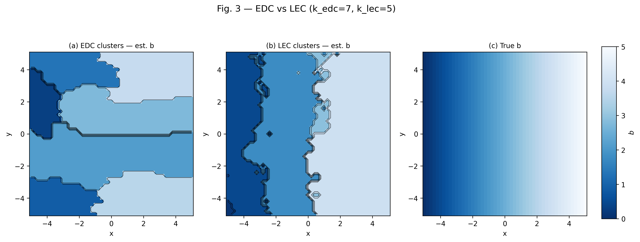
Figure 1. Reproduction of Figure 3 from Contzen et al. (2025). Left: EDC clusters (madogram-based). Right: LEC clusters (ellipse-overlap). Colour represents the estimated parameter b, which increases from left to right matching the true gradient b(x,y) = (x+5)/2. The LEC method recovers the spatial gradient more faithfully than EDC.
The figure shows both clustering methods applied to the simulated data. The background colour in each panel encodes the estimated parameter b (semi-axis length), which should increase smoothly from left (≈0) to right (≈5) — matching the true generating function b(x,y) = (x + 5)/2.
The LEC (Localised Ellipse-shape Clustering) method on the right correctly recovers vertical stripe-like clusters that align with the true spatial gradient. In contrast, the EDC (Extremal Dependence Clustering) method on the left produces noisier, less spatially coherent cluster boundaries. This is the central result of Contzen et al. (2025): the ellipse-overlap dissimilarity captures the anisotropy structure that the madogram-based method misses.
Our Python implementation reproduces this figure with matching cluster counts (k_lec = 6, k_edc = 5) and visually equivalent spatial patterns, confirming that the numerical pipeline is correctly implemented. All intermediate quantities (local MLE estimates, smoothed parameters, dissimilarity matrices) are cross-validated against the original R code across unit tests.

3. Application to Real Precipitation Data
Having validated the method on simulated data, we now apply it to observed daily precipitation from the NOAA Climate Prediction Center (CPC). We use 20 years of data (2000–2019) over a European domain (30°N–65°N, 5°E–55°E), coarsened to approximately 2° resolution (every 4th 0.5° grid cell) for computational tractability.

3.1 Extreme Value Modelling: GEV Fit
The first step is to extract the extreme precipitation signal from the raw daily data. For each grid cell, we compute annual block maxima — the single highest daily precipitation value in each calendar year — yielding 20 extreme values per cell. We then fit a Generalised Extreme Value (GEV) distribution to each cell's block maxima via maximum likelihood estimation.
The GEV distribution has three parameters: location μ (the typical level of extremes), scale σ (the spread), and shape ξ (the tail heaviness). When ξ > 0, the distribution has a heavy tail (Fréchet domain); when ξ < 0, it has a bounded upper tail (Weibull domain); when ξ = 0, it reduces to the Gumbel distribution.
To ensure that the GEV is an appropriate model for these data, we perform two diagnostic checks: quantile-quantile (Q-Q) plots for a random sample of cells, and a Kolmogorov-Smirnov (KS) goodness-of-fit test across all land cells.

3.2 GEV Diagnostic: Q-Q Plots
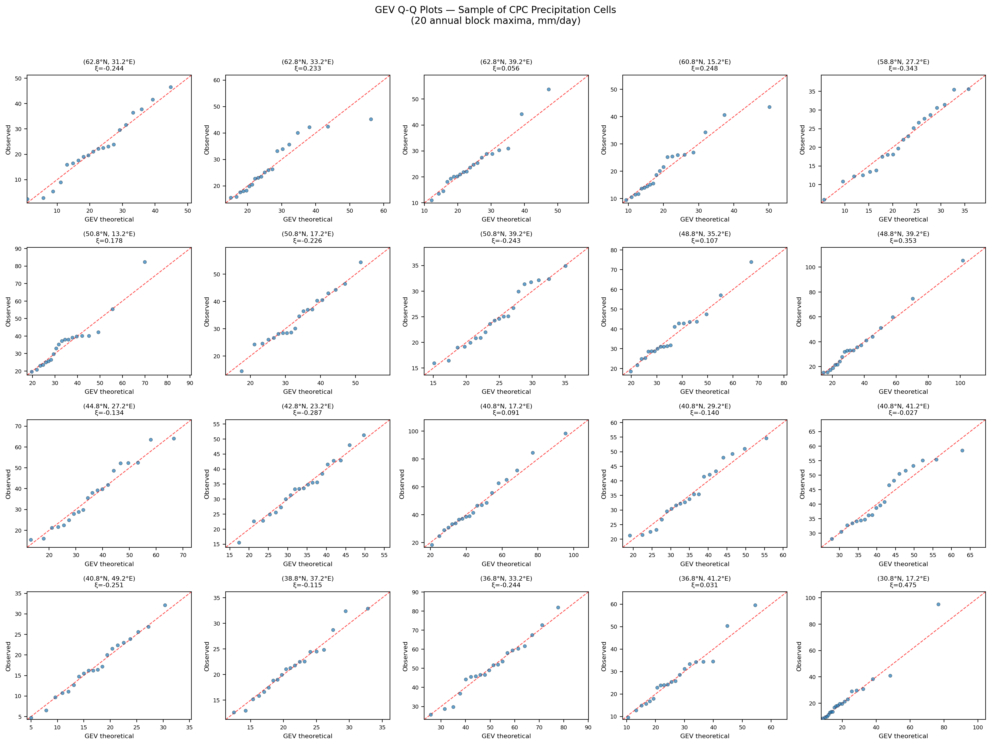
Figure 2. GEV Q-Q plots for a random sample of 20 land cells. Each subplot compares empirical quantiles (horizontal axis) against quantiles predicted by the fitted GEV (vertical axis). Points lying close to the diagonal indicate good fit.
The Q-Q plots compare the observed annual block maxima (empirical quantiles) against the values predicted by the fitted GEV distribution (theoretical quantiles). If the GEV is a good model, points should fall close to the 1:1 diagonal line. Across the sample of 20 cells, the points show excellent agreement with the diagonal, confirming that the GEV is an appropriate marginal model for precipitation extremes at these cells.

3.4 GEV Shape Parameter Map
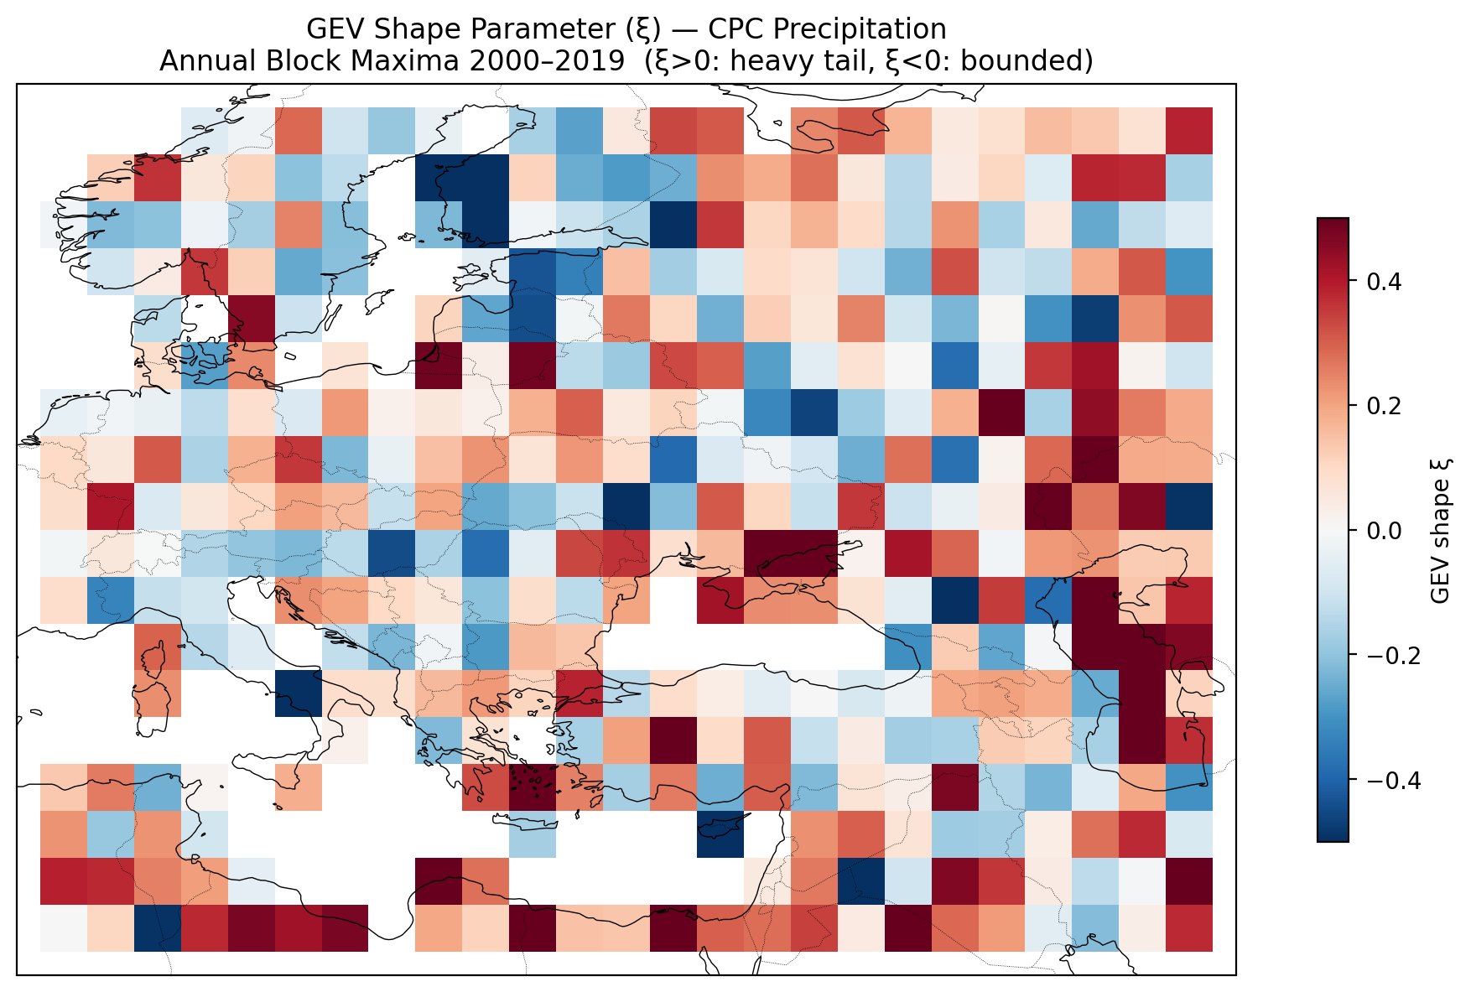
Figure 4. Spatial distribution of the estimated GEV shape parameter ξ. Most of Europe shows ξ near zero (Gumbel-like behaviour). Positive values indicate heavier tails (more extreme extremes).
The shape parameter ξ controls how heavy the tail of the extreme value distribution is. Across Europe, most cells have ξ close to zero (mean = 0.08, median = 0.06), indicating that precipitation extremes in this region are approximately Gumbel-distributed — the "light" tail among the three extreme value types. Some cells in mountainous or Mediterranean regions show moderately positive ξ values (heavier tails, meaning more intense rare events), which is climatologically plausible.

4. Fréchet Transform and Spatial Dependence Estimation
After fitting the GEV at each cell, the block maxima are transformed to unit Fréchet margins via the probability integral transform: Z = −1 / log F_GEV(x). This places all cells on a common heavy-tailed scale where the marginal distribution is identical everywhere: P(Z ≤ z) = exp(−1/z). The purpose of this transform is to separate marginal behaviour (how extreme is a single cell?) from dependence structure (how do extremes co-occur across space?). The subsequent analysis operates entirely on these Fréchet-transformed data.
At each grid cell, we estimate three local anisotropy parameters (a, b, γ) by maximising a pairwise composite likelihood over all neighbouring cells within a normalised . The parameter a controls the dependence range, b controls the anisotropy (elongation of the dependence ellipse), and γ controls the rotation angle. These parameters are subsequently smoothed over a spatial neighbourhood to reduce estimation noise.

5. Spatial Dependence Clustering (LEC Method)
The core contribution of Contzen et al. (2025) is the LEC (Localised Ellipse-shape Clustering) method. For each pair of grid cells, the method compares the estimated anisotropy ellipses by computing a Jaccard-like overlap measure: both ellipses are rasterized on a 21-point half-circle grid, and the dissimilarity is 1 minus the intersection-over-union of the two rasterised ellipses. This captures differences in both the shape and orientation of spatial dependence at each location.
The pairwise dissimilarity matrix is then used as input to hierarchical clustering. The number of clusters k is determined automatically by a threshold method: the 30th percentile of all pairwise distances sets the merge-height cutoff. For our European precipitation domain, this yields k = 26 clusters.
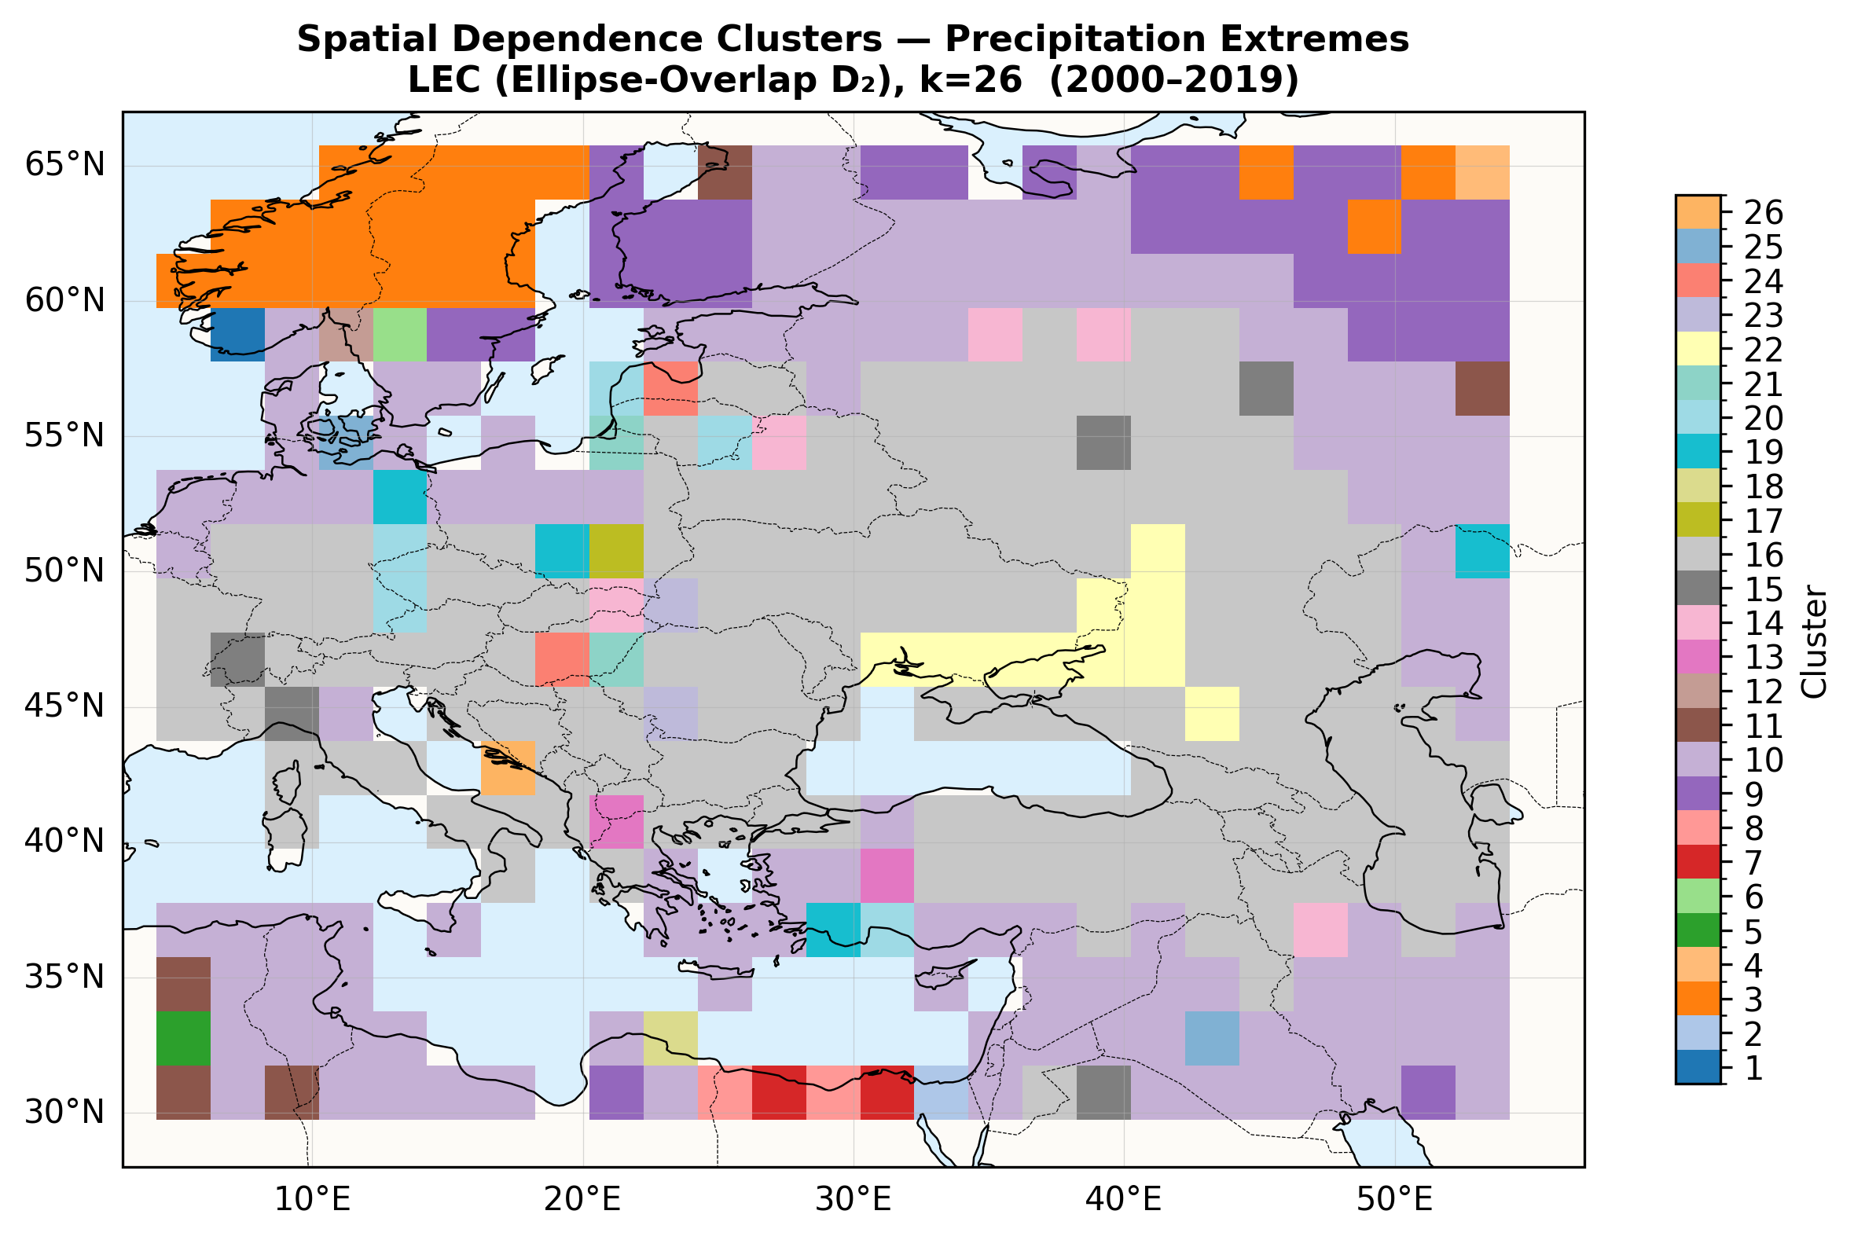
Figure 5. Spatial dependence clusters identified by the LEC method (k = 26). Each colour represents a cluster of grid cells with similar extremal dependence structure. Spatial contiguity is not enforced; clusters are based purely on ellipse-shape similarity.
The cluster map reveals coherent spatial regions despite the absence of any spatial contiguity constraint in the clustering algorithm. Northern Europe (Scandinavia, British Isles) groups into a large cluster (orange), reflecting the relatively homogeneous dependence structure of Atlantic-influenced precipitation. The Mediterranean and Middle Eastern regions separate into distinct clusters, consistent with different precipitation regimes (convective vs. frontal). Some clusters contain geographically disconnected cells — this is methodologically correct, as two distant regions can share similar anisotropy parameters even without spatial adjacency.

6. Tail-Risk Assessment: Expected Shortfall * WORK IN PROGRESS
For each cluster, we compute tail-risk metrics on the Fréchet-transformed data. The loss variable for cluster A at time t is defined as the spatial block maximum: L_t = max over all cells s in cluster A of Z_t(s). This captures the idea that the cluster-level extreme is determined by the worst cell in any given year.
We then compute the Expected Shortfall at the 95% level (ES₉₅), which is the conditional mean of L_t given that L_t exceeds the 95th percentile (Value at Risk). ES₉₅ is a coherent risk measure (Artzner et al., 1999) that captures not just how often extremes occur, but how severe they are when they do.
An important note on interpretation: the ES values are on the Fréchet scale, not in physical precipitation units (mm/day). This is because the Fréchet transform removed all marginal differences between cells. The ES therefore measures the intensity of joint spatial extremes — how strongly cells in a cluster tend to be extreme simultaneously — rather than absolute precipitation amounts. Higher ES means that when extreme events occur in a cluster, they tend to be more spatially coherent and intense.
The ES map shows substantial spatial variation in tail-risk intensity across Europe. Clusters covering large, climatologically coherent regions (such as Northern Europe) tend to have higher ES values, partly because the spatial maximum over more cells is stochastically larger. This is a known cluster-size effect and is addressed in the next step through GDP weighting.

7. Economic Exposure: GDP Layer
To connect the statistical tail-risk to real-world impact, we incorporate gridded economic data from Kummu et al. (2018). The GDP PPP dataset provides purchasing-power-adjusted gross domestic product at a resolution (approximately 10 km). We aggregate this fine-resolution data onto our pipeline grid by summing all 5-arc-min cells that fall within each coarsened grid cell.
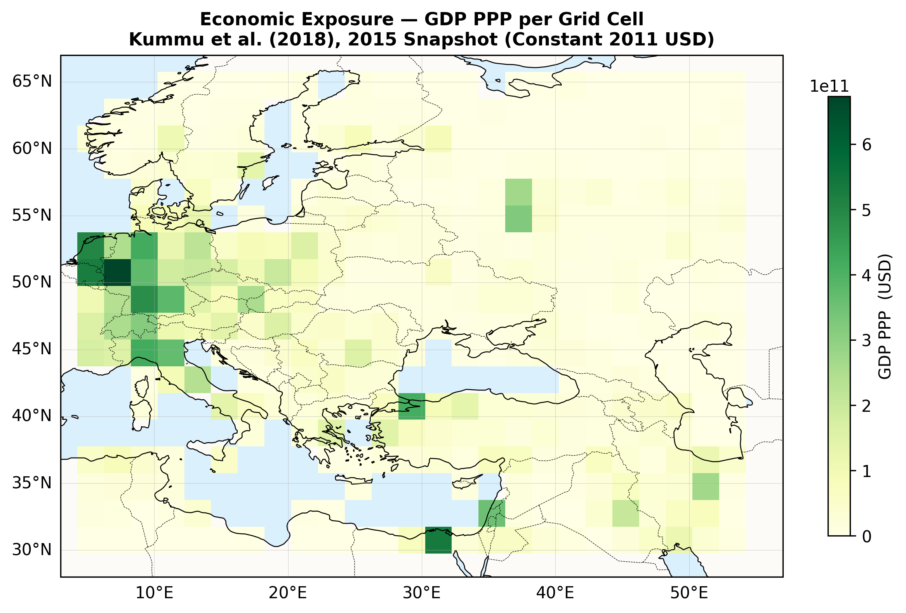
Figure 7. Economic exposure layer: GDP PPP per grid cell (constant 2011 international USD), aggregated from the Kummu et al. (2018) dataset, 2015 snapshot. Dark green indicates high economic concentration.
The GDP map shows the expected pattern: high economic concentration in Western Europe (Germany, France, UK), with moderate values across Southern and Eastern Europe and low values in North Africa and Central Asia. This purely economic layer, independent of any climate information, will be combined with the tail-risk metric in the next step.

8. Combined Risk: Hazard × Exposure
The pipeline output combines tail-risk intensity with economic exposure through a simple product:
Risk(s) = ES₉₅ᵏ⁽ˢ⁾ × GDP(s)
where k(s) is the cluster to which cell s belongs. Each cell inherits the ES of its cluster (the hazard intensity) and multiplies it by its own GDP (the economic exposure). This cell-level formulation avoids cluster-size bias: a city cell with high GDP receives higher risk than a rural cell in the same cluster, despite sharing the same hazard intensity.

8.1 What This Metric Captures
This product answers a specific question: where do spatially coherent precipitation extremes coincide with high concentrations of economic assets? It is an economic exposure metric — it identifies where the most economic value (in absolute dollar terms) is at stake when extreme precipitation events strike. High values indicate cells where large amounts of economic infrastructure and activity are exposed to intense, spatially correlated extreme events.

8.2 What This Metric Does Not Capture
In disaster risk science, the standard framework decomposes risk into three components:
Risk = Hazard × Exposure × Vulnerability
Our metric captures Hazard (ES₉₅) and Exposure (GDP), but it does not account for Vulnerability — the capacity of a population to withstand, respond to, and recover from extreme events. This is a critical distinction for interpretation:
- Low GDP, high extremes (e.g. Mediterranean, Middle East): These regions may experience intense and spatially coherent precipitation extremes, but our metric assigns them low risk because the absolute economic value at stake is small. However, these regions may in fact be highly vulnerable precisely because they lack resources for flood defences, early warning systems, and post-disaster recovery. The human impact of an extreme event may be devastating even though the GDP at stake is modest.
- High GDP, moderate extremes (e.g. Western Europe): Our metric flags these as high-risk because large economic assets are at stake. But wealthy regions typically have better infrastructure — drainage systems, flood barriers, insurance markets, emergency services — that reduce actual losses per dollar of GDP exposed. The metric may therefore overestimate the realised impact in absolute terms.
In short, GDP acts as a measure of what is at stake (economic exposure), not of how well a society can cope. A complete risk assessment would additionally require vulnerability indicators — such as poverty rates, that we can incorporate later ….

8.3 Interpreting the Risk Map
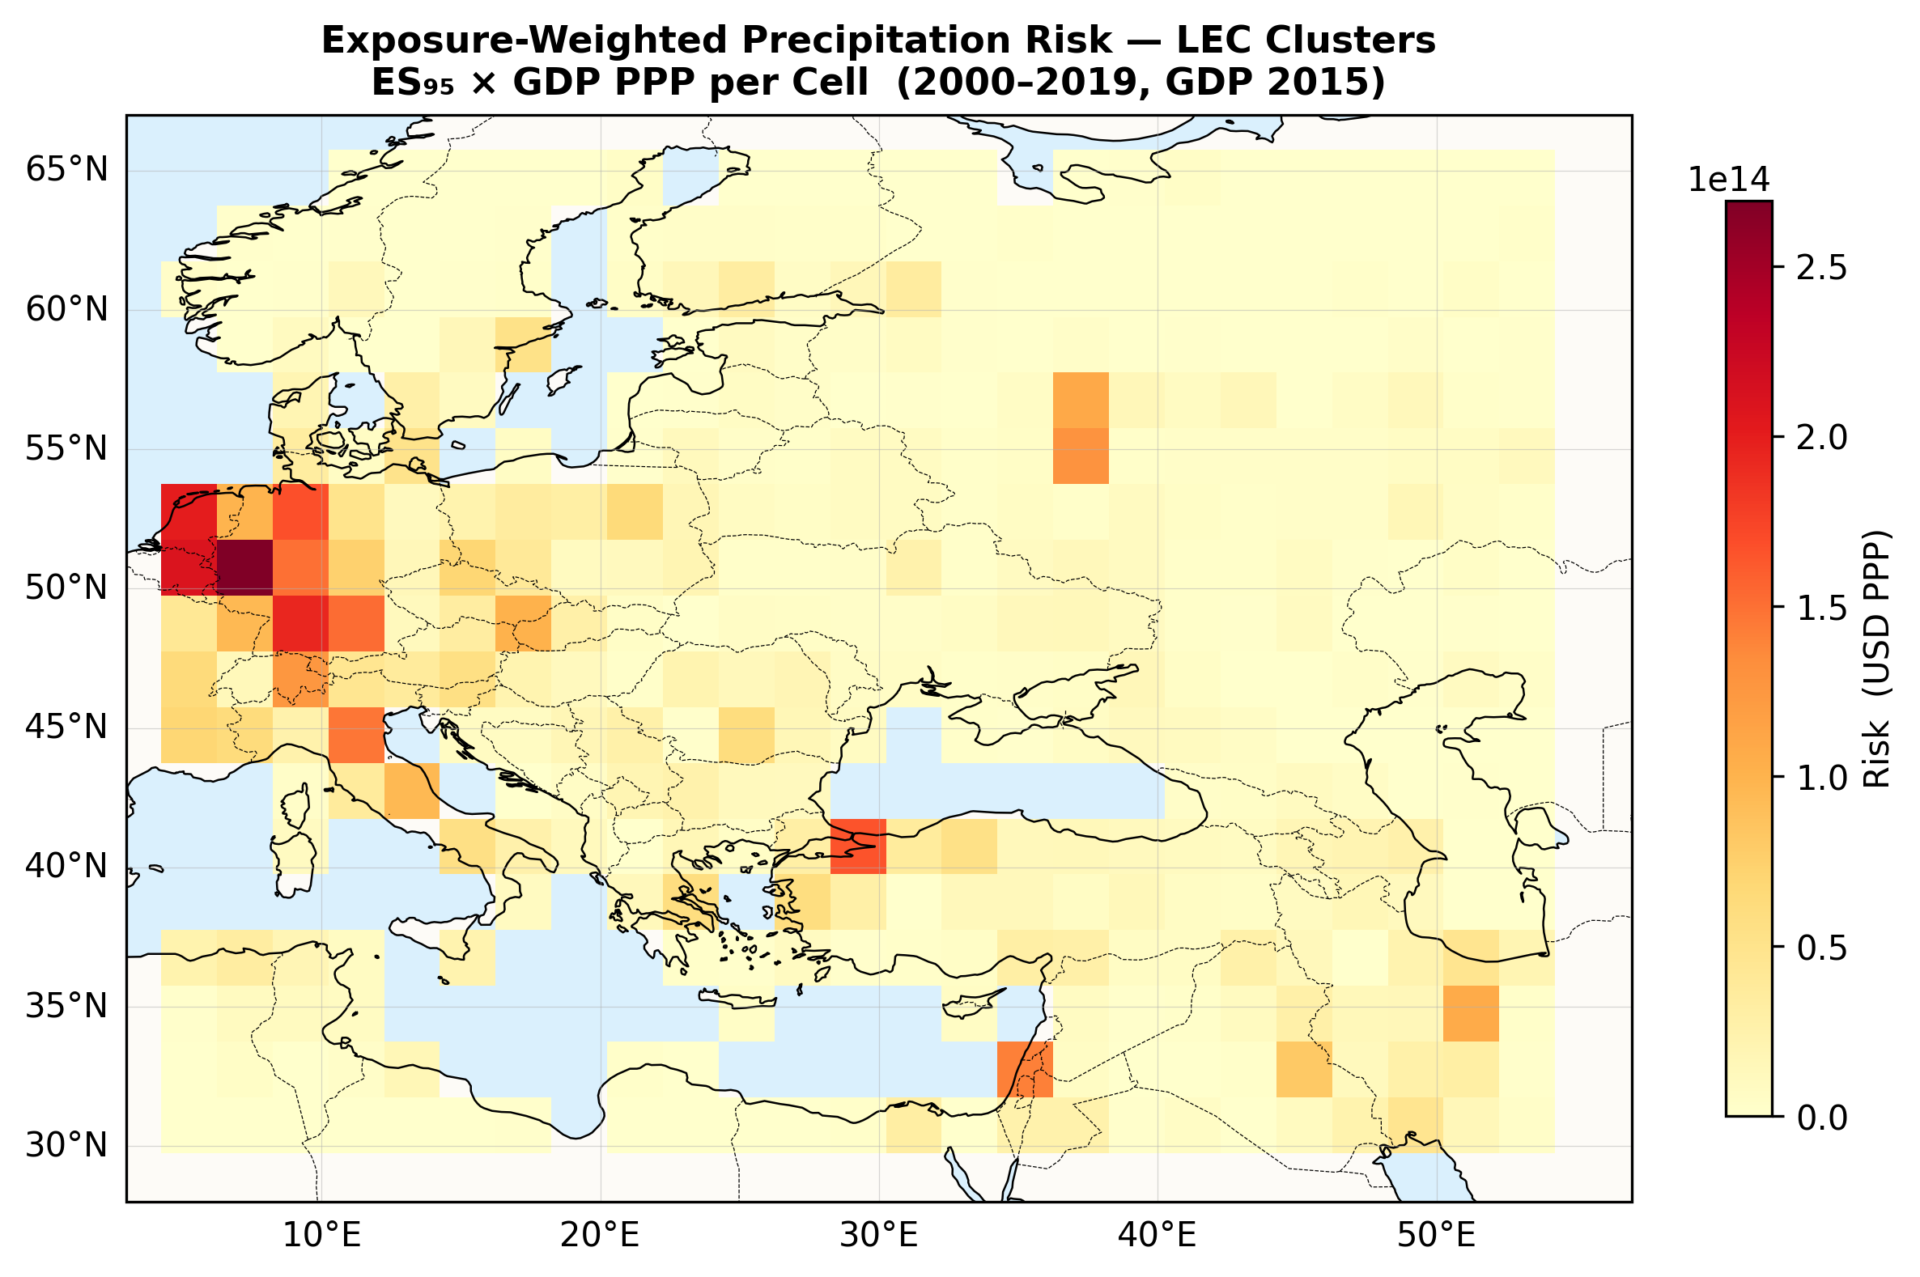
Figure 8. Exposure-weighted precipitation risk (ES₉₅ × GDP PPP) per grid cell using LEC clusters. The scale is in units of Fréchet × USD PPP (×10¹⁴). Dark red indicates where high tail-risk intensity coincides with high economic exposure.
The map identifies Western Europe (UK, western Germany, northern France) as the zone with the highest economic exposure to spatially coherent precipitation extremes. This is because these cells combine two factors: (1) moderate-to-high ES values, meaning that when extreme precipitation occurs in this Atlantic-influenced region, it tends to affect large areas simultaneously, and (2) very high GDP, meaning substantial economic assets are present in the affected area.
A secondary hotspot around Istanbul and the eastern Mediterranean reflects moderate GDP intersecting with clusters that show high extremal dependence — extreme precipitation events here tend to be spatially widespread.
Regions appearing in light blue or pale yellow — such as parts of the Mediterranean, Eastern Europe, and Central Asia — should not be interpreted as "safe from precipitation extremes." They appear as low-risk on this map because the economic value at stake is lower in absolute terms. The ES (hazard) component alone (Figure 6) may show substantial tail-risk intensity in these regions. For a complete risk picture in low-GDP regions, one would need vulnerability indicators that capture how resilient or fragile a society is to climate shocks.
The value of this map therefore lies in relative economic exposure ranking across cells — it answers the question "where are the most dollars of economic output exposed to coherent precipitation extremes?" rather than "where will precipitation extremes cause the most human suffering?" Both questions are important; this pipeline addresses the former.

9. Summary and Interpretation
This analysis demonstrates a complete pipeline from raw daily precipitation data to spatially explicit risk maps:
- GEV fitting: extracts the extreme precipitation signal and models the tail behaviour at each grid cell (validated by Q-Q plots and KS tests with only 2.6% rejection rate);
- Fréchet transform: standardises all cells to a common tail scale, separating marginal from dependence behaviour;
- Local MLE + smoothing: estimates spatially varying anisotropy parameters describing the shape and orientation of dependence ellipses;
- LEC clustering: groups cells with similar dependence structure into k = 26 clusters, validated against the Contzen et al. (2025) simulation study;
- Expected Shortfall: quantifies tail-risk intensity per cluster on the Fréchet scale;
- GDP weighting: combines statistical hazard intensity with economic exposure to produce a cell-level economic exposure index.
The key finding is that Western Europe (UK, Benelux, western Germany, northern France) has the highest economic exposure to spatially coherent precipitation extremes — not because it has the most extreme events in absolute terms, but because it combines spatially coherent extremes with high economic concentration.
An important caveat: the GDP-weighted risk map quantifies economic exposure, not human vulnerability. Regions with low GDP but intense precipitation extremes (parts of the Mediterranean, North Africa, Middle East) may appear as low-risk on this map, but may in fact face severe consequences because they lack the resources to cope. A comprehensive risk assessment would require additional vulnerability indicators (poverty, infrastructure quality, institutional capacity) that are beyond the scope of this statistical pipeline. The ES map (Figure 6) should be consulted alongside the GDP-weighted map (Figure 8) to distinguish hazard intensity from economic exposure.

9. Summary and Interpretation
This analysis demonstrates a complete pipeline from raw daily precipitation data to spatially explicit risk maps:
- GEV fitting: extracts the extreme precipitation signal and models the tail behaviour at each grid cell (validated by Q-Q plots);
- Fréchet transform: standardises all cells to a common tail scale, separating marginal from dependence behaviour;
- Local MLE + smoothing: estimates spatially parameters describing the shape and orientation of dependence ellipses;
- LEC clustering: groups cells with similar dependence structure into k = 26 clusters, validated against the Contzen et al. (2025) simulation study;
- Expected Shortfall: quantifies tail-risk intensity per cluster on the Fréchet scale;
- GDP weighting: combines statistical hazard intensity with economic exposure to produce a cell-level risk prioritisation index.
The key finding is that Western Europe (UK, Benelux, western Germany, northern France) emerges as the highest-risk area — not because it has the most extreme precipitation events in absolute terms, but because it combines spatially coherent extremes with high economic concentration. This type of insight — identifying where hazard dependence and exposure overlap — is precisely what the max-stable process clustering framework is designed to provide.

References
[1] Artzner, P., Delbaen, F., Eber, J.-M. & Heath, D. (1999). Coherent measures of risk. Mathematical Finance, 9(3), 203–228.
[2] Contzen, J., Dickhaus, T. & Lohmeyer, J. (2025). Localised clustering of extremal dependence structures. Extremes, 28, 713–737.
[3] de Haan, L. & Ferreira, A. (2006). Extreme Value Theory: An Introduction. Springer.
[4] Kummu, M., Taka, M. & Guillaume, J. H. A. (2018). Gridded global datasets for GDP and HDI. Scientific Data, 5, 180004.
[5] Padoan, S. A., Ribatet, M. & Sisson, S. A. (2010). Likelihood-based inference for max-stable processes. JASA, 105(489), 263–277.
[6] Schlather, M. (2002). Models for stationary max-stable random fields. Extremes, 5(1), 33–44.

