初赛第二轮数据

样本数量：

WIFI_AP点749个

时间戳(采样点数)：

2016-09-10　18：55：04～　2016-09-14　14-59-01　每一分钟一个采样点

预测每个WIFI AP点每十分钟的平均设备连接数量

包含**9月25日15:00:00到18:00的数据**

| departure | YES 3168 3582 2118 1394

| flights | YES 73 48 21 5

| gates | No

| security_check |No, but 14:xx时刻安检人数有5219

| wifi |No

SQL:

create database flight1;

use flight1;

create table wifi(wifitag varchar(32), pcount int, timestamp varchar(32), primary key(wifitag,timestamp));

load data local infile '/home/wkcn/proj/data/WIFI_AP_Passenger_Records_chusai_2ndround.csv' into table wifi fields terminated by ',' enclosed by '"' lines terminated by '\n';

create table flights(flight_name varchar(16), scheduled_flt_time varchar(32), actual_flt_time varchar(32), BGATE_ID varchar(16), primary key(flight_name, scheduled_flt_time));

load data local infile '/home/wkcn/proj/data/airport_gz_flights_chusai_2ndround.csv' into table flights fields terminated by ',' enclosed by '"' lines terminated by '\n';

create table gates(BGATE_ID varchar(16) primary key, BGATE_AREA varchar(16));

load data local infile '/home/wkcn/proj/data/airport_gz_gates.csv' into table gates fields terminated by ',' enclosed by '"' lines termina ted by '\n';

create table departure (passenger_ID2 int,flight_ID varchar(16),flight_time varchar(32),checkin_time varchar(32), primary key(passenger_ID2));

load data local infile '/home/wkcn/proj/data/airport_gz_departure_chusai_2ndround.csv' into table departure fields terminated by ',' enclosed by '"' lines terminated by '\n';

create table security_check (passenger_ID varchar(32),security_time varchar(32),flight_ID varchar(16));

load data local infile '/home/wkcn/proj/data/airport_gz_security_check_chusai_2ndround.csv' into table security_check fields terminated by ',' enclosed by '"' lines terminated by '\n';

记得清除csv表头

侯机时间图表:

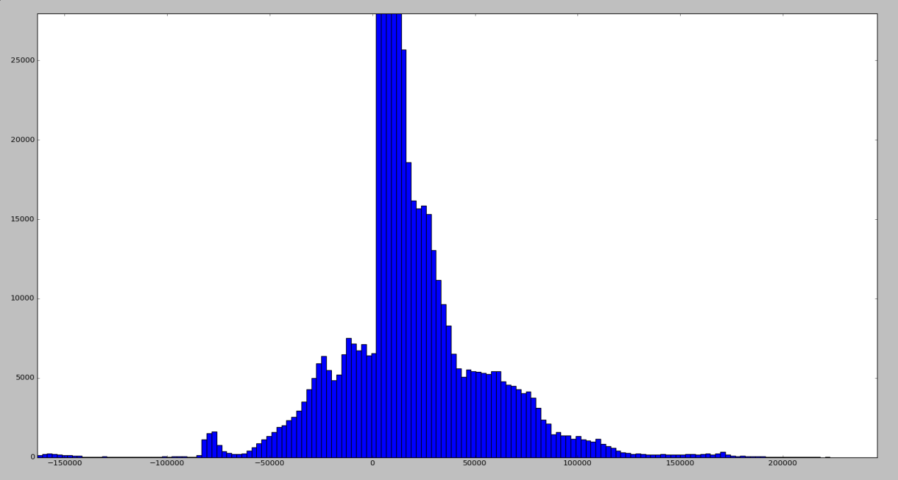

可能提前10天以上出票

登机与出票时间间隔: 小于8小时:974409, 大于8小时153285

一辆飞机一天出发一次?

自己聚合的表:

create table security_count(time varchar(32), flight_ID varchar(16), pcount int, primary key(time,flight_ID));

DESC 表名

alter table wifi change count pcount int;

create table wifi_count(wifitag varchar(32), pcount real, timestamp varchar(32), primary key(wifitag,timestamp));

create table region_count(BGATE_AREA varchar(16),time varchar(32), scheduled_flt_time varchar(32), actual_flt_time varchar(32), pcount int, primary key (BGATE_AREA, time));

create table person_count(BGATE_AREA varchar(16), time varchar(32), pcount int, primary key (BGATE_AREA, time));