Seat Reservation
Problem
-----------------------
Group 20

Name | Index No | Registration No
Dumindu Kavishka | 19000693 | 2019/CS/069
Mohammed Ashfaq | 19000081 | 2019/CS/008
Thisara Dilshan | 19000359 | 2019/CS/035
Udesh Maduranga | 19000871 | 2019/CS/087

Problem

Flight management system to manage various flights with their relent traveling paths. Passenger shall have the facility to book seats from anywhere in the flight. passengers shall have the facility to book seats from any location to any location.

Algorithm

# flight considered as an object (for easy handling of multiple flights).
# In side a flight object a 3D array is used to store relevant seat data, (hence a seat can be booked by multiple passengers, given that the seat is free upon previous passenger’s arrival on the destination)
# main menu is called through a infinite loop

ex:-
flight with 8 rows and 10 columns with a traveling path starting from
→ Sri_lanka , India , china , USA , England
passenger 1 can book seat 2,1 from sri_lanka to china
passenger 2 can book the same seat from china to USA
passenger 3 can book the same seat from USA to England

→ implimentation

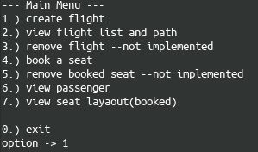
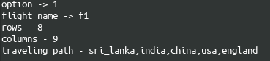

→

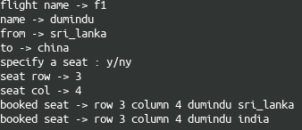
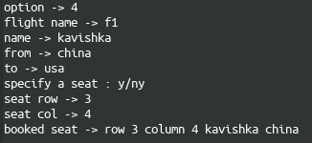

→

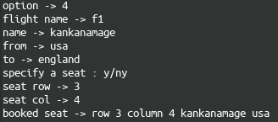
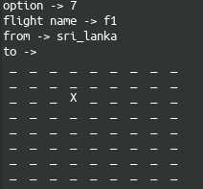

→

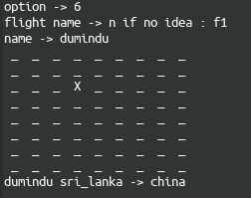
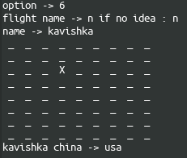

→

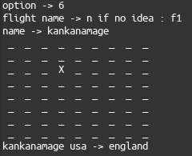

solution

import scala.io.StdIn.{readLine, readInt}
import scala.math._
import scala.Array._
import util.control.Breaks._
import scala.collection.mutable._

object seat_reservation{
def main(args: Array[String]): Unit = {
// variables
var exit: Boolean = false; var user_in: String = ""; val fly_list = ArrayBuffer[flight]()
//
while(!exit){// main menu loop
println(s"\n--- Main Menu ---");
println(f"1.) create flight\n2.) view flight list and path\n3.) remove flight --not implemented")
println(f"4.) book a seat\n5.) remove booked seat --not implemented\n6.) view passenger\n7.) view seat layaout(booked)")
println(s"\n0.) exit")
user_in = readLine("option -> ")
//
if(user_in == "1"){// create a flight
//variables
var dupli: Boolean = false; var f_name: String = ""; var rows,cols: Int = -1; var path = ArrayBuffer[String]();
//
breakable{
while(true){
print("flight name -> "); f_name = readLine()
print("rows - "); rows = readInt()
print("columns - "); cols = readInt()
print("traveling path - "); path = readLine().split(",").to(ArrayBuffer);
// check for duplication
breakable{
for(x <- fly_list){
if(x.fly_name() == f_name){
println(s"flight already exist")
user_in = readLine("enter again -> y/n : ")
if(user_in == "y"){ dupli = true; break() }
}
}
}
if(!dupli){ break() }
}
}// all is well
fly_list += new flight(f_name,rows,cols,path)// create the new object
}
else if(user_in == "2"){// view flight list and path
if(fly_list.length <= 0){
println("no flight available")
}
else{
for(x <- 0 to fly_list.length-1){
println(fly_list(x).fly_name()+"\t"+fly_list(x).fly_path()); // print flight name
}
}
}
else if(user_in == "3"){// remove flight --not implemented
println("sorry...")
}
else if(user_in == "4"){// book a seat
//variables
var fly_check: Boolean = false; var f_no: Int = -1;
breakable{// gather information through a loop
while(true){
print("flight name -> "); var f_name = readLine()
// check for flight
breakable{
for(x <- 0 to fly_list.length-1){ if(fly_list(x).fly_name() == f_name){ fly_check = true; f_no = x; break() } }
}
if(!fly_check){ println("no such flight"); break() }
//
print("name -> "); var name = readLine()
print("from -> "); var from = readLine()
print("to -> "); var to = readLine()
print("specify a seat : y/n"); user_in = readLine()
if(user_in == "y"){// seat
print("seat row -> "); var row = readInt()
print("seat col -> "); var col = readInt()
// book the flight
fly_list(f_no).book(name,from,to,row,col); break()
}
else{// no seat
// book the flight
fly_list(f_no).book(name,from,to); break()
}

}
}
}
else if(user_in == "5"){// remove booked seat --not implemented
println("sorry...")
}
else if(user_in == "6"){// view passenger
var fly_no: Int = -1; var found: Boolean = false; var name: String = "";

print("flight name -> "); var fly_name = readLine("n if no idea : ")
print("name -> "); name = readLine()
if(fly_name == "n"){// flight not given
breakable{
for(x <- fly_list){
if(x.look_pass(name)){// pass found
x.view_pass_seat(name)
break()
}
}
println("no such passenger"); found = true
break()
}
}
else{// flight given
breakable{
for(x <- 0 to fly_list.length-1){
if(fly_list(x).fly_name() == fly_name){ fly_no = x; found = true; break() }
}// flight not found
found = false; println("no such flight ")
}
if(found){ fly_list(fly_no).view_pass_seat(name) }
}
}
else if(user_in == "7"){// view seat layaout(booked)
print("flight name -> "); var fly_name = readLine()
print("from -> "); var from = readLine()
print("to -> "); var to = readLine()
//
breakable{
for(x <- fly_list){
if(x.fly_name() == fly_name){
if(to == "n" || to == ""){ x.view(from); break() }// destination do not know
else{ x.view(from,to); break() }
}
}
println("flight name may be wrong")
}
}
else if(user_in == "exit" || user_in == "0"){
exit = true;

}
else{
println("wtf, look what you type")
}
}
}

}

class flight(cls_name: String, rows: Int, cols: Int, path: ArrayBuffer[String]){

// database
val seat = Array.fill[String](rows, cols, path.length){"**empty**"}
val pass = Array.fill[String](rows*cols*path.length){"**empty**"}

def book(name: String, from: String, to: String): Unit = {
// check for name in pass.array
var stat: Boolean = false; var count: Int = 0;
breakable{
for(x <- pass){if(x == name){stat = true}}
}
//
if(stat == true){
println("already in"); return;
}
else{
// where to look
var i_from, i_to : Int = -1
i_from = path.indexOf(from); i_to = path.indexOf(to)

//traverse the seat 3D array
breakable{
for(row <- 0 to rows-1; col <- 0 to cols-1){// traverse the rows and cols
for(x <- i_from to i_to-1){
if(seat(row)(col)(x) == "**empty**"){count+=1}// checking for availability
}
if((i_to-i_from) == (count)){// space available
for(x <- i_from to i_to-1){
seat(row)(col)(x) = name
println(f"booked seat -> row ${row+1} column ${col+1} " + name +" "+path(x))
}
breakable{// add name to the pass array
for(x <- 0 to pass.length-1){
if(pass(x) == "**empty**"){
pass(x) = name
break()
}
}
}
stat = true
}
else{// space not available
println("seat not avilable"); return;
}
if(stat){break()}
}
}
}
}

def book(name: String, from: String, to: String, s_row: Int, s_col: Int): Unit = {
// variables
var stat: Boolean = false; var count: Int = 0;
// check for name in pass.array
breakable{
for(x <- pass){if(x == name){stat = true; break()}}
}
//
if(stat == true){
println("already booked"); return;
}
else{
// where to look
var i_from, i_to : Int = -1
i_from = path.indexOf(from); i_to = path.indexOf(to)
// traverse the path in seat
breakable{// may be usefull
for(x <- i_from to i_to-1){// checking for availability
if(seat(s_row-1)(s_col-1)(x) == "**empty**"){count+=1}
}
if((i_to-i_from) == (count)){// space available
for(x <- i_from to i_to-1){
seat(s_row-1)(s_col-1)(x) = name
println(f"booked seat -> row ${s_row} column ${s_col} " + name +" "+ path(x))
}
breakable{// add name to the pass array
for(x <- 0 to pass.length-1){
if(pass(x) == "**empty**"){
pass(x) = name
break()
}
}
}
}
else{// space not available
println("seat not avilable"); return;
}
}
}
}

def view(from: String, to: String): Unit = {// print the seat layout
// where to look
var i_from, i_to : Int = -1
i_from = path.indexOf(from); i_to = path.indexOf(to)
var occu: Boolean = false
//
for(row <- 0 to rows-1){// traverse rows
for(col <- 0 to cols-1){// traverse cols
occu = false
for(x <- i_from to i_to-1){// traverse the path
if(seat(row)(col)(x) != "**empty**"){occu = true}
}
if(occu) { print(" X ") } else { print(" _ ") }
}
print("\n")
}
}

def view(from: String): Unit = {// print the seat laout
// where to look
var i_from, i_to : Int = -1
i_from = path.indexOf(from); i_to = path.length
var occu: Boolean = false;
//
for(row <- 0 to rows-1){// traverse rows
for(col <- 0 to cols-1){// traverse cols
occu = false
for(x <- i_from to i_to-1){// traverse the path
if(seat(row)(col)(x) != "**empty**"){occu = true}
}
if(occu) { print(" X ") } else { print(" _ ") }
}
print("\n")
}
}

def view_pass_seat(name: String): Unit = {
// where to look
var occu: Boolean = false; var from,to,count: Int = 0;
//
for(row <- 0 to rows-1){// traverse rows
for(col <- 0 to cols-1){// traverse cols
occu = false
for(x <- 0 to path.length-1){// traverse the path
if(seat(row)(col)(x) == name){
occu = true; count+=1; to = x+1
if(count == 1){from = x};
}
}
if(occu) { print(" X ") } else { print(" _ ") }
}
print("\n")
}
println(name+" "+path(from)+" -> "+path(to))
}

def view_pass_path(name: String): Unit = {
// where to look
var found: Boolean = false; var from,to,count: Int = 0;
//
breakable{
for(row <- 0 to rows-1){// traverse rows
breakable{
for(col <- 0 to cols-1){// traverse cols
breakable{
for(x <- 0 to path.length-1){// traverse the path
if(seat(row)(col)(x) == name){
found = true; count+=1; to = x+1
if(count == 1){from = x};
}
}
if(found){break()}
}
}
if(found){break()}
}
}
if(found){break()}
}
println(name+" "+path(from)+" -> "+path(to))
}

def look_pass(name: String): Boolean = {
breakable{
for(x <- pass){
if(x == name){ return true; break() }
}
}
return false;
}

def fly_name(): String = {cls_name;} // return flight name

def fly_path(): ArrayBuffer[String] = {path} // return flight path

def fly_cap(): Int = {rows*cols} // return flight passenger capacity
}

