Zehra Cheatham, William Keenan, Kyle Fowler

April 22, 2019

GEOG 4303

Final Paper

**Ski Resort Site Selection Using a Weighted Criteria Model**

**Introduction**

From the 5th alley at A Basin, to America’s Downhill and Highlands Bowl in Aspen, to Senior’s in Telluride, the mountains seek to divide and challenge us, but the sport of skiing allows us to break down this barrier and bring us together with these beautiful parts of nature. Colorado is often called “Ski Country USA” due to its incredible number of ski resorts, fifty-two fourteen thousand foot mountain peaks, and towns with hundred year histories of skiing. The allure of the rocky mountains bring people from across the globe come experience the cold and dry powder. But even with an astonishing 26 ski resorts in the state of colorado many resorts are still packed with people, don’t offer the desired terrain, or aren't in the place within Colorado they want to explore.

Our project set out to find site around Colorado that could host a new ski resorts. This is an ambitious task that has been attempted by many throughout the state. We hoped to attack this from a solely geographic approach by using data features such as, slope, aspect, precipitation, roads, and distance to power substations. Using our coding skills in python and the tools offered by ArcGIS, we hope to determine criteria to select sites in Colorado where fantastic skiing could be brought to the masses.

**Methodological Approaches**

The main goal of the project was the creation of a weighted criteria model which would allow us to simultaneously analyze different criteria The creation of this model was the bulk of the project and yielded a strong tool in analyzing terrain. It consisted of five criteria: accessibility, elevation, aspect, distance to substation, and snowfall. Our weighted criteria model gave each of our five criteria even weights. All of these five layers are clipped to the national forest boundaries. This was crucial for our analysis in two ways: 1.) Only national forest land is feasible to build a ski resort on & 2.) We excluded the private land as its totally out of the scope of this project and its untenable goal in four weeks.

The general format which our analysis took place followed these steps:

1. Initialize the masked raster layer and convert to numpy array.
2. Define the class breaks using the minimum and maximum values of the array.
3. Reclassify using a nested numpy.where statement which assigns weights to each pixel.

*Accessibility (Meters)*

The cost distance analysis is based off of highways speeds and the actual driving time from the top 20 cities in Colorado. We used the cost distance tool which gives us an accurate timeframe for people to travel from a specific point in the mountains to closest of the twenty most populated cities. Nineteen of these cities were in the front range, and Grand Junction being in the west is the outlier. Using the cell crossing time (CCT) equation, we were able to calculate the amount of time it would take to get from point A to point B: *CCT= (P*60)/(TS*1000)* with P= cell size, and TS= speed limit. This metric combines distance from population and distance from highways (travel time) in a simple accessibility metric. This cell crossing time grid is input into the cost distance tool as the cost raster, and a vector layer consisting of the top 20 most populous cities in CO was the source raster. The output raster from this cost distance tool was masked to national forest and used as the input in our python script. It was reclassified on a scale from 1 (least accessible) to 10 (most accessible).

*Snowfall (Centimeters)*

This criteria showcases the average snowfall for each 120 meter resolution in the state of Colorado. The layer is originally comprised of a 4 kilometer resolution, then we resampled it to a 120 meter resolution to correlate with the other layers in our model. Then we converted it from vector to raster because

*Sub-Stations*

This layer was created from running the Euclidean distance tool on all currently operating substations in Colorado. This allows us the capability to find the distance to substations from the selected sites in order to receive electricity for our potential ski resort.

*Elevation (Meters)*

Altitude is crucial for snowfall and choosing sites with a large vertical declination. The higher the mountain, leads to more snowfall and colder weather, which would produce more powder and make the skiing season longer.

*Aspect*

This is one of the more important layers as it shows allows direction mountain faces point. This was classified into three rankings. This is classified into three different categories: 0,5,10. This is split based on the angles from 315 degrees- 45 degrees get a value of 10 because it northwest or northeast facing. These areas receive the least amount of sunlight throughout the winter it will hold more snow. The second ratings system includes aspects facing 225-315 degrees and 45-135 degrees, which are the mainly east and west facing. These receive similar amounts of sunlight in the winter. The final category faces directly south at 135-225 degrees.

**Creating the Model**

After the creation of each of the five reclassified layers, implementing a weighted model was accomplished using map algebra. At first, we tried multiplying each of the numpy arrays by a weight (with weights adding up to 1), and then adding the arrays together. This produced a memory error in Python because doing map algebra on five large arrays used up all of the computers available RAM. To work around this, we converted each array back into a arcpy raster object and then performed the map algebra. The output of this map algebra is a raster with values ranging from 0-10, where 10 indicates the best combination of elevation, aspect, snowfall, accessibility, and substation.

*Post Processing*

Besides our weighted criteria model we needed to make further adjustments to our raster in order make reasonable selections for our sites. First, we erased areas which had existing ski resorts which was crucial since many potential sites that we found were near current ski resorts, or were in places that previously closed down resorts. To run this “erase” we used the raster calculator tool and ran the inverse of “Is Null” and then “Set Null”. Then, we reclassified the final raster so that each pixel was assigned to an integer. We also assigned every pixel over 7 a value of 9. Next, we ran the region group tool (4 neighbor rule) on the reclassified raster and extracted only those groups with link = 9. This means that each group the tool produced only contained pixels with values over 7 in the original raster file. From here, we selected groups that were larger than 6 square kilometers. At this point we converted from raster to vector and used the minimum bounding geometry tool with the convex hull option. This created 62 polygons (in our equally weighted model) that we were left to analyze.

*Slope Analysis*

Once we ran our weighted criteria model, we computed a slope analysis on the clipped national forest area. Through this process, we found which faces of the mountain were steeper within a 30m resolution. The perfect ski resort includes a variety of the slopes. Having just steep slopes will only provide good skiing to expert skiers who can utilize double black diamonds, as well as increased risk of avalanche dangers. Having flat slopes will only attract beginner skiers who utilize blue and green slopes. In order to find the a good variety of slopes we built a query that produces gradual slopes for all levels of skiing: *(Mean>15 AND Range>40 AND STD>9)*

* Mean >15 = We chose a mean of 15 in order to rule out outliers that had 60 degree slopes and no shallower slopes. Having a high mean allowed us to get rid of skewed data.
* Range>40 = A large range of 40 would also ensure that we could have many green, blue, black and double black slopes on the mountain.
* STD>9= A standard deviation of nine ensures that we would find an area that had a good mix of steep and shallow slopes.

*Circularity analysis*

The ideal ski resort is a compact area which packs the most skiable terrain possible into an area with the least amount of lifts, catwalks, and rope tows. This is better because all areas of the resort are easily accessible and do not require riding 5 lifts just to get back to the parking lot. Looking through the already existing ski areas in Colorado, it is easy to see that most resorts follow this logic. To test our potential areas for this metric, we created a function which tests the polygons for their circularity ratio.

*Final selection criteria*

After narrowing down our search using our weighted criteria model, slope, and circularity, our final selection process required a little bit of subjectivity. We had narrowed our search down to about twelve potential sites with a goal of getting to three, and we began looking closely at each site. Luckily, our group includes an extremely knowledgeable backcountry skier, who could point out areas (from first hand experience) that might be better than others due to things such as avalanche concerns, potential road closures, and other factors that our analysis did not originally consider. Through this exploration of the final twelve sites we were able to pick three sites that we thought would be the best.

**Results**

After we finalized the script and methods used to analyze the equally weighted criteria model, we were able to play with our model and test out different weights to see what effect they would have on our final sites. After trying several different weighting schemes, we decided to include the equally weighted model, a model with accessibility at 40% and the rest at 15%, and a model with accessibility at 0%. After choosing final sites for each of these models, we ran zonal statistics as table on our sites over its respective raster to examine how each site compares.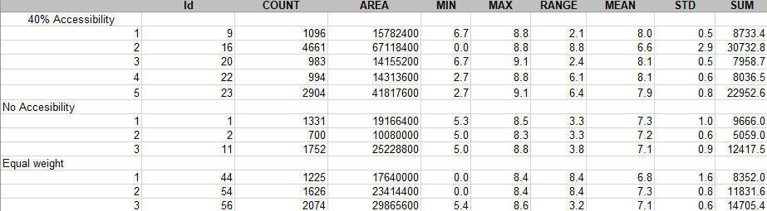

The means for some of these sites dips below 7, which may seem impossible because we only selected for pixels above 7 in our reclassification and region grouping. However, when running the minimum bounding geometry, the polygons become much larger and overlap pixels who were ignored by the region group. This is why some of the means may dip below 7.

Our results indicate that the best area to develop a ski resort is in the San Juan Mountain Range in southwestern CO. All three of our models and the results of our slope analysis showed strong preference towards this region of the state. The areas surrounding resorts such as Telluride and Purgatory were highly accessible due to their adjacency next to a major highway, receive high amounts of snowfall, and have incredible terrain for skiing.

On the map below, we selected 5 sites instead of 3 from our 40% accessibility model. This is because we wanted to include areas that were more accessible to the Front Range population. The two orange circles closer to the front range are fairly close to Denver, although the one closest to Denver is located in between Loveland and Arapahoe Basin ski areas and thus would not be a very viable location for a new resort. The issue of finding a good ski resort close to the major population centers of the state went mostly unsolved by our analysis. It seems that the best, close areas have already been developed by resorts such as Loveland, Eldora, and Keystone Mountains.

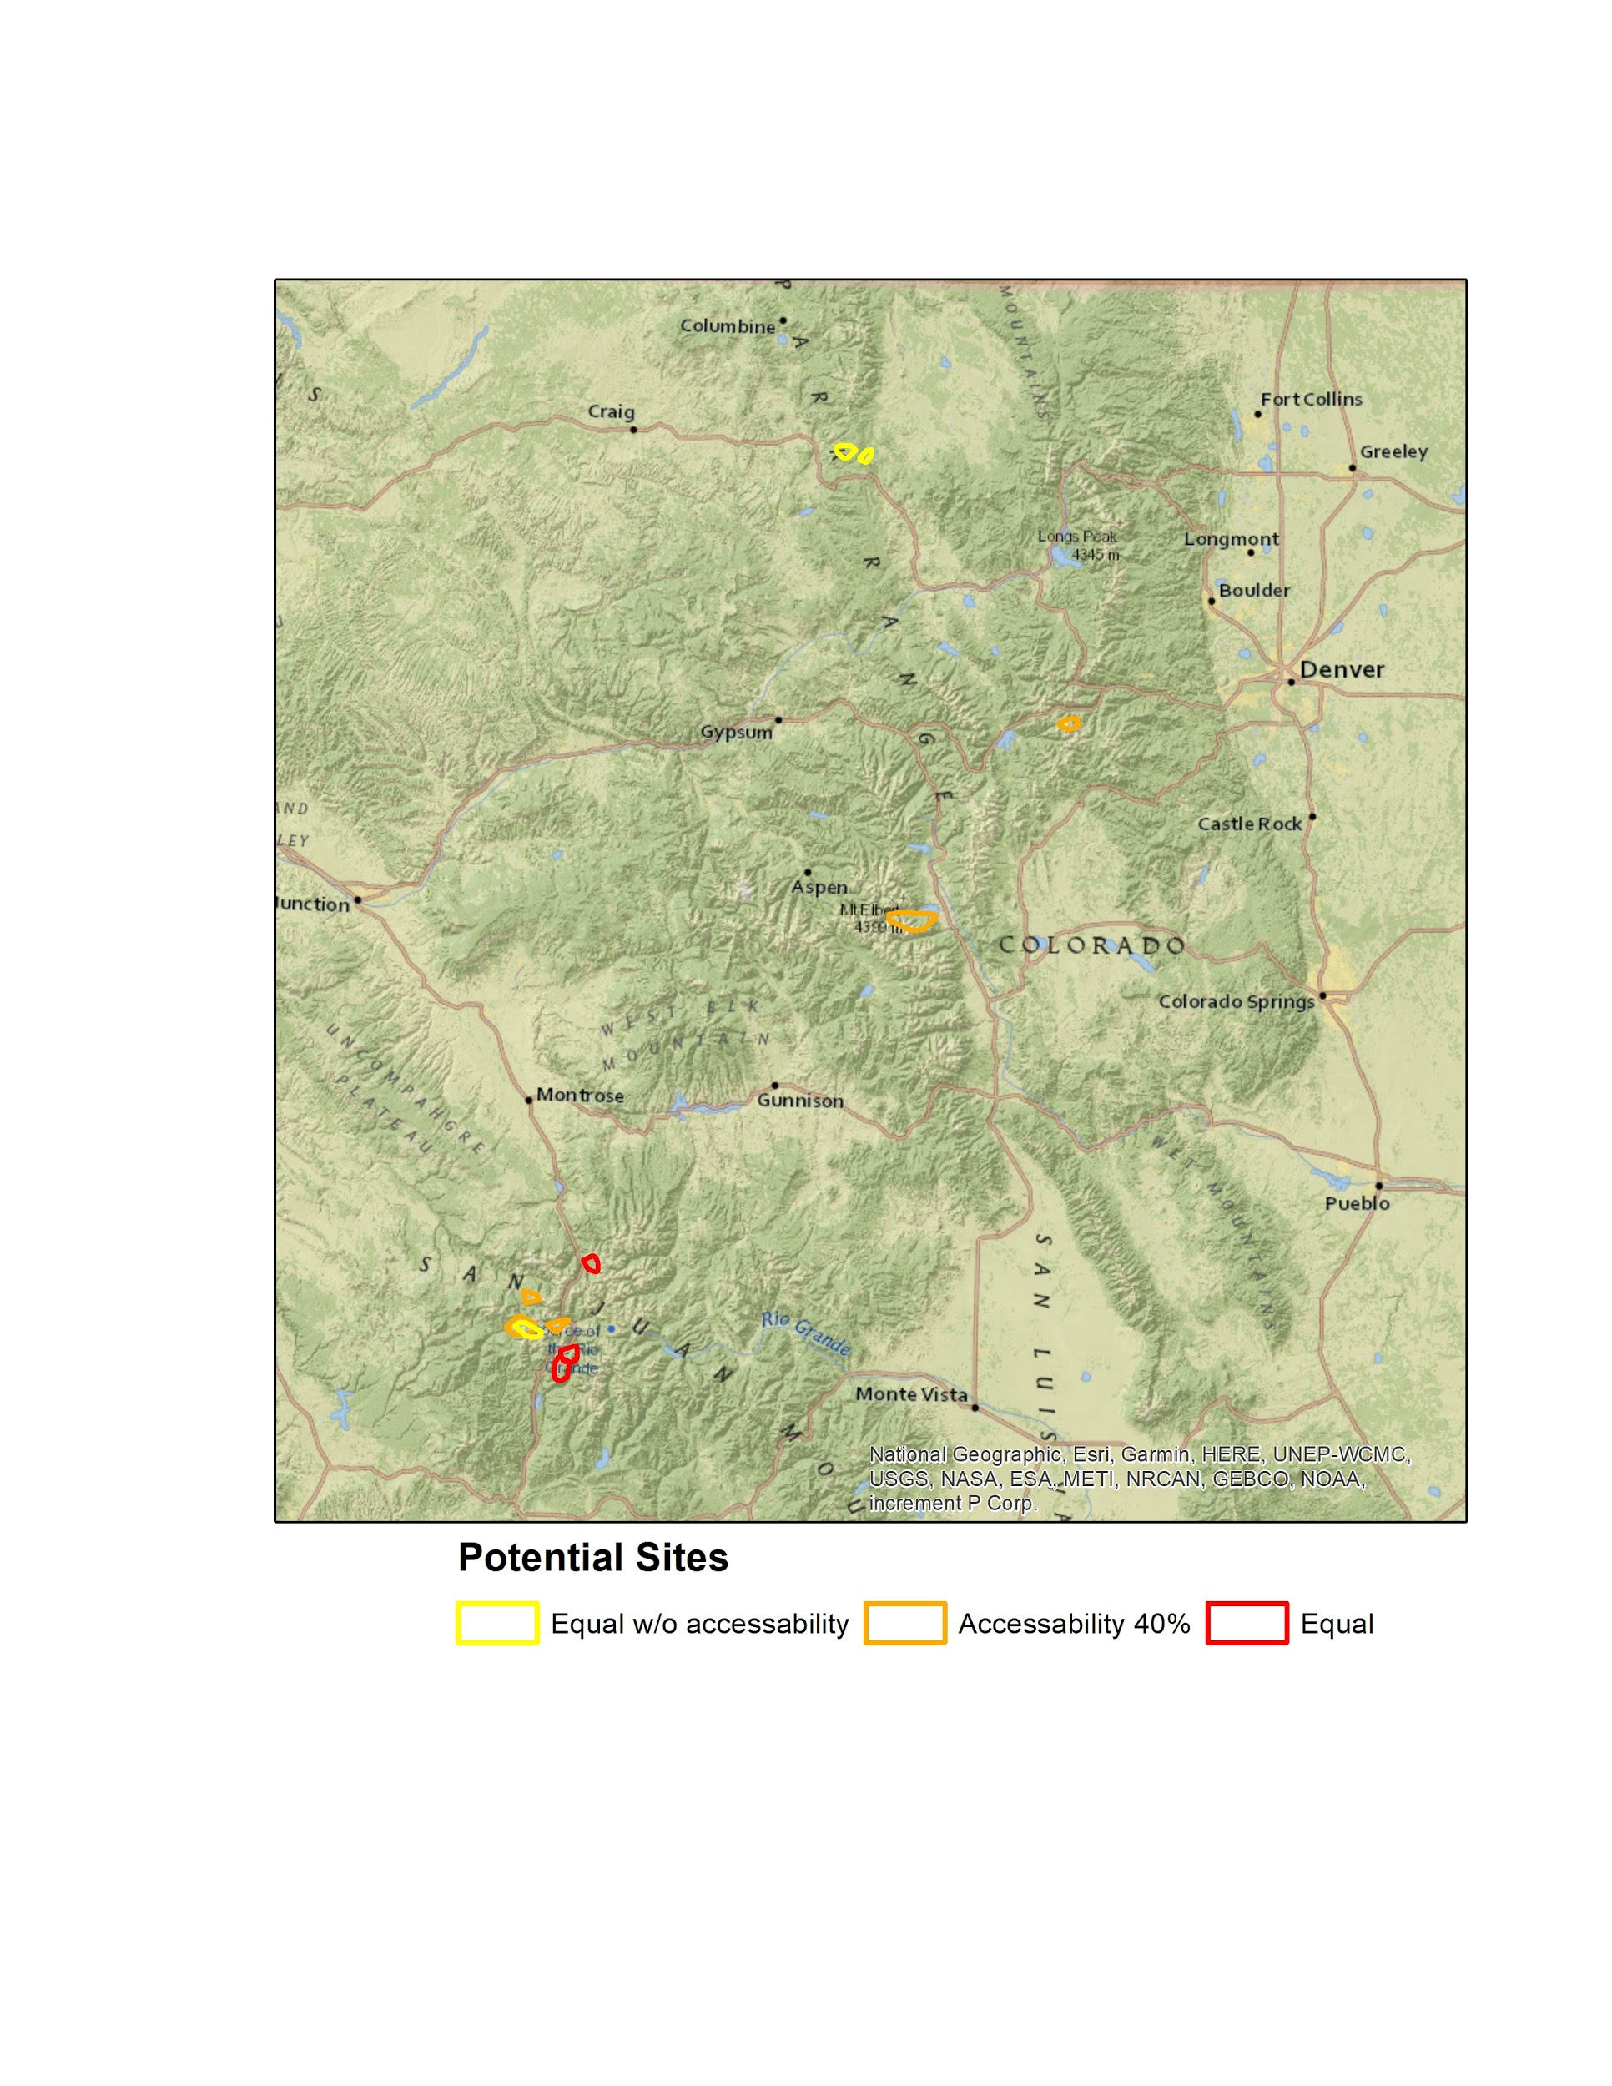

**Discussion**

We spent a great deal of time working through the various roadblocks and challenges that presented themselves during the course of the project. One of the first problems that arose was the lack of open source electrical substation data. To work around this we were going to use transmission line data provided by ArcGIS Online, but after our status presentation, Trevor was able to provide us with the substation data which was extremely useful. Another challenge for our group was a ‘memory error’ that we kept receiving when we ran the master script in Python. After countless efforts to clip potential areas of interest to reduce to storage size, we found an unusual solution that solved the problem. We converted numpy arrays back to raster objects within the script and it immediately resolved the issue.

We encountered a spatial referencing problem that caused a major setback, resulting in a delay to proceed with the project. Multiple layers weren’t spatially referenced correctly. When

viewing the layers in Arcmap two of the layers were clearly not aligned with the other layers. These two layers were shifted about 50 km to the west from the correct point of reference. Our solution was to use the extract by mask tool in ArcGIS instead of running it in Python as a code. All of the layers were pre-masked to the National Forests in ArcMap before we used them as inputs in our code. We are not sure why this solved our problem.

One criteria we really would have liked to use in our project was traffic data. Even though we were able to incorporate the amount of time it would take from a city to our potential ski resorts, it didn’t take into account any traffic that may occur during busy winter seasons where everyone is on the roads. Traffic data is an abstract element to incorporate because it involves time. The other layers in our model are stagnant statistics, such as average snowfall, elevation, and aspect. Our entire weighted criteria model doesn’t involve time or seasonality, so adding an element of traffic would have to entirely be a new project.

The original mind map created in the initial planning of this project was almost identically implemented during the execution phase *(Figure 1)*. We ended up not being able to implement the land cost into our script, because it was out of our projects scope and capability. We were also going to include both a distance to highway layer, as well as a distance from population layer, but we ended up combining them to create our accessibility layer which uses the CCT equation to provide the timed distance from the 20 most populous cities.

**Concluding Remarks**

The scope of our project was reasonable to attain in just the short five weeks we had to complete this project. During our initial planning phase we determined every group members strong attributes and utilized them to create an efficient outcome. This was our first course using python simultaneously with ArcMap so there was a bit of a learning curve, but we managed nonetheless. We all benefited from learning python, a new coding language that will enhance our future career. As previously mentioned in our discussion, during the implementation phase of the project we hit a few roadblocks that we had to overcome. These challenges helped guide us to becoming more efficient programmers.

At the end of our five weeks we were pleased with the results of our work. At times we were not sure if our result would be very meaningful or insightful or if it would produce anything valuable. Despite this, we are all very happy with the way the model has come together. The weighted criteria model seems to produce fairly accurate results that actually represent really good ski areas. Of course, there is always more we could have done to make a more accurate model, but for the time we had I believe we accomplished more than we could have hoped for.

Appendix

*Figure 1:*

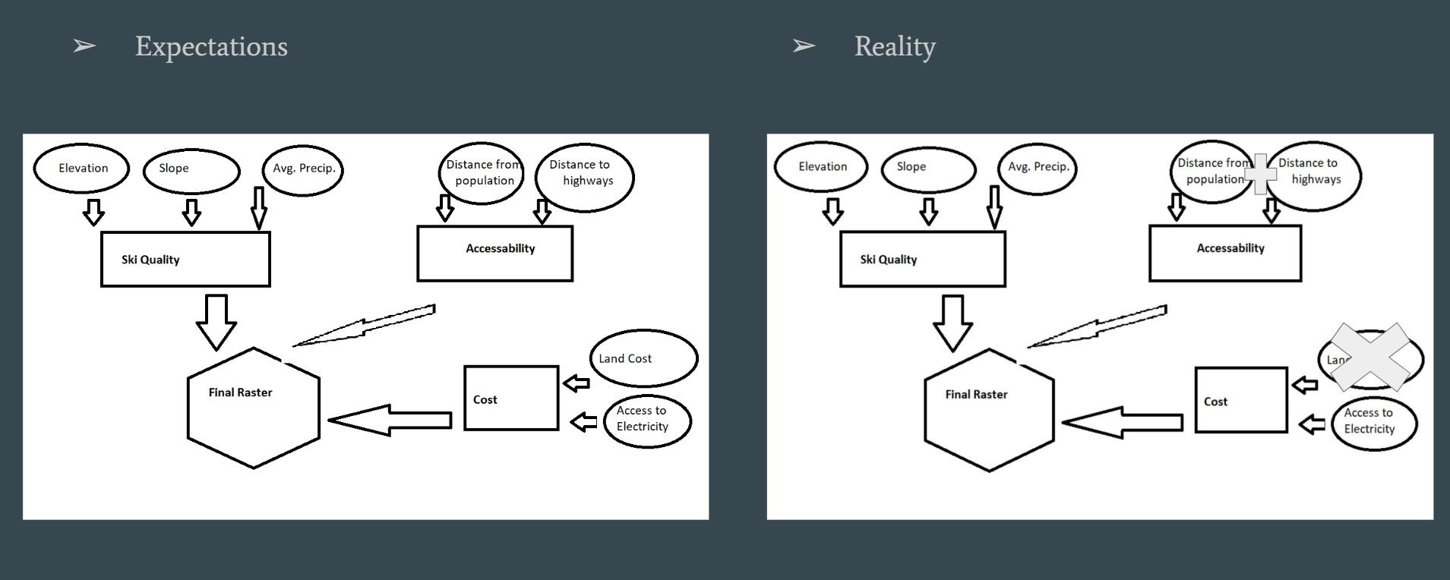

Works Cited

Buttenfield, B. (2014, January 23). [Colorado Atlas 2019]. raw data.

Marraccini, B. (2015, October 20). [Colorado Historic Snowfall 1980-2010]. raw data.

United States Department of Agriculture. (2011, August 17). [Colorado Ski permitted and

allocated area boundaries]. raw data.

Xcel Energy. (2016). [Colorado Substations]. raw data.