William Keenan

5/4/2019

**Instructions to successfully run and understand the script.**

1. Download finalData and finalScript from the google drive folder you have been shared.
2. Extract finalData into your D drive.
3. Open up ArcCatalog and ArcMap and explore the data inside finalData.
4. Open up finalScript.py in Spyder (or another IDE) and run the entire file.
5. RUN IT ONLY ONCE. Upon the second attempt to run the entire file, you will encounter a memory error. To run it again, delete the 5 numpyarraytoraster.tifs that are placed in finalData and restart the kernal.
6. After running it the first time, refresh your catalog and notice several new files in post_inputs, vector_data.gdb, and results.
7. The script creates an equally weighted model. If you would like to change the weights, go to line 194 and change it there. Changing these weights will change all of the output results.
8. To examine the statistics of our potential areas (62 polygons) a pandas dataframe called “sitesdata” is created by the script.

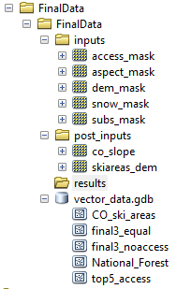

**Contents of finalData before running the script**

* The inputs folder includes all the raster layers to make the WCM.
* The post_inputs includes the slope for all of CO and the CO DEM clipped to pre-existing ski areas.
* Vector_data.gdb contains CO_ski_areas and the national forest layer which are inputs in the script
* Final3_equal, final3_noaccess, and top5_access are the final sites we manually selected from each of our weighted criteria models. These layers are not produced by the script but are here if you would like to examine the final sites we selected after analysis

**Contents after running the script**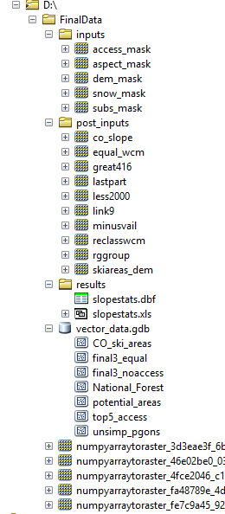

* The important files created by the script are: post_inputs/equal_wcm, vector_data.gdb/potential_areas, and results/slopestats.xls.
* Equal_wcm is the weighted criteria model raster
* Potential_areas are the final polygons selected from our analysis before slope, circularity, and subjective analysis
* Other files created by the script are intermediate steps.