ReadMe

INSTALLATION

1. run ‘pip install tkinter’
2. install sqlite3 on your system as well as python3
3. you should be able to run our program now using the following command:

‘python3 GUI.py’

ADD A CUSTOMER/VIEW CUSTOMER

To add a customer to the database, enter the name and phone number in the fields shown.

To search out a customer’s record, enter their name and CustID. Then select ‘Search Customer’.

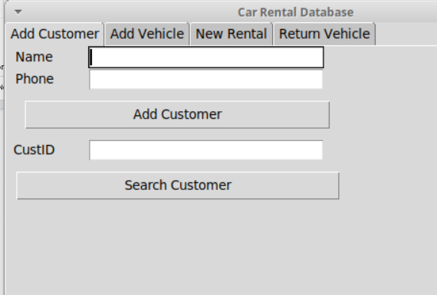

ADD NEW VEHICLE/SEARCH VEHICLE

To add a new vehicle to the database. Enter its Vehicle ID, Description, Year, Type and Category in the fields below. Then select ‘Add Vehicle’.

You can search for the Vehicles record by hitting ‘Search Vehicle’ with the Vehicle ID and description entered.

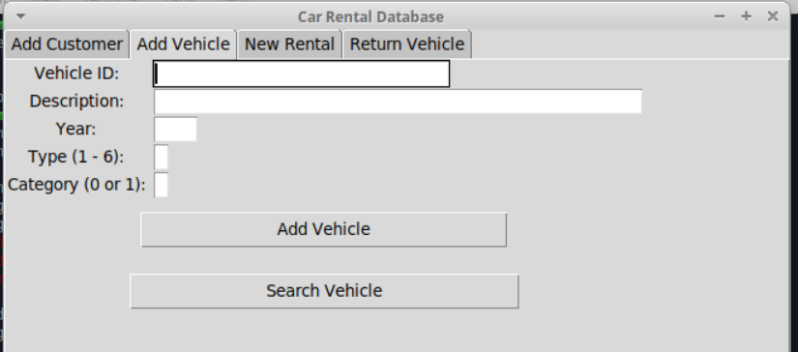

ADD NEW RENTAL

To add a new rental, enter the customer’s ID, the order date, the start date, and the return date.

Then click ‘Check for Free Vehicle’ which will populate the list of free vehicles in the dropdown menu labeled ‘Free Vehicles’.

From there you can select a vehicle that is available to rent by clicking and holding the menu, sliding the cursor to the car you want, and then releasing. Then enter the payment date (if the customer will pay today, otherwise enter NULL), rental type and amount due.

Click ‘Create Rental’ will create a new record with this info in the database.

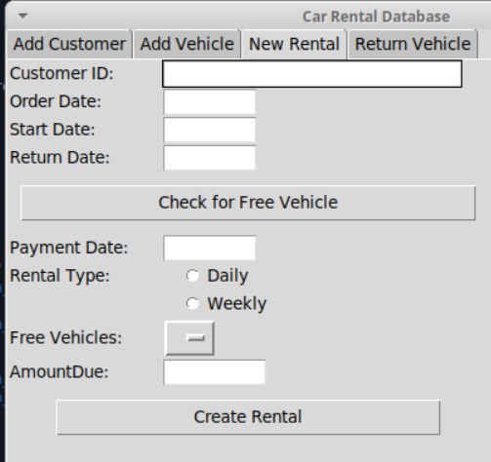

RETURN CAR

Enter the customer’s Name, the true return date, and the vehicle description. Then you may enter the payment date and hit ‘pay’ to indicate the customer payed the bill.

