
ANALYSIS REPORT
COMP 258 - Assignment 3
Use CNNs to solve object recognition problems

Wardatul Keskin | 301294696
Due Date : November 30th, 2025
Professor: Muhammad Saiful Islam

CENTENNIAL COLLEGE

Exercise 1: Using TensorFlow Data API for Loading and Preprocessing the Adult Dataset

Introduction
The purpose of this lab was to practice data pipeline construction using the TensorFlow Data API and to implement end-to-end feature preprocessing for a real-world dataset. This exercise focused on transforming the UCI Adult dataset into a clean, numerical format suitable for neural network training.
The learning objectives included:
- Understanding how to load tabular data into TensorFlow efficiently.
- Applying preprocessing steps including standardization, categorical encoding, and missing-value handling.
- Using tf.data.Dataset to create a high-performance input pipeline.
- Preparing a fully numerical, model-ready feature tensor while preserving correct semantic categories for all features.

Experiment Setup

Data Preparation and Modelling
Dataset
The UCI Adult dataset contains 48,842 samples with mixed numerical and categorical attributes describing adults' demographic and employment information. The task associated with this dataset is binary classification: predicting whether an individual’s income exceeds $50K per year. Data was loaded using the ucimlrepo library and examined for missing values.
Data Preprocessing
Feature Groups
- Numerical Features (6):
age, fnlwgt, education-num, capital-gain, capital-loss, hours-per-week
- Categorical Features (8):
workclass, education, marital-status, occupation,
relationship, race, sex, native-country
Missing Value Analysis
Analysis revealed that no numerical feature contained missing values, while several categorical features included missing indicators such as ?. These were replaced by unknown, because replacing them with the most frequent class can distort the true distribution. By doing this way, it will preserve dataset integrity.
Categorical Encoding
Each categorical column was processed using: tf.keras.layers.StringLookup(output_mode="one_hot")
Real categories were obtained by adapting the lookup layer only on non-missing values. This produced one-hot vectors where:
- Real categories are represented explicitly,
- “unknown” values are consistently mapped as a valid category.
- Any unseen values at inference time are handled via the OOV (out-of-vocabulary) bucket.
Numerical Standardization
All numeric features were standardized using TensorFlow’s Normalization layer:
normalizer = tf.keras.layers.Normalization()
normalizer.adapt(X[numeric_features])
TensorFlow Data Pipeline Construction
Following the structured pipeline design typical in instructional labs, data was transformed using the TensorFlow Data API:
- Convert pandas columns → NumPy arrays
- Create Dataset: tf.data.Dataset.from_tensor_slices((features_dict, y_array))
- Apply preprocessing function via .map()
- Add batching, shuffling, prefetching
This produced an efficient pipeline:
full_ds = (
base_ds
.shuffle(buffer)
.batch(256)
.map(preprocess, AUTOTUNE)
.prefetch(AUTOTUNE)
)

Results
The resulting dataset is now:
- Fully numeric, standardized
- Encoded using semantically correct categorical mappings
The implemented methods above, preserved the official UCI category counts:
Table 1. Number of Columns in Raw Data vs Encoded Output
Feature | UCI Categories | + Unknown | + OOV | Final dim
workclass | 8 | +1 | +1 | 10
education | 16 | 0 | +1 | 17
marital-status | 7 | 0 | +1 | 8
occupation | 14 | +1 | +1 | 16
relationship | 6 | 0 | +1 | 7
race | 5 | 0 | +1 | 6
sex | 2 | 0 | +1 | 4
native-country | 41 | +1 | +1 | 43

- Batched into optimized, pipeline-ready tensors
Batch inspection returned:
Batch X shape: (256, 116)
Batch y shape: (256,)
The final feature vector has 116 dimensions = 6 numeric + 110 categorical (sum of one-hot dims with OOV). This confirms that preprocessing was implemented correctly.
- Robust against missing or unseen categories during training/evaluation

Discussion and Conclusion
This exercise demonstrated the importance of a systematic preprocessing strategy.
Conclusion:
- Explicit handling of categorical missing values via the “unknown” label and OOV bucket prevents inflated category counts and avoids introducing artificial classes.
- Normalization and one-hot encoding were effectively implemented entirely with TensorFlow layers, ensuring consistent preprocessing during both training and inference.
- The TensorFlow Data API provides a powerful and scalable method for building data pipelines that integrate preprocessing directly into the dataset flow.
Overall, the data is now in a fully prepared, consistent, and model-ready format. This completes the preprocessing stage required for building neural network models in subsequent exercises.

Lessons Learned
- Proper preprocessing significantly influences downstream model quality.
- Using TensorFlow’s preprocessing layers enables reproducibility and deployment consistency.
- Categoricals require careful handling—treating "?", <NA>, and unseen tokens as one unified OOV category avoids silent errors.
- Interpreting dataset documentation is essential for verifying correct category counts.
- The Data API facilitates modular, efficient, and scalable pipelines.

References
Centennial College. (2025). COMP257: Data Processing & Machine Learning — Lecture Slides.
Dua, D., & Graff, C. (2019). UCI Machine Learning Repository: Adult Data Set. University of California, Irvine, School of Information and Computer Sciences. https://archive.ics.uci.edu/dataset/2/adult
Ghazal, A. (2023). ucimlrepo: Python package for accessing UCI machine learning datasets (Version 0.x). PyPI. https://pypi.org/project/ucimlrepo/
TensorFlow. (2023). TensorFlow API documentation (Version 2.x). Google Brain Team. https://www.tensorflow.org/api_docs
The pandas development team. (2023). pandas documentation. https://pandas.pydata.org/docs/

Exercise 2: Facial Recognition for Differentiating Specific Features – Using CNNs

Introduction
The purpose of this exercise was to design and implement a Convolutional Neural Network (CNN) using TensorFlow to differentiate between individuals wearing masks and those without masks. This task demonstrates practical computer vision classification techniques used widely in public health monitoring, smart surveillance systems, and automated safety compliance checking.
The learning objectives of this exercise included:
- Understanding how to construct an image-processing pipeline using TensorFlow’s tf.data API.
- Preprocessing real-world image data, including resizing, normalization, and grayscale conversion.
- Designing, training, and evaluating a CNN model for binary facial classification.
- Interpreting accuracy, loss curves, and confusion matrices to assess model performance and identify pitfalls.
- Presenting classification results in a user-friendly visual format.

Experiment Setup

Data Preparation and Modelling
Dataset
The provided dataset contained two categories, each with approximately 5,521 images:
- with_mask/ – individuals wearing a mask
- without_mask/ – individuals without a mask
The images varied significantly in:
- Face angle
- Lighting conditions
- Background complexity
- Mask shapes, colors, and coverage
- Image quality and resolution
This diversity made the task more realistic and challenging, demonstrating how CNNs generalize across heterogeneous data.
Data Preprocessing
In this experiment, images were loaded manually using OpenCV (cv2) instead of TensorFlow’s directory loader. Each image was:
- Loaded from disk using cv2.imread().
- Converted to grayscale (cv2.COLOR_BGR2GRAY).
- Resized to 100×100 pixels.
- Normalized to [0,1] by dividing by 255.0.
- Labelled as:
  - 0 → without_mask
  - 1 → with_mask
A final array of shape (11042, 100, 100, 1) was produced.

Train/Validation/Test Split
Instead of TensorFlow’s built-in split, the dataset was partitioned using two-stage scikit-learn splitting:
- 10% test set
- From the remaining 90%:
  - 80% training
  - 20% validation
Final proportions: 72% train / 18% val / 10% test
Model Architecture
The implemented CNN architecture consists of two convolution–pooling blocks followed by a fully connected classifier. The model summary from TensorFlow is included below for precision.
Input
- Input shape: (100, 100, 1)
Layer | Output Shape | Parameters | Description
Conv2D (200 filters, 3×3, ReLU) | (98, 98, 200) | 2,000 | First convolution extracting large-scale spatial patterns.
MaxPooling2D (2×2) | (49, 49, 200) | 0 | Downsamples feature maps.
Conv2D (100 filters, 3×3, ReLU) | (47, 47, 100) | 180,100 | Second convolution focusing on mask-specific details.
MaxPooling2D (2×2) | (23, 23, 100) | 0 | Downsamples again to reduce spatial resolution.
Flatten | (52,900) | 0 | Converts 3D feature maps into a 1D vector.
Dense (64 units, ReLU) | (64) | 3,385,664 | First fully connected layer learning high-level features.
Dropout (0.5) | (64) | 0 | Reduces overfitting by randomly deactivating neurons.
Dense (2 units, Softmax) | (2) | 130 | Output layer producing class probabilities.
Total Trainable Parameters: 3,567,894 parameters

Result
Training Results
The model was trained for 20 epochs with a batch size of 32.
- Accuracy Trends
- Training accuracy increased smoothly from 79% → 98%.
- Validation accuracy increased steadily from 81% → 96.6%, indicating strong generalization.
- Loss Trends
- Training loss decreased from 0.47 → 0.05.
- Validation loss decreased from 0.38 to approximately 0.12–0.13, with minor fluctuations typical for large real-world image datasets.
These curves suggest that the model learned meaningful features without severe overfitting.
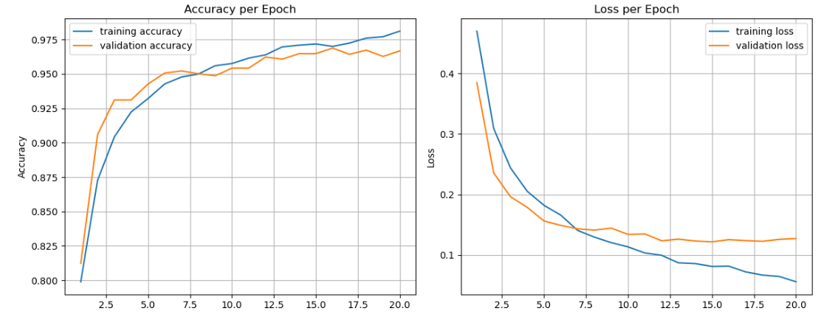
Figure 1. Graphic of Accuracy and Loss in Training and Validation
Evaluation Metrics
Using the validation set, predictions were aggregated and evaluated using:
- Confusion Matrix
True \ Pred | with_mask | without_mask
with_mask | 980 | 14
without_mask | 52 | 942

- Classification Report

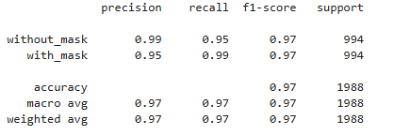
These metrics reflect excellent performance with balanced precision and recall across both classes.

Discussion and Conclusion
The final model achieved strong performance, reaching 96.6% validation accuracy and an F1-score of 0.97, demonstrating that the CNN effectively learned distinguishing features between masked and unmasked faces. The confusion matrix shows balanced performance across both classes, with only a small number of misclassifications:
- with_mask misclassified as without_mask: 14
- without_mask misclassified as with_mask: 52
Despite the strong results, several practical challenges were observed:
- Partial Mask Coverage
Images where masks sit below the nose or chin can confuse the classifier.
- Occlusions
Glasses, scarves, hats, or hands can obscure key facial regions.
- Lighting Variability
Overexposed or dark images reduce the clarity of mask boundaries.
- Pose Variations
Extreme angles or side profiles reduce visibility of mask outlines.
- Context Bias
Busy backgrounds or dataset imbalance may cause the model to rely on context rather than facial features.
- Multiple Faces in One Image
The model may focus on the wrong face if multiple subjects appear.
These pitfalls are important considerations when deploying mask detection systems in the real world.
In conclusion, this exercise successfully demonstrated:
- Manual image loading and preprocessing using OpenCV
(grayscale conversion, resizing, normalization).
- Construction of a CNN with 3.56M trainable parameters that generalized well across diverse images.
- Stable training behavior, with training loss decreasing to 0.055 and validation loss stabilizing at 0.12–0.13.
- High classification performance (97% accuracy, strong precision/recall).
- Comprehensive evaluation using accuracy/loss curves, confusion matrix, and sample prediction visualization functions.
The model performed robustly across diverse images and provides a solid foundation for more advanced tasks such as correct mask wearing detection or multi-class facial analysis.

Lesson Learned
- Manual preprocessing using OpenCV can be as effective as TensorFlow pipelines when carefully structured.
- Grayscale conversion and consistent resizing significantly improve training stability and reduce complexity.
- Model architecture choices (number of filters, dropout, softmax output) greatly influence performance and generalization.
- Accuracy and loss curves help identify mild overfitting and guide model refinement.
- Confusion matrices and classification reports reveal specific failure modes such as occlusion or poor lighting.
- Real-world datasets require attention to pose variation, mask coverage differences, and background noise, all of which affect model reliability.

References
Albawi, S., Mohammed, T. A., & Al-Zawi, S. (2017). Understanding of a convolutional neural network. 2017 International Conference on Engineering and Technology (ICET), 1–6. https://doi.org/10.1109/ICEngTechnol.2017.8308186
Centennial College. (2025). COMP258 – Neural Networks: Assignment 3 instructions and dataset [Unpublished course material].
Centennial College. (2025). Face Mask Detection reference article [Unpublished course reading].
Chollet, F. (2018). Deep learning with Python (1st ed.). Manning Publications.
Goodfellow, I., Bengio, Y., & Courville, A. (2016). Deep learning. MIT Press.
Keras. (2023). Keras API reference. https://keras.io/api/
Kingma, D. P., & Ba, J. (2015). Adam: A method for stochastic optimization. International Conference on Learning Representations. https://doi.org/10.48550/arXiv.1412.6980
Pedregosa, F., Varoquaux, G., Gramfort, A., Michel, V., Thirion, B., Grisel, O., Blondel, M., Prettenhofer, P., Weiss, R., Dubourg, V., Vanderplas, J., Passos, A., Cournapeau, D., Brucher, M., Perrot, M., & Duchesnay, E. (2011). Scikit-learn: Machine learning in Python. Journal of Machine Learning Research, 12, 2825–2830.
TensorFlow. (2023). TensorFlow documentation. https://www.tensorflow.org/

