
ANALYSIS REPORT
COMP 258 - Assignment 4
Use RNNs/LSTMs to solve NLP tasks

Wardatul Keskin | 301294696
Due Date : December 10th, 2025
Professor: Muhammad Saiful Islam

CENTENNIAL COLLEGE

Exercise 1: Use RNNs/LSTMs to solve NLP tasks

Introduction
This lab focuses on applying Recurrent Neural Networks (RNNs) and Long Short-Term Memory (LSTM) architectures to Natural Language Processing (NLP) tasks, with an emphasis on generative modelling. While NLP is commonly associated with natural languages like English, sequence models can also learn the structure and patterns of programming languages. In this exercise, we develop an LSTM-based character-level language model capable of generating synthetic Python code based on patterns learned from real-world source files.
The purpose of this lab is threefold:
- To design and implement an RNN/LSTM network that can learn sequential dependencies from text data.
- To gain hands-on experience with TensorFlow/Keras for constructing, training, and evaluating recurrent models.
- To apply sequence modelling techniques to an unconventional NLP task—automatically generating Python code snippets that resemble human-written code.
To build the training corpus, we used the CPython open-source repository, specifically the /Lib directory, which contains thousands of lines of production-level Python code. These files provide a rich and diverse dataset that allows the LSTM model to learn indentation patterns, keyword usage, naming conventions, and general syntactic structures characteristic of Python.

Experiment Setup

Data Loading and Preparation
- Downloaded the CPython repository (main.zip) using TensorFlow’s get_file() utility.
- Extracted the repository and selected the /Lib directory as the dataset source.
- Recursively loaded all .py files and concatenated them into one large text corpus.
- Truncated the corpus to a manageable size (e.g., 500,000 characters) to reduce training time.
- Generated a character-level vocabulary by identifying all unique characters.
- Converted the full text into numerical IDs based on the vocabulary.

Sequence Construction
- Defined a fixed sequence length (80 characters) for next-character prediction.
- Created overlapping input–target pairs where:
- Input = first 80 characters
- Target = same sequence shifted by one character
- Limited dataset size using a TARGET_STEPS approach, then applied a cap on the number of sequences using the TARGET_STEPS * batch_size method, resulting in approximately 96 steps per epoch.
- Built a tf.data pipeline for shuffling, batching (batch size = 64), and prefetching for improved performance.

Model Architecture
- Implemented a character-level LSTM model using TensorFlow/Keras.
- Model components:
- Embedding layer (128-dimensional)
- Stateful LSTM layer with 256 units
- Dense output layer projecting to the vocabulary size
- Compiled the model using Adam optimizer and sparse categorical cross-entropy loss.
Below is the summary of the architecture
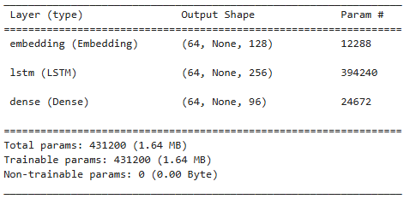

Training Procedure
- Trained the model for 50 epochs with checkpointing enabled to save weights per epoch.
- Monitored the training loss to ensure stable convergence.
- Used a separate inference model (batch_size=1) to enable sequential character generation.

Code Generation Process
- Implemented a sampling-based generation function with temperature control.
- Allowed the user to provide a starting string (e.g., "def my_function(a, b):").
- Generated 400+ characters of synthetic Python code per sample.
- Compared outputs at different temperature levels (0.5 vs. 1.0) to evaluate creativity vs. stability.

Results

Training Performance
The LSTM model was trained for 50 epochs using approximately 96 steps per epoch, which provided a balance between computational efficiency and dataset coverage. The training loss showed a strong and consistent downward trend across all epochs, indicating that the model effectively learned meaningful character-level patterns from the Python source code.
- Initial loss (Epoch 1): ~3.04
- After 10 epochs: ~1.47
- After 20 epochs: ~1.15
- After 30 epochs: ~1.01
- After 50 epochs: ~0.86
The result above is represented in the graph below:
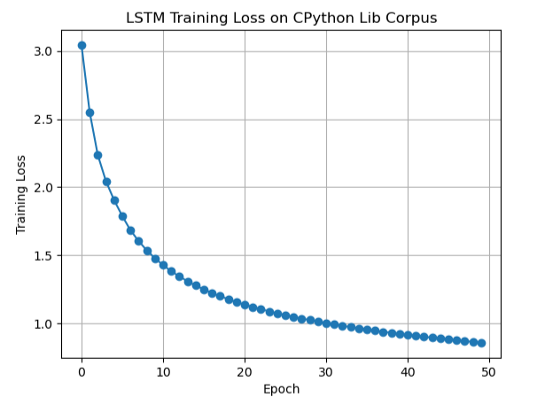
Figure 1. Training lost per epoch
The loss curve demonstrates a smooth exponential decay, typical of stable next-character prediction training. Early epochs show rapid improvement as the model learns foundational syntax patterns such as indentation, common keywords, and punctuation usage. In later epochs, the model continues refining its predictions, gradually reducing errors in more subtle patterns like spacing, naming conventions, and structural consistency.
The training remained stable throughout all 50 epochs, with no signs of divergence, vanishing gradients, or overfitting. The final model achieved a low loss value, suggesting strong short-range predictive capability, a necessary foundation for generating Python-like text during inference.
The loss graph (shown above) clearly visualizes this behaviour: an initial sharp decline followed by a slower, steady improvement as the model approaches convergence.

Quality of Generated Code
Generated code from the model is shown below:
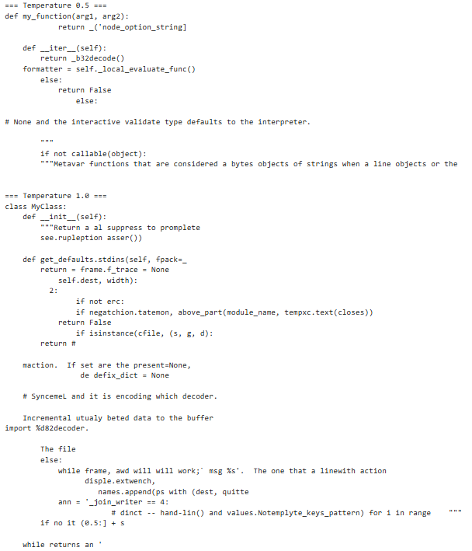
Figure 2. Generated Code
Temperature 0.5 (Conservative Sampling)
Using a temperature of 0.5, the model generated a 1000-character sequence starting from a function-style prompt. The sample began with a valid-looking function definition:
def my_function(arg1, arg2):
return _('node_option_string]
This is followed by another method-like construct and helper-style calls:
def __iter__(self):
return _b32decode()
formatter = self._local_evaluate_func()
The code then drifts into a mixture of else branches, long stretches of whitespace, comments, and partial docstrings, for example:
# None and the interactive validate type defaults to the interpreter.

"""
if not callable(object):
"""Metavar functions that are considered a bytes objects of strings when a line objects or the
Overall, at temperature 0.5 the generated text:
- Correctly uses Python keywords such as def, return, if, and else.
- Produces realistic helper names (_b32decode, _local_evaluate_func) and comment/docstring structure similar to CPython style.
- Maintains indentation reasonably well for the first few lines.
However, it also shows clear syntactic issues:
- Mismatched quotes and brackets ('node_option_string]).
- Random indentation resets and large empty regions.
- Incomplete docstrings and grammatically broken English phrases.
Despite these problems, the output is recognizably “Python-like” and stylistically close to the CPython codebase for short spans.
Temperature 1.0 (More Creative Sampling)
With temperature 1.0, the model produced another 1000-character sequence starting from a class-style prompt. The sample opened with a plausible class definition and constructor:
class MyClass:
def __init__(self):
"""Return a al suppress to promplete
see.rupleption asser())"""
Further lines included complex, but heavily corrupted, statements such as:
def get_defaults.stdins(self, fpack=_
return = frame.f_trace = None
self.dest, width):
2:
if not erc:
if negatchion.tatemon, above_part(module_name, tempxc.text(closes))
Later parts of the sequence mixed comments, malformed imports, and partial loops:
# SyncemeL and it is encoding which decoder.

Incremental utualy beted data to the buffer
import %d82decoder.
At temperature 1.0 the code:
- Still uses many valid Python constructs (class, def, return, if, comments, docstrings).
- Shows much more lexical and structural variety (new “invented” identifiers, unusual combinations of statements).
But the higher temperature also amplifies the errors:
- Frequent syntax violations: invalid function signatures, impossible expressions (return = frame.f_trace = None), and broken imports (import %d82decoder.).
- Severe indentation inconsistencies and abrupt transitions between blocks.
- Nonsensical English within docstrings and comments.
In short, temperature 1.0 produces more diverse and imaginative Python-like text, but with significantly worse syntactic and structural correctness compared to the 0.5 setting.

Discussion and Conclusion
The experiment shows that a character-level LSTM can effectively learn many of the stylistic and structural patterns present in real Python source code, particularly when trained on a rich dataset like the CPython /Lib directory. The steadily decreasing loss across 50 epochs confirms that the model successfully captured short-range dependencies, such as keyword usage (def, class, return), indentation style, common helper-function patterns, and the general rhythm of Python syntax. At lower temperatures, the generated outputs closely resembled genuine CPython code, demonstrating the model’s ability to replicate familiar constructs and formatting behaviours.
However, the generated sequences also reveal important limitations. Python is a highly structured language that requires strict adherence to indentation, matching brackets, valid identifiers, and logical block construction. While the LSTM could maintain coherence for short segments, it consistently broke down over longer sequences, producing mismatched quotes, malformed statements, incorrect indentation, and nonsensical identifiers. These errors stem from the inherent weaknesses of RNNs in modeling long-range context and enforcing grammatical rules. The temperature parameter further illustrated this: at 0.5, outputs were more stable but repetitive; at 1.0, the model became more creative but significantly less syntactically reliable.
Overall, the experiment highlights both the strengths and the limitations of LSTM-based code generation. The model can convincingly imitate the style of Python but cannot reliably generate valid or executable programs due to its inability to maintain structural consistency. This reinforces why modern code-generation systems rely on Transformer-based architectures and token-level modeling rather than character-level RNNs. Nonetheless, the lab provided valuable hands-on experience in data preparation, sequence modeling, TensorFlow implementation, and generative sampling, offering a solid foundation for understanding sequence models and their role in NLP and program synthesis.

Lessons Learned
- LSTMs learn short-range patterns well, such as Python keywords, indentation, and helper-function naming.
- Character-level modeling is limited, often producing mismatched brackets, broken syntax, and incomplete code structures.
- Long-range dependencies remain difficult for LSTMs, explaining why code generation quickly loses coherence.
- Data preprocessing decisions matter, including corpus truncation, sequence length selection, batching, and steps-per-epoch control.
- Temperature strongly affects generation: low temperature = stable but repetitive; high temperature = creative but error-prone.
- This lab highlights why industry moved beyond LSTMs, real tools like Copilot, CodeVibe, and Code Llama rely on Transformers, not RNNs.
- Transformers outperform LSTMs for code because they maintain context over long sequences and handle syntax more reliably.
- The experiment reflects the evolution of AI models, from RNNs → LSTMs → Transformers → specialized code LLMs.
- Understanding LSTM limitations helps explain AGI/ASI progress, where better memory, reasoning, and consistency are required.
- This project strengthened practical ML skills, including data preparation, model training, hyperparameter tuning, and qualitative evaluation of generative outputs.

References
Fausett, L. (1994). Fundamentals of neural networks: Architectures, algorithms, and applications. Pearson.
Géron, A. (2023). Hands-on machine learning with Scikit-Learn, Keras, and TensorFlow (3rd ed.). O’Reilly Media.
Hochreiter, S., & Schmidhuber, J. (1997). Long short-term memory. Neural Computation, 9(8), 1735–1780. https://doi.org/10.1162/neco.1997.9.8.1735
Brownlee, J. (2017). How to develop a word-level neural language model and use it to generate text. Machine Learning Mastery. https://machinelearningmastery.com/text-generation-lstm-recurrent-neural-networks-python-keras/
TensorFlow Team. (2023). TensorFlow: Large-scale machine learning on heterogeneous systems (Version 2.x) [Software]. https://www.tensorflow.org/
Python Software Foundation. (2024). CPython source code repository. https://github.com/python/cpython

