Antenna Report

# Plots

## P1 AZ Cart

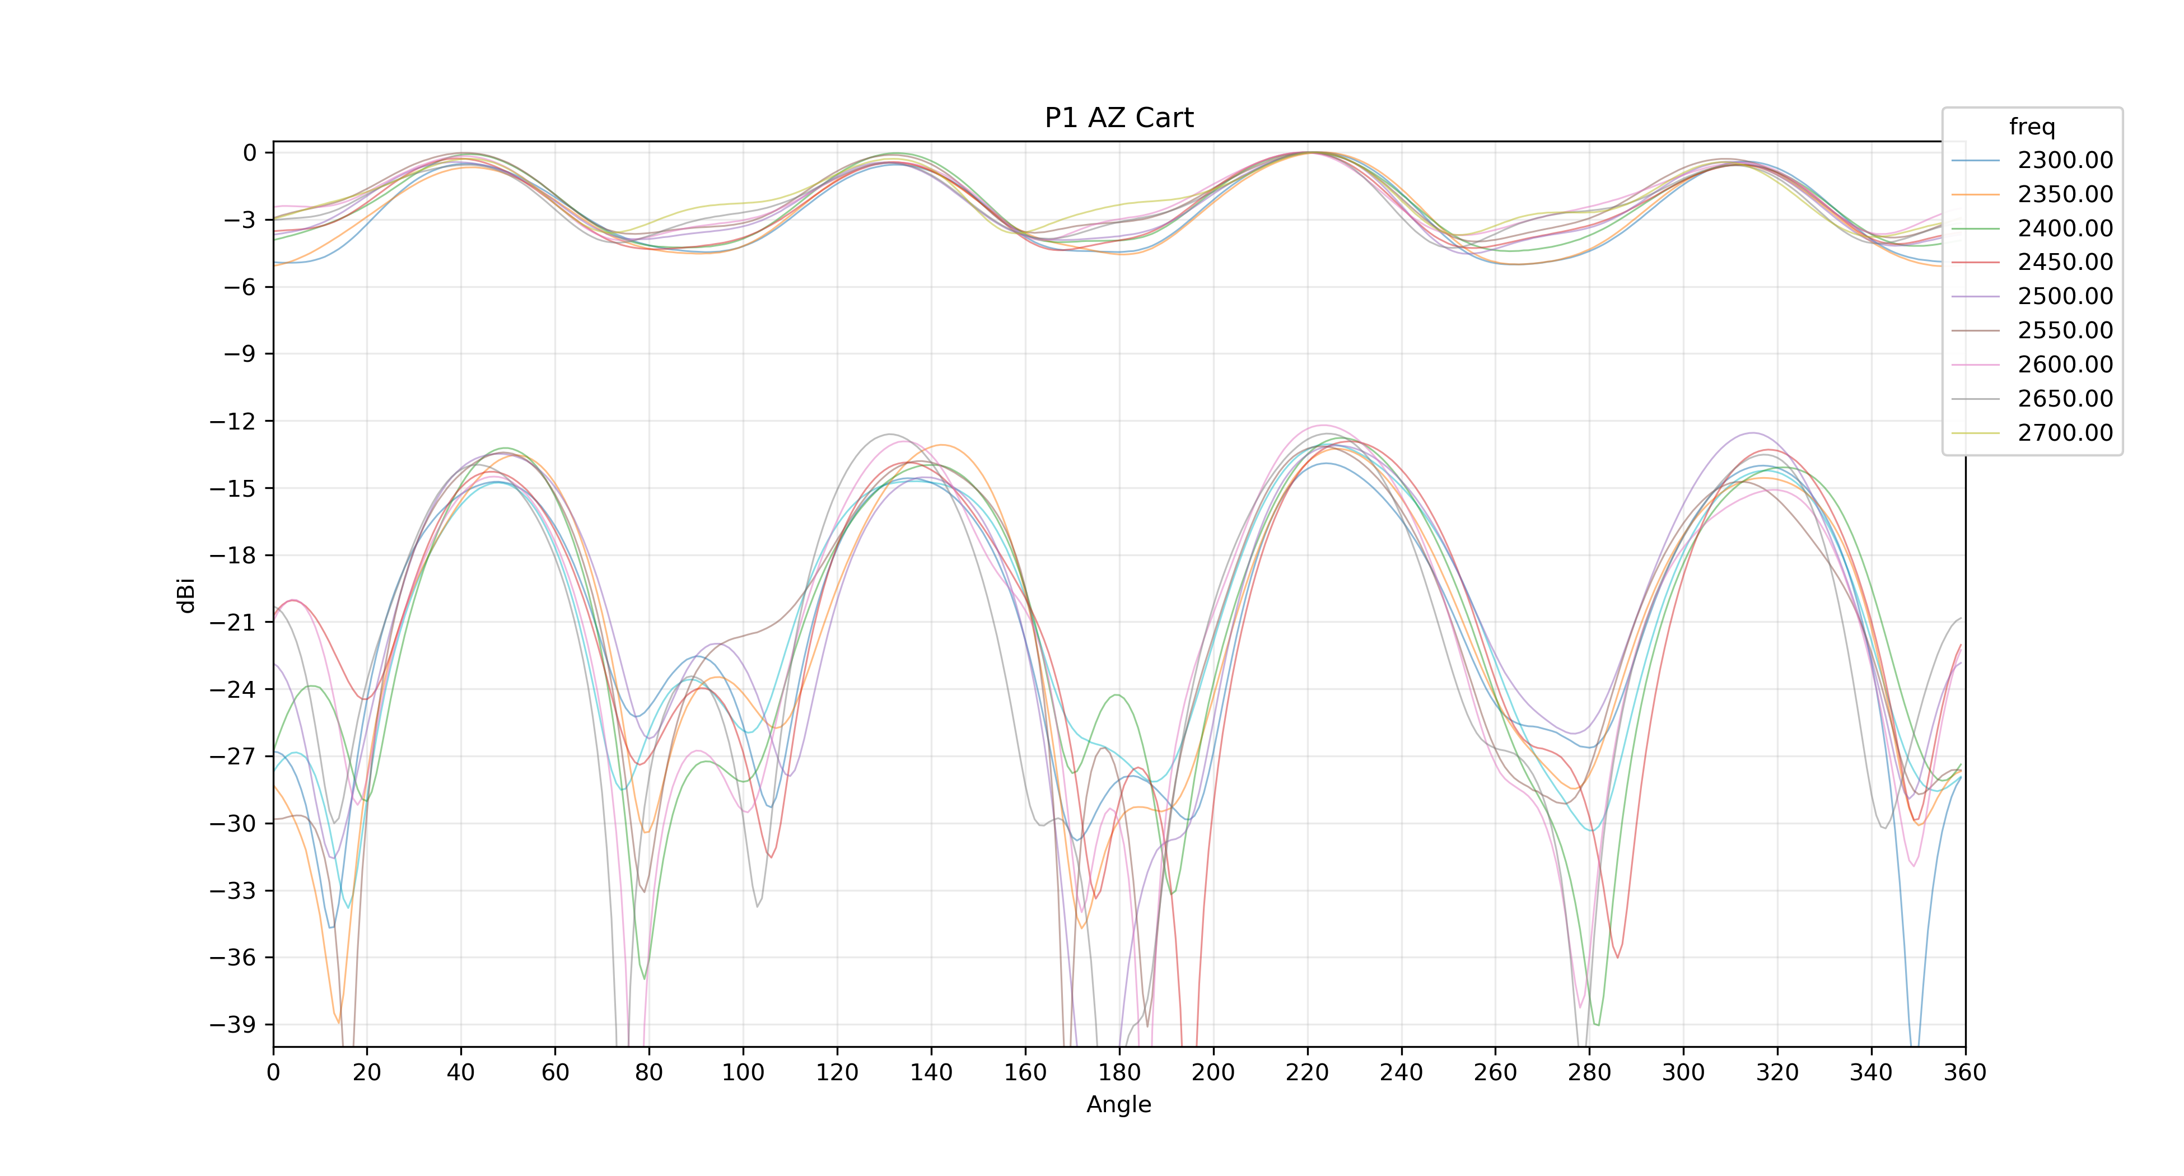

## P1 EL T0 CO Cart

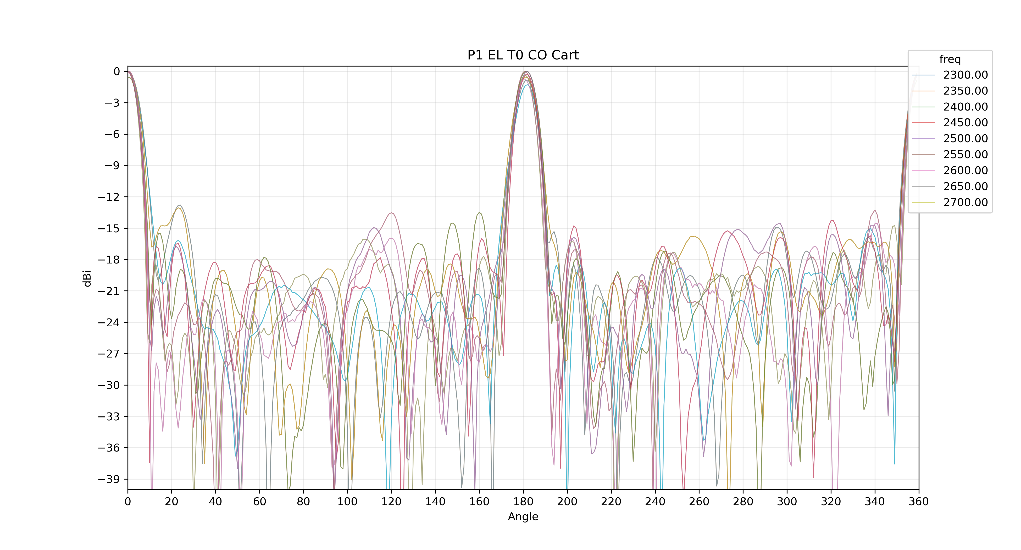

## P1 EL T1 CO Cart

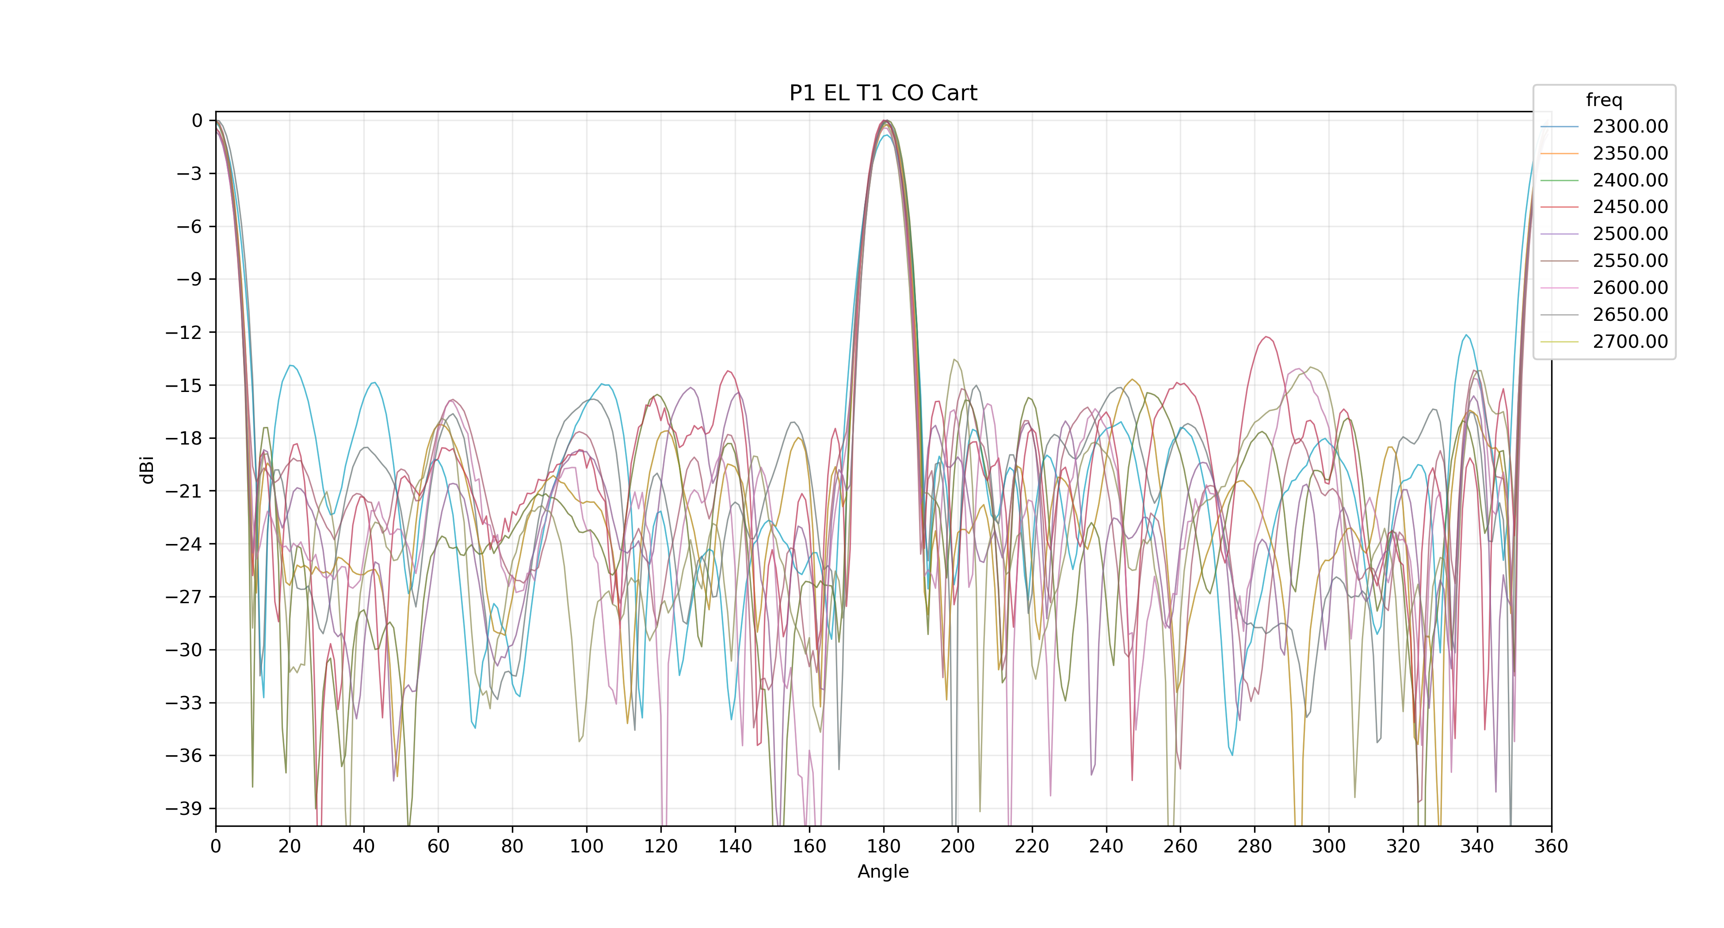

# Radiation Tables

## Cross Pol (max)

|  |  |  |  |
| --- | --- | --- | --- |
| Item | Spec | Frequency | P1 |
| Cross Pol (max) |  | 2350.0 | 13.07 |
| 2400.0 | 12.1 |
| 2450.0 | 12.05 |
| 2500.0 | 11.81 |
| 2550.0 | 12.01 |
| 2600.0 | 12.52 |
| 2650.0 | 11.96 |
| 2700.0 | 12.31 |

|  |  |
| --- | --- |
| Mean | 12.31 |
| Max | 13.07 |
| Min | 11.81 |
| Pass |  |

## Cross Pol (mean)

|  |  |  |  |
| --- | --- | --- | --- |
| Item | Spec | Frequency | P1 |
| Cross Pol (mean) |  | 2350.0 | 18.79 |
| 2400.0 | 19.06 |
| 2450.0 | 18.88 |
| 2500.0 | 18.88 |
| 2550.0 | 19.05 |
| 2600.0 | 19.25 |
| 2650.0 | 19.6 |
| 2700.0 | 20.2 |

|  |  |
| --- | --- |
| Mean | 19.11 |
| Max | 20.2 |
| Min | 18.26 |
| Pass |  |

## Ripple

|  |  |  |  |
| --- | --- | --- | --- |
| Item | Spec | Frequency | P1 |
| Ripple |  | 2350.0 | 5.1 |
| 2400.0 | 4.42 |
| 2450.0 | 4.38 |
| 2500.0 | 4.54 |
| 2550.0 | 3.99 |
| 2600.0 | 3.94 |
| 2650.0 | 4.27 |
| 2700.0 | 3.78 |

|  |  |
| --- | --- |
| Mean | 4.38 |
| Max | 5.1 |
| Min | 3.78 |
| Pass |  |

## 3dB BW EL T0 CO 1st pk

|  |  |  |  |
| --- | --- | --- | --- |
| Item | Spec | Frequency | P1 |
| 3dB BW EL T0 CO 1st pk |  | 2350.0 | 9.69 |
| 2400.0 | 9.23 |
| 2450.0 | 9.11 |
| 2500.0 | 8.39 |
| 2550.0 | 8.12 |
| 2600.0 | 8.12 |
| 2650.0 | 8.02 |
| 2700.0 | 7.55 |

|  |  |
| --- | --- |
| Mean | 8.6 |
| Max | 9.69 |
| Min | 7.55 |
| Pass |  |

## 3dB BW EL T0 CO mid pk

|  |  |  |  |
| --- | --- | --- | --- |
| Item | Spec | Frequency | P1 |
| 3dB BW EL T0 CO mid pk |  | 2350.0 | 9.31 |
| 2400.0 | 9.99 |
| 2450.0 | 9.55 |
| 2500.0 | 8.69 |
| 2550.0 | 8.76 |
| 2600.0 | 8.59 |
| 2650.0 | 8.74 |
| 2700.0 | 8.32 |

|  |  |
| --- | --- |
| Mean | 9.03 |
| Max | 9.99 |
| Min | 8.32 |
| Pass |  |

## 1st USL EL T0 CO 1st pk

|  |  |  |  |
| --- | --- | --- | --- |
| Item | Spec | Frequency | P1 |
| 1st USL EL T0 CO 1st pk |  | 2350.0 | 12.79 |
| 2400.0 | 13.06 |
| 2450.0 | 14.9 |
| 2500.0 | 16.75 |
| 2550.0 | 21.58 |
| 2600.0 | 20.85 |
| 2650.0 | 26.73 |
| 2700.0 | 18.58 |

|  |  |
| --- | --- |
| Mean | 17.94 |
| Max | 26.73 |
| Min | 12.79 |
| Pass |  |

## 1st USL EL T0 CO mid pk

|  |  |  |  |
| --- | --- | --- | --- |
| Item | Spec | Frequency | P1 |
| 1st USL EL T0 CO mid pk |  | 2350.0 | 18.0 |
| 2400.0 | 17.87 |
| 2450.0 | 13.5 |
| 2500.0 | 15.72 |
| 2550.0 | 19.53 |
| 2600.0 | 25.28 |
| 2650.0 | 25.39 |
| 2700.0 | 17.34 |

|  |  |
| --- | --- |
| Mean | 19.19 |
| Max | 25.39 |
| Min | 13.5 |
| Pass |  |

## USL range EL T0 CO 1st pk

|  |  |  |  |
| --- | --- | --- | --- |
| Item | Spec | Frequency | P1 |
| USL range EL T0 CO 1st pk |  | 2350.0 | 12.79 |
| 2400.0 | 13.06 |
| 2450.0 | 14.9 |
| 2500.0 | 16.44 |
| 2550.0 | 16.74 |
| 2600.0 | 20.85 |
| 2650.0 | 21.83 |
| 2700.0 | 18.58 |

|  |  |
| --- | --- |
| Mean | 16.82 |
| Max | 21.83 |
| Min | 12.79 |
| Pass |  |

## USL range EL T0 CO mid pk

|  |  |  |  |
| --- | --- | --- | --- |
| Item | Spec | Frequency | P1 |
| USL range EL T0 CO mid pk |  | 2350.0 | 18.0 |
| 2400.0 | 17.87 |
| 2450.0 | 13.5 |
| 2500.0 | 15.72 |
| 2550.0 | 19.53 |
| 2600.0 | 19.1 |
| 2650.0 | 22.35 |
| 2700.0 | 17.34 |

|  |  |
| --- | --- |
| Mean | 18.16 |
| Max | 22.35 |
| Min | 13.5 |
| Pass |  |

## USL range (BS) EL T0 CO 1st pk

|  |  |  |  |
| --- | --- | --- | --- |
| Item | Spec | Frequency | P1 |
| USL range (BS) EL T0 CO 1st pk |  | 2350.0 | 12.79 |
| 2400.0 | 13.06 |
| 2450.0 | 14.9 |
| 2500.0 | 16.44 |
| 2550.0 | 16.74 |
| 2600.0 | 20.85 |
| 2650.0 | 21.83 |
| 2700.0 | 18.58 |

|  |  |
| --- | --- |
| Mean | 16.82 |
| Max | 21.83 |
| Min | 12.79 |
| Pass |  |

## USL range (BS) EL T0 CO mid pk

|  |  |  |  |
| --- | --- | --- | --- |
| Item | Spec | Frequency | P1 |
| USL range (BS) EL T0 CO mid pk |  | 2350.0 | 18.0 |
| 2400.0 | 17.87 |
| 2450.0 | 13.5 |
| 2500.0 | 15.72 |
| 2550.0 | 19.53 |
| 2600.0 | 19.1 |
| 2650.0 | 22.35 |
| 2700.0 | 17.34 |

|  |  |
| --- | --- |
| Mean | 18.16 |
| Max | 22.35 |
| Min | 13.5 |
| Pass |  |

## Tilt Deviation EL T0 CO 1st pk

|  |  |  |  |
| --- | --- | --- | --- |
| Item | Spec | Frequency | P1 |
| Tilt Deviation EL T0 CO 1st pk |  | 2350.0 | 1.44 |
| 2400.0 | 1.34 |
| 2450.0 | 1.35 |
| 2500.0 | 0.94 |
| 2550.0 | 1.14 |
| 2600.0 | 1.53 |
| 2650.0 | 1.55 |
| 2700.0 | 1.28 |

|  |  |
| --- | --- |
| Mean | 1.34 |
| Max | 1.55 |
| Min | 0.94 |
| Pass |  |

## Tilt Deviation EL T0 CO mid pk

|  |  |  |  |
| --- | --- | --- | --- |
| Item | Spec | Frequency | P1 |
| Tilt Deviation EL T0 CO mid pk |  | 2350.0 | 1.44 |
| 2400.0 | 1.06 |
| 2450.0 | 1.4 |
| 2500.0 | 1.56 |
| 2550.0 | 1.65 |
| 2600.0 | 0.89 |
| 2650.0 | 0.64 |
| 2700.0 | 0.68 |

|  |  |
| --- | --- |
| Mean | 1.21 |
| Max | 1.65 |
| Min | 0.64 |
| Pass |  |

## Peak Deviation EL T0 CO 1st pk

|  |  |  |  |
| --- | --- | --- | --- |
| Item | Spec | Frequency | P1 |
| Peak Deviation EL T0 CO 1st pk |  | 2350.0 | 1.0 |
| 2400.0 | 1.0 |
| 2450.0 | 1.0 |
| 2500.0 | 1.0 |
| 2550.0 | 1.0 |
| 2600.0 | 1.0 |
| 2650.0 | 1.0 |
| 2700.0 | 1.0 |

|  |  |
| --- | --- |
| Mean | 1.0 |
| Max | 1 |
| Min | 1 |
| Pass |  |

## Peak Deviation EL T0 CO mid pk

|  |  |  |  |
| --- | --- | --- | --- |
| Item | Spec | Frequency | P1 |
| Peak Deviation EL T0 CO mid pk |  | 2350.0 | 2.0 |
| 2400.0 | 1.0 |
| 2450.0 | 1.0 |
| 2500.0 | 2.0 |
| 2550.0 | 2.0 |
| 2600.0 | 1.0 |
| 2650.0 | 1.0 |
| 2700.0 | 1.0 |

|  |  |
| --- | --- |
| Mean | 1.44 |
| Max | 2 |
| Min | 1 |
| Pass |  |

## 3dB BW EL T1 CO 1st pk

|  |  |  |  |
| --- | --- | --- | --- |
| Item | Spec | Frequency | P1 |
| 3dB BW EL T1 CO 1st pk |  | 2350.0 | 9.25 |
| 2400.0 | 8.55 |
| 2450.0 | 8.4 |
| 2500.0 | 8.46 |
| 2550.0 | 8.39 |
| 2600.0 | 8.24 |
| 2650.0 | 7.85 |
| 2700.0 | 8.14 |

|  |  |
| --- | --- |
| Mean | 8.58 |
| Max | 9.93 |
| Min | 7.85 |
| Pass |  |

## 3dB BW EL T1 CO mid pk

|  |  |  |  |
| --- | --- | --- | --- |
| Item | Spec | Frequency | P1 |
| 3dB BW EL T1 CO mid pk |  | 2350.0 | 9.23 |
| 2400.0 | 8.79 |
| 2450.0 | 9.03 |
| 2500.0 | 8.59 |
| 2550.0 | 7.97 |
| 2600.0 | 8.38 |
| 2650.0 | 8.36 |
| 2700.0 | 7.73 |

|  |  |
| --- | --- |
| Mean | 8.63 |
| Max | 9.55 |
| Min | 7.73 |
| Pass |  |

## 1st USL EL T1 CO 1st pk

|  |  |  |  |
| --- | --- | --- | --- |
| Item | Spec | Frequency | P1 |
| 1st USL EL T1 CO 1st pk |  | 2350.0 | 19.81 |
| 2400.0 | 19.45 |
| 2450.0 | 16.99 |
| 2500.0 | 18.34 |
| 2550.0 | 18.07 |
| 2600.0 | 19.17 |
| 2650.0 | 22.17 |
| 2700.0 | 18.89 |

|  |  |
| --- | --- |
| Mean | 18.53 |
| Max | 22.17 |
| Min | 13.89 |
| Pass |  |

## 1st USL EL T1 CO mid pk

|  |  |  |  |
| --- | --- | --- | --- |
| Item | Spec | Frequency | P1 |
| 1st USL EL T1 CO mid pk |  | 2350.0 | 17.0 |
| 2400.0 | 19.42 |
| 2450.0 | 26.12 |
| 2500.0 | 17.52 |
| 2550.0 | 19.83 |
| 2600.0 | 24.21 |
| 2650.0 | 19.27 |
| 2700.0 | 25.38 |

|  |  |
| --- | --- |
| Mean | 21.38 |
| Max | 26.12 |
| Min | 17.0 |
| Pass |  |

## USL range EL T1 CO 1st pk

|  |  |  |  |
| --- | --- | --- | --- |
| Item | Spec | Frequency | P1 |
| USL range EL T1 CO 1st pk |  | 2350.0 | 18.54 |
| 2400.0 | 19.45 |
| 2450.0 | 16.99 |
| 2500.0 | 17.87 |
| 2550.0 | 18.07 |
| 2600.0 | 19.17 |
| 2650.0 | 21.65 |
| 2700.0 | 18.89 |

|  |  |
| --- | --- |
| Mean | 18.28 |
| Max | 21.65 |
| Min | 13.89 |
| Pass |  |

## USL range EL T1 CO mid pk

|  |  |  |  |
| --- | --- | --- | --- |
| Item | Spec | Frequency | P1 |
| USL range EL T1 CO mid pk |  | 2350.0 | 17.0 |
| 2400.0 | 17.73 |
| 2450.0 | 18.31 |
| 2500.0 | 14.21 |
| 2550.0 | 15.43 |
| 2600.0 | 17.78 |
| 2650.0 | 18.55 |
| 2700.0 | 18.81 |

|  |  |
| --- | --- |
| Mean | 17.74 |
| Max | 21.84 |
| Min | 14.21 |
| Pass |  |

## USL range (BS) EL T1 CO 1st pk

|  |  |  |  |
| --- | --- | --- | --- |
| Item | Spec | Frequency | P1 |
| USL range (BS) EL T1 CO 1st pk |  | 2350.0 | 18.54 |
| 2400.0 | 19.45 |
| 2450.0 | 16.99 |
| 2500.0 | 17.87 |
| 2550.0 | 18.07 |
| 2600.0 | 19.17 |
| 2650.0 | 21.65 |
| 2700.0 | 18.89 |

|  |  |
| --- | --- |
| Mean | 18.28 |
| Max | 21.65 |
| Min | 13.89 |
| Pass |  |

## USL range (BS) EL T1 CO mid pk

|  |  |  |  |
| --- | --- | --- | --- |
| Item | Spec | Frequency | P1 |
| USL range (BS) EL T1 CO mid pk |  | 2350.0 | 17.0 |
| 2400.0 | 17.73 |
| 2450.0 | 18.31 |
| 2500.0 | 14.21 |
| 2550.0 | 15.43 |
| 2600.0 | 17.78 |
| 2650.0 | 18.55 |
| 2700.0 | 18.81 |

|  |  |
| --- | --- |
| Mean | 17.74 |
| Max | 21.84 |
| Min | 14.21 |
| Pass |  |

## Tilt Deviation EL T1 CO 1st pk

|  |  |  |  |
| --- | --- | --- | --- |
| Item | Spec | Frequency | P1 |
| Tilt Deviation EL T1 CO 1st pk |  | 2350.0 | 2.5 |
| 2400.0 | 1.83 |
| 2450.0 | 1.76 |
| 2500.0 | 1.67 |
| 2550.0 | 1.81 |
| 2600.0 | 1.98 |
| 2650.0 | 1.57 |
| 2700.0 | 1.72 |

|  |  |
| --- | --- |
| Mean | 1.81 |
| Max | 2.5 |
| Min | 1.49 |
| Pass |  |

## Tilt Deviation EL T1 CO mid pk

|  |  |  |  |
| --- | --- | --- | --- |
| Item | Spec | Frequency | P1 |
| Tilt Deviation EL T1 CO mid pk |  | 2350.0 | 0.22 |
| 2400.0 | 0.17 |
| 2450.0 | 0.01 |
| 2500.0 | 0.62 |
| 2550.0 | 0.37 |
| 2600.0 | 0.52 |
| 2650.0 | 0.63 |
| 2700.0 | 0.61 |

|  |  |
| --- | --- |
| Mean | 0.4 |
| Max | 0.63 |
| Min | 0.01 |
| Pass |  |

## Peak Deviation EL T1 CO 1st pk

|  |  |  |  |
| --- | --- | --- | --- |
| Item | Spec | Frequency | P1 |
| Peak Deviation EL T1 CO 1st pk |  | 2350.0 | 2.0 |
| 2400.0 | 2.0 |
| 2450.0 | 2.0 |
| 2500.0 | 2.0 |
| 2550.0 | 2.0 |
| 2600.0 | 1.0 |
| 2650.0 | 1.0 |
| 2700.0 | 2.0 |

|  |  |
| --- | --- |
| Mean | 1.67 |
| Max | 2 |
| Min | 1 |
| Pass |  |

## Peak Deviation EL T1 CO mid pk

|  |  |  |  |
| --- | --- | --- | --- |
| Item | Spec | Frequency | P1 |
| Peak Deviation EL T1 CO mid pk |  | 2350.0 | 0.0 |
| 2400.0 | 0.0 |
| 2450.0 | 0.0 |
| 2500.0 | 1.0 |
| 2550.0 | 0.0 |
| 2600.0 | 1.0 |
| 2650.0 | 1.0 |
| 2700.0 | 1.0 |

|  |  |
| --- | --- |
| Mean | 0.44 |
| Max | 1 |
| Min | 0 |
| Pass |  |