Do you spend too much time programming,
and not enough doing research?
This course can help.

Software Development for Scientists and Engineers
The Problem: Computers are as important to modern science as telescopes, oscilloscopes, and test tubes. Despite this, most scientists and engineers are never taught how to design, develop, test, and deploy software efficiently. The result is that they spend more time programming than they should, and produce software that is less trustworthy than it should be. |  | 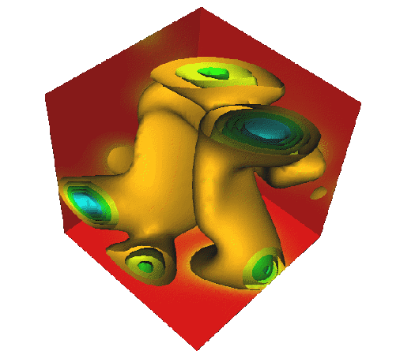
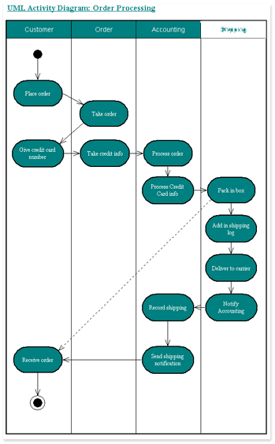 | The Solution: SDSE is a one-term non-credit course that teaches best practices for software development. The course focuses on tools and techniques that have been proven to help individuals and teams meet their targets. SDSE is open to graduate students in science, engineering, and related disciplines at the University of Toronto and affiliated institutions.

Topics | Version control  Unit testing  Process control  Systematic debugging  Design patterns | Processing text and binary data  Scripting  File system programming  Analysis and estimation  Persistence
Requirements | Students must have prior experience with C, C++, Java, or Fortran, and to be able to use a shell, an editor, and a browser on either Unix or Windows.
Format | Weekly ninety-minute lectures. Practical exercises will be assigned each week, and discussed on-line the next week. Some individual tutoring and consultation will be available.
Contact | Dr. Gregory V. Wilson  Department of Computer Science  gvwilson@cs.utoronto.ca

