MARS TARGET ENCYLOPEDIA: INFORMATION EXTRACTION FOR PLANETARY SCIENCE. K. L. Wagstaff¹, R. Francis¹, T. Gowda¹, Y. Lu¹, E. Riloff², and K. Singh¹, ¹Jet Propulsion Laboratory, California Institute of Technology, 4800 Oak Grove Drive, Pasadena, CA 91109, kiri.wagstaff@jpl.nasa.gov, ²University of Utah, Salt Lake City, UT.

Introduction: We created a new reference database called the Mars Target Encyclopedia (MTE) that contains compositional information about science targets (usually rocks or soils) on Mars. Users can search for all targets that contain an element (e.g., “calcium”) or mineral (e.g., “hematite”). They can also look up information about a specific target of interest (e.g., “Dillinger”) to browse previous findings about its composition.
The information that populates the MTE was mined automatically from the planetary science literature using state-of-the-art advances in information extraction. All information in the MTE is linked to the source publication from which it was extracted, so users can easily browse the full context in the original document.
Surface targets on Mars: Mars rover missions identify new observational targets on a daily basis. Each such rock, soil, or point of interest is given a unique name, often derived from Earth locations (e.g., “Ithaca”, “Staten Island”), Earth people (e.g., “John Klein”), or whimsy (e.g., “Frood”). The Mars Science Laboratory rover has identified more than 7,000 targets in 4.5 years. There are hundreds of publications about these targets.
Information extraction methods: Information extraction (IE) methods have been employed to extract diverse information such as terrorist events in news articles or protein interactions in biomedical documents. We trained an IE system to recognize “named entities” such as targets, elements, and minerals and then identify composition relationships between targets and elements or minerals.
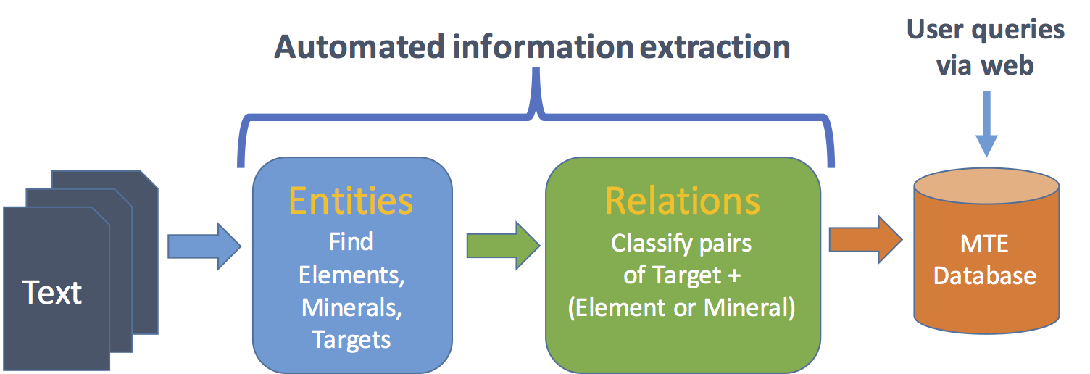

to quickly process large amounts of text and pull out relevant structured information

Replace these instructions with the text of your abstract. Do NOT delete the section break above. The text will appear in two columns that are each ~3 inches wide. (Please make sure your paper size is set to U.S. letter, 8.5" × 11", before submitting your abstract.) Page margins are set to be one inch on all sides. If you are including tables or figures, they MUST be imported into this file.
This template is designed to accommodate abstracts for the majority of USRA meetings; it is your responsibility to be aware of the guidelines (length restrictions, file size, etc.) for a particular meeting. These will be detailed in the Call for Abstracts section of the meeting announcement.
The text will automatically wrap to a second page if necessary. The running head on the second page of this template has been eliminated intentionally.
Digital Formats: Any image file format that can be imported into this file will be acceptable for publication; to avoid technical problems, we suggest using TIFF (.tif) or GIF (.gif) files for photographs, and encapsulated PostScript (.eps) or Windows metafiles (.wmf) for line drawings. We ask that you use smaller-format files whenever possible (for example, don’t use a 1-MB TIFF file if a 250-K GIF file provides acceptable resolution).
Heading Styles: The section heads in this template use the correct style (upper and lower case, bold, followed by a colon). The format for second-level heads is show below:
Sample of a level-two head. Automatic paragraph indents are imbedded to appear every time you use a hard return. If you’re using the spell checker and it doesn’t seem to be working, check the “Language” option under the “Tools” to make sure that “No Proofing” isn’t selected as the default. You should also check that the default font is Times New Roman and not New York (this conversion takes place on some Macintosh systems).
References: Use the brief numbered style common in many abstracts, e.g., [1], [2], etc. References should then appear in numerical order in the reference list, and should use the following abbreviated style:
[1] Author A. B. and Author C. D. (1997) JGR, 90, 1151–1154. [2] Author E. F. et al. (1997) Meteoritics & Planet. Sci., 32, A74. [3] Author G. H. (1996) LPS XXVII, 1344–1345. [4] Author I. J. (2002) LPS XXXIII, Abstract #1402.
Additional Information: If you have any questions or need additional information regarding the preparation of your abstract, call the LPI at 281-486-2142 or -2188 (or send an e-mail message to publish@hou.usra.edu).
Please DO NOT submit duplicates of your abstract; should you find it necessary to replace or repair your abstract PRIOR TO the submission deadline, use the tools provided in the USRA meeting portal. If the deadline has already passed, contact the numbers provided on the meeting website.

- MTE motivation + use cases
- MTE entry screenshot
- System: PDF -> text -> reference removal -> NER -> RE
- Performance of NER
- Performance of RE

References: [1] CoreNLP. [2] Giuliano et al. (2006). [3] Wagstaff, K. L. et al. (2015) AAAI Workshop on Knowledge Extraction from Text.

