What is an Activity

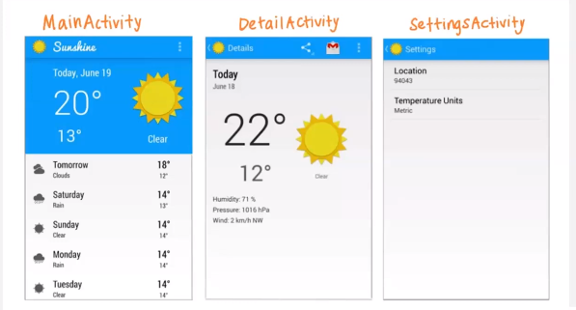

* An activity can be these different views

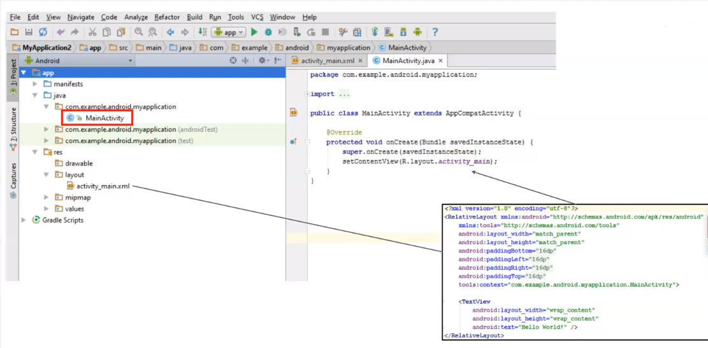

* Located in the layout -> activity_main.xml
  + And the MainActivity n the com.* package

The Activity Lifecycle

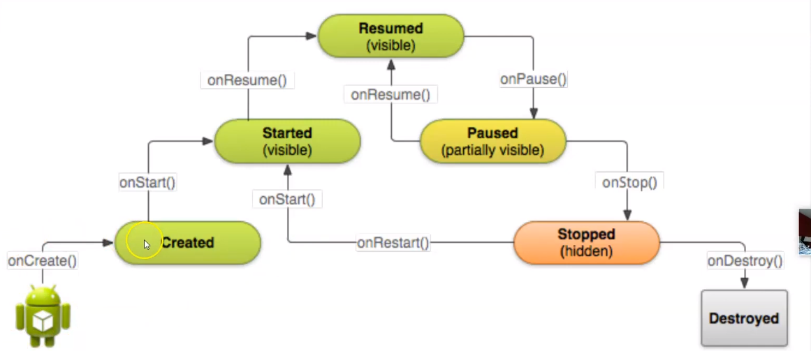

**The 4 Activity States**

1. Resumed
   1. The activity is in the foreground and the user can interact with it
      1. *Running State*
2. Paused
   1. The activity is partially obscured by another activity
   2. Other activity in the foreground is semitransparent or doesn’t cover the entire screen
   3. Cannot receive user input or execute any code
3. Stopped
   1. Completely hidden and not visible
   2. In the background
   3. All state information such as member variables is retained, but cannot execute any code
4. Destroyed
   1. Activity is nonexistent
   2. Does not take up short term memory on the device

**Which Method to Use?**

* onCreate()
  + To initialize the activity
  + usually call setContentView(int)
    - Includes the layout resource to define the UI
  + findViewById(int) to retrieve widgets in the UI that is needed to interact with for programming
* onPause()
  + Stop animations or other actions to conserve CP
  + Commit unsaved changes
  + Release system resources
    - Such as broadcast recievers, handles to sensors (like GPS), or any resource that may affect battery life while activity is paused
* onResume()
  + Restart what was stopped when paused
    - Must take in account if the application wasn’t placed into pause recently
* onStop()
  + More CPU intensive shut-down operations such as writing to a database
* onDestroy()
  + Terminate threads or background processes started in onCreate()
  + Should not be used for cleaning up and saving data since it may not be unreliable
    - Not always called

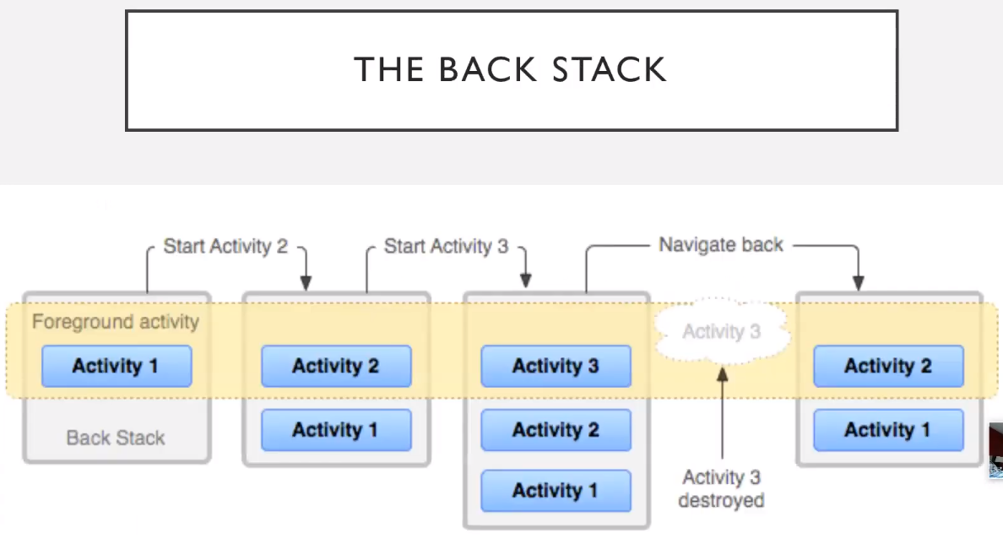

* Remember the stack, PLATES

**Activity State**

* The activity is destroyed when
  + When the finish() call is fetched
  + User presses the back button
* Activity gets destroyed and recreated if
  + User rotates device
  + User changes language
  + The application is terminated by the system to regain RAM
* The saved data that the system uses to restore the previous state is called the *instance state* and is a collection of key-value pairs stored in a Bundle object
* By default, the system uses the Bundle instance state to save information about each View object in your activity layout (such as text value entered into an EditText object)
* If the activity instance is destroyed and recreated, the state of the layout is restored to its previous state with no code required by you

