Introduction
The ESP-12E Motor Shield is compatible with ESP12E Dev Kit and ESP8266 NodeMCU.
By using the overlap-plug design, the NodeMCU module plugs directly into the Motor Shield. This shield board is driven by a full-bridge chip L293DD from STMicroelectronics, which can directly drive 2-channel DC motors or one-channel stepper motor. The chip is rated to deliver up to 1.2A when a heat-sink is in place. However this shield module is not supplied with a heatsink on the chip, so you cannot run the shield at such levels without adding one. But in our use case, this is not an issue.

On this motor shield board, the IO ports from the ESP are used as control input ports, consuming four ESP ports: D1, D2, D3, and D3. These are usually used to control two DC motors, that are wired to the A-/A+ and B-/B+ ports on the connector block. In our use case, these terminals don’t connect to motors, but to the Yeasu control box’s DIN socket to command either the Azimuth (D1), or the Elevation (D2) (or both concurrently) movement, and the movement direction. D3 signals the Azimuth movement direction (CCW or CW) and D4 the elevation direction (Up or Down).

We are using this ‘motor shield’ board because its cheap and convenient to use, with a connector block where we can screw in cables coming from the outside world and it has the socket where we can plug in the ESP 8266 module. And it comes with sufficiently exposed header pins to which we canjust connet all the external components we need to make this all work. So no need to make any special circuit board, solder in the components. The only work you need to do is to make a nice small plastic box into which you can mount all the bits and pieces in a secure way.

I just used a very inexpensive plastic box and then carefully marked a rectangle, which I then drilled out and filed so that the small OLED can be mounted inside such that it is viable from the front. Internally I used some insulation tape and black duct-tape to secure it into position. And then I drilled a few holes, two for the push buttons, one for the short 8-core screened cable that comes from the controller. I also filed a small slit close to the top of the lid, so I can use a standard micro-usb cable, that runs from my laptop to the unit and plugs directly into the ESP8266 board. Yes you can always drill a hole, cut the usb cable, then resolder the plug on afterwards once its through the hole. I took the short-cut approach and it works just as well, but perhaps not all that pretty.

So there are many advantages to using this ‘Motor Shield’.
But there was one small complication. The two + and – ports on the A and B motor outputs can be configured only as follows:
- Both + and – ports are open circuit, OR
- The + port goes to VCC, with the – taken to GND, OR
- The + port goes to GND, with the – taken to VCC.

The board does not make it possible to take only one of the ports to GND, whilst the other remains open circuit. Why is this a complication? The Yeasu AzEl controllers have 2 inputs with which to control the Azimuth (CW and CCW) and another 2 inputs for controlling the Elevation (Up, Down). When you ground these inputs, there is a transistor that ‘turns on’ and energizes the corresponding relay, which in turn provides power to the rotator in a manner which generates the desired movement. Because the rotor board is designed to power higher voltage motors, it conveniently provides for two input voltages. So in our case, it is powered from 3.3V (via a voltage regulator on the ESP 8266 board) and with the ‘motor voltage’ supplied from the Yeasu controller, using the 12-14V delivered out of its DINN socket. For us it means that the ports on our configuration are either Open Circuit, GND, or at the very same 12V as used internally to feed the aforementioned transistor switching circuit. When we supply the 12V back to any of the 4 control input pins, then these transistors cannot ‘turn on’ and supplying the 12V is then essentially the logical equivalent to an open circuit.

The other advantage of the motor shield is that on any port, we cannot provide GND to both input pins at the same time, even if we make a programming error.

In addition, this shield board has many pins, such as VIN, 3.3V, DIO, AIO, SDIO, UART, SPI, RST, and EN, thus can conveniently connect all kinds of sensors (e.g., temperature and humidity, buzzer, light, relay sensor, etc.).

In our case, we implement an I2C bus using D6 (SDA) and D7 (SCL), which connects to a OLED display module and a A2D module.
We also hook up two push buttons to D8 and D5, which serve as inputs to our menu system.

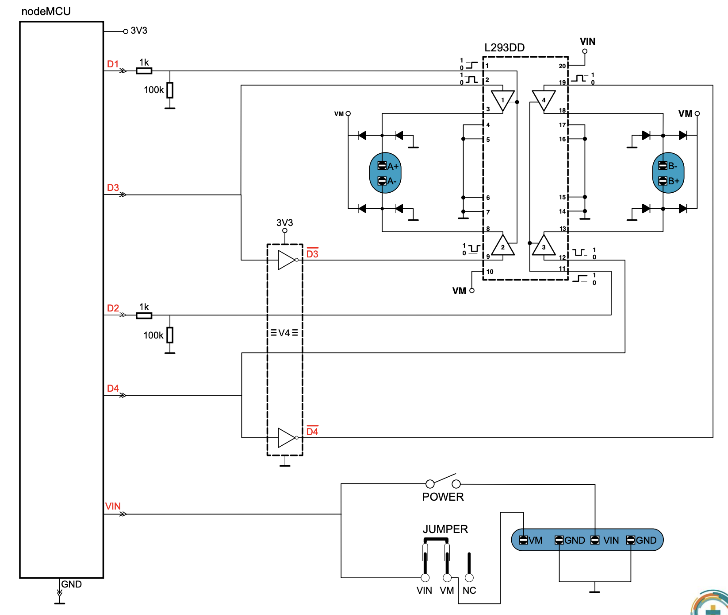

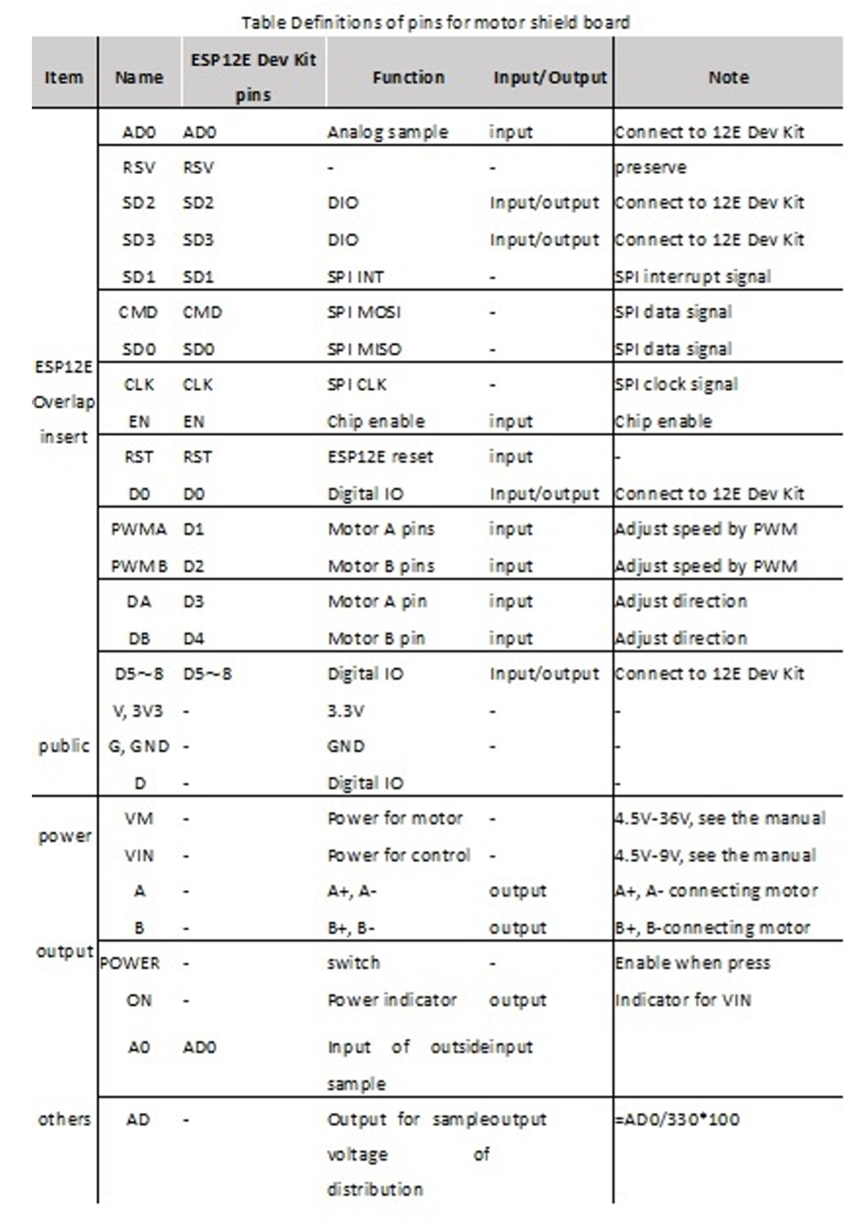

Table Definitions of pins for motor shield board
Item | Name | ESP12E Dev Kit Pins | Function | Input/Output | Note
ESP12E Overlap insert | AD0 | AD0 | Analog sample | input | Connect to 12E Dev Kit
 | RSV | RSV | - | - | preserve
 | SD2 | SD2 | DIO | Input/output | Connect to 12E Dev Kit
 | SD3 | SD3 | DIO | Input/output | Connect to 12E Dev Kit
 | SD1 | SD1 | SPI INT | - | SPI interrupt signal
 | CMD | CMD | SPI MOSI | - | SPI data signal
 | SD0 | SD0 | SPI MISO | - | SPI data signal
 | CLK | CLK | SPI CLK | - | SPI clock signal
 | EN | EN | Chip enable | input | Chip enable
 | RST | RST | ESP12E reset | input | -
 | D0 | D0 | Digital IO | Input/output | Connect to 12E Dev Kit
 | PWMA | D1 | Motor A pins | input | Adjust speed by PWM
 | PWMB | D2 | Motor B pins | input | Adjust speed by PWM
 | DA | D3 | Motor A pin | input | Adjust direction
 | DB | D4 | Motor B pin | input | Adjust direction
 | D5~8 | D5~8 | Digital IO | Input/output | Connect to 12E Dev Kit
public | V, 3V3 | - | 3.3V | - | -
 | G, GND | - | GND | - | -
 | D | - | Digital IO | - | -
power | VM | - | Power for motor | - | 4.5V-36V, see the manual
 | VIN | - | Power for control | - | 4.5V-9V, see the manual
output | A | - | A+, A- | output | A+, A- connecting motor
 | B | - | B+, B- | output | B+, B- connecting motor
 | POWER | - | switch | - | Enable when press
 | ON | - | Power indicator | output | Indicator for VIN
 | A0 | AD0 | Input of outside input sample | input | -
others | AD | - | Output for sample voltage of distribution | output | =AD0/330*100

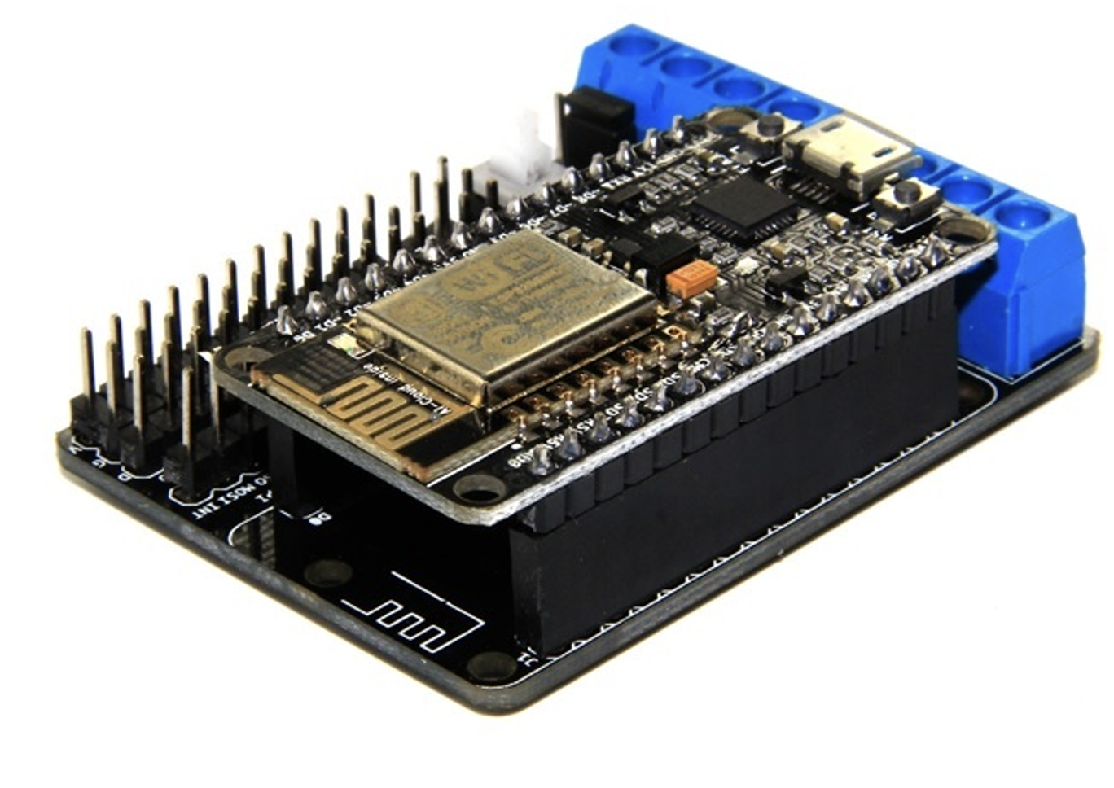

NodeMCU pins already hard-wired to the shield.

Function | NodeMCU Pin | GPIO | Notes
Azimuth CW (A+)  Azimuth CCW (A-) | D1 | 5 | Shield Motor A Enable
Azimuth CW (A+)  Azimuth CCW (A-) | D3 | 0 | Shield Motor A Direction
Elevation Up (B+)  Elevation Down (B-) | D2 | 4 | Shield Motor B Enable
Elevation Up (B+)  Elevation Down (B-) | D4 | 2 | Shield Motor B Direction
USB Serial TX (to Mac/PC) | TX | 1 | Leave free
USB Serial RX (from Mac/PC) | RX | 3 | Leave free

NodeMCU Shield Hookups.
Function | NodeMCU Pin | GPIO | Notes
I2C SDA (OLED + ADS1115) | D6 | 12 | Clean pin for OLED display and A2D module
I2C SCL (OLED + ADS1115) | D7 | 13 | Clean pin for OLED display and A2D module
Button 1 (Menu nav) | D8 | 15 | Wire button to VCC (Any pin on 3.3V rail)
Button 2 (Menu nav) | D5 | 14 | Wire button to GND (Any pin on GND rail)

Please note that on Button 1, we wire the other terminal to VCC (3.3V), whilst on Button 2, we wire the other terminal to GND. Why the difference?
Pin D8/GPIO15 must be LOW at reset for the ESP8266 to boot normally. And so this module comes with a fixed pull-down resistor. If you power up the unit whilst this button is pressed, it wont boot properly at all. Pin D5 has a programmable pull-up resistor, which we use in our firmware to keep this pin at 3.3V, but which goes to 0V when Button 2 is pressed. When you press Button 1, D8 goes from 0V to 3.3V. We are using ALL the GPIO pins on this MCU, except D0, which we leave alone because its even more tricky to use that for a button.

The Oled
PINs are (when looking from the front),
Pin 1(left most pin) : GND – Connect to GND rail (e.g. Column 1)
Pin 2 : VCC – Connect to 3.3v rail (e.g. Column 1)
Pin 3 : SCL – Connect to D7 GPIO pin. (Using two ends of 3 leg splitter wire)
Pin 4(right most pin): SDA – Connect to D6 GPIO pin. (Using two ends of 3 leg splitter wire)

ADS1115 module
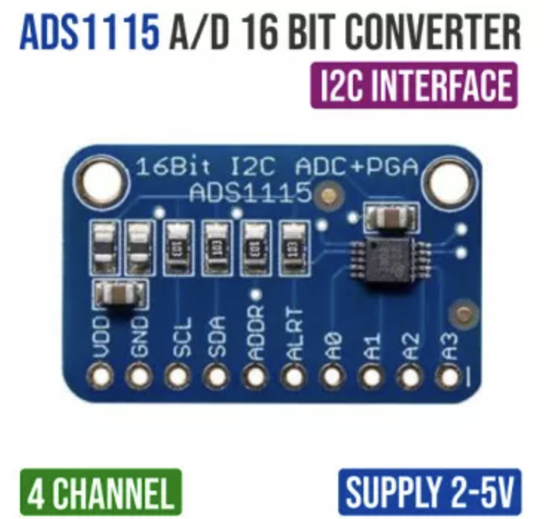
The 3rd leg of the above two ‘splitter wires’ goes to the SCL and SDA of the ADS1115 module.
The ADS1115 module will also need a GND and VCC hookup. Just extend the very same GND and VCC wires you use to power the OLED, to power this module also. Alternatively, pick another pair of GND and 3.3V rail pins on the Motor shield. There are many to pick from. It is best to just solder your wiring to this unit as it comes with the pin headers separately. Soldering is more secure than using the hook up jumper blocks.

IMPORTANT:
Before connecting the Yeasu controller’s Azimuth and Elevation output voltages to the above module and powering all of this up, you MUST adjust the two variable resistor pots on the back of the Yeasu Az/El controller.

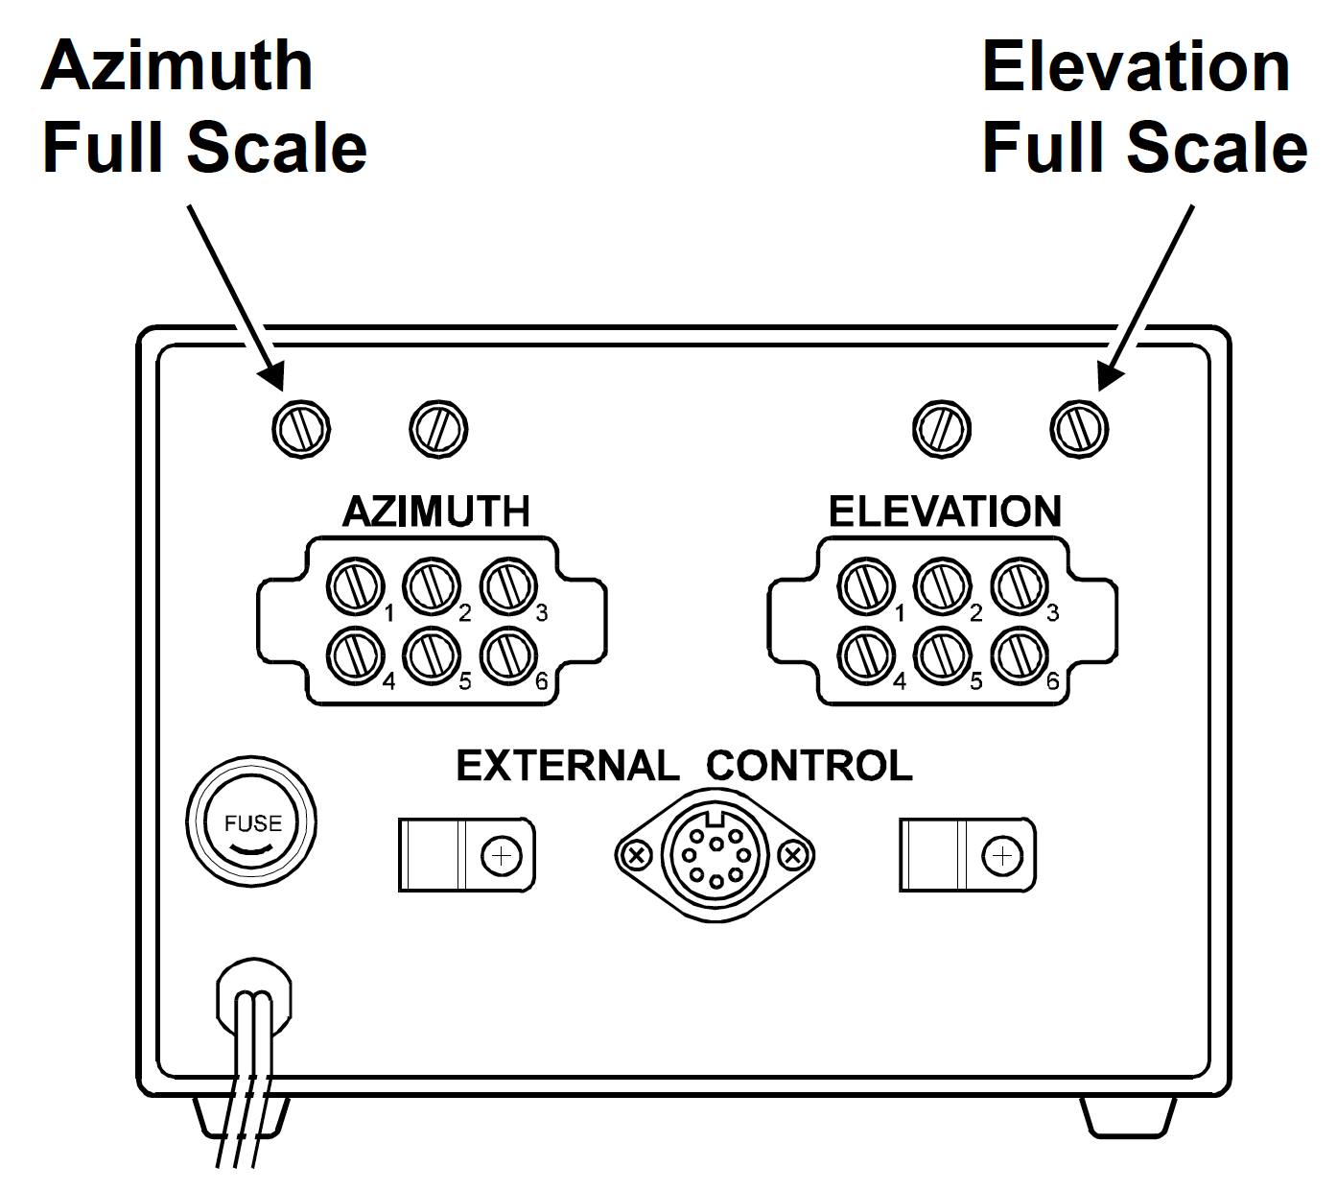
The arrows above are pointing at the pots used to calibrate the meter values displayed on the unit itself. But do you see the other two pots just next to the one’s being indicated?
It is these two pots you MUST adjust to prevent the output voltage from DESTROYING the ADS1115 module. This module can only handle up to 3.3V safely. The Yaesu controller outputs 4.5V if the cable lengths are short.

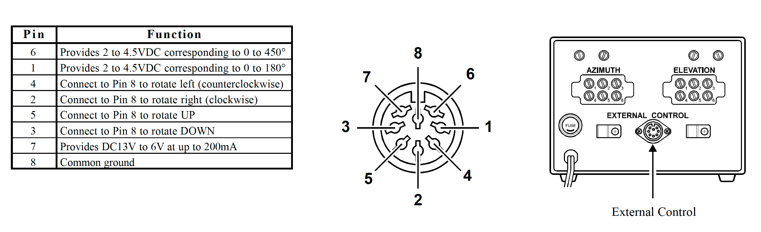
Pin Number | Function Name | Interface Connection Protocol | Electrical & Logic Specification
1 | EL Feedback | Connect to ADC Input | Analog output voltage representing 0° to 180° Elevation.
2 | AZ Feedback | Connect to ADC Input | Analog output voltage representing 0° to 450° Azimuth.
3 | EL UP | Connect to Relay / NPN Switch | Pull low to GND to drive Elevation up.
4 | AZ CW | Connect to Relay / NPN Switch | Pull low to GND to drive Azimuth Clockwise (Right).
5 | EL DOWN | Connect to Relay / NPN Switch | Pull low to GND to drive Elevation down.
6 | AZ CCW | Connect to Relay / NPN Switch | Pull low to GND to drive Azimuth Counter-Clockwise (Left).
7 | +13.5V Out | Leave Disconnected (Recommended) | Power output from controller. Avoid using for custom microcontrollers.
8 | GND | Connect to Interface Ground | Common ground reference. Must connect to interface ground.

Calibration procedure:
- Rotate Azimuth clockwise till you reach the limit, so you reach Maximum Azimuth meter deflection. This corresponds with the maximum Azimuth output voltage.
- Measure the voltage between Pin 6 and Ground at the connector.
- Adjust the ‘Azimuth’ pot (the one right above the letter ‘M’ in the image above so you read 3.3V on your Volt meter.
- Rotate Azimuth counter-clockwise till you reach the limit. Measure the voltage again. Should should read a much lower value now, approaching 0.
- Rotate Elevation UP till you reach the limit, so you reach Maximum Elevation meter deflection. This corresponds with the maximum Elevation output voltage.
- Measure the voltage between Pin 1 and Ground at the connector.
- Adjust the ‘Elevation’ pot (the one right above the letter ‘V’ in the image above so you read 3.3V on your Volt meter.
- Rotate Elevation DOWN till you reach the limit. Measure the voltage again. You should read a much lower value now, approaching 0.

Connecting the Yaesu controller’s position output voltages, to the Analog to Digital module.
Map out the wires within the cable coming from the 8 pin DIN connector going to the Yaesu controller.
- Connect ADS1115 - A0 => Pin 6 wire (Azimuth output voltage)
- Connect ADS1115 - A1 => Pin 1 wire (Elevation output voltage)

The ground for the above, below.

Connecting the Yaesu controller’s Az/El controls to the Shield.
On the blue connector block, you will find the following connection points. 5 of the wires within the cable running to Yaesu controller 8-pin DIN connector must be connected and screwed down here.
- A- => Pin 4 wire: Counter-Clockwise (Azimuth)
- A+ => Pin 2 wire: Clockwise (Azimuth)
- B- => Pin 5 wire: UP (Elevation)
- B+ => Pin 3 wire: DOWN (Elevation)
- VM => Pin 7 wire: DC13V supplied by AZEL control box
- GND => Pin 8 wire: Common Ground
- VIN. => Not used. We are powering the unit via the USB connector.
- GND. => Not used. (electrically connected to GND above).
Power
Supplying 5V via the USB port is the most common and safe option. If you are going to be interfacing with the unit from the computer anyhow over the USB cable, then you don’t have to worry about any additional power supply. If not, you probably have a few good USB ‘chargers’ lying around that came with a micro usb interface and should work also.
You can also power the unit via the terminal marked as VIN, using a stable 5V supply. The on-board voltage regulator can handle up to 10V. Higher voltages fries the unit. The module can draw up to ~400mA during Wi-Fi transmission, so make sure your power supply can handle the current, not just the voltage.
NB: Make sure you don’t have the jumper that shorts VIN and VM installed. We are running these at different voltages! VIN runs at 5V, supplied from your USB cable. VM runs at 12V supplied by the Yeasu control box. You don’t want to feed 12V into your USB socker and fry your ESP8266 module!.

