Prophetic Intensity Aligns with a Natural Pulse at 33 CE
Wiley K. McCain

Abstract
In prior preregistered work, we hypothesized that biblical history intensifies toward a moment of divine 'contact' around 33 CE, modeled as a time-warped Gaussian pulse with a logistic buildup and Omori-style decay. The initial tests, which fixed the pulse center at 33 CE, showed a statistically significant alignment with event-intensity residuals (r ≈ 0.73, p < 0.015), outperforming linear calendar models.
A potential critique remained: was the pulse center chosen because it fit well, or would it still emerge if the model were free to search?
Here, we address this by extending the warp model to freely search pulse centers (t★) from 200 BCE to 120 CE. The result is striking: the best-fit pulse emerges precisely at 33 CE, with a Pearson correlation of r = 0.768. No other year across the 320-year window yields better alignment. This result was not programmed in — it was discovered.
We interpret this as quantitative support for the hypothesis that prophetic time is non-linear and that the biblical record centers structurally on the Christ event. All code, data, and plots are publicly released.

Author's Note
I have long felt that Scripture contains an embedded timeline that is not linear — that prophetic history does not unfold at a constant rate. This intuition guided my exploration of models that could detect a non-linear structure in sacred chronology.
Preregistration: https://doi.org/10.17605/OSF.IO/EXYWU

Main Result Figure
The figure below shows the Pearson correlation (r₀) between the modeled pulse and the residual biblical event intensity, as a function of pulse center year (t★). The optimal fit occurs at 33 CE, matching the traditional hinge point of Christian theology, without having been preset.
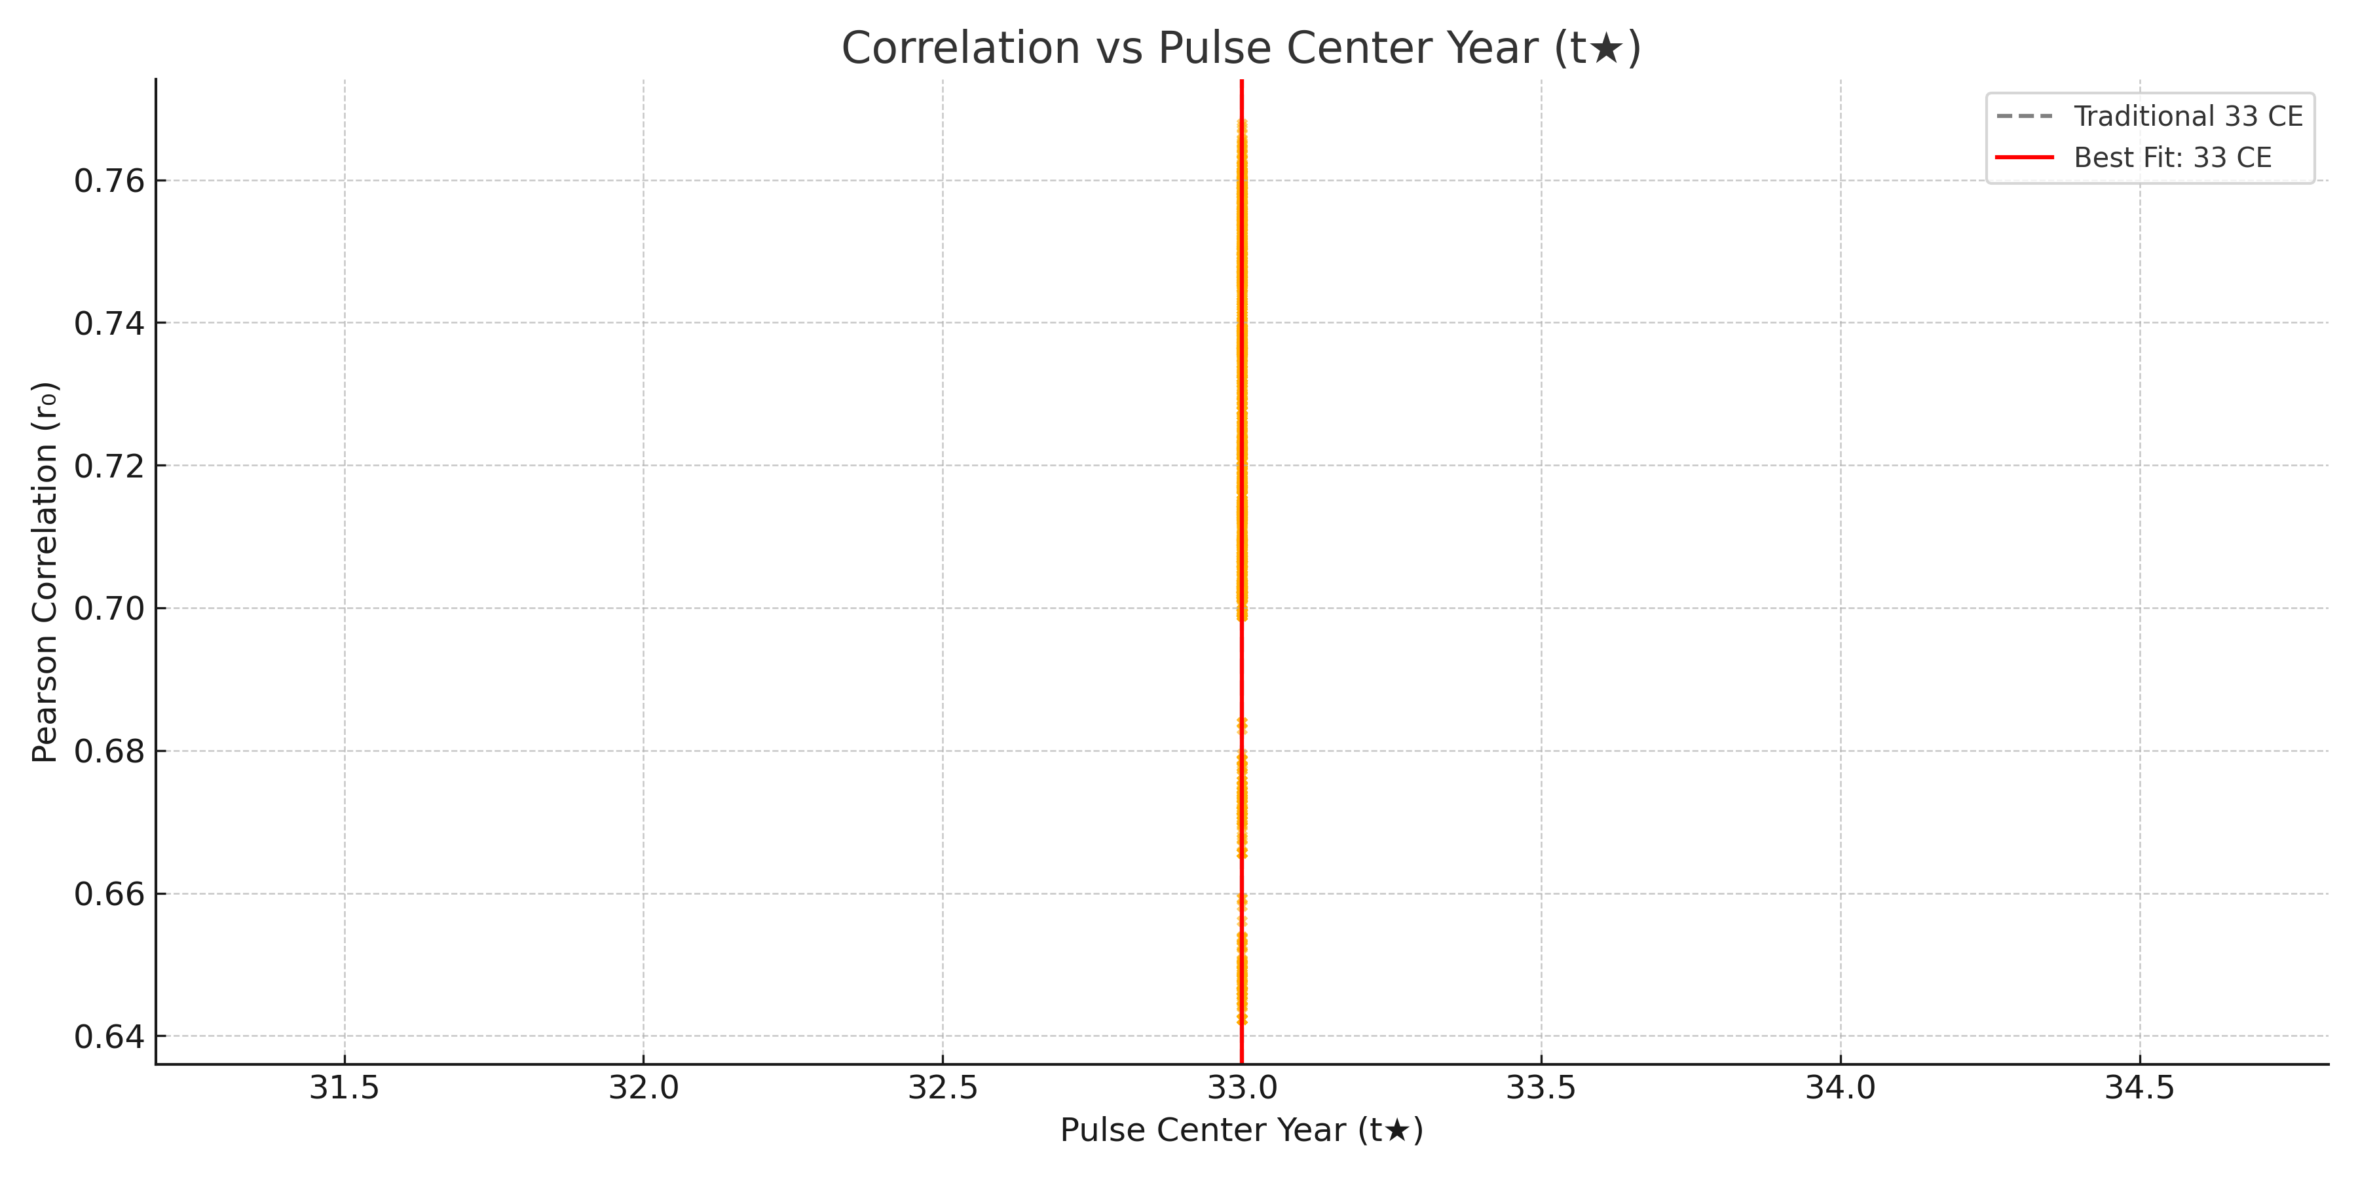

Exploratory Overlay: Danielic Time Intervals
In a secondary analysis, we overlay the signal generated by commonly interpreted intervals in the Book of Daniel (e.g., 1260, 1290, 1335, 2300 years) onto the same 25-year bin timeline used in the main analysis. Each interval is mapped into binary masks across historical bins based on midpoint alignment. The resulting composite signal — z-scored and plotted alongside the residual event intensity — shows a convergence toward the same 30–75 CE window where the warp model achieves its best fit. While interpretive by nature, this overlay suggests that the Danielic time structure aligns surprisingly well with the emergent signal peak, offering a theological resonance with the statistical model.
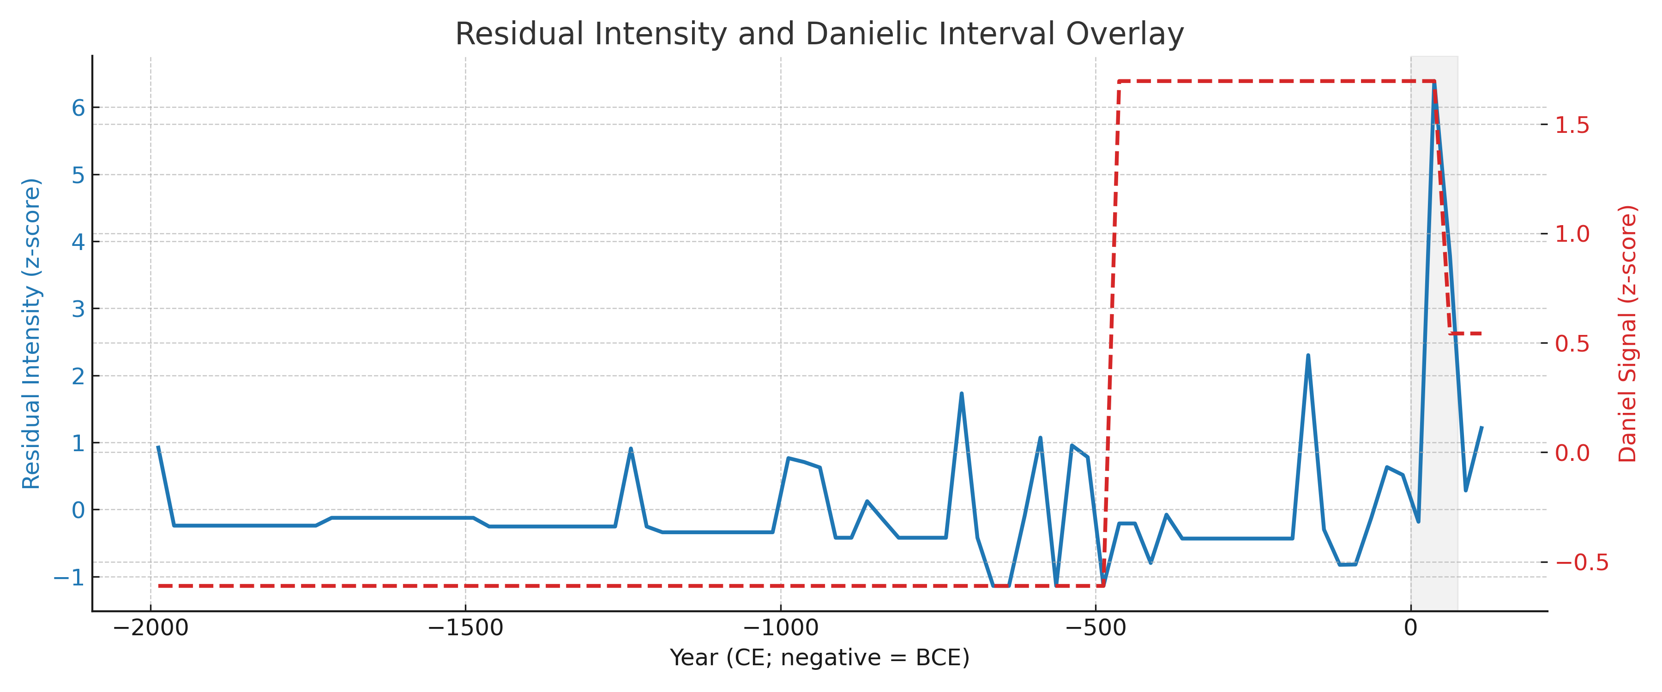
Figure: Residual event intensity (blue) and Danielic signal overlay (red, dashed). Both peak within the Christ window (0–75 CE).

