Rain Check App

1. Introduction

The ability to access accurate and up-to-date weather information is important for a variety of reasons, from planning outdoor activities to making informed decisions about travel and clothing choices. With the proliferation of smartphones, it is now easier than ever to access this information on the go, and mobile weather apps have become an increasingly popular tool for staying informed about the weather.

Our software is a mobile app designed for Android devices that provides users with current weather information and weather forecasts for cities around the world. The app is written in Java and utilizes data from a third-party weather API to retrieve and display accurate weather data.

The app allows users to search for the weather in any city by entering the city name. The app displays the current weather conditions, including temperature, time of day, and wind speed, as well as a full day forecast for every hour for the selected city.

Developing a mobile app can be a complex process, and there are many considerations that must be taken into account, from design and usability to performance and reliability. In this report, I will describe the development process for our weather app, including any challenges I faced and how I addressed them. I will also describe the testing process I used to ensure the app was working correctly before releasing it. Finally, I will reflect on our experience developing the app and discuss any potential future enhancements or improvements.

1. Development Process

The development process for our weather app involved several stages, including design, implementation, and testing. In this section, I will describe each of these stages in detail and discuss any challenges or issues I encountered along the way.

Design:

Before I began writing code, I spent time designing the user interface and user experience for the app. I wanted to create a simple and intuitive design that would make it easy for users to search for and access weather information. I also considered the layout and arrangement of the various weather data elements on the screen, such as the current temperature and forecast data.

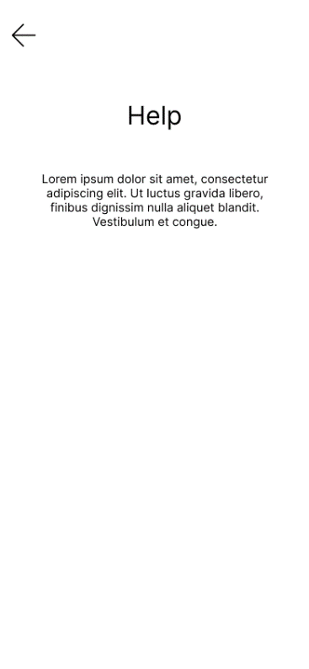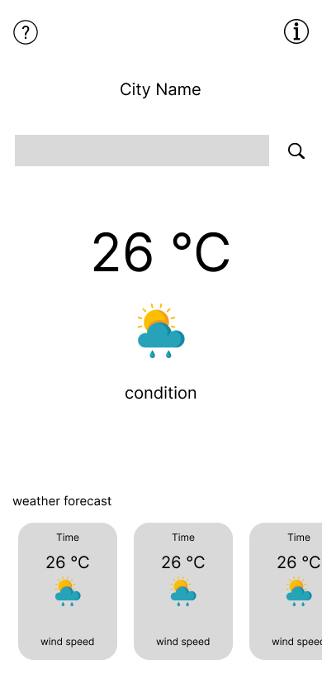To ensure that the design was user-friendly and easy to navigate, latest trends in UI/UX design were incorporated. Adding rounded corners, using a popular font and using user friendly colors that are accessible were some of them.

Implementation:

Once I had a clear design in place, I began implementing the app using Java. I used a popular Android development framework called Android Studio to create the app and connect to the third-party weather API. This process involved writing code to handle user input, retrieve and parse weather data from the API, and display the data on the screen.

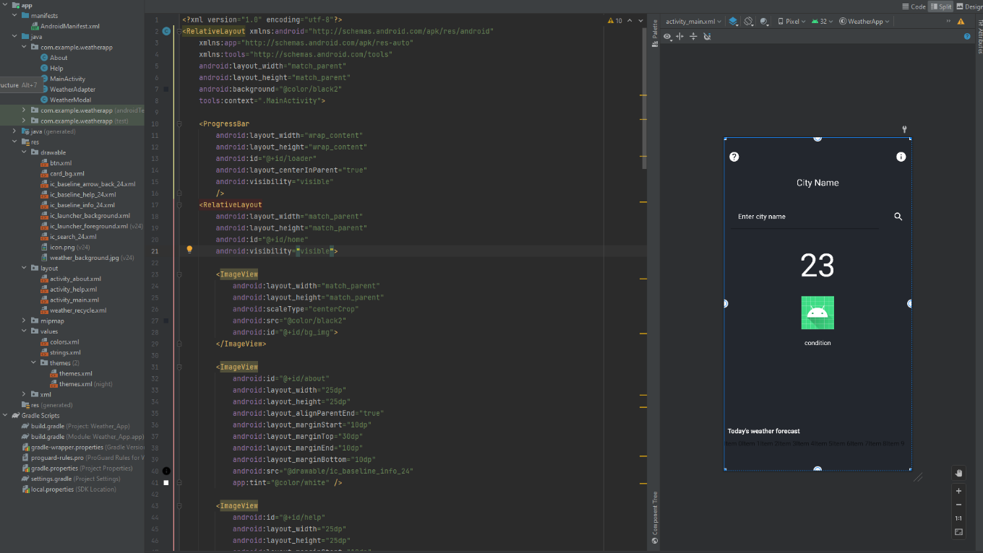One challenge I encountered during the implementation phase was handling errors and exceptions that could occur when connecting to the API or parsing the data. To address this, I implemented error handling logic to display appropriate messages to the user in the event of an error.

Testing:

As I developed the app, I conducted testing at various stages to ensure it was working correctly. This included unit testing of individual functions and components, as well as integration testing to ensure that the app was functioning correctly as a whole. I also tested the app on a variety of Android devices to ensure it was compatible with different screen sizes and resolutions.

One aspect of testing that I focused on was the reliability and accuracy of the weather data. I ran multiple test cases to ensure that the app was able to retrieve and display accurate weather data for various cities around the world. I also tested the app under different network conditions to ensure it was able to handle disruptions in connectivity.

Overall, the development process for the app was challenging at times, but also rewarding as I saw the app come to life. In the next section, I will describe the testing process in more detail.

1. Testing

Ensuring that the app was working correctly and providing accurate weather data was a key focus during the development process. To achieve this, I conducted thorough testing at various stages of the development process.

Unit testing:

I began by conducting unit testing on individual functions and components of the app. This involved writing test cases that exercised specific parts of the code and verifying that the output was as expected. I used a popular Java testing framework called JUnit to automate the execution of these test cases.

Integration testing:

Once I had completed unit testing on individual components, I moved on to integration testing to ensure that the app was functioning correctly as a whole. This involved testing the app end-to-end, from the user interface to the data retrieval and display. I ran a variety of test cases to cover different scenarios and user flows within the app.

Device testing:

In addition to unit and integration testing, I also conducted testing on a variety of Android devices to ensure the app was compatible with different screen sizes and resolutions. This involved installing the app on multiple devices and testing the app's functionality and performance.

Weather data testing:

Finally, I focused on testing the accuracy and reliability of the weather data provided by the app. I ran test cases for a variety of cities around the world and compared the results to data from other sources to ensure the accuracy of the app's data.

Overall, the testing process was an important part of ensuring the quality and reliability of the app. In the next section, I will reflect on our experience developing the app and discuss any potential future enhancements or improvements.

1. Conclusion

In this report, I have described the development process for the weather app, including the design, implementation, and testing phases. I faced several challenges along the way, but were able to overcome them through careful planning and problem-solving.

The final result is a mobile app that provides users with accurate and up-to-date weather information for cities around the world. The app is simple and easy to use, with a clean and intuitive design. I believe it will be a useful tool for anyone looking to stay informed about the weather on the go.

Looking forward, I see potential for further enhancing and improving the app. For example, I could add additional features such as alerts for severe weather conditions or personalized recommendations based on the user's location and weather preferences. I could also expand the app to other platforms, such as iOS, to make it more widely available to users.

In conclusion, developing the weather app was a challenging but rewarding experience. I am proud of the final product and believe it will be a valuable resource for users looking to stay informed about the weather.