1. Research Question(s):

Brief summary of the research questions motivating your data visualization. These should be answerable and expressed in a way that guides your visualization design decisions.

- What are the direct routes/destinations from each commercial airport?

- What are the possible connections from each airport?

2. Data Source(s):

Give the titles and URLs of all data sources , e.g. Global unemployment forecast to hit 212m - http://www.theguardian.com/news/datablog/2015/jan/20/global-unemployment-forecast-to-hit-212m-country-by-country-breakdown)

OpenFlights – Airport, airline and route data
URL - http://openflights.org/data.html
GitHub - https://github.com/jpatokal/openflights

3. User Instructions:

Brief instructions on how to use your data visualization. You may include screen shots if you wish.

Step 1: Initial Screen

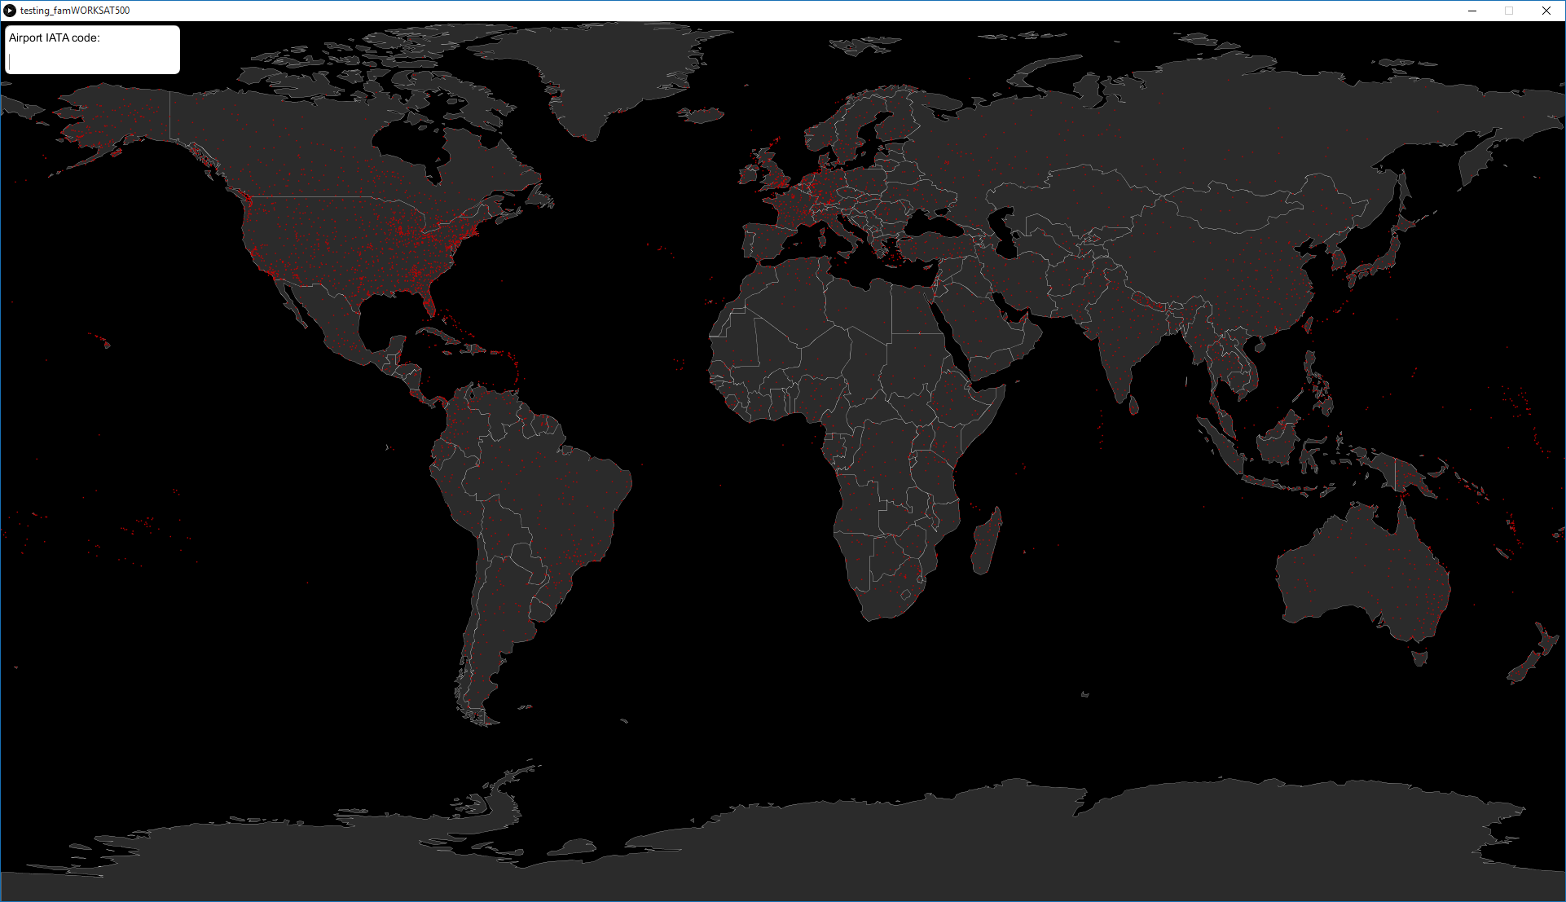

Step 2: Searching for an Airport and its possible destinations; please use this link to find your desired airports IATA/FAA Code: https://en.wikipedia.org/wiki/List_of_airports_by_IATA_code:_A
After you’ve found your desired airports code, type it in in the top left corner of the screen and hit ENTER. You can also hover over a country and it will display the name of the country.

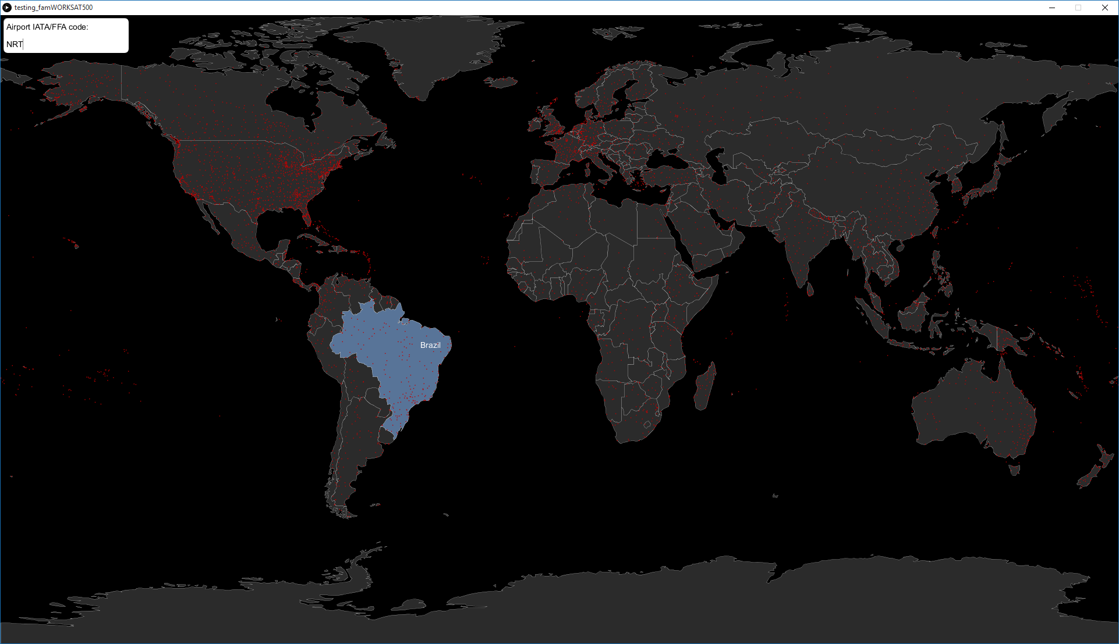

Step 3: Results; once you’ve pressed ENTER, you will be shown all the possible direct routes from your airport, in order to search another airport, just press ENTER again.

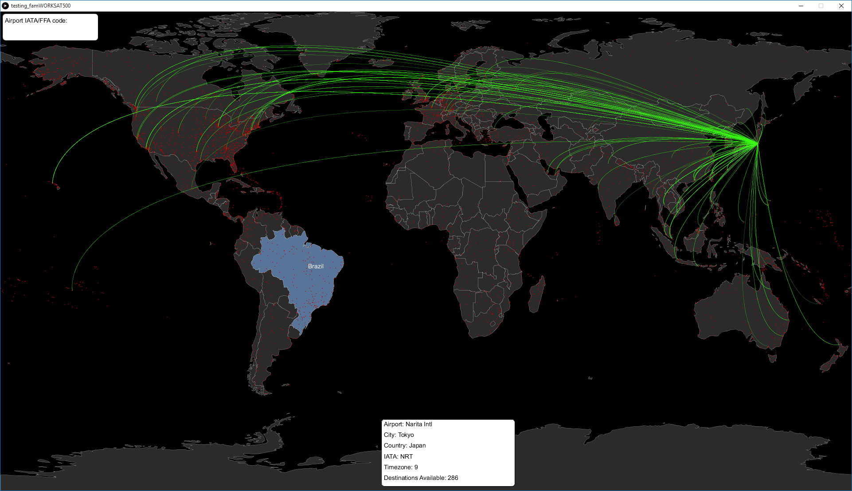

You will also be presented with a short info box for your selected airport, such as Airport Name, City, Country, IATA, Timezone and the amount of direct destinations available. As we can see Narita Airport, Japan has 286 possible destinations which are mainly located in Europe and North America.

4. Design Justification:

Provide a detailed justification for the design choices you made in creating your visualization sketch. They should be categorized under the following two headings (you may wish to refer to Munzner, 2014 Ch.4 and Ch. 5 to help structure your answer).

4.1 Visual Encoding:

4.2 Interaction:

5. Further Work:

Identify any enhancements to your sketch that could be developed to make it more effective in answering your research questions.

Use of a further advanced API such as SkyScanner, which would provide live prices on all the possible destinations that are available from chosen airports. Which would give more insight into the data as it could also serve as a service for people who are looking for flights from their local airport.

With more time and a better dataset, such as again Skyscanner, I would be able to display the live flights and their location/duration, by animating planes along their axis in proportion to their live location.

Use of a 3D map world such as possibly Google Earth API, which would perhaps reduce the visual clutter of the route edges that is seen on the GeoMap and create a more feasible model.

Allow users to select individual edges to allow for a more detailed route information box between just two airports.

Allow users to filter by continent/country/city. So all possible flights from or to a continent/city/country.

Optimize code to reduce lag.

